**Method**

Principal Response Curve (PRC) analysis was performed using the default parameters.

**Supplementary method**

**4) Principal Response Curve**

The effect of microbiome transplantation was further evaluated with the Principal Response Curve (PRC) method (Van den Brink & Braak 1999). It focuses on the differences between the bacterial compositions in the test group compared to that of the control at the corresponding time. Data was logarithm transformed by taking log (count + 1).

**Results**

To further examine how OMT affects the microbiome, PRC analysis was performed and a clear effect was observed after Week 2 in the test communities. This reveals the transfer of bacterial taxa from the donor microbiome into the test ones. For instance, there were boosts in abundances of ASV40 (Chlorobi G-1 sp.), ASV150 (*Neisseria* sp.), and ASV44 (*Bergeyella* sp.) in the test group after OMT (Figure S5, S6, Table S3). Meanwhile some taxa that were absent in the donor healthy microbiome were reduced in the test group: ASV63 *Aquaspirillum* sp., ASV243 *Moraxella* sp. and ASV128 Absconditabacteria (SR1) G-2 sp.

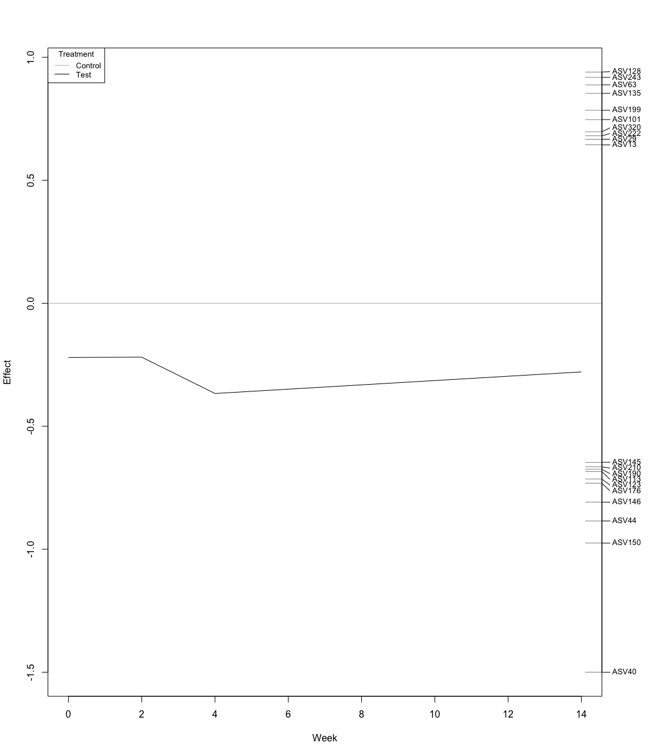

Figure S5 Principal response curves (PRC) showing the effects of OMT in the test group when compared to the control. Only the ASVs with the top 20 scores (in absolute value) were shown in this figure. Timepoint was shown on the x-axis and on the y-Axis the difference of test group from the control. The farther apart from the x-Axis the more different are the test communities compared to the control. The effect of OMT is clear between week 2 and 4, which recovered towards the end of the study. The taxa in terms of ASV are shown on the right that indicate the contribution of the taxa to this plot. Since the PRC is negative, taxa indicated with a positive score are expected to decrease in abundance in the test group relative to the controls, and vice versa. For instance, ASV 40 has the largest effect score at -1.5 and thus is inferred to increase significantly after OMT. The changes in the abundances of these taxa are shown in FigureS6 for cross-checking.

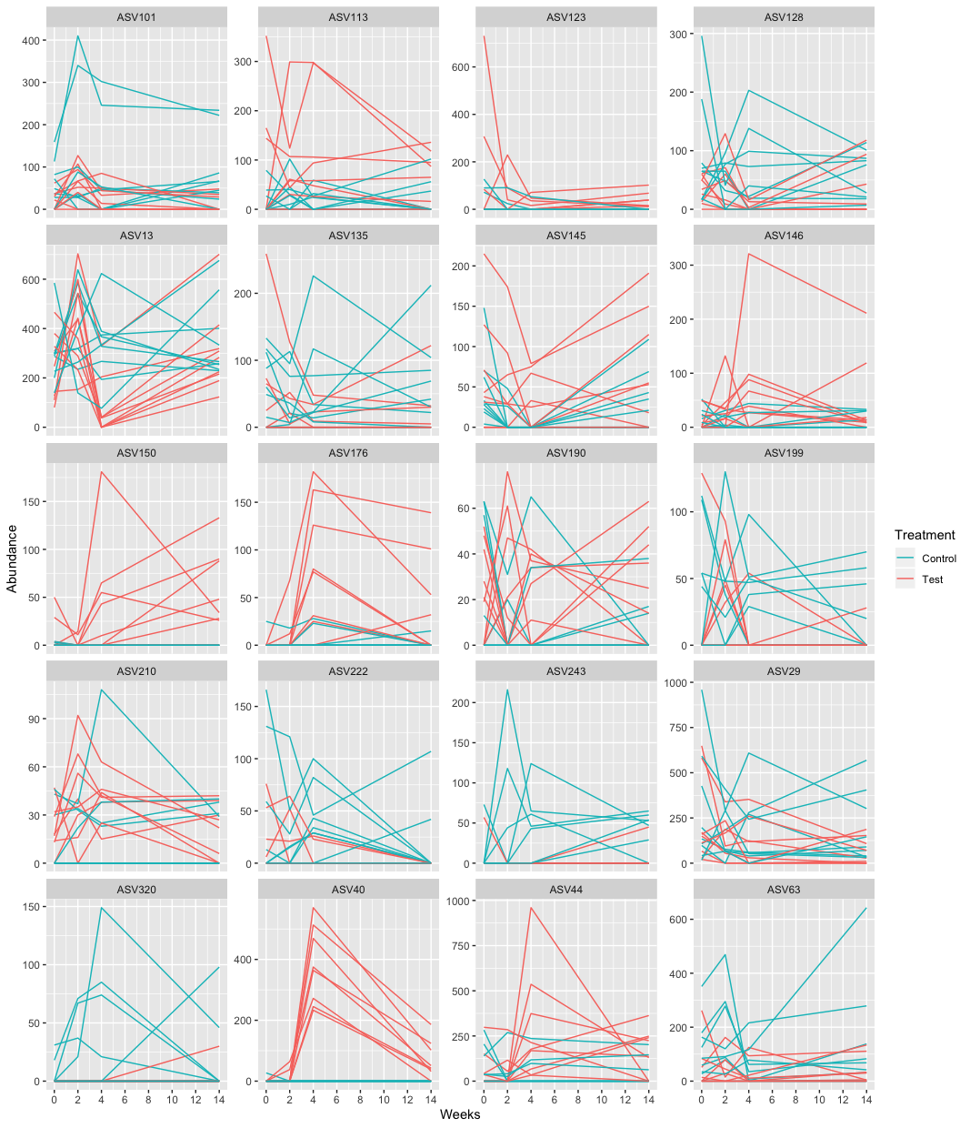

**Figure S6 Abundance plot of the top 20 PRC scoring ASVs.**

**Table S3 Identities of the top 20 PRC scoring ASVs.** The last column shows the average abundance of the ASV in the healthy donor samples that were transplanted to the test group.

|  |  |  |  |  |
| --- | --- | --- | --- | --- |
| **ASV** | **PRC score** | **Phylum** | **Species** | **Healthy donor** |
| ASV40 | -1.50 | Chlorobi | Chlorobi G-1 sp. | 498.4 |
| ASV150 | -0.98 | Proteobacteria | *Neisseria* sp. | 90.9 |
| ASV44 | -0.89 | Bacteroidetes | *Bergeyella* sp. | 183.1 |
| ASV146 | -0.81 | Firmicutes | *Helcococcus* sp. COT 140 | 82.2 |
| ASV176 | -0.73 | Proteobacteria | *Xenophilus* sp. | 42.4 |
| ASV123 | -0.71 | Proteobacteria | *Neisseria* sp. | 76.2 |
| ASV113 | -0.68 | Firmicutes | *Parvimonas* sp. COT 101 | 0 |
| ASV190 | -0.68 | Proteobacteria | *Cardiobacterium* sp. | 34.7 |
| ASV210 | -0.67 | Firmicutes | Peptostreptococcaceae XI G-10 sp. | 0 |
| ASV145 | -0.65 | Fusobacteria | *Fusobacterium* sp. | 20 |
| ASV13 | 0.64 | Chlorobi | Chlorobi G-1 sp. COT 046 | 24.6 |
| ASV29 | 0.67 | Bacteroidetes | *Porphyromonas* sp. | 0 |
| ASV222 | 0.68 | Proteobacteria | *Neisseria* sp. | 0 |
| ASV320 | 0.70 | Saccharibacteria (TM7) | TM7 G-3 sp. | 0 |
| ASV101 | 0.75 | Chlorobi | Chlorobi G-1 sp. | 0 |
| ASV199 | 0.78 | Bacteroidetes | *Alloprevotella* sp. | 0 |
| ASV135 | 0.85 | Absconditabacteria (SR1) | Absconditabacteria (SR1) sp. | 0 |
| ASV63 | 0.89 | Proteobacteria | *Aquaspirillum* sp. | 60.1 |
| ASV243 | 0.92 | Proteobacteria | *Moraxella* sp. | 0 |
| ASV128 | 0.94 | Absconditabacteria (SR1) | SR1 G-2 sp. | 0 |