GIVING PRESENTATIONS

Exercise 1
Discuss some ways in which you can attract the audience’s attention.

- _________________________________________________________
- _________________________________________________________
- _________________________________________________________
- _________________________________________________________
- _________________________________________________________
- _________________________________________________________
- _________________________________________________________
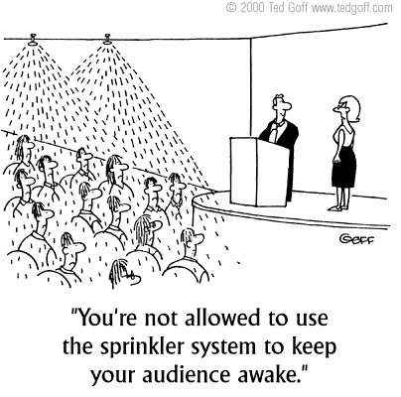

Exercise 2
a. Contrary to what most people think, most presentation disasters are not fatal. They can be resolved comfortably if you keep smiling and stay focused. How can you react in the following situations? Comment on these examples using your personal experiences, if possible.

What do you do if …

- You run out of time

- You lose your train of thought mid-sentence

- Several people start a side conversation while you are speaking

- You drop your notes on the floor
- You plan to work through a handout page by page, but people are moving ahead at their own pace.

- You have a complete blackout

- You gave the wrong facts during your presentation

b. Here are some important problems that people face when giving a presentation. Match what you think in these problematic situations with how you should respond to them.

what you think | what you say
- I've got my facts all wrong!  - Too fast! Go back and explain again.  - I've forgotten to say something!  - Too complicated! Make it simpler.  - I'm talking nonsense.  - How do you say this in English?  - I'm running out of time! | - So, let's just recap on that.  - So, basically, what I'm saying is this …  - Sorry, what I meant is this …  - Sorry, I should just mention one thing.  - So, just to give you the main points here…  - Sorry, what's the word / expression?  - Sorry, perhaps I didn't make that quite clear.

Exercise 3
a. Presentation style. Answer the following questions in groups.
- What does body language involve, according to you?

- What are the things a speaker has to pay attention to regarding his / her voice?

- How can a speaker make sure his presentation is listener oriented (without taking into account the contents of the presentation).
  - Here are a number of speakers’ profiles that you might want to avoid.

- spineless: the speaker feels he needs to lean on something
- skater: the speaker holds both hands on her back , as in a long-distance skating contest
- fig leaf: the speaker steadily holds both hands before him, as if keeping a fig leaf in place
- peasant girl: the speaker plants both hands in her waist
- old farmer: the speaker plants both hands in his trouser pockets
- Cossack: the speaker crosses his arms, looking defensive
- handless: the speaker hides both hands under long sleeves, which works well with oversized knitwear
- polar bear: the speaker paces up and down the room relentlessly
- wriggler: the speaker seems to have an itch in an unlikely spot
- inspector: the speaker clearly feels a continual need to check whether nose, ears, hair, chin, and other parts are still in place

c. Take turns giving a presentation in which your body language, voice or listener orientation is seriously flawed. The others guess and write down what you are enacting.

Exercise 4
Putting Advice into Practice. Prepare a 5-minute presentation (in 10 minutes) on a topic of choice. A couple of students will be picked out to give their presentation in front of the class. The others evaluate their performance in terms of enthusiasm, calmness, fluency, accuracy, etc.

Fill in the checklist.

general appearance
enthusiasm
calmness

fluency

accuracy

body language (hands, eye contact, facial expression, movement) + voice
listener orientation

