Chapter 1
THE PROBLEM AND ITS SCOPE
1.1 Introduction
Office work is a lot easier when we use information systems. They help us get rid of processes and use digital solutions instead. This means we can keep our data accurate find information faster and manage our records in a way. For offices that deal with a lot of client information it is very important to keep easy-to-access records. This helps us provide service to our clients.
The Support Services Facilitators Office helps people who live in the area. Now they use a paper logbook to keep track of what people ask for. This is not a way to do things because records can get lost or damaged. It is also hard to find information and it takes a lot of time to check on requests. Making reports also takes a time. All these problems make it hard for the office to manage records and keep track of what clients doing.
To fix these problems someone came up with the idea of the SSFO eLog. This is a web-based system that helps the office keep track of what clients ask for. The system stores all the records in one place gives each request a number and provides tools to check on requests and make reports. The SSFO eLog is meant to replace the paper logbook. It should help the office manage records better keep data safe and make office work more efficient. The SSFO eLog is a solution, for the Support Services Facilitators Office.
1.2 Purpose and Description
The SSFO eLog system is meant to make things better for the Support Services Facilitators Office when it comes to keeping track of what clients are asking for. Now they use a paper logbook, which is not very good because records can get lost it takes a long time to find information and it is hard to keep an eye on what is going on with client requests. The new system is going to fix these problems by giving them one place to keep all the records and track what is happening with requests.
The SSFO eLog is a system on the web that clients and administrators use separately. Clients can tell the SSFO eLog system what they need upload papers that prove what they are saying and see what is happening with their requests. Administrators can look at records change information, about requests say yes or no to requests. Make reports. The SSFO eLog system is a tool that helps the Support Services Facilitators Office keep records and watch what is going on in a way so everything is easier to get to, more organized and works more smoothly.
1.3 Objectives
1. To design a web-based electronic logging system. This system will help record and monitor client requests, in the SSFO office.
2. To develop a platform. This platform will manage client records track the status of requests and generate reports.
3. To test the SSFO eLog system. We will check how well it works if it is reliable and easy to use.
1.4 Scope and Limitations
The client request system is used for logging client requests tracking the status of these client requests and managing records for these client requests. It has pages for clients and administrators. Administrators can use the system to approve client requests reject client requests, edit client requests and make reports, for client requests.
The client request system needs the internet to work. It does not do payment transactions or work when it is offline. The client request system is only used for recording client requests monitoring client requests and managing client requests at the SSFO office. It does not cover all the work that is done for assistance.
1.5 Definition of Terms
System: The SSFO eLog is a website that helps track and manage client requests.
Users: These are the people who live there or make requests using the SSFO eLog.
Admin: These are the people in charge who handle requests, approvals and settings, on the SSFO eLog.

Chapter 2
REVIEW OF RELATED STUDIES AND SYSTEM
2.1 Foreign
Development of a Web-based records management system: an ERMS initiative for the Office of Senior Citizen Affairs in the Philippines.
The people at Libadia and others made a web-based system for the Office of Senior Citizen Affairs in 2025. This system is called Electronic Records Management System or ERMS for short. It helps with keeping records in one place so people can find information faster. It does some tasks on its own. This study shows that using the web for these systems makes things work better people make mistakes and everyone can use it. This is important, for the system because it is trying to do something similar it wants to make managing information easier and make the office work better by using computers to do tasks. The SFFO system and the Electronic Records Management System are similar in that they both want to use automation to improve things.

Database-Driven Web Applications for Data Management
Williams and Lane talked about this in 2020. They said that PHP and MySQL can be used to develop web-based database applications. The thing that makes this work is something called CRUD operations. This means creating, reading, updating and deleting data. A lot of platforms use this because they need to be able to put in data get data out update it and delete it when it is not needed anymore. The SSFO eLog system is an example of this. It uses PHP and MySQL to manage the requests from clients, store records and make reports all in one place. This is really helpful, for keeping everything organized.

Digital Transformation in Office Record Systems
Silberschatz, Korth and Sudarshan said in 2020 that database systems are really important for keeping track of data and making sure the data is correct in information systems. Database systems help keep everything organized. When you design a database the way it works better and you do not have to store the same information over and over again. This study is good for the SSFO eLog system because it shows that having a planned database design is very important for managing client records in a good way. The database systems, like the one used in the SSFO eLog system need to be designed to manage client records efficiently.
2.2 Local
Electronic Record Management Systems in Local Government Units
Electronic record management systems are increasingly being used by local government units in the Philippines to deliver services. It also enhances record accuracy. Reduces manual workload. These improvements are key to service efficiency in local government units. The SSFO eLog system is an example of how digital systems can be used to achieve this. Local government units can benefit from using electronic record management systems. They can improve service delivery and operational efficiency. The study by Aliling et al. Supports the use of systems, in local governance. It highlights the benefits of digitizing records within offices.

Web-Based Information Systems in Barangay Offices
Franco and his team developed a website to record and monitor things in 2023. This website was used in health offices and it replaced the old way of keeping records by hand. The new system made it easier to get the information they needed it was more accurate. It was easier to use. This shows that using computers and digital systems can really work well in offices. The SSFO eLog system is similar because it also wants to replace records with a digital system that is organized and easy to use so that it is better for monitoring and managing the SSFO eLog system and the information, in the SSFO eLog system.

Centralized Information Management Systems
Gallera s 2023 study pointed out that centralized information systems help local government units to quickly find records make it easier for users and manage data over time. The study also shows that a system that is easy to use and simple to maintain is crucial for its long-term success. This actually backs up the SSFO eLog system because it stresses the importance of having one database where client requests can be tracked and managed in an efficient way with the SSFO eLog system being a key example of this. The centralized database allows for tracking of client requests which is a major benefit of the SSFO eLog system.

Chapter 3
DESIGN AND METHODOLOGY
Requirement Analysis
To create the proposed SSFO eLog system the researcher used the 4D Model. This 4D Model is made up of four parts: Define, Design, Develop and Deploy. The researcher used the SSFO eLog system 4D Model to figure out the research environment. They also used the SSFO eLog system 4D Model to find out what was needed. The SSFO eLog system 4D Model helped the researcher to understand the steps that had to be taken and the rules that had to be followed for the SSFO eLog system.
3.1 4D Model
DEFINE
DEPLOY
DEVELOP
DESIGN

Figure 1.0 4D Model
Define Phase
The researcher found some issues with the paper logbook at the Support Services Facilitators Office. The logbook has problems like records getting lost or damaged. It also takes a time to find the information we need from it. This causes delays and people who need help have to wait a time. The researcher came up with a solution to these problems. The solution is called the SSFO eLog. The SSFO eLog is a system on the web. It helps with submitting requests and getting approvals at the Support Services Facilitators Office. The SSFO eLog makes the logbook digital, which solves the problems with the paper logbook, at the Support Services Facilitators Office. The SSFO eLog is a way to manage requests and approvals. It helps people get the help they need on time.
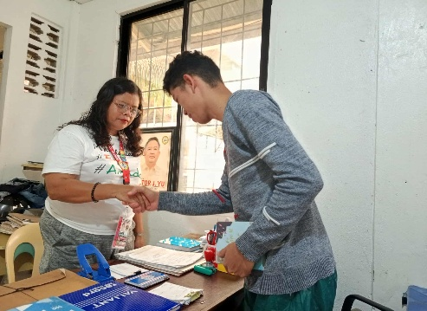
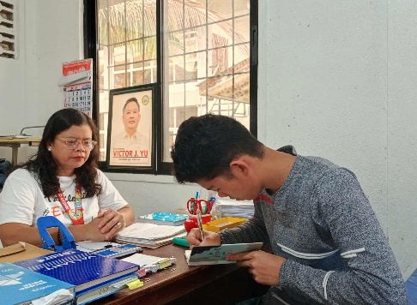

Design Phase
The system has two parts: the Client part and the admin part. The Client part is where people can send in requests and see what is happening with them. The admin part is where the administrators do their work. They use the admin part to manage things make changes and make reports. All the information is stored in one place, which's a MySQL database. This way everything is easy to find and use. The MySQL database is like a filing system, for the system.

Develop Phase
The system was made with PHP and MySQL and HTML and CSS and JavaScript. This system does a lot of things. It can create records, view records, update records and delete records. The system uses these things to manage requests. The system was checked to make sure the PHP and MySQL and HTML and CSS and JavaScript system works right and the PHP and MySQL and HTML and CSS and JavaScript system is reliable. The PHP and MySQL and HTML and CSS and JavaScript system was tested to make sure the PHP and MySQL and HTML and CSS and JavaScript system is functional and works the way it should.

Deploy Phase
The system was set up in the SSFO office for use. Staff members were trained on how to use it. Clients were also shown how to submit requests. This system works on a website platform that you can access with the internet. The staff and clients can use it from any computer with internet.
3.2 Current System Flow
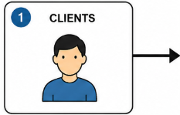
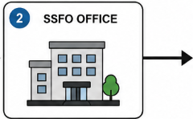
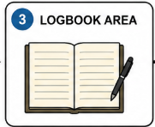
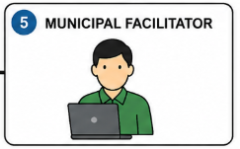
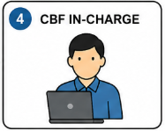
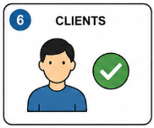
Client is notified of approval
and next steps.
Municipal Facilitator
reviews and approves
the request.
Clients visits the SSFO Office.
Clients proceed
to the Logbook Area.
CBF In-charge
forwards the request
to the Municipal Facilitator.
SSFO Staff / CBF In-charge
logs the request manually
in the logbook.

Figure 2.0 Current System Flow
The current SSFO system uses a manual logbook to record requests. Clients must visit the office in person, and records are handwritten. Retrieval of past records is time-consuming, and reports must be manually prepared. The absence of automation leads to inefficiency and data loss risks.
3.3 Context Diagram
Clients
SSFO eLog.
SSFO Adminn/Staff





Figure 3.0 Context Diagram
The context diagram shows the system as a whole and its interaction with external entities. The Client submits requests and receives updates from the system, while the SSFO Admin/Staff manages and processes the requests.

3.4 Activity Diagram
SSFO Staff
Update or Edit Details
Generate Reports
Approve /Decline
Review Requests

Log Out
Clients
Track Status
Upload Attachments
Receive Notifications
Submit Request

Figure 4.0 Activity Diagram
The figure 3.2, which is the activity diagram, illustrates the process of the SSFO staff (admin) and the client in the SSFO eLog System. The client can submit a request for assistance, upload necessary attachments, track the status of the request, receive notifications regarding updates or approvals, and log out of the system after completing their transaction. The SSFO staff or admin, on the other hand, can review and verify submitted requests, approve, or reject them based on validity, update client records, generate reports, send notifications to clients, and log out.
Scan QR code
3.5 USE Case Diagram
Login
Submit Request

Upload Attachment


Review Request
SSFO staff
Client

Approve / Reject Request

Track Status
Receive Notification

Generate Report
Logout

Figure 5.0 Case Diagram
SSFO eLog System use case diagram The SSFO eLog System’s Use Case Diagram illustrates communication between Client (User) of the System and admin (SSFO Staff) of the System where the Client can create request and upload attachments for their need and client also get notification after request for which update he did. Moreover, admin can view requests made by the client, accept and reject request and also make the records on their basis by getting output reports of approved and rejected requests in terms of analytics for proper record management for their company records.

REFERENCES
Libadia, M., Botangen, K. A., Lucero, P. J., & Tecson, J. (2025). Development of a Web-based records management system: an ERMS initiative for the Office of Senior Citizen Affairs in the Philippines. Records Management Journal, 35(2), 160–179. https://doi.org/10.1108/rmj-06-2023-0031

Ali, M. I., Ghazali, O., Khan, S., & Hussain, S. (2020). A cloud-based secured IoT framework for log management. International Journal of Advanced Computer Science and Applications, 11(2), 95–102. https://doi.org/10.14569/IJACSA.2020.0110213

Franco, E. N., Latiza, J. M. B., & Villanueva, D. V. (2023). Barangay Health Workers’ Recording and Monitoring System [Undergraduate thesis, Capiz State University]. CAPSU Institutional Repository. https://repository.capsu.edu.ph/handle/123456789/143

T. Aliling, J., Santa Ana, B. B., & Soberano, PhD, K. T. (2025). Digitalizing Governance: A Transformation on the Processes of One Community in the Philippines. INTERNATIONAL JOURNAL OF MULTIDISCIPLINARY RESEARCH AND ANALYSIS, 08(06). https://doi.org/10.47191/ijmra/v8-i06-68 (Original work published as Digitalizing Governance: A Transformation on the Processes of One Community in the Philippines)

Jovie Micayas Gallera. (2023). Technological Innovations and Future Prospect for the Resident Information Management System for Local Barangay in Surigao City. International Journal of Advanced Research in Science, Communication and Technology, 513–523. https://doi.org/10.48175/ijarsct-12173

