Office Viewer Test Sample — Word
  - Representative DOCX features for rendering and interaction tests

Purpose | Regression and feature validation for a web-based Office viewer
Coverage | Text styles, lists, tables, images, hyperlinks, headers/footers, page breaks
Language mix | English with a small Japanese line: 表示テスト用サンプル
Created | OpenAI-generated sample data

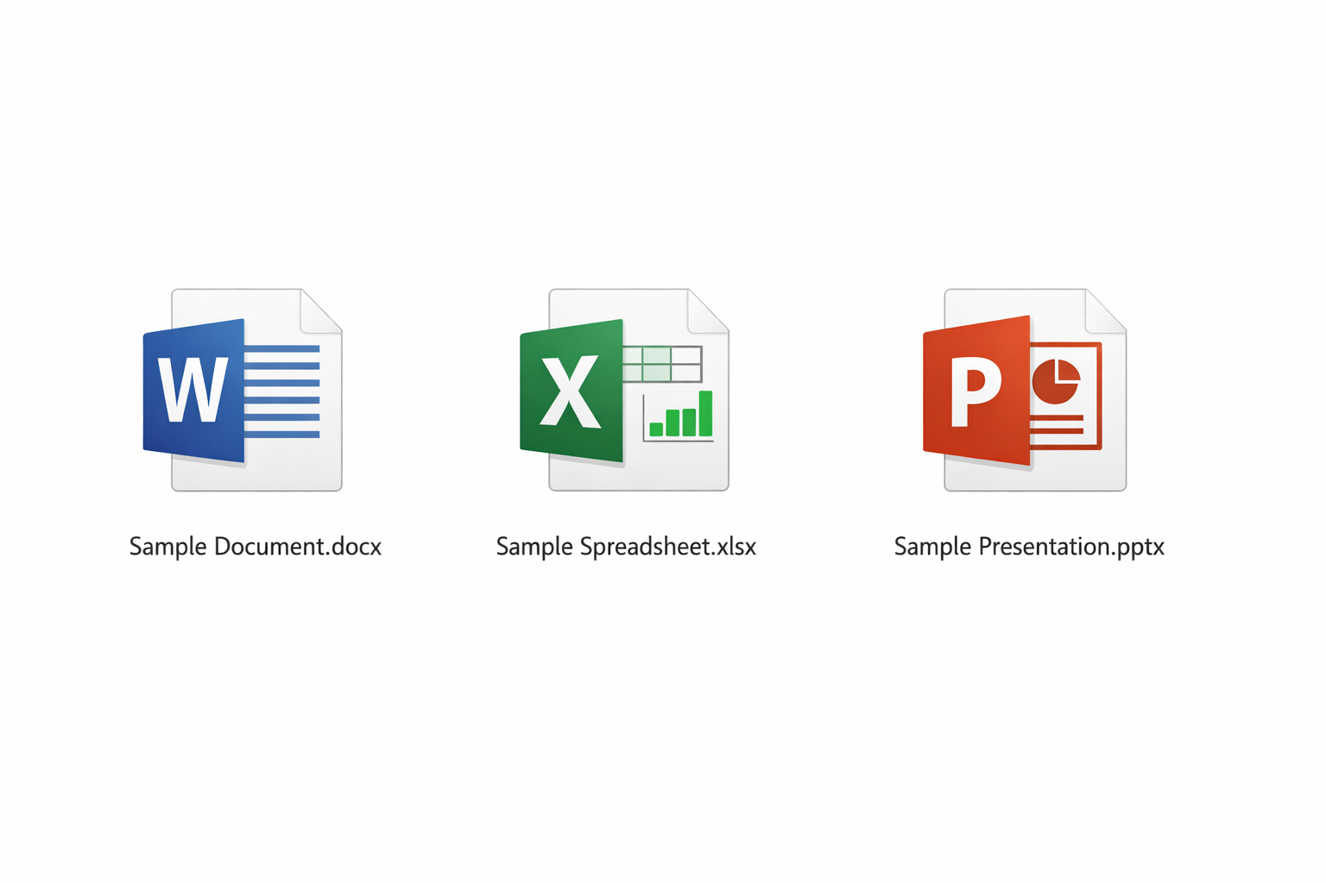
Figure 1. Embedded raster image for image rendering, scaling, and centering checks.

1. Rich Text and Paragraph Features
This sample includes bold, italic, underlined, colored, and highlighted inline text. It also exercises paragraph spacing, line wrapping, and mixed content within a single run sequence.
Note box: viewers should preserve indentation, spacing, and font styling inside callout-style paragraphs.

2. Bulleted and Numbered Lists
- Top-level bullet item with a moderate sentence length for wrapping behavior.
- Second bullet item.
- Third bullet item with mixed formatting inside the same bullet.
- Nested bullet item.
- First numbered step.
- Second numbered step.
- Third numbered step with a short note.

3. Hyperlink and Quoted Text
Reference link: OpenAI — useful to verify clickable external hyperlinks in the viewer.
“A good document viewer must preserve structure, not just plain text.”

4. Code-style Paragraph
render(file) -> paginate() -> layout() -> paint()

5. Table with Alignment and Wrapping
The table below intentionally mixes compact values and longer descriptive text.
ID | Feature | Type | Priority | Expected behavior
DOC-01 | Headers and footers | Layout | High | Header text remains aligned right; footer page number stays centered.
DOC-02 | Hyperlinks | Interaction | High | External links are visibly styled and can be selected.
DOC-03 | Images | Media | High | Embedded images scale proportionally without cropping.
DOC-04 | Mixed inline styles | Text | Medium | Bold/italic/color/highlight segments remain distinct.

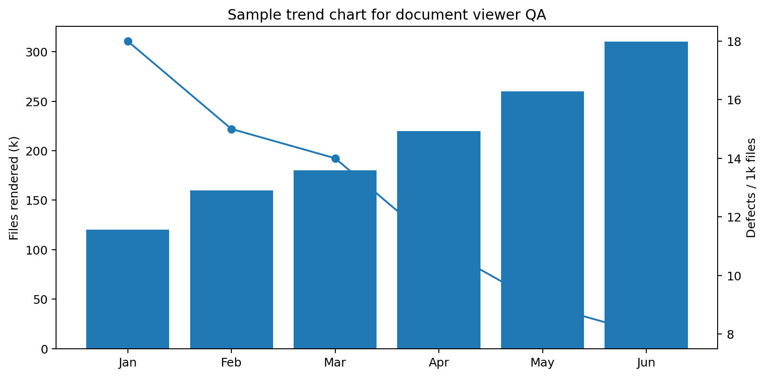
Figure 2. Sample chart image with axes, labels, bars, and a line series.

6. Feature Matrix
This page verifies repeated table rendering and page-break handling.
Area | Sample | Inline style | Lists | Table | Image | Notes
Cover | Title page | — | — | Info table | Icons image | Centered composition
Text | Rich paragraph | Bold / italic / color / highlight | Bullets + numbering | — | — | Mixed runs
Table | Feature checklist | Normal | — | 5 columns | Chart image below | Wrap + alignment
Appendix | Revision log | Normal | — | 4 columns | — | Lightweight final page

Appendix A. Revision Log
Version | Date | Author | Summary
0.1 | 2026-04-19 | OpenAI | Initial sample with representative layout and formatting features.
0.2 | 2026-04-19 | OpenAI | Added hyperlink, chart image, page numbering, and appendix.

