**HW1 Report**

R10922067 林云雲

**Introduction**

This homework consists of the following two parts:

**Part 1.** A program is built with python to flip an image vertically, horizontally, and diagonally.

**Part 2.** *Gimp*, a free image editor, is used to do image rotation, scaling, and binarizing.

**Part 1**

**1.1. Directory Layout**

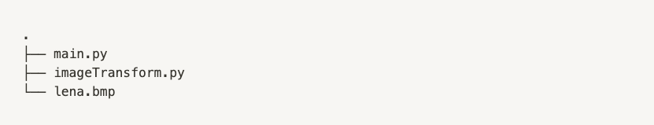

**1.2. Usage**

Run the following command in the terminal.

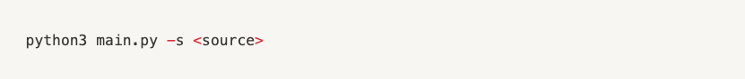

Parameters

-s <source> : the file path of source image, default = lena.bmp

**1.3. Source Code**

1.3.1 main.py

Imports functions from ImageTransform class to flip the source image vertically, horizontally, and diagonally. The three result images will be saved under current directory.

1.3.2 imageTransform.py

Implements the ImageTransform class including the following functions:

flip_vertically

Returns a vertically flipped image by *reversing the order of the rows* in the source image.

flip_horizontally

Returns a horizontally flipped image by *reversing the order of the columns* in the source image.

flip_diagonally

Returns a diagonally flipped image along the top-left to bottom-right diagonal line by *swapping the row and the column* of each pixel in the source image.

**1.4. Results**

|  |  |  |
| --- | --- | --- |
| Vertically Flipped | Horizontally Flipped | Diagonally Flipped |
|  |  |  |

**Part 2**

**2.1. Gimp**

Official website: <https://www.gimp.org/>

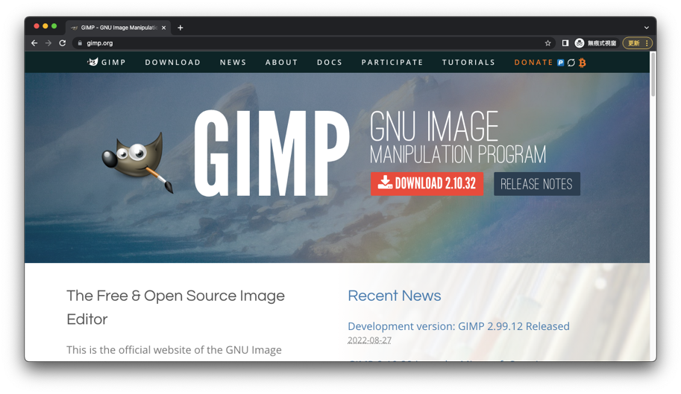

Software Interface

**2.2. Results**

2.2.1 Rotate 45 degrees clockwise

|  |  |
| --- | --- |
| Editing screenshot | Result Image |
|  |  |

2.2.2 Scale down to half size

|  |  |
| --- | --- |
| Editing screenshot | Result Image |
|  |  |

2.2.3 Binarize with threshold 128

|  |  |
| --- | --- |
| Editing screenshot | Result Image |
|  |  |