**HW10 Report**

R10922067 林云雲

**Introduction**

This program implements the following Zero-crossing operators for image edge detection:

*Laplacian mask (2 types), Minimum Variance Laplacian, Laplacian of Gaussian, Difference of Gaussian*.

Each of these methods defines its masks to calculate gradient magnitude for every pixel to generate the output image.

**Usage**

Place the source image and main.py under the same directory. Run the following command in the terminal.

python3 main.py -s <source> -m <method> -t <threshold>

Parameters

-s <source> : the file path of source image, default = lena.bmp

-m <method> : the method for edge detection, default = L4

*Options:

-L4 : Laplacian mask (0, 1, 0, 1, -4, 1, 0, 1, 0)

-L8 : Laplacian mask (1, 1, 1, 1, -8, 1, 1, 1, 1)

-MVL : Minimum Variance Laplacian

-LoG : Laplace of Gaussian

-DoG : Difference of Gaussian

-t <threshold> : the threshold for edge detection, default = 15

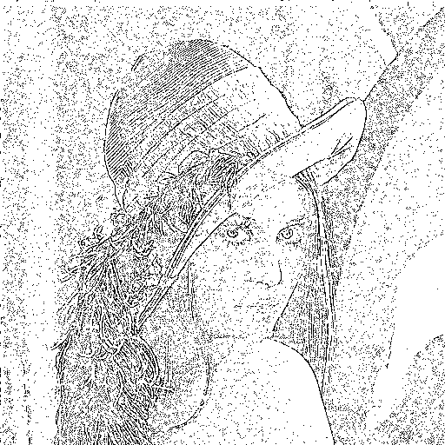**Laplacian Mask (0, 1, 0, 1, -4, 1, 0, 1, 0)**

1. Mask

|  |  |  |
| --- | --- | --- |
| 0 | 1 | 0 |
| 1 | -4 | 1 |
| 0 | 1 | 0 |

1. The result (threshold=15 for example) is saved   
   as laplacian_4.png as shown on the right.

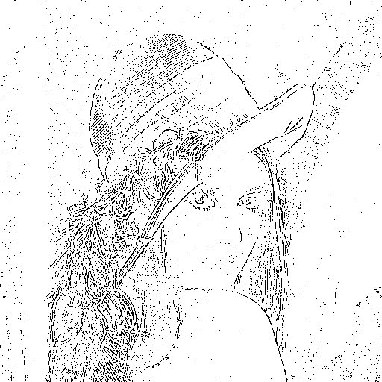**Laplacian Mask (1, 1, 1, 1, -8, 1, 1, 1, 1)**

1. Mask

|  |  |  |  |
| --- | --- | --- | --- |
| $$\frac{1}{3}$$ | 1 | 1 | 1 |
| 1 | 8 | 1 |
| 1 | 1 | 1 |

1. The result (threshold=15 for example) is saved   
   as laplacian_8.png as shown on the right.

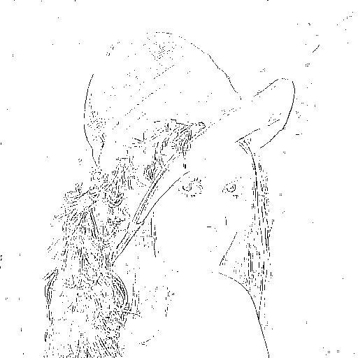**Minimum Variance Laplacian**

1. Mask

|  |  |  |  |
| --- | --- | --- | --- |
| $$\frac{1}{3}$$ | 2 | -1 | 2 |
| -1 | -4 | -1 |
| 2 | -1 | 2 |

1. The result (threshold=20 for example) is saved   
   as MVL.png as shown on the right.

**Laplacian of Gaussian**

1. Mask

|  |  |  |  |  |  |  |  |  |  |  |
| --- | --- | --- | --- | --- | --- | --- | --- | --- | --- | --- |
| 0 | 0 | 0 | -1 | -1 | -2 | -1 | -1 | 0 | 0 | 0 |
| 0 | 0 | -2 | -4 | -8 | -9 | -8 | -4 | -2 | 0 | 0 |
| 0 | -2 | -7 | -15 | -22 | -23 | -22 | -15 | -7 | -2 | 0 |
| -1 | -4 | -15 | -24 | -14 | -1 | -14 | -24 | -15 | -4 | -1 |
| -1 | -8 | -22 | -14 | 52 | 103 | 52 | -14 | -22 | -8 | -1 |
| -2 | -9 | -23 | -1 | 103 | 178 | 103 | -1 | -23 | -9 | -2 |
| -1 | -8 | -22 | -14 | 52 | 103 | 52 | -14 | -22 | -8 | -1 |
| -1 | -4 | -15 | -24 | -14 | -1 | -14 | -24 | -15 | -4 | -1 |
| 0 | -2 | -7 | -15 | -22 | -23 | -22 | -15 | -7 | -2 | 0 |
| 0 | 0 | -2 | -4 | -8 | -9 | -8 | -4 | -2 | 0 | 0 |
| 0 | 0 | 0 | -1 | -1 | -2 | -1 | -1 | 0 | 0 | 0 |

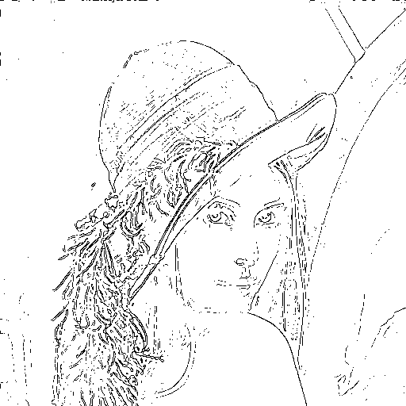

1. The result (threshold=3000 for example) is saved as LoG.png as shown on the right.

**Difference of Gaussian**

1. Mask (inhibitory σ = 3, excitatory σ = 1, kernel size=11)

|  |  |  |  |  |  |  |  |  |  |  |
| --- | --- | --- | --- | --- | --- | --- | --- | --- | --- | --- |
| -1 | -3 | -4 | -6 | -7 | -8 | -7 | -6 | -4 | -3 | -1 |
| -3 | -5 | -8 | -11 | -13 | -13 | -13 | -11 | -8 | -5 | -3 |
| -4 | -8 | -12 | -16 | -17 | -17 | -17 | -16 | -12 | -8 | -4 |
| -6 | -11 | -16 | -16 | 0 | 15 | 0 | -16 | -16 | -11 | -6 |
| -7 | -13 | -17 | 0 | 85 | 160 | 85 | 0 | -17 | -13 | -7 |
| -8 | -13 | -17 | 15 | 160 | 283 | 160 | 15 | -17 | -13 | -8 |
| -7 | -13 | -17 | 0 | 85 | 160 | 85 | 0 | -17 | -13 | -7 |
| -6 | -11 | -16 | -16 | 0 | 15 | 0 | -16 | -16 | -11 | -6 |
| -4 | -8 | -12 | -16 | -17 | -17 | -17 | -16 | -12 | -8 | -4 |
| -3 | -5 | -8 | -11 | -13 | -13 | -13 | -11 | -8 | -5 | -3 |
| -1 | -3 | -4 | -6 | -7 | -8 | -7 | -6 | -4 | -3 | -1 |

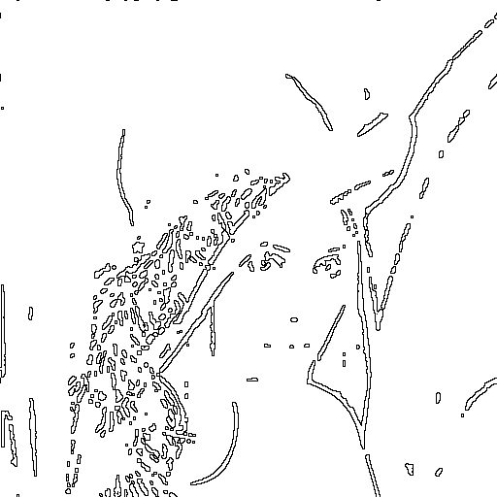

1. The result (threshold=1 for example) is saved as DoG.png as shown on the right.