**HW3 Report**

R10922067 林云雲

**Introduction**

This program consists of three parts:

**Part 1.** Read the input source image and generate its original histogram.

**Part 2.** Adjust the intensity of the original image by 1/3 and generate its histogram.

**Part 3.** Apply histogram equalization to the darken image in Part 2 and generate its histogram.

**Usage**

Place the source image and main.py under the same directory. Run the following command in the terminal.

python3 main.py -s <source> -m <intensity_multiplier>

Parameters

-s <source> : the file path of source image, default = lena.bmp

-m <intensity_multiplier> : the multiplier for intensity adjustment in Part 2, default = 1/3

**Part 1. Original image and histogram**

* 1. **Method**

First, source image is read with grayscale mode.

For each pixel, increment the pixel count of the its corresponding intensity in the histogram.

* 1. **Result**

The result image and histogram are saved as original_image.bmp and original_histogram.png as shown below.

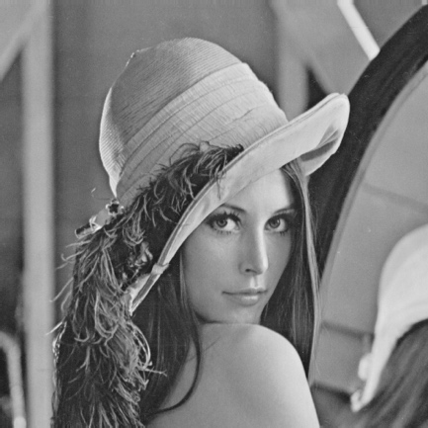 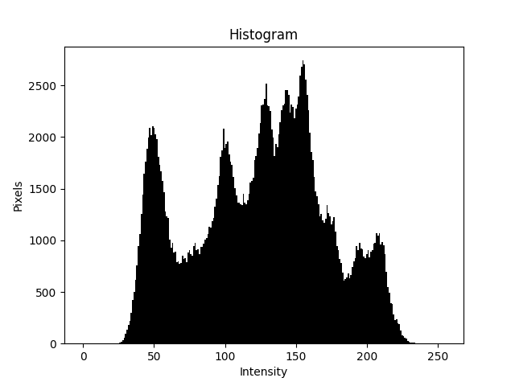

**Part 2. Darken image and histogram**

* 1. **Method**

For each pixel in the original image, multiply the pixel’s intensity and then generate its histogram as did in Part 1.

* 1. **Result**

The result image and histogram are saved as dark_image.bmp and dark_histogram.png as shown below.

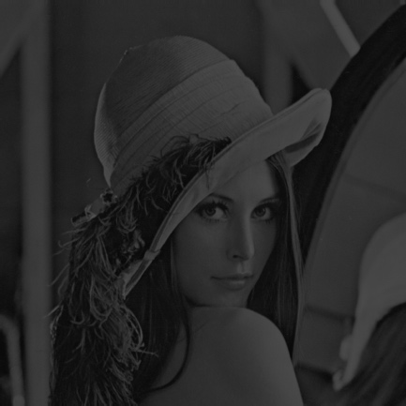 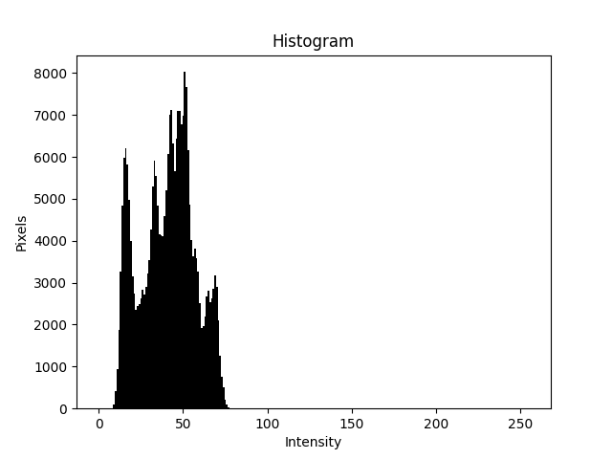

**Part 3. Histogram equalization**

* 1. **Method**

The darken image and histogram generated in Part 2 is taken as the input for this process. The goal is to normalize the distribution of intensity within the image, i.e. to flatten the probability density function of intensity ($PDF$). The integral of a $PDF$ is known as the cumulative distributive function ($CDF$). For a flatten $PDF$, it would have a linearized $CDF$ across the value range. Hence we can derive the following histogram equalization formula:

|  |  |
| --- | --- |
| $$s_{k}=\sum_{j=0}^{k}{\frac{n_{j}}{n}}×\left(L-1\right)=CDF\left(k\right)×(L-1)$$ | $$k:0, 1, 2, …, L-1 \\ L:number of grey levels in image \left(in this case 256\right) \\ n_{j}:number of times j-th grey level appears in image \\ n:total number of pixels in the image \\ cdf:cummulative distributive function$$ |

For each intensity value $k$ within 0-255, we calculate its $cdf$ value with the input histogram, and scale by 255 to get the transformed intensity value $s_{k}$. Finally, we process each pixel in the input image and reassign its intensity with the transformed value.

The picture shown below are the $CDF$ before and after equalization. We can see that the $CDF$ has be linearized across 0-255 after equalization as mentioned earlier.

|  |  |
| --- | --- |
| Darken image | Equalized image |

* 1. **Result**

The result image and histogram are saved as equalized_image.bmp and equalized_histogram.png as shown below.

