**HW5 Report**

R10922067 林云雲

**Introduction**

This program applies grayscale morphology operations to a grayscale image, including dilation, erosion, opening, closing.

**Usage**

Place the source image and main.py under the same directory. Run the following command in the terminal.

python3 main.py -s <source> -b <binary_threshold>

Parameters

-s <source> : the file path of source image, default = lena.bmp

**Binary Morphology**

* 1. **Dilation**

For each pixel in the input grayscale image, superimpose the flat octagonal kernel (3, 5, 5, 5, 3) with origin at (2, 2) on top of the grayscale image so that the origin coincides with the input pixel. Since the kernel is flat (value = 0 for all kernel pixels), the dilation is equivalent to finding the *local maximum* value in the local area covered by the kernel and assign it to the pixel. The result image is saved as dilation.bmp as shown below.

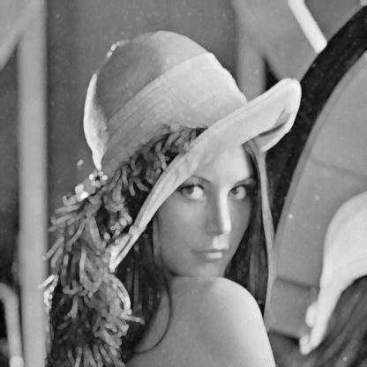

* 1. **Erosion**

For each pixel in the input grayscale image, superimpose the flat octagonal kernel (3, 5, 5, 5, 3) with origin at (2, 2) on top of the grayscale image so that the origin coincides with the input pixel. Since the kernel is flat (value = 0 for all kernel pixels), the erosion is equivalent to finding the *local minimum* value in the local area covered by the kernel and assign it to the pixel. The result image is saved as erosion.bmp as shown below.

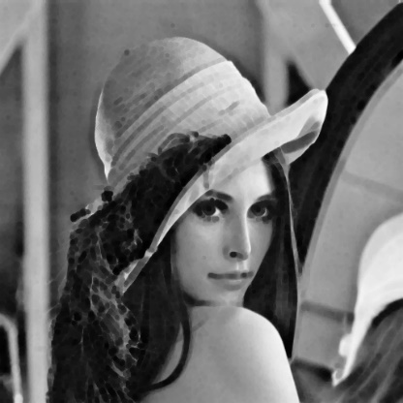

* 1. **Opening**

Apply dilation and then erosion with the octagonal kernel. The result image is saved as opening.bmp as shown below.

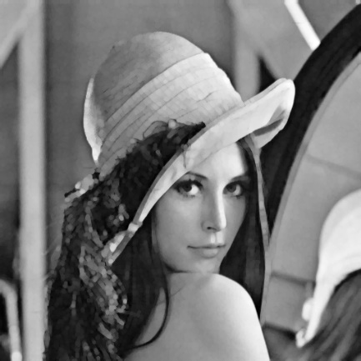

* 1. **Closing**

Apply erosion and then dilation with the octagonal kernel. The result image is saved as closing.bmp as shown below.

