**HW9 Report**

R10922067 林云雲

**Introduction**

This program does edge detection to an image with *Robert’s Operator, Prewitt’s Edge Detector, Sobel’s Edge Detector, Frei-and-Chen’s Gradient Operator, Kirsch’s Compass Operator, Robinson’s Compass Operator, Nevatia-Babu 5x5 Operator*. Each of these methods defines its masks to calculate gradient magnitude for every pixel to generate the output image.

**Usage**

Place the source image and main.py under the same directory. Run the following command in the terminal.

python3 main.py -s <source> -m <method> -t <threshold>

Parameters

-s <source> : the file path of source image, default = lena.bmp

-m <method> : the method for edge detection, default = Robert

*Options:

-Robert

-Prewitt

-Sobel

-FreiAndChen

-Kirsch

-Robinson

-Nevatia-Babu

-t <threshold> : the threshold for edge detection, default = 12

**Robert’s Operator**

1. 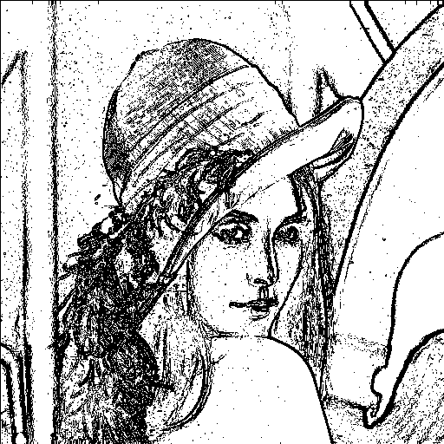Masks

|  |  |
| --- | --- |
|  |  |
|  |  |

**2.** Gradient Magnitude

**3.** The result (threshold=12 for example) is saved   
as robert.png as shown on the right.

**Prewitt’s Edge Detector**

1. 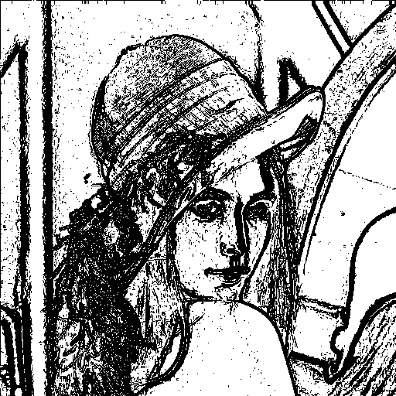Masks

|  |  |
| --- | --- |
|  |  |
|  |  |

**2.** Gradient Magnitude

**3.** The result (threshold=24 for example) is saved   
as prewitt.png as shown on the right.

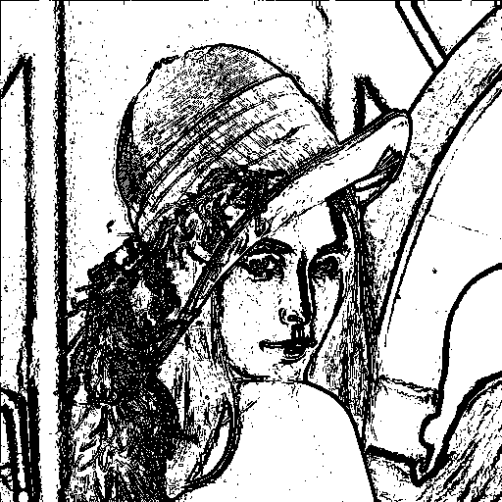**Sobel’s Edge Detector**

1. Masks

|  |  |
| --- | --- |
|  |  |
|  |  |

**2.** Gradient Magnitude

**3.** The result (threshold=38 for example) is saved   
as sobel.png as shown on the right.

**Frei-and-Chen’s Gradient Operator**

1. 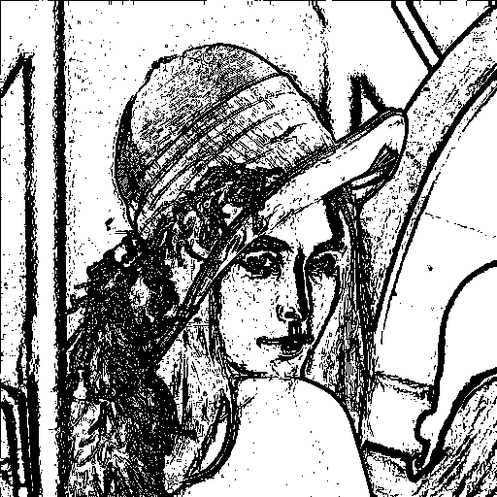Masks

|  |  |
| --- | --- |
|  |  |
|  |  |

**2.** Gradient Magnitude

**3.** The result (threshold=30 for example) is saved   
as frei_and_chen.png as shown on the right.

**Kirsch’s Compass Operator**

1. Masks

|  |  |  |  |  |  |  |  |
| --- | --- | --- | --- | --- | --- | --- | --- |
|  |  |  |  |  |  |  |  |
|  |  |  |  |  |  |  |  |

**2.** Gradient Magnitude

**3.** The result (threshold=135 for example) is saved as kirsch.png as shown below.

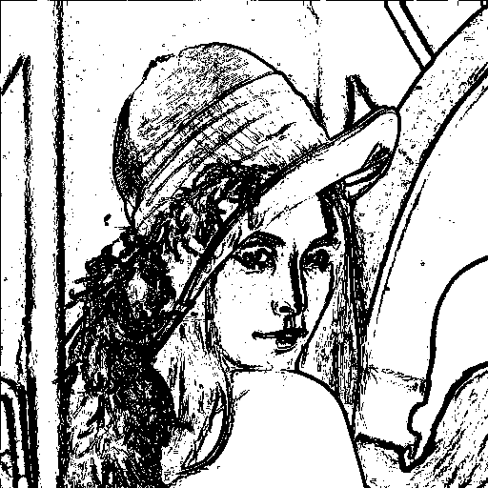

**Robinson’s Compass Operator**

1. Masks

|  |  |  |  |  |  |  |  |
| --- | --- | --- | --- | --- | --- | --- | --- |
|  |  |  |  |  |  |  |  |
|  |  |  |  |  |  |  |  |

**2.** Gradient Magnitude

**3.** The result (threshold=43 for example) is saved as robinson.png as shown below.

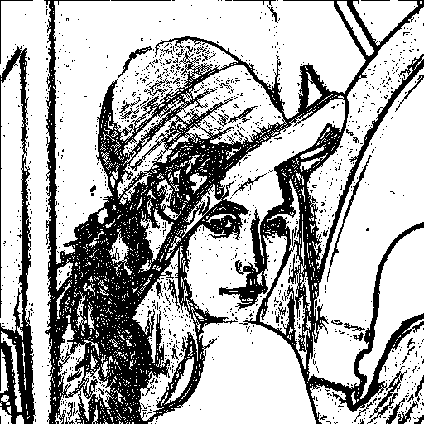

**Nevatia-Babu 5x5 Operator**

1. Masks

|  |  |  |
| --- | --- | --- |
|  |  |  |
|  |  |  |
|  |  |  |
|  |  |  |

**2.** Gradient Magnitude

**3.** The result (threshold=12500 for example) is saved as nevatia_babu.png as shown below.

