1.

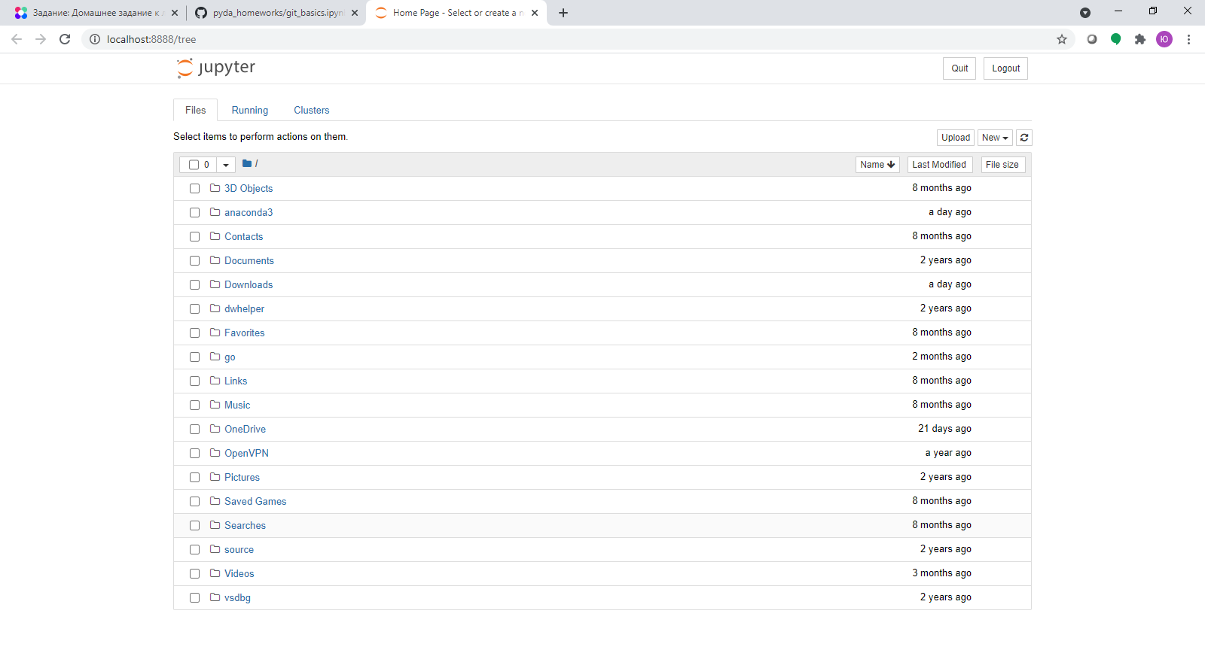

2.

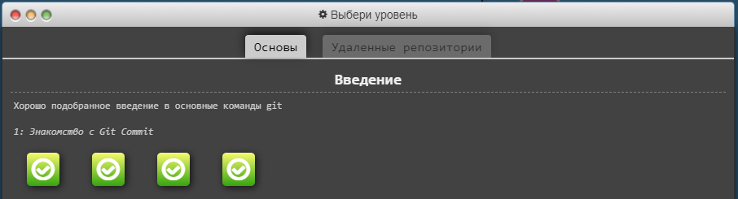

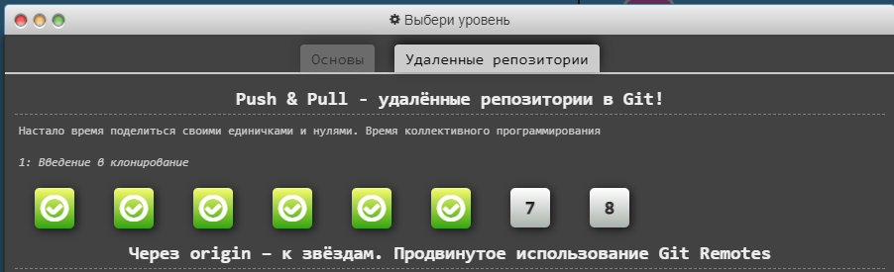

3. <https://github.com/yukonopleva/python_hw>