Адрес | Код команды | Мнемоника | Комментарии
03B | 0200 | CLA
03C | A04D | LD 0x55 | Alt kısmı x yükle
03D | 0C00 | Push it to (stack-1) | Alt ksıımX -> stack
03E | A04F | LD 0x57 | Alt ksımı Y yükle
03F | 0C00 | PUSH it to (SP -1 -1) | Alt kısım Y ->stack
040 | D65F | CALL 0x65F (sp -3) | Alt kısımlar toplanır alt program
041 | 0800 | Pop (sp -2) | ve geri döner.
042 | 0800 | Pop (SP -1 (result)) | ve geri döner.
043 | E051 | ST 0x59 lower sum(x+y) | ALT x , y TOPLAMI KAYDEDİLDİ
044 | A04D | LD 0x56 Hıger part x
045 | 0C00 | Push it to (stack-1)
046 | A050 | LD 0x58 higer part y
047 | 0C00 | Push it to (stack-1)
048 | D663 | CALL 0x663 (sp-3)
049 | 0800 | Pop (sp -2)
04A | 0800 | Pop (sp -1)
04B | E052 | ST 0x59 lower sum(x+y)
04C | 0100 | HLT | Остановка программы
04D | XXXX | first number lower part
04E | XXXX | First number higher part
04F | YYYY | Second number lower part
050 | YYYY | Second number higher part
051 | 0 | R lower | Результат
052 | 0 | R Higer

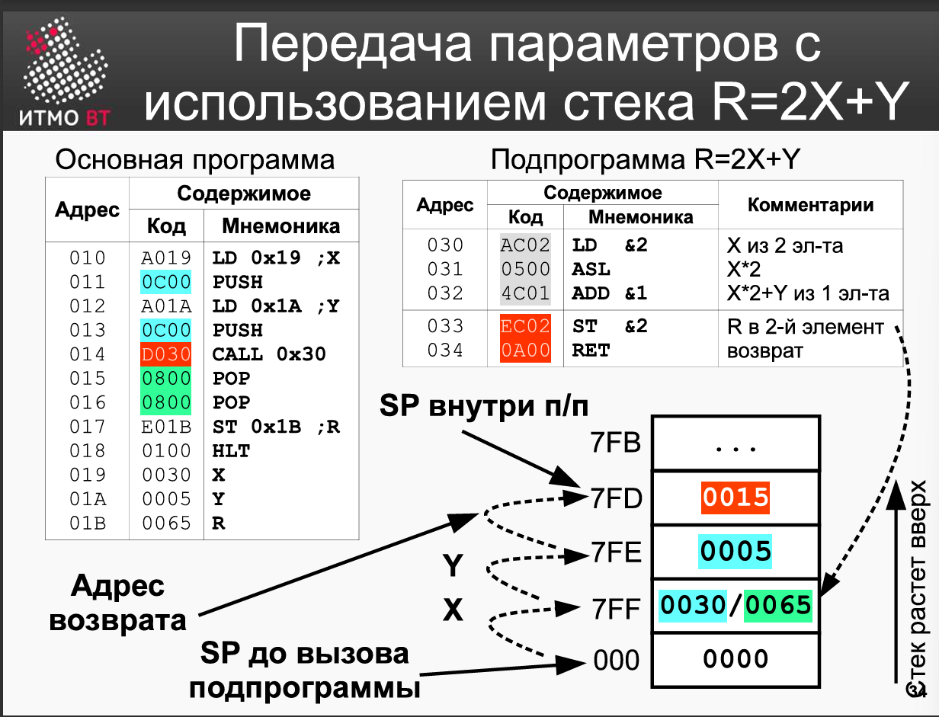
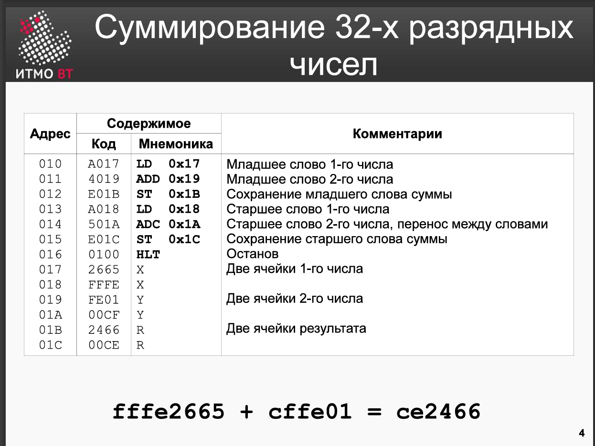

Адрес | Код команды | Мнемоника | Комментарии
65F | AC02 | LD (SP+2) | AC = MEM(SP+2) 7FF = lower x
660 | 4C01 | ADD (SP +1) | SP +1 = 7FE => Lower x + lower y
661 | EC02 | ST (SP+2) | Сохранение результата
662 | 0A00 | RET | Возврат IP = SP
663 | AC02 | LD SP+2 | AC = High x
664 | 2008 | And 0x8 | 0008 and X kontrolü (To find most significant value)
665 | F002 | BEQ | And sonucu 0 ise atla (check negativity)
666 | AC02 | LD SP+2 | And sonucu 0 değil bitmask lazım tekrar yükle
667 | 3E0B | OR #672 | Bitmask uygulandı
668 | EC02 | ST SP+2 | Sp + 2 kısmına x savelendi.
669 | AC01 | LD SP+1 | High y to AC
66A | 2008 | And 0x8 | 0008 and Y kontrolü
66B | F002 | BEQ | And sonucu 0 ise atla
66C | AC01 | LD SP+1 | And sonucu 0 değil bitmask lazım tekrar yükle
66D | 3E05 | OR #672 | Bitmask uygulandı
66E | EC01 | ST SP+1 | Sp + 1 kısmına x savelendi.
66F | AC02 | LD SP+2
670 | 5C01 | ADC | AC = AC (sp+2) + C + (sp+1)
671 | EC01 | ST sp(+1) | Save value to the (sp+1)
672 | 0A00 | RET | Возврат IP = SP
673 | FFF0 |  | Bitmask value to extend the number

1000 -- 0000 0000 0000 0000

Адрес | Код команды | Мнемоника | Комментарии
03B | 0200 | CLA
03C | A05B | LD LD X_LOW | Load lower part of X into AC
03D | 0C00 | Push it to (stack-1) | Push X_low onto stack (SP decreases)
03E | A05D | LD Y_LOW | Load lower part of Y into AC
03F | 0C00 | PUSH it to (SP -1 -1) | Push Y_low onto stack (SP decreases)
040 | D65F | CALL 0x65F (sp -3) | Call subroutine. Returns sum_low in AC, Carry set.
041 | 0800 | Pop (sp -2) | Clean Y_low from stack (Pop into dummy R0, or AC if no R0)  Clean X_low from stack (Pop into dummy R0, or AC)
042 | 0800 | Pop (SP -1 (result))
043 | E05F | ST R_LOW
044 | A05C | LD X_HIGH
045 | 2062 | AND SIGN_BIT_MASK 0008
046 | F004 | BEQ SKIP_EXT_X | If AC is zero (sign bit was 0, positive), tekrar x yükle
047 | A05C | LD X_HIGH | Sign bit was 1 (negative). Reload ORIGINAL X_high from stack
048 | 3061 | OR SIGN_MASK | Apply sign extension mask (FFF0)
049 | 0C00 | PUSH(SP-1) | For Negative push
04A | C04D | JUMP 4D
04B | A05C | LD X_HIGH | If positive, then it branched here loaded ac again
04C | 0C00 | PUSH(SP-1) | For Positive push
04D | A05E | LD Y_HIGH | Load higher part of Y
04E | 2062 | AND SIGN_BIT_MASK
04F | F004 | BEQ SKIP_EXT_X | If AC is zero (sign bit was 0, positive), skip 04A
050 | A05E | LD Y_HIGH | Sign bit was 1 (negative). Reload ORIGINAL X_high from stack
051 | 3061 | OR SIGN_MASK | Apply sign extension mask (FFF0)
052 | 0C00 | PUSH(SP-2)
053 | C056 | JUMP 4D
054 | A05E | LD Y_HIGH | If positive, then it branched here loaded ac again
055 | 0C00 | PUSH(SP-2) | For Positive push
056 | D663 | CALL 663 | Call subroutine. Returns sum_high in AC.
057 | 0800 | POP | Clean Y_high_ext from stack
058 | 0800 | POP | Clean X_high_ext from stack
059 | E060 | ST r_HIGH | Store higher 16 bits of result (contains bits 16-19 and sign ext)
05A | 0100 | HLT
05B | 1111 |  | X_LOW
05C | 0001 |  | X_HIGH
05D | 2222 |  | Y_LOW
05E | 000A |  | Y_HIGH
05F | 00BB |  | R_LOW
060 | 00CC |  | R_HIGH
061 | FFF0 |  | SIGN_MASK
062 | 0008 |  | SIGN_BIT_MASK

R_HIGH = FFFB X_HIGH(0001) + Y_HIGH(000A) -- FFFA
R_LOW = 3333 X_LOW(1111) + Y_LOW(2222)
NUMBER = FFFB 3333 ---- B333

Адрес | Код команды | Мнемоника | Комментарии
 | ADD_LOW |  | Input: (SP+1)=X_low, (SP+2)=Y_low
65F | AC02 | LD (SP+2) | AC = MEM(SP+2) 7FF = lower x
660 | 4C01 | ADD (SP +1) | SP +1 = 7FE => Lower x + lower y
661 | EC02
662 | 0A00 | RET | Возврат IP = SP
 | ADD_HIGH |  | Input: (SP+1)=X_high_ext, (SP+2)=Y_high_ext, Carry flag set from ADD_LOW
663 | AC02 | LD SP+2 | Load Y_high_ext into AC
664 | 5C01 | ADC (SP+1) | AC = Y_high_ext + X_high_ext + Carry
 | EC02
665 | 0A00 | RET | Возврат IP = SP

