**Business Intelligence and Data Visualization Lab Manual**

**CSL 232**

Project Report

**Faculty name:** Dr. Pankaj Agarwal **Student name**: Yukta Batra and Bhavya Sharma

**Roll No.:** 19csu364 & 19csu371

**Semester:** 5th Sem

**Group:** DS-E-10

**Department of Computer Science and Engineering**

**The NorthCap University, Gurugram- 122001, India**

**Session 2021-22**

**Table of Contents**

|  |  |  |
| --- | --- | --- |
| **S.No** |  | **Page No.** |
| **1.** | **Project Description** | **4** |
| **2.** | **Problem Statement** | **5** |
| **3.** | **Analysis**  **3.1 Hardware Requirements**  **3.2 Software Requirements** | **5** |
| **4.** | **Design**  **4.1 Data/Input Output Description:**  **4.2 Algorithmic Approach / Algorithm / DFD / ER diagram/Program Steps** | **6** |
| **7.** | **Conclusion and Future Scope** | **31** |
| **8.** | **Bibliography** | **32** |

ABSTRACT: This project is an implementation of the CRISP-DM methodology to apply a classification model to the issue of

identifying fatal aircraft accidents/incidents based on flight information such as aircraft attributes, geographical attributes and

purpose of flight etc. The process followed mirrors CRISP-DM as closely as possible and covers data exploration, data preparation,

data modelling and data evaluation. Attribute usefulness and feature selection are analysed using statistical techniques and some

interesting relationships are examined. There are a significant number of missing values in many of the attributes which are

discussed as well as outlier detection, data bias and data transformation. The performance of the model will be evaluated and

reviewed.

This process underpins a business objective which is the use of the predictive model to identify criteria that can identify those

aircraft accidents/incidents which result in fatalities. The ability to predict these fatal events has the primary objective of saving

lives. In parallel to saving lives there would be a significant cost saving in terms of aircraft damage, liability claims and reputational

damage for aircraft carriers.

ABSTRACT: This project is an implementation of the CRISP-DM methodology to apply a classification model to the issue of

identifying fatal aircraft accidents/incidents based on flight information such as aircraft attributes, geographical attributes and

purpose of flight etc. The process followed mirrors CRISP-DM as closely as possible and covers data exploration, data preparation,

data modelling and data evaluation. Attribute usefulness and feature selection are analysed using statistical techniques and some

interesting relationships are examined. There are a significant number of missing values in many of the attributes which are

discussed as well as outlier detection, data bias and data transformation. The performance of the model will be evaluated and

reviewed.

This process underpins a business objective which is the use of the predictive model to identify criteria that can identify those

aircraft accidents/incidents which result in fatalities. The ability to predict these fatal events has the primary objective of saving

lives. In parallel to saving lives there would be a significant cost saving in terms of aircraft damage, liability claims and reputational

damage for aircraft carriers.

ABSTRACT: This project is an implementation of the CRISP-DM methodology to apply a classification model to the issue of

identifying fatal aircraft accidents/incidents based on flight information such as aircraft attributes, geographical attributes and

purpose of flight etc. The process followed mirrors CRISP-DM as closely as possible and covers data exploration, data preparation,

data modelling and data evaluation. Attribute usefulness and feature selection are analysed using statistical techniques and some

interesting relationships are examined. There are a significant number of missing values in many of the attributes which are

discussed as well as outlier detection, data bias and data transformation. The performance of the model will be evaluated and

reviewed.

This process underpins a business objective which is the use of the predictive model to identify criteria that can identify those

aircraft accidents/incidents which result in fatalities. The ability to predict these fatal events has the primary objective of saving

lives. In parallel to saving lives there would be a significant cost saving in terms of aircraft damage, liability claims and reputational

damage for aircraft carriers.

**ABSTRACT**

This project is made to apply a classification model to the issue of identifying fatal aircraft accidents/ incidents based on flight information such as aircraft attributes, geographical attributes and purpose of flight etc. This project underpins a business objective which is the use of the predictive model to identify criteria that can identify those aircraft accidents/incidents which result in fatalities. The ability to predict these fatal events has the main objective of saving lives. In parallel to saving lives there would be a significant cost saving in terms of aircraft damage, liability claims and reputational damage for aircraft carriers.

* **Link for the project published on tableau online:**

[**https://prod-apnortheast-a.online.tableau.com/#/site/yuktabatra/workbooks/359629?:origin=card_share_link**](https://prod-apnortheast-a.online.tableau.com/#/site/yuktabatra/workbooks/359629?:origin=card_share_link)

**INTRODUCTION**

The NTSB aviation accident database contains information from 1962 and later about civil aviation accidents and selected incidents within the United States, its territories and possessions, and in international waters. Generally, a preliminary report is available online within a few days of an accident. Factual information is added when available, and when the investigation is completed, the preliminary report is replaced with a final description of the accident and its probable cause. Full narrative descriptions may not be available for dates before 1993, cases under revision, or where NTSB did not have primary investigative responsibility.

**ABOUT THE DATASET**

**We got our data from Kaggle.**

[**https://www.kaggle.com/khsamaha/aviation-accident-database-synopses**](https://www.kaggle.com/khsamaha/aviation-accident-database-synopses)

This dataset is originally from the National Transportation Safety Board (NTSB). The National Transportation Safety Board is an independent U.S. government investigative agency responsible for civil transportation accident investigation. The NTSB aviation accident database contains information from 1962 and later about civil aviation accidents and selected incidents within the United States, its territories and possessions, and in international waters.

* **PROBLEM STATEMENT:**

Our Approach The NTSB accident database is a complex relational database that stores hundreds, sometimes thousands of details about each aviation accident. Designing an information visualization tool to explore the entire dataset at once is a daunting task. This paper demonstrates how subsets of related information can be pulled out and examined for possible trends and correlations. Information visualization can help investigators see at a glance what other influences may be common that increase the likelihood of accidents, or affect pilots ability to react effectively. For instance, are there trends relating to environmental effects such as visibility, light conditions, or wind velocity? What is the size of plane that is most commonly involved in accidents? Are accidents more common on particular days of the week? What airports seem to be the deadliest?

* **HARDWARE REQUIREMENTS:**

**Data/Input Output Description:**

* **Categorical Analysis of Accidents:**

There are 2 key aviation weather conditions.

First is VMC which means conditions are such that pilots have sufficient visibility to fly the air craft maintaining visual separation from terrain and other aircrafts.

Second is IMC which means weather conditions require pilots to fly primarily by reference to instruments.

Let’s Analyze the data on basis of these conditions:

The bulk of accidents in the dataset took place during VMC weather conditions which are great conditions for flying as VMC requires greater visibility and cloud clearance than IMC.

* **Broad Phase of Flight**

Identifying phases of flight is important because many safety event definitions are specific to phases of light.

According to the plot, the bulk of accidents took place during landing or take-off. It is well known in the industry that these are high-risk — often referred to as “critical phases of flight”.

From this, we can deduce that if you are in an accident during the landing phase, you are having a higher chance of getting injured then during the takeoff phase.

* **Weather conditions and purpose of flight**

As from the above observation we see that the bulk of the distribution is associated with VMC weather conditions. However, that is likely to the fact that the vast majority of flights are flown in VMC conditions.

**Weather conditions and purpose of flight (1948-2020)**

From the above data, we can see that during VMC weather conditions, there are more accidents while landing, as landing is referred as critical phase of flight where during IMC weather conditions, there are less number of accidents while landing due to advancement in technology**.**

* **Yearly Depiction of Accidents**

It is hard to understate the roles that increase safety regulation and requirements on both operators and on pilots have played in the overall reduction in crashes and fatalities – especially those in the commercial airline industry. Most notably, the Airline Safety and Federal Aviation Administration Extension Act of 2010 required significantly more training for pilots – 1,500 hours up from 250 before, flight and duty time regulations, and many other industry safety and transparency requirements. Many other laws, including the Federal Aviation Regulations (FARs) as well as international conventions, regulate everything from product and aircraft manufacturing and maintenance to pilot schools and business operations for commercial as well as general aviation.

The number of accidents has overall decreased by approx. 47% between 1948 and 2020 from approx. 3400 observations to approx. 1600 observations.

* **Top 10 companies whose planes are involved in accidents**

**Aviation crashes by make 1948-2020**

More than half (54 percent) of all aviation accidents in the NTSB’s database involve either a Cessna (25,865 crashes), Piper (14,105) crashes or Beech (5,098) aircraft. These three manufacturers have historically been the largest producers of aircraft for general aviation purposes – though both Beech and Cessna have since become subsidiaries of Textron Aviation.

* **Injury severity and purpose of flight**

From the above data, we can conclude that Firefighter Planes have a smaller number of fatal Injury severity as compared to other planes. On one hand, they are at higher risk of accidents but due to Aerodynamic Shapes and very Powerful Engines they have lesser number of Fatal Injuries.

* **Yearly description of purpose of flights**

From the above data we can conclude that most flights flew in 1982 hence there was increase in aviation accidents in that year.

* **Purpose of flights**

From the above data we can see that an average 267 fatal accidents per year were associated with business flying, compared to an average 23 fatal accidents per year related to instructional flying, 13 for aerial application, and 4 for corporate/executive flights.

* **Yearly visualization of business purpose of flights**

From the above data we can see that an average 267 fatal accidents per year were associated with business flying.

* **Monthly visualization of business purpose of flights**

As mentioned earlier business purpose of flights had more number of accidents in past. The above graph shows monthly accidents in business purpose of flights and we can see that in august more number of flights take off having the highest number of accidents. This is also likely to be correlated with the increased numbers of flights during the summer holiday period.

* **Analysis of Instructional purpose of flights**

In the above graphs it is very clear that after business purpose of flight having highest number of accidents, instructional purpose of flights was the second largest. And from the above graph we can see monthly data of accidents in instructional purpose of flights**.**

* **Yearly analysis of instructional accidents**

* **Amateur Built:**

Amateur built usually means whether an aircraft is homebuilt or not i.e. the major portion of which has been fabricated and assembled by person who undertook the construction project solely for their own education or recreation.

Amateur-built aircraft accounted for an average of 14% of these same general aviation maintenance-related accidents, even though amateur-built aircraft account for less than 3% of the GA hours flown.

The increase in number of substantial aircraft damage record was very significant in comparison to the other types of aircraft damage

* **Analysis of injuries over years**

**Uninjured and serious (1948-2020)**

**Fatal and minor injuries(1948-2020)**

After a 37 year high of 2,533 fatal aircraft crash injuries in 1996, the total deaths has bounced up and down seemingly at random. While it stands to reason that less crashes means less injuries and deaths, the nature of aviation accidents means that only a few major crashes can completely change the data from year to year.

Meanwhile, total aviation crashes have dropped from a high of 3,583 in 1982 down to 1,581 in 2020 – a decrease nearly 56 percent. However, as the total crashes have gone down, the percentage of those crashes that have been fatal has gone up, from 18.2 percent in 1982 to 22.5 percent in 2020.

* **Why have crashes gone down in recent years?**

It is hard to understate the roles that increase safety regulation and requirements on both operators and on pilots have played in the overall reduction in crashes and fatalities – especially those in the commercial airline industry. In fact, before a passenger was killed aboard a Southwest flight in 2018, the last fatal airline crash in the United States was in February 2009. That disaster, the crash of Continental Connection Flight 3407, killed all 49 people on board and another person on the ground in Clarence, NY. The resulting lawsuits and advocacy from the families of those who were killed made sweeping changes to the airline industry. Most notably, the Airline Safety and Federal Aviation Administration Extension Act of 2010 required significantly more training for pilots – 1,500 hours up from 250 before, flight and duty time regulations, and many other industry safety and transparency requirements. Many other laws, including the Federal Aviation Regulations (FARs) as well as international conventions, regulate everything from product and aircraft manufacturing and maintenance to pilot schools and business operations for commercial as well as general aviation.

* **Visualization of uninjured air carrier accidents**

Air carrier is the full name of the operator of the accident aircraft. This typically refers to an organization or group (e.g. airline or corporation) rather than the pilot, contaminated with the carrier, business or code share name if the accident aircraft was operated by a business , air carrier or as a part of a code share agreement.

From the above data , United Airlines have maximum uninjured people in their accident flights.

* **Major accident of united airlines flight**

United Airlines Flight 232 was a regularly scheduled [United Airlines](https://en.wikipedia.org/wiki/United_Airlines) flight from [Stapleton International Airport](https://en.wikipedia.org/wiki/Stapleton_International_Airport) in [Denver](https://en.wikipedia.org/wiki/Denver) to [O'Hare International Airport](https://en.wikipedia.org/wiki/O%27Hare_International_Airport) in [Chicago](https://en.wikipedia.org/wiki/Chicago), continuing to [Philadelphia International Airport](https://en.wikipedia.org/wiki/Philadelphia_International_Airport). On July 19, 1989, the [DC-10](https://en.wikipedia.org/wiki/McDonnell_Douglas_DC-10) (registered as N1819U) serving the flight crash-landed at [Sioux City, Iowa](https://en.wikipedia.org/wiki/Sioux_City,_Iowa), after suffering a catastrophic failure of its tail-mounted [engine](https://en.wikipedia.org/wiki/Jet_engine) due to an unnoticed manufacturing defect in the engine's fan disk, which led to the loss of many [flight controls](https://en.wikipedia.org/wiki/Flight_control_system). Of the 296 passengers and crew on board, 112 died during the accident, while 184 people survived.[[a]](https://en.wikipedia.org/wiki/United_Airlines_Flight_232#cite_note-nbDiedLater-3) The crash was the fifth-deadliest one involving the DC-10, behind [Turkish Airlines Flight 981](https://en.wikipedia.org/wiki/Turkish_Airlines_Flight_981), [American Airlines Flight 191](https://en.wikipedia.org/wiki/American_Airlines_Flight_191), [Air New Zealand Flight 901](https://en.wikipedia.org/wiki/Air_New_Zealand_Flight_901), and [UTA Flight 772](https://en.wikipedia.org/wiki/UTA_Flight_772). Despite the deaths, the accident is considered a prime example of successful [crew resource management](https://en.wikipedia.org/wiki/Crew_resource_management) because of the large number of survivors and the manner in which the flight crew handled the emergency and landed the airplane without conventional control. It is also the deadliest accident in the history of United Airlines

* FAR (Federal Aviation Regulations)

The Federal Aviation Regulations (FARs) are rules prescribed by the [Federal Aviation Administration](https://en.wikipedia.org/wiki/Federal_Aviation_Administration) (FAA) governing all [aviation](https://en.wikipedia.org/wiki/Aviation) activities in the [United States](https://en.wikipedia.org/wiki/United_States). The FARs are part of Title 14 of the [Code of Federal Regulations](https://en.wikipedia.org/wiki/Code_of_Federal_Regulations) (CFR). A wide variety of activities are regulated, such as [aircraft design](https://en.wikipedia.org/wiki/Aircraft_design_process) and maintenance, typical airline flights, pilot training activities, [hot-air ballooning](https://en.wikipedia.org/wiki/Hot_air_balloon), [lighter-than-air aircraft](https://en.wikipedia.org/wiki/Aerostat), man-made structure heights, obstruction lighting and marking, [model rocket](https://en.wikipedia.org/wiki/Model_rocket) launches, [model aircraft](https://en.wikipedia.org/wiki/Model_aircraft) operations, Unmanned Aircraft Systems [(UAS)](https://en.wikipedia.org/wiki/Unmanned_aerial_vehicle#Terminology) and kite flying. The rules are designed to promote [safe aviation](https://en.wikipedia.org/wiki/Air_safety), protecting pilots, flight attendants, passengers and the general public from unnecessary risk.

General aviation (14CFR Part 91) includes all civilian aviation operations except those involving revenue-based passenger transportation (Electronic Code of Federal Regulation, 2015) such as air carriers. Although accident rates for the airlines have dramatically declined over the last several decades ,only a modest decrease has been witnessed for general aviation General aviation safety in the United States is heavily influenced by the geographical region .Prior studies have demonstrated that states characterized by mountainous terrain and high elevation, carry a higher accident rate than those (15.3 and 8.5 accidents per 100,000 flight hours, respectively) featuring low lying, relatively flat terrain .The fatal accident rate is also greater; a study published over 25 years ago reported a 68% increase in fatal general aviation accidents in the Colorado Rockies relative to the rest of the state . A subsequent study mirrored these findings again showing an elevated fatality rate for accidents in mountainous terrain.

* Yearly FAR description(1948-2020)

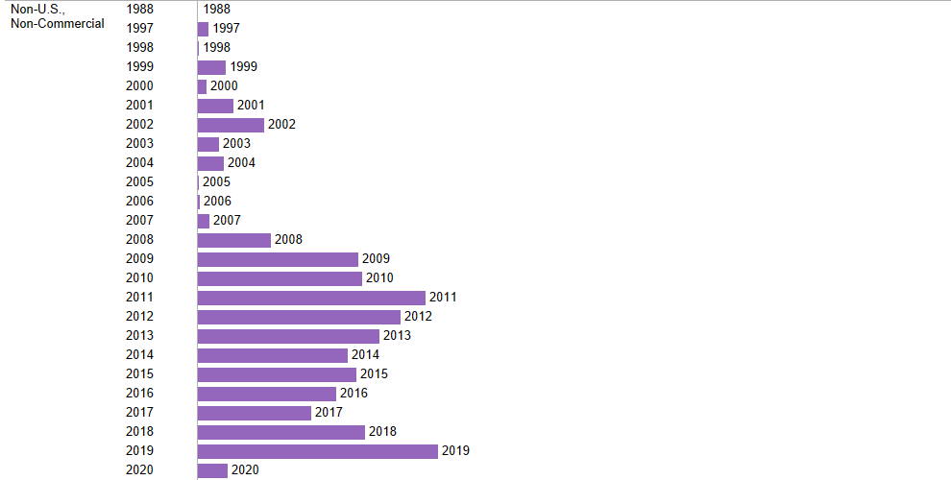

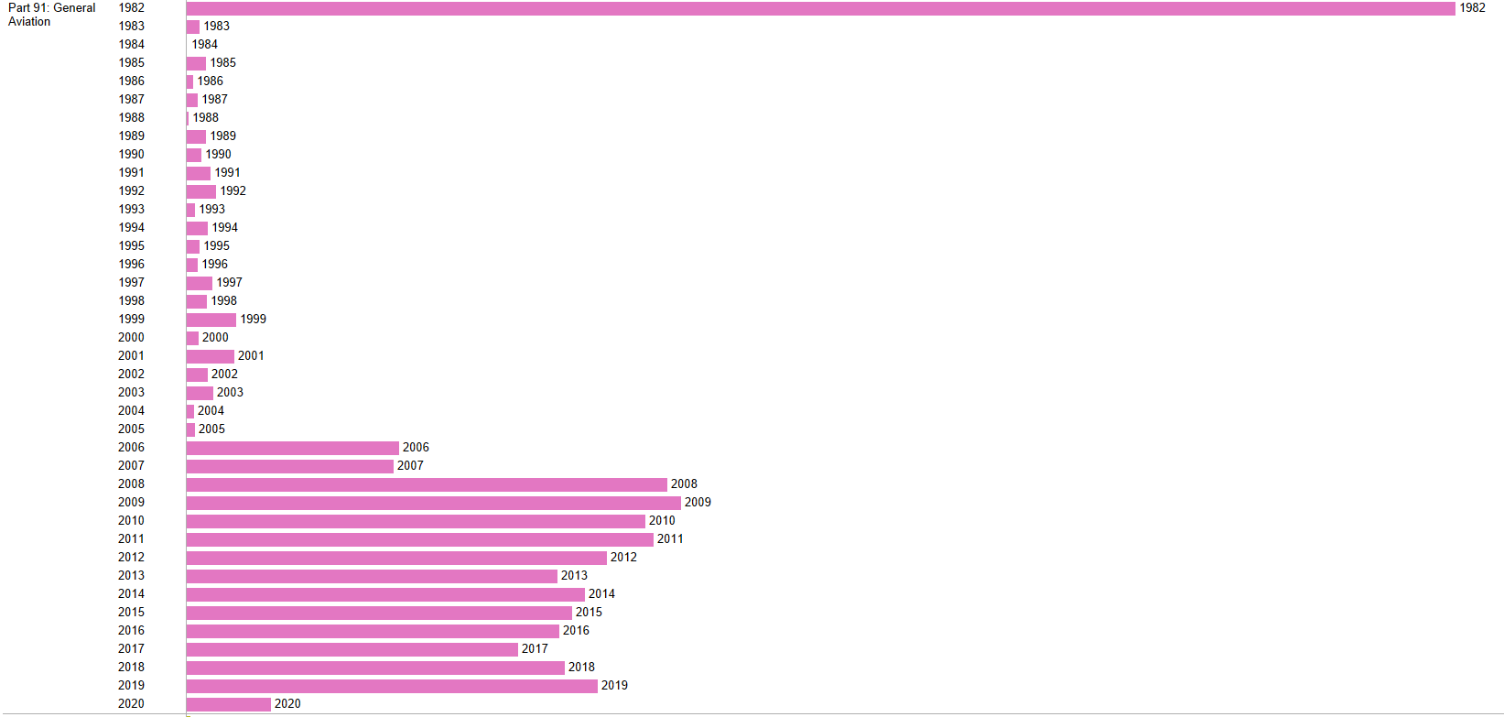

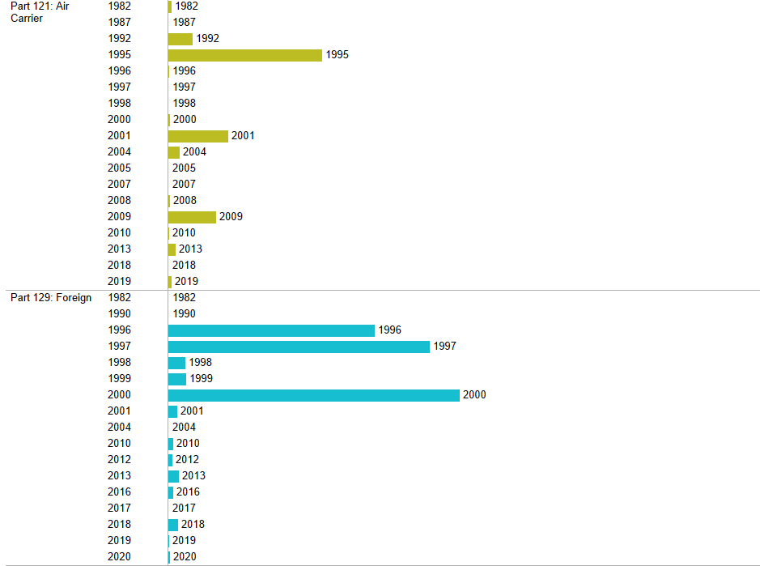

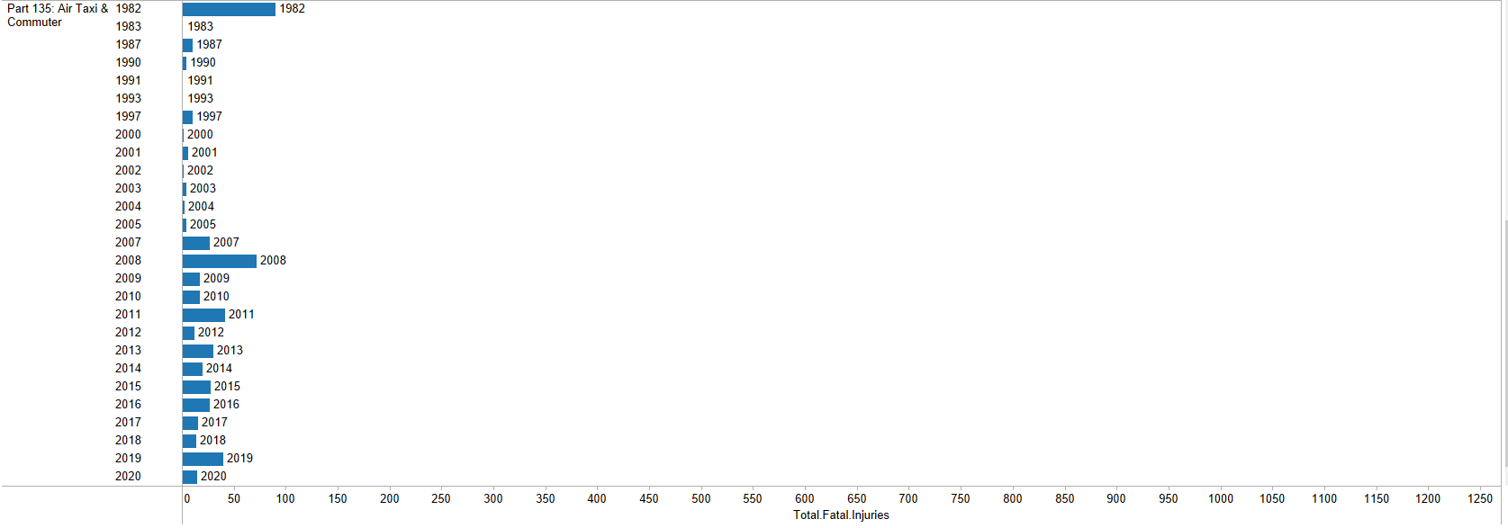

* **Yearly accidents(1948-2020)**

* **How safe are aeroplanes?**

It depends on the type of aircraft that you are flying in. When looking at overall fatal crash rate, the numbers show that flight one of the safest forms of travel. The National Safety Council puts the odds of dying as a passenger of an airplane as 1 in 188,106 – the second safest form of travel behind railway travel ( 1 in 243,765). Still, each crash is much more likely to be fatal than crashes in other forms of transportation. From 1982 – 2018, 20 percent of all aviation crashes and incidents involved at least one fatality. For comparison’s sake, less than one percent of U.S. car accidents are fatal.

However, crashes are most likely to occur in single engine planes – and typically in general aviation rather than on commercial airlines. In fact, 79 percent of all aircraft accidents and 72 percent of fatal crashes involved single engine planes.

* **Where aviation accidents occur the most?**

Between 1982 and 2018, 7,8161 aviation crashes occurred in the United States. These crashes where scattered across the country. However, the most crashes occurred in Anchorage, Alaska – by nearly double over the next closest area, Miami, Florida with 269 crashes.

Plotting the Latitude vs Longitude of the accidents essentially gives us the map of the US. The plots also indicates that the coastal states are more heavily impacted compared to mid-western states and most of Alaska. This can be explained by the volume of flight to/from destinations those areas of the US. A sad chart however as it shows that the vast majority of US States suffered an aviation tragedy between 1948 and 2020.

* **Engine types**

According to the plots above, the bulk of engine types in the reported accidents are [Reciprocating engine](https://en.wikipedia.org/wiki/Reciprocating_engine) types which were prevalent in commercial aircraft, particularly in aircraft built during the 20th century. Recent aircraft, like the [Airbus A380](https://en.wikipedia.org/wiki/Airbus_A380#Engines) or the Boeing [787 Dreamliner](https://en.wikipedia.org/wiki/Boeing_787_Dreamliner#Engines) rely on [Jet engines](https://en.wikipedia.org/wiki/Jet_engine#Turbine_powered) (e.g. TurboFan, TurboProp).

* **Engine types and fatal injuries**

According to the plot, the bulk of the data for fatalities is with the engine type r[eciprocating engine](https://en.wikipedia.org/wiki/Reciprocating_engine) type.

* **Weather Conditions and Total Fatal Injuries**

As previously noted, weather conditions do not show a particularly strong relationship with total fatal injuries. The bulk of the distribution is associate with VMC weather conditions. However, that is likely to the fact that the vast majority of flights are flown in VMC conditions.

**Conclusion:**

Information Visualization helps uncover the underlying data in large datasets. It can help investigators determine what influences are in common that increase the likelihood of accidents. Because there are many factors involved with aviation accidents, it is important to be able to visualize the data from different perspectives. By utilizing multiple visualization tools, analysts can double check trends, patterns, and relationships between the data being investigated, as well as assist investigators in determining the key points of the causations. Our data shows that most accidents were caused by pilot error. While there may have been other contributing factors such as air traffic control error, improper maintenance, and natural conditions, ultimately the pilots’ inability to adapt caused the fatal accidents. Accidents have been a part of aviation history since the beginning. Advanced technology and better training have brought down the number of accidents and injuries over the past decade. However, aviation fatalities continue to be a major area that needs further studies. Using visualization, our research explored various factors related to these accidents. Visualization tools helps us to look at the data in a different perspective. Although some factors like weather are not completely avoidable, aircraft designers can use this information to build aircraft with resistant materials and build technology to better handle such situations. Additional training and stricter regulations can help tackle the human error factor of accidents. As amateur enthusiasts fill the airspace with custom built aircraft, it is important to study the cause and effects of past accidents to create a better future for aviation

**Bibliography**

1. <https://www.researchgate.net/publication/331742698_ANALYSIS_OF_AVIATION_ACCIDENTS_DATA>
2. <https://www.asias.faa.gov/apex/f?p=100:8:::NO::P8_STDY_VAR:2>
3. <https://www.ntsb.gov/Pages/home.aspx>