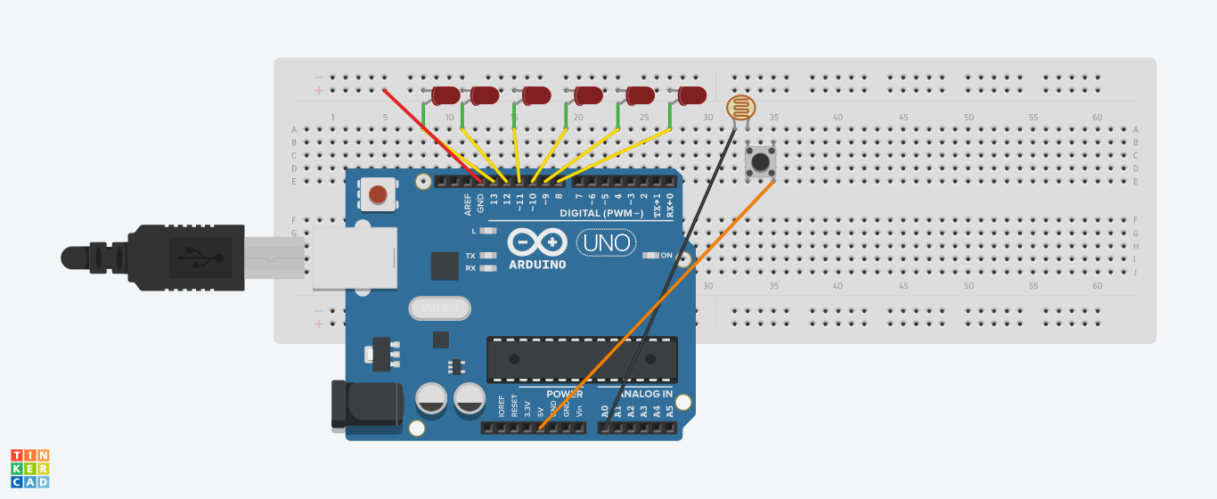

Theory:

When the outer light gets dim the sensor detects and sends the signal to the arduino , after that the Arduino transmits the information further to the LEDs and then LEDs start their work.

Observations:

As the light gets dimmer, the LEDs start their work accordingly.

Arduino process the received information i.e. the LEDs do the work further.

Precautions:

Connections must be tight,

Board and port should be chosen carefully.

Positive and negative terminals of all the components should be connected accurately.

Problems and troubleshooting:

Hardware should be correctly fitted on the Breadboard or they might get fuse or get permanently damaged.

The incorrect coding might cause problems in the hardware.

Arduino wire must be checked if they are loose or not. Ports should be properly cleaned before using.

Learning outcomes:

From this experiment we have learnt how to code in the software.

In this project we learnt how to make Diwali light of different patterns with different conditions(sensor here).