HPL 2026
WEEK 1 — BACKEND
Technical Design & Architecture Template
HPL 2026 • SMVITM Bantakal • in association with Code Troopers

TEAM | PROJECT | TRACK | WEEK
agri innovators | Smart Waste Management Simulator | Backend | 1

Purpose of this document
This is the team's Week 1 backend design. It should make the architecture, data model, business logic, APIs, security boundaries, and important backend processes easy for a judge to understand and evaluate.

Judge-first principle
Prefer diagrams, tables, concise decisions, and concrete examples over generic architecture prose. A judge should be able to understand the system quickly and trace an important requirement from workflow → business rule → API → database.

1. System Overview
Item | Details
Backend Responsibility | Owns all persistent data, business rules, and APIs for Evaluation 1 of the Smart Waste Management Simulator — matching the official brief's "Drop 1 — Backend: Geographical Maps & Data Integration" scope. This covers: user identity and role-based access; habitation profiles and their seven parameter categories (with full edit history); storage, linking and overlay of GIS map layers per habitation; and validation/normalization of uploaded datasets. Simulation, forecasting and optimization logic are later evaluation drops and are consumers of these APIs, not part of this document.
Primary actors / roles | Municipal Admin — full administrative control: manages user accounts; can create, edit, or delete any habitation, parameter set, or map layer.  Planner — creates and edits habitations and their parameters; uploads map layers and datasets for habitations they own.  Researcher — read-only access to habitation data, parameters, map layers and validation reports, across all habitations.
Functional Decomposition | Four modules, mapping 1:1 to the four mandatory Evaluation-1 requirements:  1. Identity & Access — registration, login, JWT issuance, RBAC enforcement.  2. Habitation Parameters — CRUD APIs for the 7 parameter categories, with change history.  3. GIS Map Layer — storage, habitation-linking and multi-layer overlay of map data.  4. Data Validation & Normalization — ingesting uploaded datasets, checking them, and reporting errors back to the uploader.
Main entities | User, Habitation, the seven parameter-category records (Demography, Infrastructure, Industrial, Natural Resources, Terrain, Economic, Cultural), ParameterChangeLog, MapLayer, UploadBatch, ValidationIssue.

2. Backend Architecture
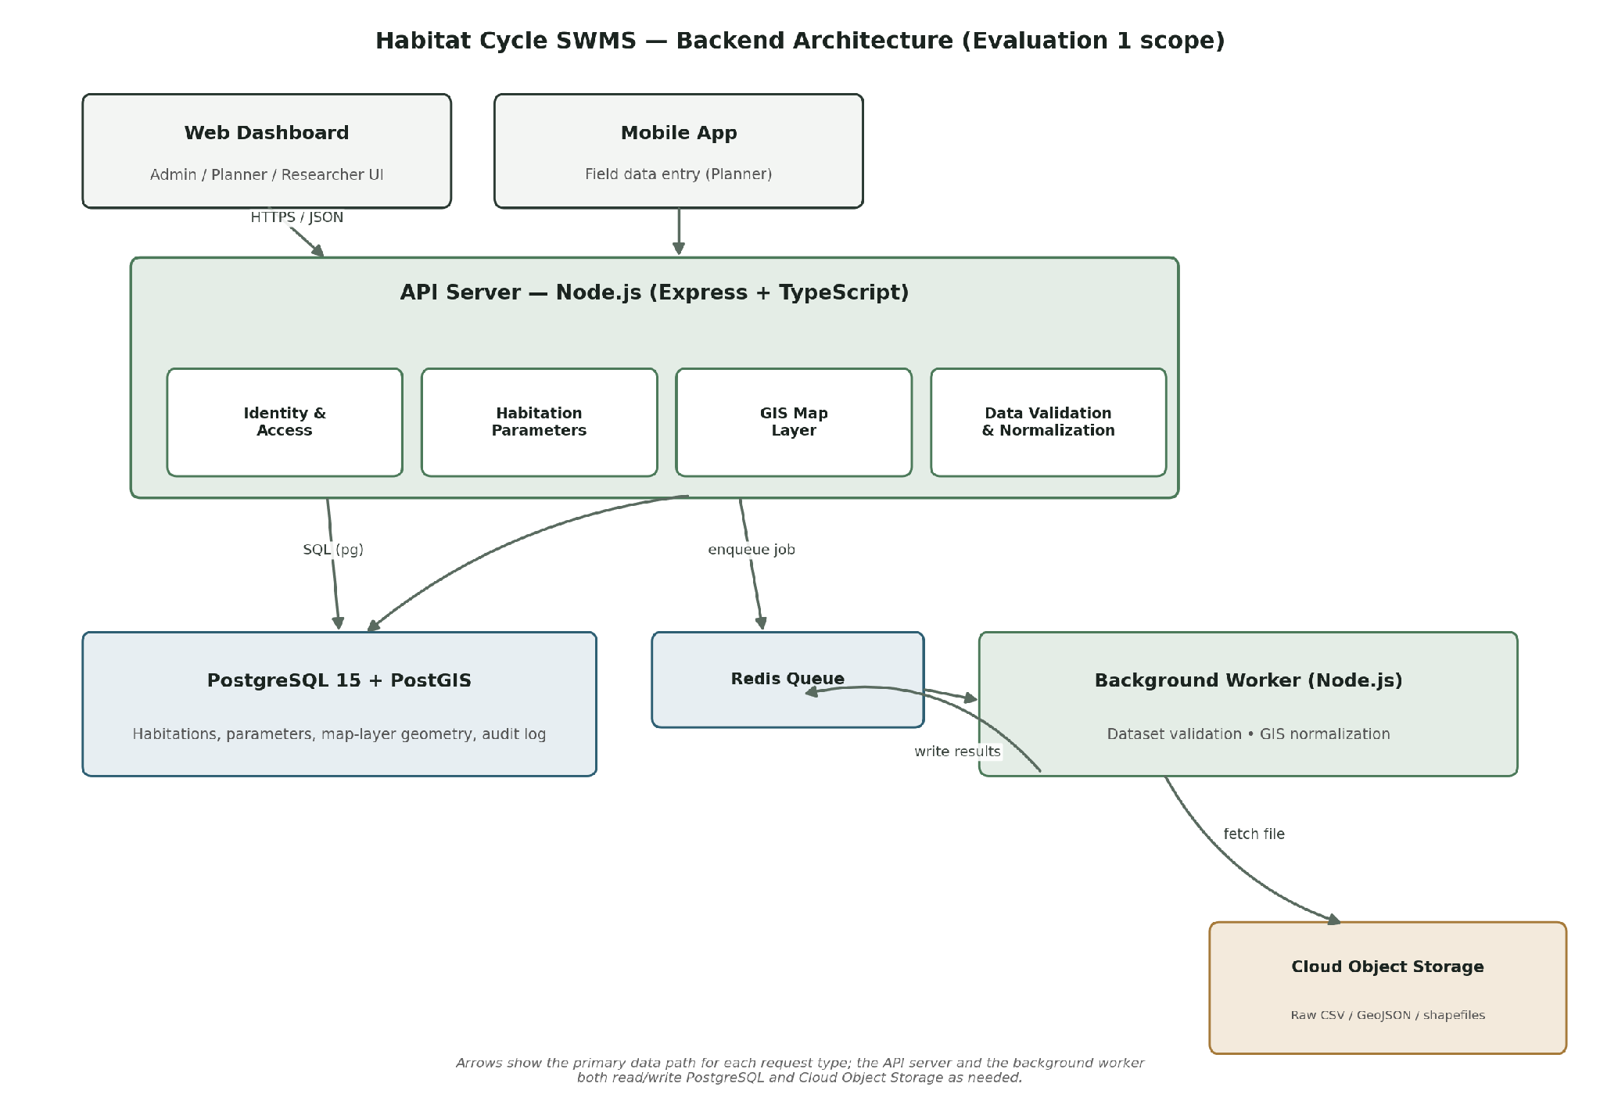
Figure 1 — Backend component architecture. Clients talk only to the API server; the background worker and the database are never exposed directly.

Components
Component | Responsibility | Technology
API / Server | Handles all REST endpoints; validates every request; enforces RBAC; orchestrates the four backend modules. | Node.js 20 + Express + TypeScript
Database | Owns users, habitations, all seven parameter-category tables, map-layer geometry, and the immutable parameter change log. | PostgreSQL 15 + PostGIS extension
Background worker | Runs dataset validation/normalization and GIS geometry normalization outside the request/response cycle, so large-file processing never blocks or times out an HTTP request. | Node.js worker process + BullMQ (fallback: worker_threads)
Cache / queue | Brokers background jobs between the API server and the worker; caches frequently-requested map-layer overlay responses. | Redis 7
External service | Persists the original uploaded files (CSV / XLSX / GeoJSON / Shapefile) before and after normalization, so a failed processing run never loses the source data. | AWS S3-compatible object storage

Key Architecture Decisions
ID | Decision | Reason | Trade-off / Limitation
AD-01 | Modular monolith — one deployable API service containing four internal modules (Identity, Habitation, GIS, Validation), rather than separate microservices. | Fastest path to a working, consistent backend within the evaluation timeline for one team; a single DB connection keeps multi-step writes transactionally simple. | Modules cannot be scaled or deployed independently. If usage grows well beyond hackathon scope, the GIS or Validation module would need to be split out.
AD-02 | PostgreSQL + PostGIS as the single database, instead of a separate specialised GIS data store. | Map-layer geometry (roads, water bodies, settlement boundaries) can be stored, queried and overlaid using the same relational engine already used for habitation and parameter data — no second data store to keep in sync. | PostGIS query performance on very large / high-resolution geometries is weaker than a purpose-built tile server; acceptable at village/ward/town/city scale.
AD-03 | Dataset validation and GIS normalization run asynchronously on a background worker, not inline in the HTTP request. | Uploaded spreadsheets and GIS files can be large; row-by-row / geometry validation would risk blocking the request thread and hitting client timeouts. | Adds a queue component (Redis + BullMQ); the client must poll or receive a status update instead of an instant response.
AD-04 | Stateless JWT authentication instead of server-side sessions. | Keeps the API stateless and horizontally scalable without a shared session store; works identically for the web dashboard and any future mobile client. | Revoking a compromised access token before its natural (15-minute) expiry requires an explicit deny-list check rather than simply deleting a session.

3. Core Backend Workflows
The four workflows below cover every mandatory Evaluation-1 requirement end-to-end. Each is the path the backend actually executes — not a UI screen flow.
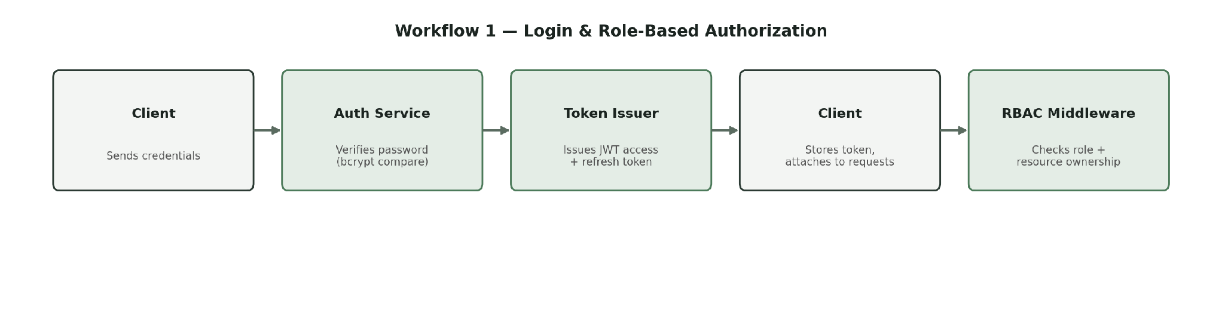
Workflow 1 — Login & Role-Based Authorization. Every subsequent request in Workflows 2–4 passes through the same RBAC Middleware step shown here.
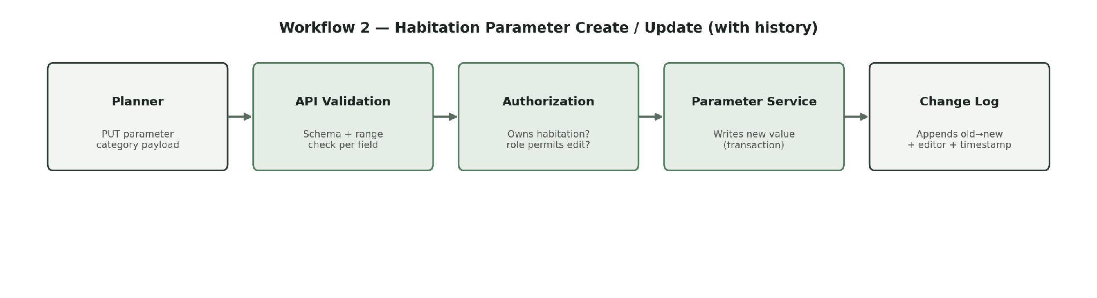
Workflow 2 — Habitation Parameter Create / Update. The Change Log write happens in the same database transaction as the parameter update, so a parameter can never be saved without a corresponding history entry.
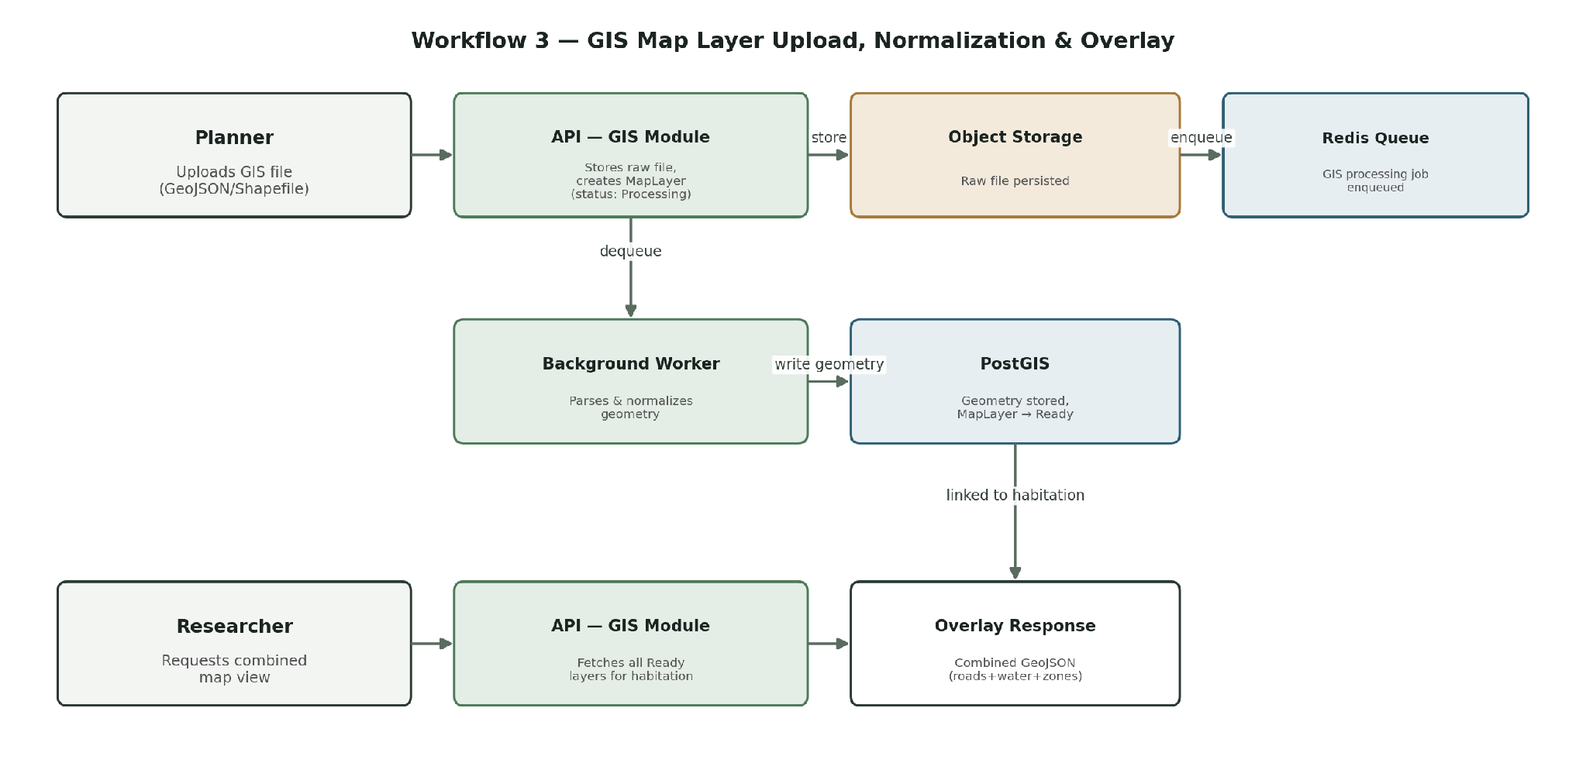
Workflow 3 — GIS Map Layer Upload, Normalization & Overlay. The upper path (Planner → Researcher) shows ingestion; the lower path shows how multiple stored layers are combined into one overlay response on request.
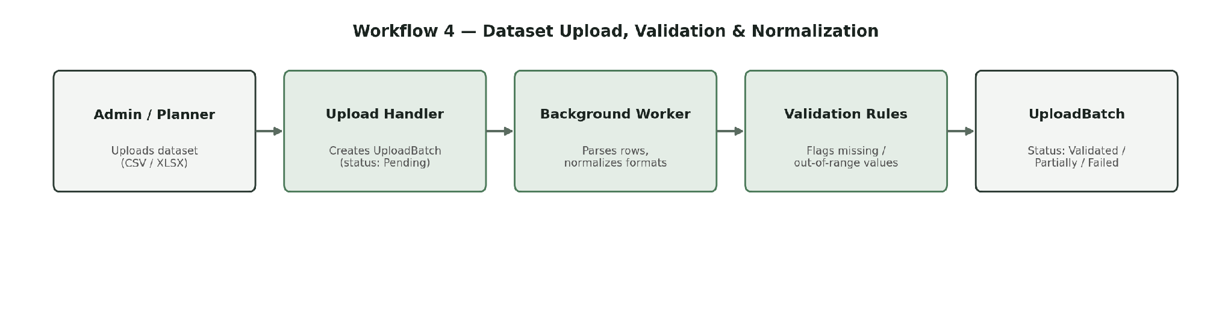
Workflow 4 — Dataset Upload, Validation & Normalization. This is the same pipeline whether the dataset targets a parameter category (CSV/XLSX) or a map layer (GeoJSON/Shapefile); only the row-level validation rules differ.

4. Data Model
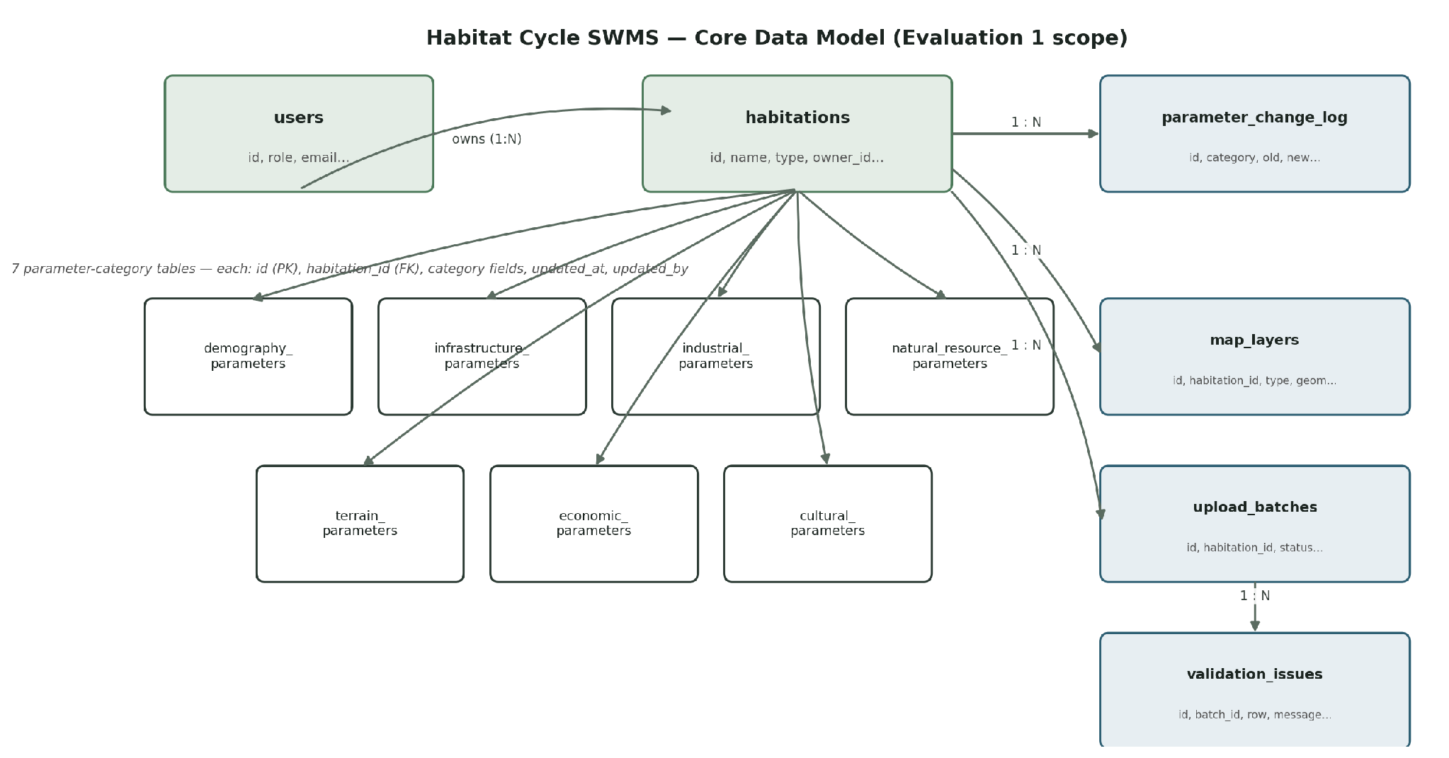
Figure 2 — Core data model for Evaluation 1 scope. All seven parameter-category tables share an identical pattern (see the note under Table: demography_parameters).

Database Schema
Every table is defined exactly once below. The seven parameter-category tables share one identical structural pattern; demography_parameters is documented in full as the exemplar, and the remaining six are listed compactly immediately after it.

TABLE: users
Column | Type | PK / FK | Nullable | Default | Description
id | UUID | PK | No | generated | Unique identifier
name | VARCHAR(120) | — | No | — | Full name
email | VARCHAR(160) | — | No | — | Unique login email (unique index)
password_hash | VARCHAR(255) | — | No | — | bcrypt hash — never returned by any API response
role | ENUM(admin, planner, researcher) | — | No | researcher | Determines every RBAC decision
is_active | BOOLEAN | — | No | true | Deactivated accounts cannot log in
created_at | TIMESTAMP | — | No | now() | Account creation time
updated_at | TIMESTAMP | — | No | now() | Last profile update

TABLE: habitations
Column | Type | PK / FK | Nullable | Default | Description
id | UUID | PK | No | generated | Unique identifier
name | VARCHAR(160) | — | No | — | e.g. "Shirva Village"
type | ENUM(village, ward, town, city) | — | No | — | Determines default parameter scale
latitude | DECIMAL(9,6) | — | No | — | Real-world map location
longitude | DECIMAL(9,6) | — | No | — | Real-world map location
owner_id | UUID | FK → users.id | No | — | Planner/Admin who created it
is_deleted | BOOLEAN | — | No | false | Soft-delete flag
deleted_at | TIMESTAMP | — | Yes | NULL | Set on soft-delete
created_at | TIMESTAMP | — | No | now() | —
updated_at | TIMESTAMP | — | No | now() | —

TABLE: demography_parameters (exemplar for the 7-category pattern)
Column | Type | PK / FK | Nullable | Default | Description
id | UUID | PK | No | generated | —
habitation_id | UUID | FK → habitations.id | No | — | One row per habitation (unique constraint)
population | INTEGER | — | No | — | Total resident population
population_density_per_sq_km | INTEGER | — | No | — | People per km²
growth_rate_pct | DECIMAL(4,2) | — | No | 0 | Annual growth rate
floating_pop_pct | DECIMAL(5,2) | — | Yes | 0 | Non-resident daily population share
household_size | DECIMAL(3,1) | — | Yes | — | Average persons per household
literacy_pct | DECIMAL(5,2) | — | Yes | — | Demographic indicator
version | INTEGER | — | No | 1 | Incremented on each update (optimistic locking)
updated_at | TIMESTAMP | — | No | now() | —
updated_by | UUID | FK → users.id | No | — | Who last edited this record

The remaining six parameter-category tables follow this exact pattern — id (PK), habitation_id (FK, unique), category-specific fields, version, updated_at, updated_by — with only the category-specific fields differing. ENUM field scales: industrial_activity_intensity and accessibility → ENUM(low, medium, high); cost_constraint_level → ENUM(low, moderate, high, severe).

Table | Category-specific fields
infrastructure_parameters | road_coverage_pct, roads_alleys_count, residential_zone_pct, industrial_zone_pct, schools_count, clinics_count, collection_vehicles, collection_point_density_pct, existing_landfill_capacity_tonnes
industrial_parameters | has_organized_industry, has_unorganized_industry, industrial_activity_intensity (ENUM: low/medium/high), industrial_waste_tonnes_per_day, hazardous_share_pct
natural_resource_parameters | annual_rainfall_mm, water_bodies_count, forest_cover_pct, sensitive_area_nearby
terrain_parameters | slope, soil_type, wind_condition, accessibility (ENUM: low/medium/high), flood_prone
economic_parameters | per_capita_income_annual, annual_budget_inr, willingness_to_pay_pct, cost_constraint_level (ENUM: low/moderate/high/severe)
cultural_parameters | diet_type, segregation_adherence_pct, festival_spike_pct, local_practice_notes

TABLE: parameter_change_log
Column | Type | PK / FK | Nullable | Default | Description
id | UUID | PK | No | generated | —
habitation_id | UUID | FK → habitations.id | No | — | —
category | VARCHAR(40) | — | No | — | e.g. "demography"
field_name | VARCHAR(60) | — | No | — | Which field changed
old_value | TEXT | — | Yes | — | Value before the edit (null on first creation)
new_value | TEXT | — | No | — | Value after the edit
changed_by | UUID | FK → users.id | No | — | Who made the change
changed_at | TIMESTAMP | — | No | now() | Immutable — rows are only ever inserted, never updated or deleted

TABLE: map_layers
Column | Type | PK / FK | Nullable | Default | Description
id | UUID | PK | No | generated | —
habitation_id | UUID | FK → habitations.id | No | — | Every layer belongs to exactly one habitation
layer_type | ENUM(road, water_body, terrain, settlement, boundary) | — | No | — | What the layer represents
geometry | GEOMETRY | — | No | — | PostGIS geometry column (point/line/polygon); GIST index defined
source_file_url | VARCHAR(500) | — | No | — | Object-storage key (not a public URL; pre-signed on demand)
status | ENUM(processing, ready, failed) | — | No | processing | Set by the background worker
is_deleted | BOOLEAN | — | No | false | Soft-delete flag
deleted_at | TIMESTAMP | — | Yes | NULL | —
uploaded_by | UUID | FK → users.id | No | — | —
uploaded_at | TIMESTAMP | — | No | now() | —

GIS note: A map_layers row is one geometry feature (point/line/polygon), not a whole multi-feature file. A "layer" (e.g. "roads") is the set of all map_layers rows sharing the same habitation_id and layer_type. A GIST index is defined on geometry and a btree index on (habitation_id, layer_type, status).

TABLE: upload_batches
Column | Type | PK / FK | Nullable | Default | Description
id | UUID | PK | No | generated | —
habitation_id | UUID | FK → habitations.id | No | — | —
category | VARCHAR(40) | — | No | — | Which parameter category the dataset targets
original_filename | VARCHAR(255) | — | No | — | —
file_checksum | VARCHAR(64) | — | No | — | SHA-256 — used to detect duplicate uploads
status | ENUM(pending, validating, validated, partially_validated, failed) | — | No | pending | See state diagram in Section 5
row_count | INTEGER | — | Yes | — | Total rows parsed
valid_row_count | INTEGER | — | Yes | — | Rows with no issues
normalized_file_url | VARCHAR(500) | — | Yes | NULL | Object-storage key for the normalized output file
is_deleted | BOOLEAN | — | No | false | Soft-delete flag; set when parent habitation is soft-deleted
uploaded_by | UUID | FK → users.id | No | — | —
uploaded_at | TIMESTAMP | — | No | now() | —

TABLE: validation_issues
Column | Type | PK / FK | Nullable | Default | Description
id | UUID | PK | No | generated | —
batch_id | UUID | FK → upload_batches.id | No | — | —
row_number | INTEGER | — | No | — | 1-indexed row in the source file
field_name | VARCHAR(60) | — | Yes | — | Which column the issue is in
issue_type | ENUM(missing_value, invalid_range, invalid_format, duplicate) | — | No | — | —
message | VARCHAR(255) | — | No | — | Human-readable explanation shown to the uploader
created_at | TIMESTAMP | — | No | now() | —

5. Business Logic & Rules

Business Rules
ID | Rule | Enforced By
BR-01 | Only Admin and Planner roles may create or edit a habitation; Researcher is strictly read-only across the entire backend. | Authorization middleware (role check)
BR-02 | A Planner may only edit habitations they own; an Admin may edit any habitation. | Service-layer resource-ownership check
BR-03 | Every update to a parameter-category record must write an immutable parameter_change_log entry (old value, new value, editor, timestamp) in the same transaction. On first creation, one log row per field is written with old_value = null. Change-log rows are never edited or deleted. | Database transaction in the Parameter service
BR-04 | A map layer must always be linked to exactly one habitation; it cannot exist or be queried without a valid habitation_id. | DB foreign key (NOT NULL, ON DELETE RESTRICT) + API validation
BR-05 | Uploaded datasets are only accepted in supported formats — CSV/XLSX for parameter data, GeoJSON/Shapefile for map layers. Unsupported formats are rejected before any validation begins. | Upload-handler MIME/extension check; archive-bomb ratio check; content-parse check
BR-06 | An UploadBatch cannot be marked "validated" if any row has a missing mandatory field or an out-of-range value; such a batch becomes "partially_validated" instead, with every issue listed. | Validation service business logic
BR-07 | Duplicate uploads — identical file checksum for the same habitation and category — are not reprocessed; the existing UploadBatch and its validation report are returned with HTTP 200. | Service layer + unique constraint on (habitation_id, category, file_checksum)
BR-08 | Only an Admin may create or activate Planner/Admin accounts. POST /api/auth/register is public but creates only Researcher accounts (is_active = false) requiring Admin activation. No user can self-elevate their role. | Authorization middleware + role field is immutable on self-update endpoint
BR-09 | Deleting a habitation (Admin-only) is a soft delete (is_deleted + deleted_at). Soft-deleting a habitation cascades to soft-delete its parameter-category rows, map_layers, and non-validating upload_batches. Deletion is blocked (409) if any upload_batches row is status = "validating". | Service-layer deletion logic; DB foreign keys as backstop

State / Workflow Transitions
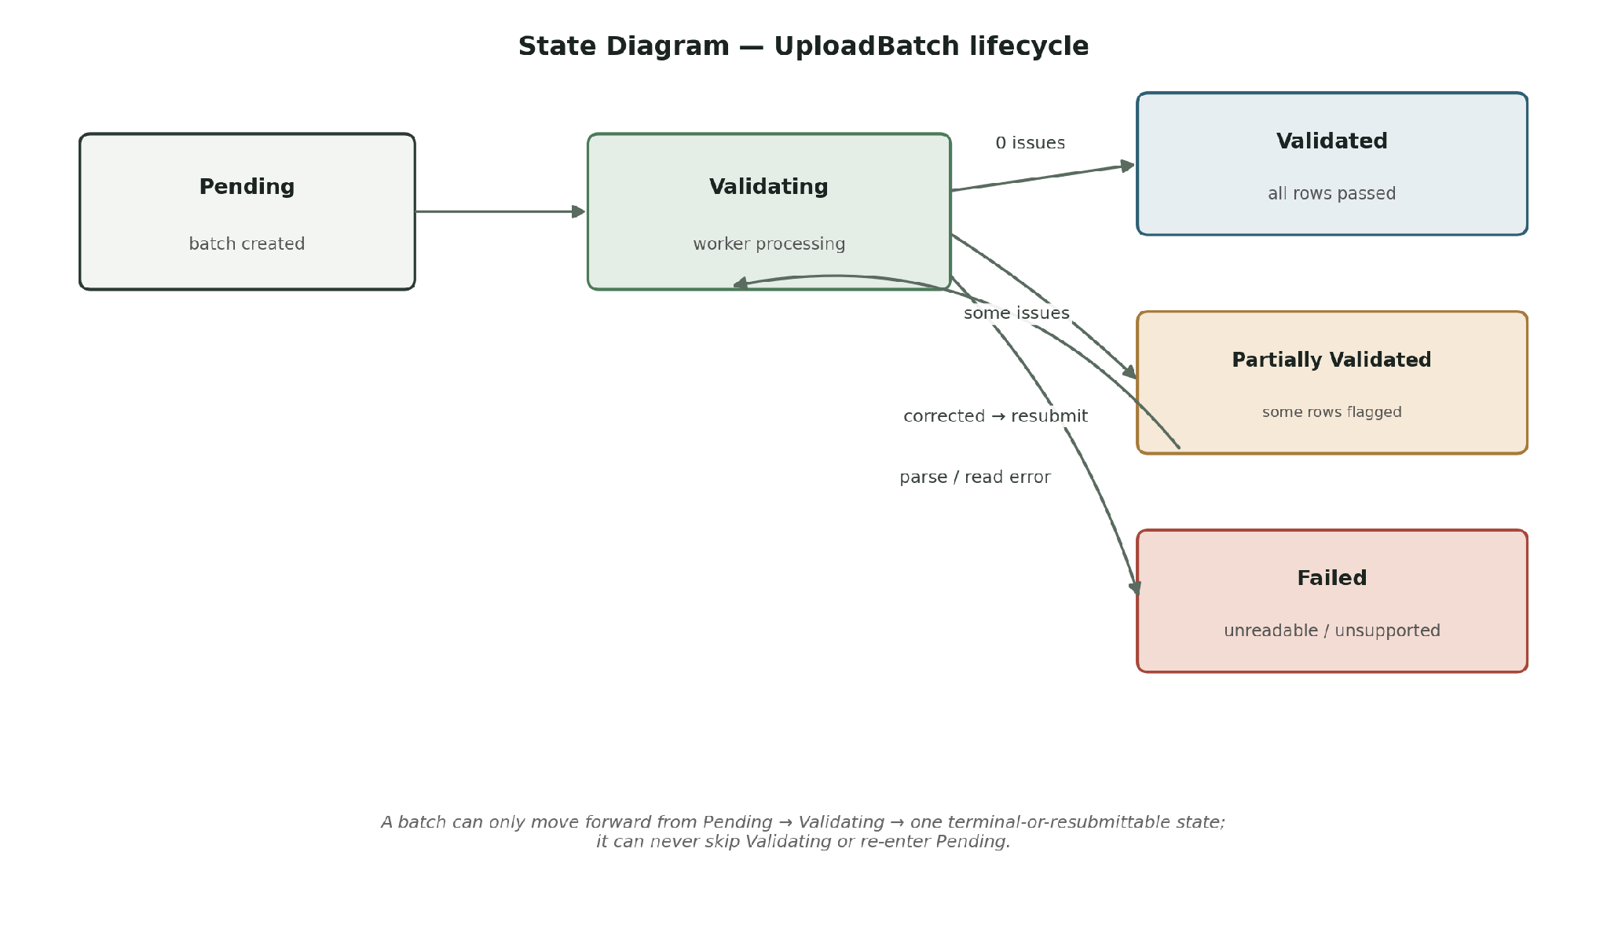
UploadBatch is the only entity in this scope with a meaningful workflow lifecycle. A batch can never skip "Validating" or return to "Pending".

6. API Design

API Summary
All list endpoints (API-04, API-13) support ?page and ?pageSize (default 20, max 100) and return { data, pagination: { page, pageSize, total } }. Every response includes a requestId (UUID) for log correlation. All 400-level validation errors use the shape: { success: false, error: { code, message, fields: [{ field, issue }] } }. All timestamps are stored in UTC and serialized with a trailing Z.

ID | Method | Endpoint | Auth | Role | Purpose
API-01 | POST | /api/auth/register | Public | — | Create new Researcher account (is_active = false; Admin must activate)
API-02 | POST | /api/auth/login | Public | — | Authenticate; issue access + refresh JWTs
API-03 | POST | /api/auth/refresh | Required | Any | Exchange a valid refresh token for a new access token
API-04 | GET | /api/habitations | Required | Any | List habitations visible to the caller (?type, ?ownerId, ?page, ?pageSize)
API-05 | POST | /api/habitations | Required | Admin, Planner | Create a new habitation
API-06 | GET | /api/habitations/{id} | Required | Any | Get one habitation's profile
API-07 | PATCH | /api/habitations/{id} | Required | Admin, Owner Planner | Update habitation profile fields
API-08 | DELETE | /api/habitations/{id} | Required | Admin | Soft-delete a habitation (cascades to parameters, layers, batches)
API-09 | GET | /api/habitations/{id}/parameters/{category} | Required | Any | Read one parameter category's current values
API-10 | PUT | /api/habitations/{id}/parameters/{category} | Required | Admin, Owner Planner | Create/update one parameter category (writes change log; supports expectedVersion for optimistic locking)
API-11 | GET | /api/habitations/{id}/parameters/{category}/history | Required | Any | View parameter change history
API-12 | POST | /api/habitations/{id}/map-layers | Required | Admin, Owner Planner | Upload a GIS file; creates ingestion record + per-feature MapLayer rows via background worker
API-13 | GET | /api/habitations/{id}/map-layers | Required | Any | List map layers; ?overlay=true returns them combined; ?layerType to filter
API-14 | DELETE | /api/map-layers/{id} | Required | Admin, Owner Planner | Soft-delete a map layer
API-15 | POST | /api/uploads | Required | Admin, Planner | Upload a dataset for validation/normalization
API-16 | GET | /api/uploads/{id} | Required | Any | Get an upload batch's status and summary
API-17 | GET | /api/uploads/{id}/issues | Required | Any | Get the detailed validation issue list for a batch (?issueType filter)
API-18 | PATCH | /api/users/{id}/activate | Required | Admin | Activate a registered user account

Detailed Endpoint Contracts
Six endpoints — one per module, plus the two most-exercised GIS and validation reads — are documented in full below; the remaining eleven follow the same request/response conventions.

API-02 — POST /api/auth/login
Field | Details
Purpose | Authenticate a user with email + password and issue a JWT access token and refresh token.
Authentication | Public
Authorization | None (this endpoint issues the credentials that later authorize everything else)
Parameters | None (body only)
Validation | email must be a valid email format; password required and non-empty; 3 consecutive failures for the same email within 5 minutes triggers a 60-second rate limit
Success status | 200
Error statuses | 400 (malformed body) · 401 (invalid email/password) · 429 (rate-limited)

Request: { "email": "planner@shirva.gov.in", "password": "correct-horse-battery-staple" }
Response: { "success": true, "data": { "accessToken": "eyJ...", "refreshToken": "d290...", "user": { "id": "u_123", "name": "A. Shetty", "role": "planner" } } }

API-10 — PUT /api/habitations/{id}/parameters/{category}
Field | Details
Purpose | Create or update one parameter category's values for a habitation, writing a change-log entry for every field that changed.
Authentication | Required
Authorization | Admin (any habitation) or the Planner who owns habitation {id}. Researcher → 403.
Parameters | Path: id (habitation UUID), category (one of demography | infrastructure | industrial | natural_resource | terrain | economic | cultural)
Validation | Body must match the category's schema exactly; numeric fields are range-checked (e.g. population > 0, any *_pct field between 0–100); unknown fields are rejected. If expectedVersion is supplied and does not match the current version, request is rejected with 409.
Success status | 200
Error statuses | 400 (schema/range violation) · 401 · 403 (wrong role or non-owner) · 404 · 409 (optimistic-lock conflict; response includes current version)

Request: { "population": 4300, "populationDensityPerSqKm": 950, "growthRatePct": 2.1, "floatingPopPct": 8, "householdSize": 4.6, "literacyPct": 78, "expectedVersion": 3 }
Response: { "success": true, "data": { "habitationId": "h_045", "category": "demography", "updatedAt": "2026-09-16T08:12:00Z", "fieldsChanged": ["population", "growthRatePct"], "version": 4 } }

API-12 — POST /api/habitations/{id}/map-layers
Field | Details
Purpose | Upload a GIS file (GeoJSON or Shapefile). Creates an ingestion record synchronously; background worker parses and creates one map_layers row per feature.
Authentication | Required
Authorization | Admin (any habitation) or the Planner who owns habitation {id}. Researcher → 403.
Parameters | Path: id (habitation UUID). Body: multipart/form-data with file + layerType
Validation | layerType must be one of road | water_body | terrain | settlement | boundary; file must be .geojson, .json, .shp, or .zip (zipped shapefile) and ≤ 50MB; archive-bomb ratio check applied
Success status | 201
Error statuses | 400 (unsupported format / missing layerType) · 401 · 403 · 404 · 413 (file too large)

Request: multipart/form-data: layerType: "road", file: shirva_roads.geojson
Response 201: { "success": true, "data": { "id": "ing_001", "habitationId": "h_045", "layerType": "road", "status": "processing", "featureCount": 47 } }

API-13 — GET /api/habitations/{id}/map-layers?overlay=true
Field | Details
Purpose | List all map layers for a habitation; with overlay=true, return them merged into one combined GeoJSON FeatureCollection for a single-call map render.
Authentication | Required
Authorization | Any authenticated role may view
Parameters | Path: id (habitation UUID). Query: overlay (boolean, default false), layerType (optional filter), page, pageSize (default 20, max 100)
Validation | Only layers with status = ready are included in an overlay response; processing layers are reported separately
Success status | 200
Error statuses | 401 · 404

Request: GET /api/habitations/h_045/map-layers?overlay=true
Response: { "success": true, "data": { "type": "FeatureCollection", "crs": { "type": "name", "properties": { "name": "EPSG:4326" } }, "features": [ { "type": "Feature", "properties": { "layerType": "road" }, "geometry": { "type": "LineString", "coordinates": [[74.8765, 13.1234], [74.8790, 13.1256]] } }, { "type": "Feature", "properties": { "layerType": "water_body" }, "geometry": { "type": "Polygon", "coordinates": [[[74.880, 13.120], [74.885, 13.120], [74.885, 13.125], [74.880, 13.120]]] } } ], "processingLayerIds": ["ml_902"] } }

API-15 — POST /api/uploads
Field | Details
Purpose | Upload a dataset (CSV/XLSX) for a habitation and parameter category; creates an UploadBatch and enqueues it for background validation and normalization.
Authentication | Required
Authorization | Admin or Planner (owner of the target habitation). Researcher → 403.
Parameters | Body: multipart/form-data with file, habitationId, category
Validation | File must be .csv or .xlsx and ≤ 20MB. Archive-bomb + content-parse checks applied. If a batch with identical (habitationId, category, file_checksum) already exists, the existing batch and its report are returned with 200 (per BR-07) — no new batch is created.
Success status | 202 (new batch created) · 200 (duplicate detected; existing batch returned)
Error statuses | 400 (unsupported format) · 401 · 403 · 404

Request: multipart/form-data: habitationId: "h_045", category: "demography", file: shirva_demography_2026.csv
Response 202: { "success": true, "data": { "id": "ub_337", "status": "pending", "originalFilename": "shirva_demography_2026.csv" } }

API-17 — GET /api/uploads/{id}/issues
Field | Details
Purpose | Return the full row-by-row list of validation issues found in an upload batch.
Authentication | Required
Authorization | Any authenticated role may view
Parameters | Path: id (UploadBatch UUID). Query: issueType (optional filter)
Validation | Returns an empty array (not an error) if the batch validated with zero issues. Returns 404 if the parent habitation is soft-deleted.
Success status | 200
Error statuses | 401 · 404

Request: GET /api/uploads/ub_337/issues
Response: { "success": true, "data": [ { "row": 14, "field": "population", "issueType": "missing_value", "message": "Row 14 has no value for 'population'." }, { "row": 22, "field": "growth_rate_pct", "issueType": "invalid_range", "message": "Row 22: growth_rate_pct = 340 is outside 0–100." } ] }

7. Authentication & Authorization

Authentication
Item | Implementation
Authentication mechanism | JWT (stateless bearer tokens) — no server-side session store
Credential storage | Passwords hashed with bcrypt, cost factor 12; plaintext password is never stored, logged, or returned
Token / session lifetime | Access token: 15 minutes. Refresh token: 7 days.
Refresh mechanism | POST /api/auth/refresh exchanges a valid, non-expired refresh token for a new access token. Refresh tokens are single-use and rotated on every refresh (the old one is invalidated).

RBAC Matrix
Three roles exist in this backend — Municipal Admin, Planner, and Researcher — matching the brief's user models exactly.

Action | Admin | Planner | Researcher
Create habitation | ✓ | ✓ | ✗
View habitation | ✓ | ✓ | ✓
Update habitation parameters | ✓ (any) | ✓ (own only) | ✗
Delete habitation | ✓ | ✗ | ✗
Upload map layer | ✓ (any) | ✓ (own only) | ✗
View map layer / overlay | ✓ | ✓ | ✓
Upload dataset for validation | ✓ (any) | ✓ (own only) | ✗
View validation report | ✓ | ✓ | ✓
Manage / activate user accounts | ✓ | ✗ | ✗

Security Controls
Control | Approach
Input validation | Zod schema validation on every request body, query string, and path parameter, before it reaches any business logic
Authorization | Express middleware resolves the JWT and attaches {userId, role} to the request; a per-route guard then checks role and, where relevant, resource ownership before the handler runs
Password security | bcrypt hashing (cost factor 12); 8-character minimum length enforced at registration
Sensitive data | DB credentials, JWT signing key, and object-storage keys are held in environment variables (secrets manager in production), never committed to source; password_hash is excluded from every API response via an explicit serializer allow-list. File URLs are stored as object-storage keys and exposed only as short-lived pre-signed URLs (10-minute expiry), generated per request with the same RBAC check as the resource itself.
Rate limiting | IP-based limiter: 10 requests/minute on /api/auth/*, 5 requests/minute on /api/uploads, to reduce brute-force and abuse risk
File security | Archive-bomb ratio check (reject if decompressed > 20× compressed size); files written to a randomized temp path outside any web-servable directory; content-validated before processing

8. Background Processing & Services
Two background processes are used. Both exist because a mandatory Evaluation-1 requirement (GIS map integration; data validation & normalization) explicitly involves processing uploaded files that can be large — this is a genuine architectural need, not one invented to fill out the template.

ID | Process / Service | Trigger | Purpose | Technology | Failure Handling
BG-01 | Dataset Validation Worker | New row in upload_batches (status = pending) | Parses the uploaded file, normalizes formats (e.g. spreadsheet date formats → ISO 8601, unit conversions), validates every row, writes validation_issues, and updates the batch's final status. Writes normalized output to object storage (normalized_file_url). Re-checks parent habitation is_deleted before writing results. | Node.js worker + BullMQ (Redis-backed); worker concurrency capped at 5 jobs; fallback: worker_threads | Retries twice with exponential backoff; on repeated failure the batch is marked "failed" and the uploader is notified with the reason.
BG-02 | GIS Layer Normalization Worker | New map ingestion record (status = processing) | Parses the uploaded GeoJSON/Shapefile, reprojects to a common CRS, simplifies geometry where needed, and creates one map_layers row per feature in PostGIS. Updates the ingestion record's status to ready or failed. | Node.js worker + BullMQ + turf.js/shpjs (GDAL/ogr2ogr bindings optional); worker concurrency capped at 5 jobs | Retries once; on repeated failure the ingestion record is marked "failed" while the original file remains safely in object storage.

9. External Integrations
ID | Service | Purpose | Direction | Data Exchanged | Failure Behaviour
EXT-01 | Cloud Object Storage (AWS S3-compatible) | Persist the original uploaded files (CSV/XLSX/GeoJSON/Shapefile) and normalized outputs so the source data is never lost even if a background job fails. | Backend → Service | Raw file bytes + filename/content-type metadata; object-storage keys saved on map_layers.source_file_url / upload_batches.normalized_file_url; pre-signed URLs generated on demand for client downloads. | If unreachable, the upload request fails fast with 503 before any database row is created — no orphaned "processing" records are left behind. The client is told to retry.

10. Error Handling & Reliability

Standard Error Response
{ "success": false, "error": { "code": "RESOURCE_NOT_FOUND", "message": "Resource does not exist" } }

HTTP Status Conventions
Situation | Status | Example
Invalid input | 400 | Demography payload is missing "population", or population is negative
Unauthenticated | 401 | Request to a protected endpoint with a missing or expired JWT
Unauthorized | 403 | A Researcher calls PUT /parameters/{category}; or a Planner edits a habitation they don't own
Not found | 404 | GET /api/habitations/{id} for an id that doesn't exist or is soft-deleted
Conflict | 409 | Optimistic-lock mismatch on PUT /parameters/{category}; re-validating an already-"validated" batch; or deleting a habitation with an in-flight upload
Duplicate (no reprocessing) | 200 | Same dataset uploaded twice — existing UploadBatch and report returned
Server failure | 500 | Unexpected database connection failure while saving a parameter update

Important Failure Scenarios
ID | Failure | Expected Backend Behaviour
ERR-01 | Database failure during a write (e.g. parameter save) | The write is wrapped in a transaction; on failure the transaction is rolled back in full (no partial parameter update without its change-log row), a 500 is returned, and the client is expected to retry.
ERR-02 | External object storage unavailable during a map-layer / dataset upload | The upload request fails fast with 503 before any database row is created — no MapLayer or UploadBatch is left in a permanent "processing" state with no file behind it.
ERR-03 | Invalid state transition (e.g. re-validating an already-"validated" batch, or deleting a habitation mid-validation) | Rejected with 409 and a message naming the current state, so the client knows exactly why the action was refused.
ERR-04 | Duplicate request / operation (e.g. the same dataset uploaded twice) | Detected via the (habitation_id, category, file_checksum) unique constraint (BR-07); the existing UploadBatch is returned with 200 instead of creating and reprocessing a duplicate.
ERR-05 | Background worker picks up a job whose parent habitation was soft-deleted mid-run | Worker re-checks is_deleted before writing results. If deleted, the job is discarded and logged as discarded_orphaned_job — no validation_issues are written against a deleted parent.

11. Testing Strategy
Test scenarios are grouped under four requirement IDs, one per backend module, so every test traces back to a specific mandatory requirement:
- REQ-01 — Authentication & RBAC enforcement
- REQ-02 — Habitation parameter CRUD (7 categories) with change history
- REQ-03 — GIS map layer storage, linking, and overlay
- REQ-04 — Data validation & normalization of uploaded datasets

Test ID | Requirement / Flow | Scenario | Expected Result
T-01 | REQ-01 | Valid login credentials | 200 — access + refresh tokens issued
T-02 | REQ-01 | Invalid password | 401 — no token issued
T-03 | REQ-01 | Researcher calls PATCH /habitations/{id} | 403 — rejected before any DB write
T-04 | REQ-02 | Valid Demography payload from the owning Planner | 200 — parameter saved, parameter_change_log row created
T-05 | REQ-02 | Payload missing a required field (e.g. population) | 400 — error names the missing field
T-06 | REQ-02 | Planner edits a habitation owned by a different Planner | 403 — resource-ownership check fails
T-07 | REQ-02 | PUT with wrong expectedVersion | 409 — response includes current version
T-08 | REQ-03 | Valid GeoJSON upload | 201 — ingestion record created (processing); map_layers rows become "ready" once the worker completes
T-09 | REQ-03 | Corrupted or unsupported file type upload | Ingestion record status becomes "failed" with a readable error message
T-10 | REQ-03 | Self-intersecting geometry upload | MapLayer status → "failed" with geometry validation error
T-11 | REQ-04 | Dataset with 3 rows missing rainfall data | Batch status "partially_validated"; exactly 3 validation_issues rows created
T-12 | REQ-04 | Re-upload of an identical file (same checksum) | 200 — existing batch returned; no duplicate processing job enqueued
T-13 | REQ-01 | Planner views another Planner's upload report | 200 — RBAC grants "View validation report" to all authenticated roles
T-14 | REQ-02 | Admin soft-deletes habitation with in-flight validating batch | 409 — deletion blocked until batch completes

Critical Test Coverage
- Authentication / unauthenticated access
- Role-based authorization across all three roles (Admin / Planner / Researcher boundaries)
- Resource-ownership restrictions (a Planner editing only habitations they own)
- Validation and malformed input, for every one of the seven parameter categories
- UploadBatch state transitions (Pending → Validating → Validated / Partially Validated / Failed)
- Critical database relationships and constraints (habitation → parameter cascade rules; the unique file-checksum constraint)
- Background-worker failure handling (GIS parse failure; worker picks up job after parent habitation soft-deleted)
- Optimistic-locking conflict on concurrent parameter edits

