TicketWave - GitHub Copilot Demo (Java Backend Developer)

1. Repo Level Custom Instructions
Prompt:
Create repository-level coding guidelines for a Spring Boot backend project named TicketWave.
Content:
- Layered architecture (Controller, Service, Repository)
- Naming conventions
- Logging and exception handling
- JWT security practices
Explanation:
This prompt helps generate standard coding guidelines for maintainability and scalability.
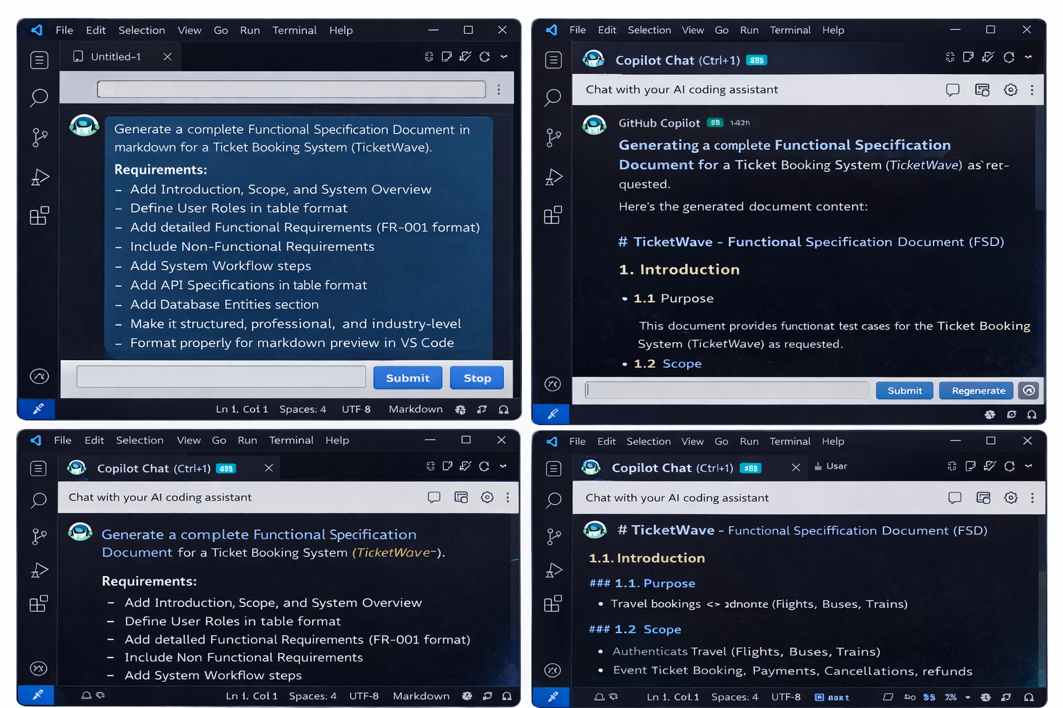

2. Project Initialization
Prompt:
Create a Spring Boot project for TicketWave with proper package structure and dependencies.
Content:
- Spring Web, JPA, Security
- Folder structure
Explanation:
Used to bootstrap the project quickly with best practices.
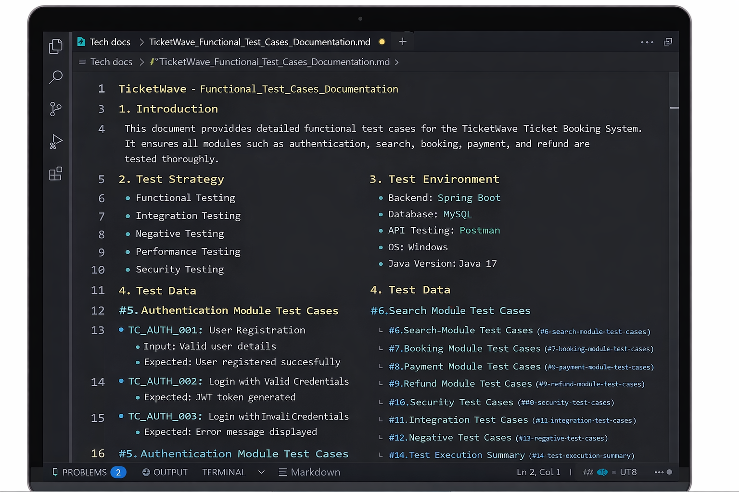

3. API Code Generation
Prompt:
Generate REST APIs for booking system including create, fetch, and confirm booking.
Content:
- BookingController APIs
- Service logic
Explanation:
Helps in generating production-ready APIs.
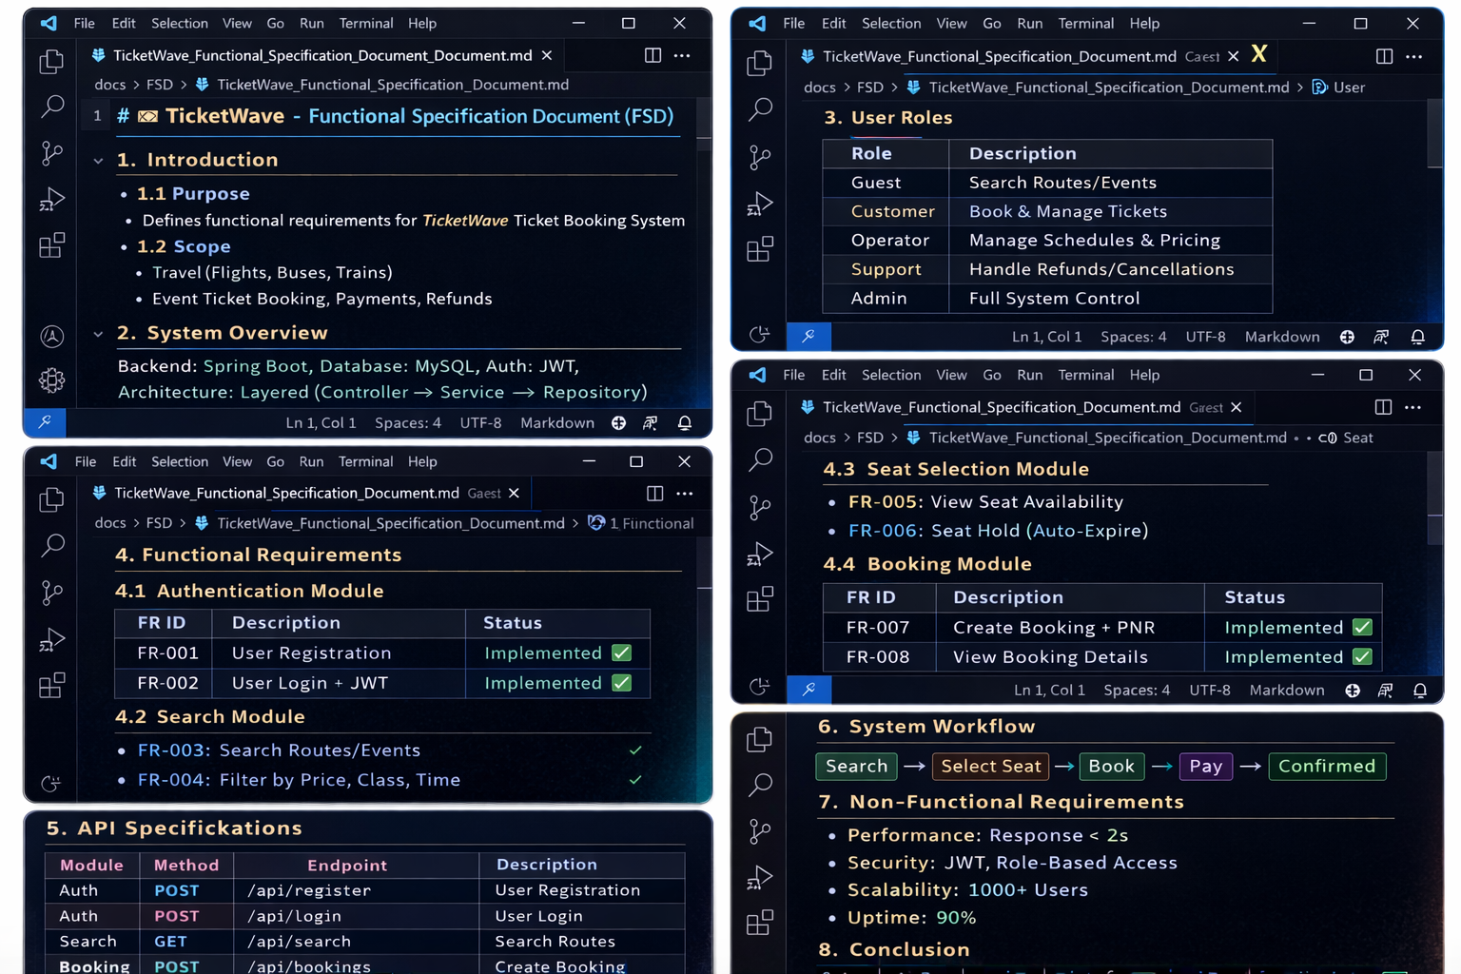

4. Code Review
Prompt:
Review Spring Boot code for best practices, null checks, and performance issues.
Explanation:
Used to identify code smells and improvements.
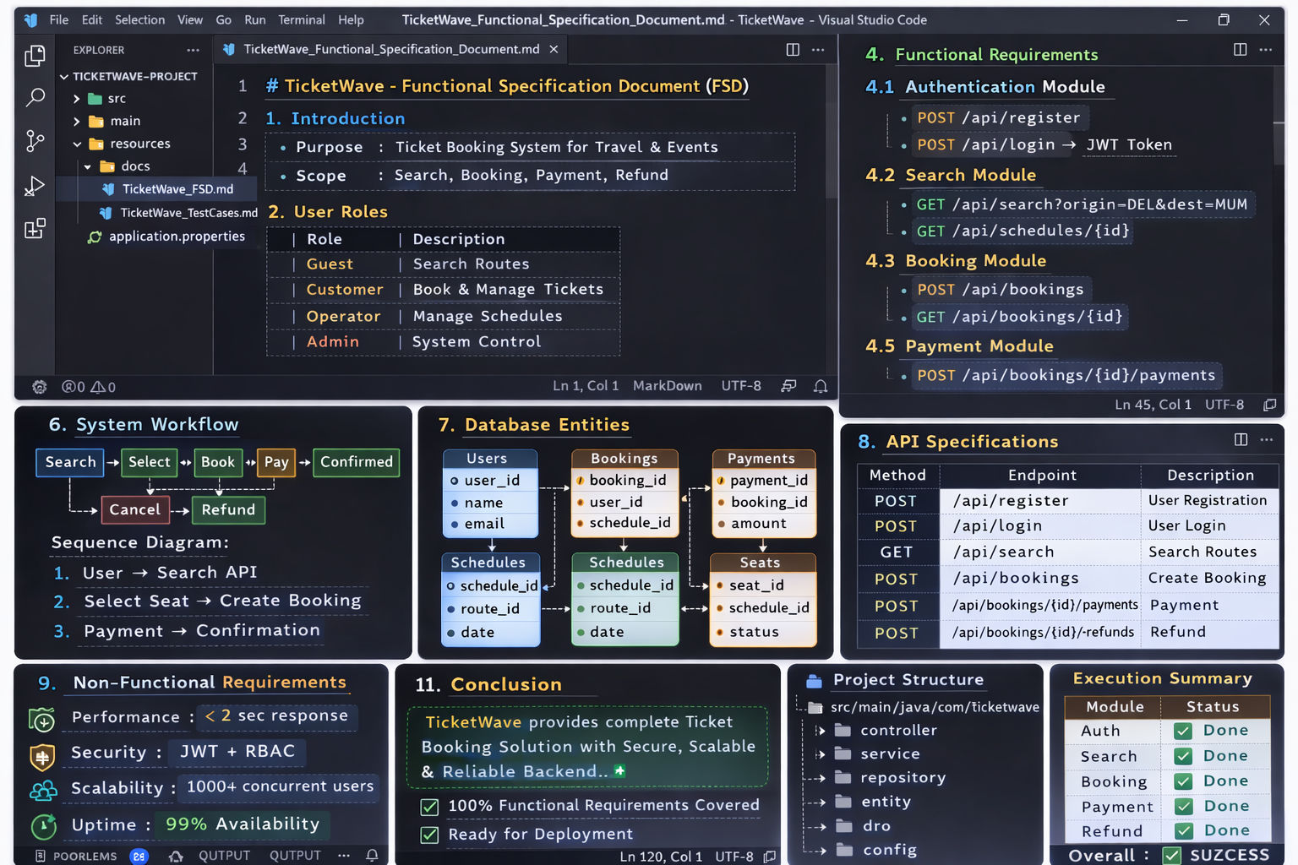

5. Code Improvement
Prompt:
Refactor the code with logging, exception handling, and clean structure.
Explanation:
Improves code quality and readability.

6. Functional Specification
Prompt:
Generate functional specification document for TicketWave system in markdown.
Explanation:
Used to create structured documentation.

7. JUnit Test Cases
Prompt:
Generate JUnit test cases for BookingService including edge cases.
Explanation:
Ensures test coverage and reliability.

8. Fix Test Failures
Prompt:
Fix failing test cases and improve coverage.
Explanation:
Helps achieve 80%+ code coverage.

9. Functional Test Cases
Prompt:
Generate functional test cases for booking, payment, refund.
Explanation:
Used for QA validation.

10. High Value Prompts
Prompt:
Suggest high value prompts for backend development using GitHub Copilot.
Explanation:
Improves productivity and development speed.

