Data Structures and Algorithms

1- E-commerce Platform Search Function

Step-1 Understand Asymptotic Notation:

- Big O notation focuses on the growth rate of an algorithm, which helps in selecting the most efficient algorithm for a task.
- It provides an upper bound on the growth rate of an algorithm’s time or space complexity as the input size increases.

Big-O | Name | Description | Example Algorithm
O(1) | Constant time | Executes in the same time regardless of input size | Accessing  array element
O(log n) | Logarithmic time | Reduces input size at each step | Binary Search
O(n) | Linear time | Time grows directly with input size | Linear search, Traversal
O(n logn) | Log-linear time | Efficient sorting | Merge sort, Quick sort
O(n^2) | Quadratic time | Time grows with square of input | Bubble sort, Nested sort
O(2^n) | Exponential time | Doubles with each input increases | Recursive fibonacci
O(n!) | Factorial time | Extremely slow for large inputs | Brute  force peermutations

Step-2 and Step-3 Setup and Implementation:

Code:

using System;
class Product
{
public int ProductId { get; set; }
public string ProductName { get; set; }
public string Category { get; set; }
public Product(int id, string name, string category)
{
ProductId = id;
ProductName = name;
Category = category;
}
public override string ToString()
{
return $"ID: {ProductId}, Name: {ProductName}, Category: {Category}";
}
}
class ECommerceSearch
{
public static Product LinearSearch(Product[] products, string name)
{
foreach (var product in products)
{
if (product.ProductName.Equals(name, StringComparison.OrdinalIgnoreCase))
{
return product;
}
}
return null;
}
public static Product BinarySearch(Product[] products, string name)
{
int left = 0, right = products.Length - 1;
while (left <= right)
{
int mid = (left + right) / 2;
int cmp = string.Compare(products[mid].ProductName, name, StringComparison.OrdinalIgnoreCase);
if (cmp == 0) return products[mid];
else if (cmp < 0) left = mid + 1;
else right = mid - 1;
}
return null;
}
static void PrintTable(Product[] products)
{
Console.WriteLine("\n-------------------- Product List --------------------");
Console.WriteLine($"{"Product ID",-10} {"Product Name",-20} {"Category",-15}");
Console.WriteLine("------------------------------------------------------");
foreach (var p in products)
{
Console.WriteLine($"{p.ProductId,-10} {p.ProductName,-20} {p.Category,-15}");
}
Console.WriteLine("------------------------------------------------------\n");
}
static void Main()
{
Console.Write("Enter number of products: ");
int n = int.Parse(Console.ReadLine());
Product[] unsortedProducts = new Product[n];
for (int i = 0; i < n; i++)
{
Console.WriteLine($"\nEnter details for Product {i + 1}:");
Console.Write("Product ID: ");
int id = int.Parse(Console.ReadLine());
Console.Write("Product Name: ");
string name = Console.ReadLine();
Console.Write("Category: ");
string category = Console.ReadLine();
unsortedProducts[i] = new Product(id, name, category);
}
PrintTable(unsortedProducts);
Product[] sortedProducts = (Product[])unsortedProducts.Clone();
Array.Sort(sortedProducts, (a, b) => a.ProductName.CompareTo(b.ProductName));
Console.Write("Enter product name to search: ");
string searchName = Console.ReadLine();
var resultLinear = LinearSearch(unsortedProducts, searchName);
Console.WriteLine("\n--- Linear Search Result ---");
Console.WriteLine(resultLinear != null ? resultLinear.ToString() : "Product not found.");
var resultBinary = BinarySearch(sortedProducts, searchName);
Console.WriteLine("\n--- Binary Search Result ---");
Console.WriteLine(resultBinary != null ? resultBinary.ToString() : "Product not found.");
}
}

output:

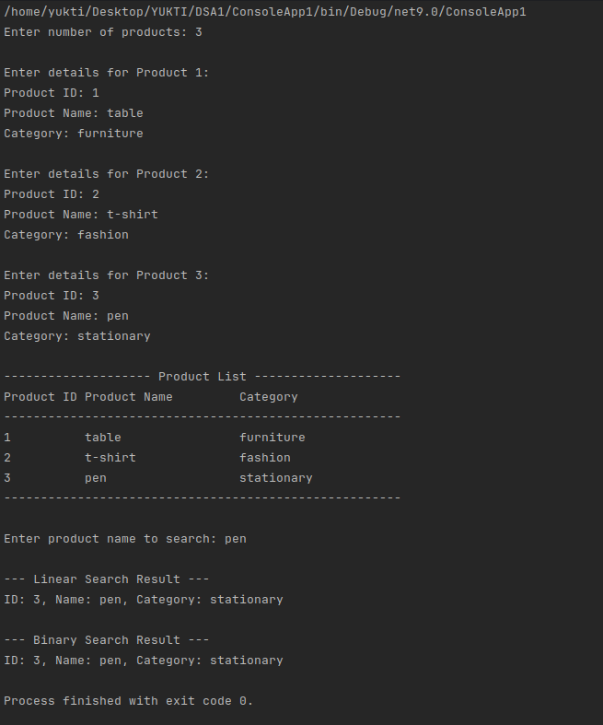

Step:4 Analysis
Algorithm | Best Case | Average Case | Worst Case
Linear Search | O(1) | O(n) | O(n)
Binary Search | O(1) | O(log n) | O(log n)

1. Linear Search:

  - Best Case: The target product is the first element in the list, requiring only one comparison (O(1)).
  - Average Case: On average, the algorithm will search through half the list (O(n/2)), but this is simplified to O(n) because Big O focuses on asymptotic growth.
  - Worst Case: The target product is the last element or not present in the list, requiring the algorithm to traverse the entire list (O(n)).

- Binary Search:
  - Best Case: The target product is the middle element, requiring only one comparison (O(1)).
  - Average Case: The algorithm repeatedly halves the search space until it finds the target product, resulting in O(logn).
  - Worst Case: The algorithm has to narrow down the entire search space, which still results in O(logn).

Recommendation

For an e-commerce platform, Binary Search is the more suitable algorithm because:
- Large Datasets: E-commerce platforms typically deal with large datasets (thousands or millions of products), where the logarithmic complexity of binary search provides significant performance benefits over linear search.
- Sorted Data: Products can be pre-sorted by name, ID, or other attributes, making binary search feasible. Sorting the data is a one-time cost, and subsequent searches are very fast.
- Frequent Searches: In an e-commerce platform, search operations are frequent, so the efficiency of binary search outweighs the initial sorting overhead.
However, Linear Search can still be used in cases where:
- The dataset is small.
- The data is unsorted or changes frequently, making sorting impractical.

2- Financial Forecasting

Step-1: Understand Recursive Algorithm

Recursion is a programming concept where a function calls itself within its own definition to solve a problem. It is particularly useful for problems that:
- Have a repetitive, self-similar structure (e.g., calculating future values based on previous years).
- Can be broken down into a base case and a recursive case.
Recursion simplifies the code for such problems by breaking them into smaller subproblems. However, improper use of recursion can lead to excessive computation or stack overflow for large inuts.

Step-2: Setup
To calculate the future value of an investment over time, we will define a recursive method based on the following parameters:
- Initial Value: The starting value of the investment.
- Annual Growth Rate: The percentage growth rate per year.
- Number of Years: The number of years to forecast

Step-3 : Implementation
using System;
using System.Collections.Generic;
class FinancialForecast
{
public static double CalculateFutureValue(double initialValue, double growthRate, int years, List<double> yearlyValues)
{
if (years == 0)
{
yearlyValues.Add(initialValue);
return initialValue;
}
double currentValue = initialValue * (1 + growthRate);
yearlyValues.Add(currentValue);
return CalculateFutureValue(currentValue, growthRate, years - 1, yearlyValues);
}
public static double CalculateFutureValueIterative(double initialValue, double growthRate, int years, List<double> yearlyValues)
{
double result = initialValue;
for (int i = 0; i < years; i++)
{
result *= (1 + growthRate);
yearlyValues.Add(result);
}
return result;
}
static void Main()
{
Console.Write("Enter initial value: ");
double initial = double.Parse(Console.ReadLine());
Console.Write("Enter annual growth rate (e.g., 0.05 for 5%): ");
double rate = double.Parse(Console.ReadLine());
Console.Write("Enter number of years: ");
int years = int.Parse(Console.ReadLine());
List<double> yearlyValuesRecursive = new List<double>();
double futureValueRecursive = CalculateFutureValue(initial, rate, years, yearlyValuesRecursive);
Console.WriteLine($"\nPredicted future value after {years} years (Recursive): {futureValueRecursive:F2}");
Console.WriteLine("\nYearly Values (Recursive):");
for (int i = 0; i < yearlyValuesRecursive.Count; i++)
{
Console.WriteLine($"Year {i + 1}: {yearlyValuesRecursive[i]:F2}");
}
List<double> yearlyValuesIterative = new List<double>();
double futureValueIterative = CalculateFutureValueIterative(initial, rate, years, yearlyValuesIterative);
Console.WriteLine($"\nPredicted future value after {years} years (Iterative): {futureValueIterative:F2}");
Console.WriteLine("\nYearly Values (Iterative):");
for (int i = 0; i < yearlyValuesIterative.Count; i++)
{
Console.WriteLine($"Year {i + 1}: {yearlyValuesIterative[i]:F2}");
}
}
}

output:
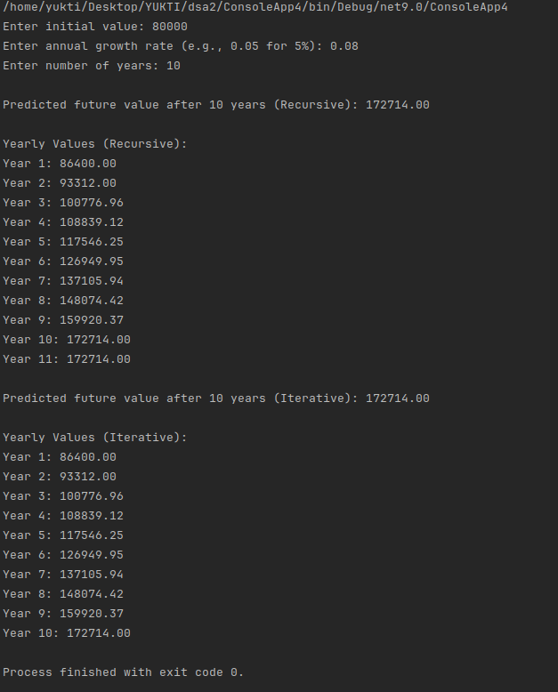

Step-4 : Analysis

Recursive Algorithm
- Time Complexity: O(n), where n is the number of years (one recursive call per year).
- Space Complexity: O(n), due to the recursive call stack.
- Limitations:
  - Stack Overflow: For large n, the recursion depth may exceed the stack limit.
  - Overhead: Recursive calls add computational overhead.

Optimized Solution: Iterative Approach
- Time Complexity: O(n).
- Space Complexity: O(1), as no call stack is used.
- Advantages:
  - No stack overflow risk.
  - Faster execution due to no recursion overhead.

Conclusion
The iterative approach is more efficient and robust for large inputs compared to recursion.

