WEEK – 3
Entity Framework Core

1:Understanding ORM with a Retail Inventory System

Scenario:
You’re building an inventory management system for a retail store. The store wants to track products, categories, and stock levels in a SQL Server database.

A) What is ORM (Object-Relational Mapping)?

Object-Relational Mapping (ORM) is a technique that maps objects in programming languages (e.g., C#) to relational database tables. It enables developers to interact with the database using objects instead of writing raw SQL queries.
How ORM maps C# classes to database tables:
- Classes → Tables: Each C# class corresponds to a database table.
- Properties → Columns: Properties of a class represent columns in the table.
- Relationships: Navigation properties represent relationships like one-to-many or many-to-many.
Benefits of ORM:
- Productivity: Reduces the time spent writing SQL queries.
- Maintainability: Makes code easier to maintain and adapt to database schema changes.
- Abstraction from SQL: Developers can focus on application logic without writing complex SQL.

B) EF Core vs EF Framework:

Feature | EF CORE 8.0 | EF FRAMEWORK (EF6)
Performance | Async/Await, Compiled Queries | Mature but slower context tracking
Modern Features | JSON columns, Bulk Operations | Limited to traditional SQL patterns
Use Case | New projects, Microservices | Legacy Windows applications

C) EF Core 8.0 Features:

JSON Column Mapping

- Stores complex C# objects (e.g., dictionaries, custom classes) as JSON strings in database columns.

Compiled Models
- Pre-compiles the model during build time to reduce runtime initialization overhead.

Command Interceptors
- Intercept and modify database operations (e.g., logging, audit trails).

2: IMPLEMENTATION OF INVENTORY MANAGEMENT SYSTEM FOR A RETAIL STORE.

RetailInventory.cs

using System;
using System.Collections.Generic;
using Microsoft.EntityFrameworkCore;
public class RetailInventoryContext : DbContext
{
public DbSet<Product> Products { get; set; }
public DbSet<Category> Categories { get; set; }
public DbSet<Stock> Stocks { get; set; }
protected override void OnConfiguring(DbContextOptionsBuilder optionsBuilder)
{
optionsBuilder
.UseMySql(
"Server=127.0.0.1;Port=3306;Database=RetailInventoryDB;User=yukti;Password=Yukti@2429Secure;",
new MySqlServerVersion(new Version(8, 0, 42))
)
.LogTo(Console.WriteLine, Microsoft.Extensions.Logging.LogLevel.Debug);
}
}
public class Product
{
public int ProductId { get; set; }
public string Name { get; set; }
public int CategoryId { get; set; }
public Category Category { get; set; }
}
public class Category
{
public int CategoryId { get; set; }
public string Name { get; set; }
public List<Product> Products { get; set; } = new List<Product>();
}
public class Stock
{
public int StockId { get; set; }
public int ProductId { get; set; }
public int Quantity { get; set; }
public Product Product { get; set; }
}
class Program
{
static void Main(string[] args)
{
Console.WriteLine("Starting the application...");
try
{
using (var context = new RetailInventoryContext())
{
var category = new Category
{
Name = "Electronics",
Products = new List<Product>
{
new Product { Name = "Smartphone" },
new Product { Name = "Laptop" }
}
};
if (string.IsNullOrEmpty(category.Name))
{
throw new InvalidOperationException("Category name cannot be null or empty.");
}
context.Categories.Add(category);
context.SaveChanges();
Console.WriteLine("Category and products added to the database.");
foreach (var product in category.Products)
{
var stock = new Stock
{
ProductId = product.ProductId,
Quantity = 100
};
context.Stocks.Add(stock);
}
context.SaveChanges();
Console.WriteLine("Stock added for products.");
}
}
catch (Exception ex)
{
Console.WriteLine("An error occurred:");
Console.WriteLine($"Message: {ex.Message}");
if (ex.InnerException != null)
{
Console.WriteLine($"Inner Exception: {ex.InnerException.Message}");
}
Console.WriteLine($"Stack Trace: {ex.StackTrace}");
}
}
}

RetailInventory.csproj

<Project Sdk="Microsoft.NET.Sdk">
<PropertyGroup>
<OutputType>Exe</OutputType>
<TargetFramework>net9.0</TargetFramework>
<ImplicitUsings>enable</ImplicitUsings>
<Nullable>enable</Nullable>
</PropertyGroup>
<ItemGroup>
<PackageReference Include="Microsoft.EntityFrameworkCore" Version="8.0.13" />
<PackageReference Include="Microsoft.EntityFrameworkCore.Relational" Version="8.0.13" />
<PackageReference Include="Microsoft.EntityFrameworkCore.SqlServer" Version="8.0.13" />
<PackageReference Include="Microsoft.EntityFrameworkCore.Design" Version="8.0.13">
<IncludeAssets>runtime; build; native; contentfiles; analyzers; buildtransitive</IncludeAssets>
<PrivateAssets>all</PrivateAssets>
</PackageReference>
<PackageReference Include="Pomelo.EntityFrameworkCore.MySql" Version="8.0.3" />
</ItemGroup>
</Project>

appsettings.json

{
"ConnectionStrings": {
"RetailInventoryContext": "Server=127.0.0.1;Port=3306;Database=RetailInventoryDB;User=root;Password=yukti2429;"
},
"Logging": {
"LogLevel": {
"Default": "Debug",
"Microsoft": "Debug"
}
}
}

Output:

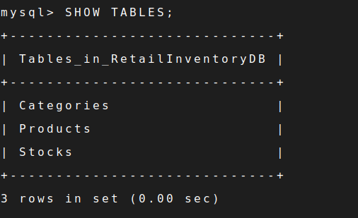

2: Setting Up the Database Context for a Retail Store

RetailStore.cs

using Microsoft.EntityFrameworkCore;
using System;
using System.Collections.Generic;
using System.Linq;
using System.Threading.Tasks;
public class Product
{
public int Id { get; set; }
public string Name { get; set; } = string.Empty;
public decimal Price { get; set; }
public int CategoryId { get; set; }
public Category? Category { get; set; }
}
public class Category
{
public int Id { get; set; }
public string Name { get; set; } = string.Empty;
public List<Product> Products { get; set; } = new List<Product>();
}
public class AppDbContext : DbContext
{
public DbSet<Product> Products { get; set; }
public DbSet<Category> Categories { get; set; }
protected override void OnConfiguring(DbContextOptionsBuilder optionsBuilder)
{
optionsBuilder.UseSqlServer(
@"Server=localhost;Database=RetailStoreDB;
Integrated Security=True;TrustServerCertificate=True;");
}
}
class RetailStore
{
static async Task Main(string[] args)
{
using (var context = new AppDbContext())
{
await context.Database.EnsureCreatedAsync();
if (!context.Categories.Any())
{
var electronics = new Category { Name = "Electronics" };
var groceries = new Category { Name = "Groceries" };
context.Categories.AddRange(electronics, groceries);
await context.Products.AddRangeAsync(
new Product { Name = "Laptop", Price = 75000, Category = electronics },
new Product { Name = "Rice Bag", Price = 1200, Category = groceries }
);
await context.SaveChangesAsync();
}
}
using (var context = new AppDbContext())
{
var categories = await context.Categories
.Include(c => c.Products)
.ToListAsync();
foreach (var category in categories)
{
Console.WriteLine($"Category: {category.Name}");
foreach (var product in category.Products)
{
Console.WriteLine($"- {product.Name}: ₹{product.Price}");
}
Console.WriteLine();
}
}
}
}

RetailStore.csproj

<Project Sdk="Microsoft.NET.Sdk">
<PropertyGroup>
<OutputType>Exe</OutputType>
<TargetFramework>net8.0</TargetFramework>
<Nullable>enable</Nullable>
</PropertyGroup>
<ItemGroup>
<PackageReference Include="Microsoft.EntityFrameworkCore.SqlServer" Version="8.0.17" />
<PackageReference Include="Microsoft.EntityFrameworkCore.Design" Version="8.0.17" />
</ItemGroup>
</Project>

appsettings.json

{
"ConnectionStrings": {
"RetailStoreDB": "Server=localhost;Database=RetailStoreDB;User=yukti;Password=Yukti@2429;Port=3306;CharSet=utf8mb4;SslMode=Preferred"
},
"Logging": {
"LogLevel": {
"Default": "Debug",
"Microsoft.EntityFrameworkCore.Database": "Information"
}
}
}

3: Using EF Core CLI to Create and Apply Migrations

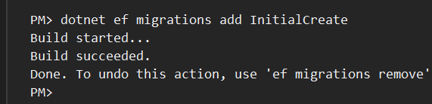

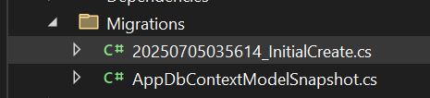

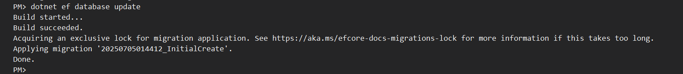
Snapshot of sql server management studio

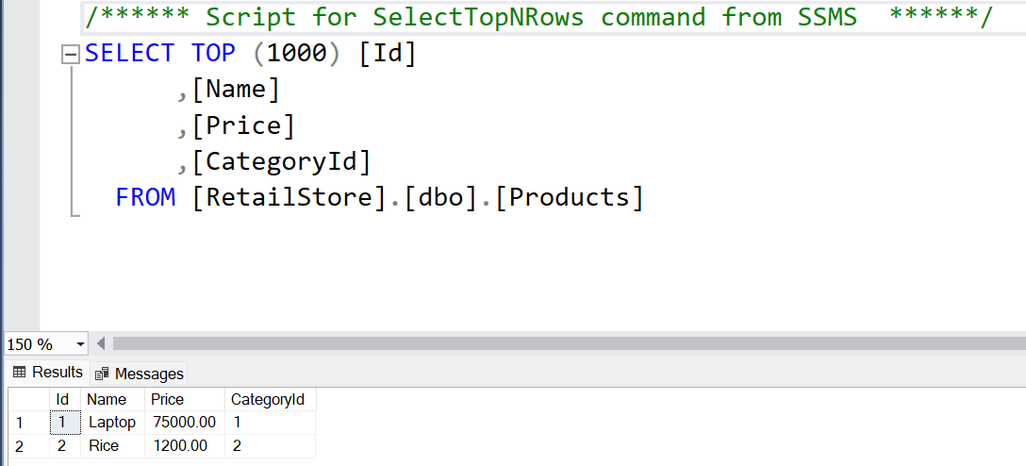
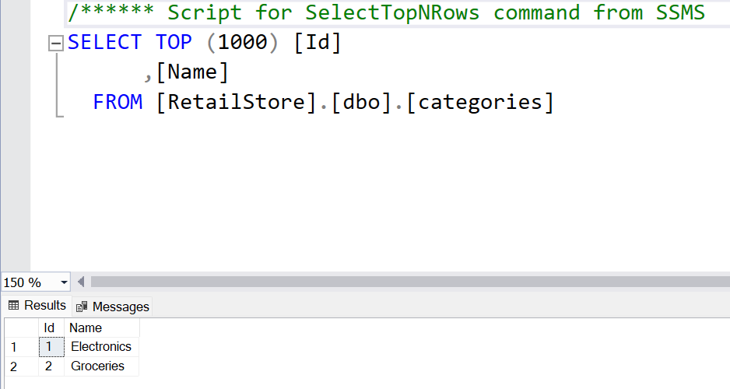

4: Inserting Initial Data into the Database

Product.cs

using RetailInventorySystem.Data;
using System;
using System.Linq;
using System.Threading.Tasks;

class Program
{
static async Task Main()
{
using var context = new AppDbContext();

// Prevent duplicate seeding
if (!context.Categories.Any() && !context.Products.Any())
{
var electronics = new Category { Name = "Electronics" };
var groceries = new Category { Name = "Groceries" };

await context.Categories.AddRangeAsync(electronics, groceries);

var product1 = new Product { Name = "Laptop", Price = 75000, Category = electronics };
var product2 = new Product { Name = "Rice Bag", Price = 1200, Category = groceries };

await context.Products.AddRangeAsync(product1, product2);
await context.SaveChangesAsync();

Console.WriteLine("Data inserted successfully.");
}
else
{
Console.WriteLine("Data already exists. Skipping seeding.");
}
}

Output:

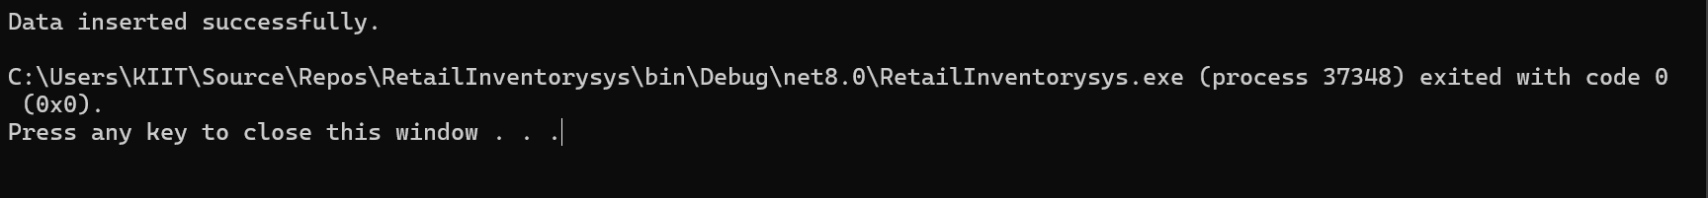

5: Retrieving Data from the Database

Updated Program.cs

using System;
using System.Linq;
using System.Threading.Tasks;
using Microsoft.EntityFrameworkCore;

class Program
{
static async Task Main()
{
using var context = new AppDbContext();

// ✅ 1. Print all products with category name
var products = await context.Products.Include(p => p.Category).ToListAsync();
foreach (var p in products)
Console.WriteLine($"{p.Name} - INR{p.Price} - {p.Category?.Name}");

// ✅ 2. Find product by ID
var product = await context.Products.FindAsync(1);
Console.WriteLine($"Found: {product?.Name}");

// ✅ 3. Get first expensive product (Price > 50,000)
var expensive = await context.Products.FirstOrDefaultAsync(p => p.Price > 50000);
Console.WriteLine($"Expensive: {expensive?.Name}");
}
}

Output;

