**11/09/2020**

**Task: JS Test  
-----------------------------------------------------------------------------------------------**

**index.html**

<!DOCTYPE html>

<html>

    <head>

        <title>JS Testing</title>

    </head>

    <body>

        <script src="js/valid1.js"></script>

        <h1>JavaScript</h1>

        <input type="button" value=Test onclick="jfunc()">

    </body>

</html>

**js/valid1.js**

function jfunc(){

    alert("Clicked!!!");

}

**\***

**\***

**Task: Validation Test  
-----------------------------------------------------------------------------------------------**

**form1.html**

<!DOCTYPE html>

<html>

    <head>

        <title>JS Testing</title>

    </head>

    <body>

        <script src="js/valid1.js"></script>

        <h1>JavaScript</h1>

        <form name="frm1" method="POST" onsubmit="return jfunc1()" action=test.html>

        Name: <input type="text" id="t1"/>

        Designation: <input type="text" id="t2">

        <input type="submit">

        </form>

    </body>

</html>

**test.html**

<!DOCTYPE html>

<html>

    <head>

        <title> JS testing </title>

    </head>

    <body>

        <h1>form submitted</h1>

    </body>

</html>

**js/valid1.js**

function jfunc1(){

    var name = frm1.t1.value;

    var designation = frm1.t2.value;

    if(name==""){

        alert("Please enter the name");

        frm1.t1.focus();

        return false;

    }

    if(designation == ""){

        alert("Please enter the designation");

        frm1.t2.focus();

        return false;

    }

    else return true;

}

**\***

**\***

**Task: Event Test  
-----------------------------------------------------------------------------------------------**

**test2.html**

<!DOCTYPE html>

<html>

    <head>

        <title>TEst2</title>

        <script src="js/valid2.js"></script>

    </head>

    <body>

        <button onclick="jfunc2()">Click to open new window</button>

    </body>

</html>

**js/valid2.js**

function jfunc2(){

    window.open("test2.html","target", "width=200,height=100");

}

**\***

**\***

**Task: MongoDB practical  
-----------------------------------------------------------------------------------------------**

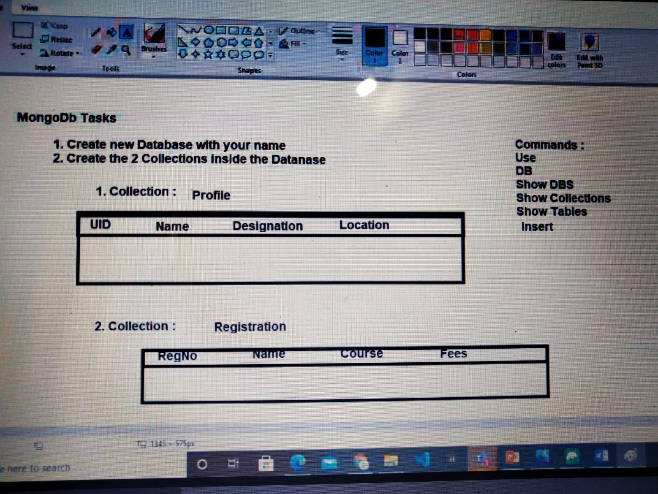

use anuragdb

db.createCollection**(**'Profile'**)**

db.Profile.insert**({** UID**:**1**,** NAME**:**"Anurag"**,**Designation**:**"GET"**,** Location**:**"Mahape"**})**

db.Profile.insert**({** UID**:**2**,** NAME**:**"Dibyajyoti"**,**Designation**:**"GET"**,** Location**:**"Mahape"**})**

db.Profile.insert**({** UID**:**3**,** NAME**:**"Yogesh"**,**Designation**:**"GET"**,** Location**:**"Chennai"**})**

db.createCollection**(**'Registration'**)**

db.Registration.insert**({** RegNo**:**1**,** Name**:**"Anurag"**,**Course**:**"MEAN"**,** Fees**:**1000**})**

db.Registration.insert**({** RegNo**:**2**,** Name**:**"Dibyajyoti"**,**Course**:**".NET"**,** Fees**:**1000**})**

db.Registration.insert**({** RegNo**:**3**,** Name**:**"Yogesh"**,**Course**:**"JAVA"**,** Fees**:**2000**})**

show collections

show tables