An Explainable Data-Driven Framework for Population Health Analytics and Predictive Modeling Using CDC BRFSS 2024

Yukti Madan
Department of Computer Science and Engineering
Symbiosis Institute of Technology
Nagpur, Maharashtra, India
yukti.madan.btech2023@sitnagpur.siu.edu.in
Sumit Masirkar
Department of Computer Science and Engineering
Symbiosis Institute of Technology
Nagpur, Maharashtra, India
sumit.masirkar.btech2023@sitnagpur.siu.edu.in

Abstract—Despite the significant improvement in the prevention and treatment of cardiovascular diseases, they continue to be a crucial public health problem, and the use of data-driven solutions is essential to investigate population-level health patterns and to understand what factors are linked to current disease status. This study is based on a large-scale health surveillance dataset published by the Centers for Disease Control and Prevention (CDC) called the Behavioral Risk Factor Surveillance System (BRFSS) that is designed to be explainable. After applying study's inclusion criteria, 452,464 eligible respondents were included in the analytical cohort. The outcome variable (dependent variable) is _MICHD, the self-reported history of myocardial infarction or coronary heart disease. Data preprocessing comprised missing-value treatment, scaling of numerical features, encoding of categorical features, target leakage and stratified split of data into training, validation and test sets. Discrimination, calibration and threshold dependent classification metrics were used to compare Logistic Regression and HistGradientBoosting classifiers. To choose the model, we used the validation precision-recall area under the curve (PR-AUC) and the unweighted HistGradientBoosting model was chosen upon a validation PR-AUC of 0.3701 and a ROC-AUC of 0.8449. The model performance on independent test partition was PR-AUC: 0.3808 and ROC-AUC: 0.8492. The test sensitivity and specificity at the threshold value selected for validation of 0.080 were 83.91% and 70.45%, respectively. The interpretability of the model was explored using partial dependence analysis and grouped permutation importance. Influential predictors included age, general health status, sex and history of stroke. The results highlight the potential of predictive modelling and explainability to be combined in a reproducible population-health analytics workflow. The data are cross-sectional and self-reported, so the model reflects past disease status, rather than future cardiac outcomes. It should therefore not be used to make a clinical diagnosis.
Keywords—Behavioral Risk Factor Surveillance System, cardiovascular disease, population health analytics, machine learning, explainable artificial intelligence, HistGradientBoosting, risk classification.

Introduction
Large-scale public health surveillance data can be used to examine associations between socioeconomic, demographic, health behaviours and chronic conditions. Machine learning can also be used in addition to traditional statistical analysis to uncover relationships and interactions among many predictors that are not necessarily linear. But a good population health model isn't merely a matter of choosing a high-performing algorithm. Other considerations include data quality, the definition of the outcomes, data missingness, class imbalance, validation design, model calibration, and interpretability [27], [29], [31], [32].
The Behavioral Risk Factor Surveillance System (BRFSS) is one of the largest sources of population-level health information in the United States. Gathers self-reported data on chronic conditions, health-related behaviours, preventive services, health care access and demographic data. These variables have been used in research examining a wide range of outcomes, such as self-rated health, diabetes, asthma, cardiovascular disease, mental health, and oral health [1, 2, 4, 6, 9, 11, 12]. CDC publishes annual BRFSS datasets and technical reports that contain information on the survey design, calculated variables, weighting procedures, and analytical considerations [41].
The BRFSS data has been shown to be useful for predictive modelling in prior research. The authors Clark et al. have explored machine learning to predict self-rated health throughout the life course and demonstrated the potential of population survey data for understanding the life course differences across demographic groups [1]. Ullah et al. explored machine learning techniques for risk identification of diabetes, and Chowdhury et al. explored algorithms and data augmentation techniques for a diabetes diagnosis based on an imbalanced BRFSS dataset [2] [3]. It was found that balancing the Michigan BRFSS data was important in predicting asthma by Budhathoki et al. [4] when their data showed the outcomes were imbalanced. The results of these studies suggest that significant differences can result in the interpretation of predictive performance due to the type of processing and evaluation used.
There has been interest in cardiovascular disease modelling, as well. Imani et al. studied prediction of cardiovascular disease based on the 2022 BRFSS data and imbalanced-data modelling methods [9]. Le et al. studied explainable methods for predicting cardiovascular disease [10]. More recent studies have considered leakage-safe modelling [17] and interpretable prediction [19] and alternative validation methods in the context of health-related classification problems. However, the output from a disease-specific model should not be assumed to be transferable to other outcomes, survey years or populations.
Explainable artificial intelligence (XAI) is a growing approach to explore how machine learning systems make predictions. Explainability techniques have been used in the study of cardiovascular disease [8] to diabetes [9] to depression [10] to chronic kidney disease [11] to other health outcomes [12]-[19]. The systematic reviews have also considered the methods, constraints and assessment of explanations in healthcare applications [34]-[40]. The findings of these studies make it clear that interpretability is needed in healthcare analytics and that an explanation of the behaviour of a model does not imply a causal relationship between a predictor and a health outcome.
There are some methodologically related gaps in the literature that are identified. Most current BRFSS studies are centered on a predesigned disease instead of having a broader population-health exploration and prediction. Second, data preprocessing, dealing with class imbalance, model validation, survey-aware analysis, and explainability are frequently discussed in disease-specific pipelines. Thirdly, recent research emphasizes the need to consider the characteristics of the data in surveys, the validation strategy, and leakage prevention when building models from population-level data [17, 18, 27, 29, 32]. The gaps lead to a replicable approach that links data quality assessment, statistical analysis, predictive modelling and explanation in a single analytical workflow.
This study is designed and tested this framework with data from the CDC BRFSS 2024. Built variable _MICHD is used for the implemented predictive task which classifies the self-reported history of myocardial infarction or coronary heart disease. The study shows the performance of Logistic Regression and HistGradientBoosting on a test set held-out from the training process, explores the impact of the choice of classification threshold, and applies model agnostic explainability methods to examine the impact of influential predictors.
The study has made the following contributions:
- An automated tool to prepare and classify the data using BRFSS 2024 and create a reproducible workflow.
- A modelling pipeline that does not explicitly model the target variables that are derived from the leakage variables.
- Comparative assessment of linear and non-linear classifiers, through discrimination, calibration and threshold dependent measures.
- An analysis of the relevance of classification threshold, sensitivity, specificity and precision.
- Assessment of model interpretability through global and local analyses to explore variables that have a significant impact on the model and representative prediction cases.
- An explicit discussion of limitations of the cross-sectional survey data and descriptive survey-weighted estimates.

RELATED WORK AND RESEARCH GAP

Machine Learning for Population Health
Survey data and administrative health records have been studied to predict population health. Morgenstern et al. conducted a review of machine learning uses for population-health-prediction and found there was significant variability in modelling and reporting [27]. There has been a growing amount of research that explores the application of machine learning to research socioeconomic and population level health patterns [28]. However, methodological and equity issues have been discussed in broader reviews of the use of machine learning in the context of non-communicable diseases at the population level [29] and [30].
The range of potential applications to analyses using BRFS data is demonstrated. The self-rated health, diabetes, asthma, mental health, and oral health have been studied with various machine learning algorithms previously [1]-[6], [11], [12]. Studies analyzing chronic kidney disease, arthritis and other health outcomes also exist in the literature [13], [16]. Taken together, these studies illustrate the utility of BRFSS to study the population as a whole, while also showing the importance of tailoring the design and evaluation of the model to the specific outcome and the data structure.

Cardiovascular Disease Prediction
The statistical and machine learning methods have been explored for cardiovascular disease prediction. The machine-learning model for the risk prediction of CHD with non-invasive indicators was investigated by Wu et al. [8]. Imani et al. investigated imbalanced BRFSS 2022 data for the classification of cardiovascular disease [9]. Le et al. explored explainable methods for cardiovascular disease predictors, and Islam et al. introduced a leakage-safe precision-aware modelling technique for population-scale heart disease risk prediction [10, 17]. In the community and clinical population, Tong et al. explored explainable Logistic Regression for heart disease risk prediction [19].
These studies offer context on methods, which is relevant to the current study. Results, however, on the various datasets, definitions of targets, sampling and assessment procedures are not directly comparable. The present study hence tests its candidate models as a result of a common preprocessing and partitioning method, reporting performance on its test partition which it did not use during model training.

Class Imbalance and Model Evaluation
Class imbalance occurs because the outcome is less common when it is a chronic condition. Resampling and data augmentation strategies have been explored for diabetes and asthma prediction research through the use of BRFSS data [3, 4]. Imbalanced-data modelling has also been investigated in the context of cardiovascular disease studies [9, 24]. These studies show that accuracy is not enough: even though the overall accuracy is high, the model may have a high accuracy rate because it is able to predict the majority class relatively well, while it has a low accuracy rate when it comes to the minority class (relatively few positive cases).
ROC-AUC and PR-AUC are therefore included in the present study in conjunction with sensitivity, specificity, precision, F1 score, balanced accuracy and Brier score. PR-AUC is very useful if the positive class is not very common; Brier score gives an idea of the error in probabilistic prediction. The metrics reported as threshold dependent are reported separately because the threshold affects the proportion of positive cases found and the proportion of false positives.

Describe EAI in Healthcare
Explainability has been studied for several health-related prediction tasks. Explainable approaches have been applied to cardiovascular disease, diabetes, depression, chronic kidney disease, arthritis and other diseases [8]-[19]. Roughly, there are systematic reviews that have studied the importance of explainability in healthcare, such as the interpretability and efficacy of explanation techniques [34]-[40].
The grouped permutation importance method is applied in this study to assess the impact on model performance if the information of an original predictor is disrupted. Partial dependence analysis is employed to study the variation in model probabilities with selected values of predictor(s). These are ways of describing the behaviour of the fitted model. They do not show that a change in a predictor would result in a change of cardiovascular disease status.

Research Gap
The literature review yields five related gaps.
- Many current studies are based on a single defined health outcome that do not include a broader process of population-health discovery [2, 4, 9, 11, 12, 16, 18, 20, 22].
- Second, not all data preprocessing, predictive modelling, explainability and visualization are combined into a single and reproducible workflow [27] [32]-[35].
- Thirdly, there are decisions that must be made explicitly that impact reported performance: class imbalance, validation design, model evaluation [3, 4, 9, 24, 27].
- Fourth, leakage and survey-aware analysis is important for population level data, particularly when the calculated variables are based on underlying questionnaire responses and observations are made using a complex sampling design [17] [18] [41].
- Fifth, explainability needs to be regarded as an analytical aspect, not just an end-user visualization. Model explanations in health care predictions need to be interpreted in the context of their meaning and limitations [34]–[40].
This work aims to address these gaps by combining data preparation, leakage aware feature engineering, model comparison, threshold analysis and model-agnostic explanations in one workflow for the BRFSS 2024. The study isn't intended to address all the gaps that were found in the literature. The evaluation is, in particular, a cross sectional survey year and is therefore not prospective clinically valid. Explainability has been studied for several health-related prediction tasks. Explainable approaches have been applied to cardiovascular disease, diabetes, depression, chronic kidney disease, arthritis and other diseases [8]-[19]. Roughly, there are systematic reviews that have studied the importance of explainability in healthcare, such as the interpretability and efficacy of explanation techniques [34]–[40].

Data Set and Problem Formulation

Data Source
The 2024 combined landline and cellular telephone BRFSS public-use data from the CDC is used in the study [41]. BRFSS surveys non-institutionalized U.S. adults and those in participating territories about self-reported health. Demographic information, chronic health conditions, indicators of access to health care, and health-related behaviours are all part of the survey. The definitions of the variables and their calculated values, sampling design, and weighting procedures are documented by the CDC [41].
The original public-use data set has 457,670 records of respondents. According to the project's eligibility criteria, 452,464 records were kept and 5,206 records were removed. The analysis was performed based on already available responses to surveys and variables calculated from them. The results of this study are cross-sectional and self-reported, and thus describe patterns in the health status that people reported in the past, not confirmed diagnoses or future incidence of disease.

Target Variable
The target variable is _MICHD, a CDC-calculated variable that indicates if the respondent had a history of myocardial infarction or CHD. CDI's calculated-variable documentation indicates that CVDINFR4 and CVDCRHD4 are the source questions for _MICHD.
The total number of eligible cases in the target population was 42,338 positive cases and 410,126 negative cases. The unweighted positive class prevalence was 9.36%, or about 9.69 classes for every one that were negative. The prevalence of the project was 6.80% after survey weighting. The values shown are different numbers: unweighted is the analytical sample, and weighted is the number that reflects the survey expansion weights.
The goal of the modelling is binary classification of self-reported historical disease status. Not about predicting a future cardiovascular event, causal estimation nor clinical diagnosis.

Predictor Selection and Leakage Prevention
The project chose 38 original predictor variables that included demographic data, health status, health behaviours and access to healthcare. CVDINFR4 and CVDCRHD4, the two source variables for creating _MICHD, were not included in the predictor set because they were direct targets. The predictive feature matrix was also limited to excluding survey-design and identification variables, such as _LLCPWT, _STSTR, _PSU, and _STATE.
This is so important because if target-oriented variables are used in the model, then the model can learn the information that was used to create the target, rather than learning meaningful relationships between the variables and the target.

Analytical Partitions
The eligible cohort was split into training (70%), validation (15%), and test (15%) subsets with a stratified random split with seed 42. The training set consisted of 316724 records, the validation set of 67870 records and the test set of 67870 records. The distribution of target classes was preserved in the three subsets by stratification.
Preprocessing transformations and candidate models were implemented in the training partition. Model comparison and classification-threshold selection was done on the validation partition. The test partition was delayed till after the choice of the model and operational threshold. This separation helps decrease the chance of reporting performance estimates that have been optimized indirectly towards the test set.

METHODOLOGY

Description of Analytical Framework
The workflow implemented comprised the following steps:
- Acquisition and Data-quality checking of data sets.
- Filtering and setting targets for eligibility.
- Prediction of the target and protection against leakage of the target.
- Treatment of missing values and transformation of features.
- Stratified training, validation and test partitioning.
- Model selection according to candidate models and training and validation.
- Classification-threshold selection.
- Final holdout evaluation.
- Explainability analysis (both global and local).
- Interpretation of results findings and methodological limitations.
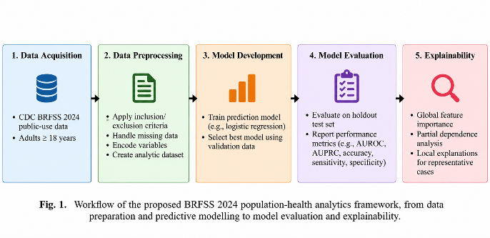
- Workflow of the proposed framework for BRFSS 2024 data preprocessing, predictive modeling, model evaluation, explainability, and population-health interpretation.

Data Preprocessing
Selected variables were numerical and categorical responses to the survey. Training-partition medians were used for numerical variable imputation and a fitted numerical scaling transformation was used for numerical scaling. The transformation parameters were computed from the training data and then used to transform the validation and test data without refitting.
One-hot encoding was performed on categorical variables. Explicit missing indicators were kept as they were present, and missing categorical responses were coded with the project's missing value code. The physical-health and mental-health variables were also processed by making the assumption that a response of 88 represented zero days when the child was unwell and a response of 77 or 99 were considered missing. The BMI variable, stored in the scale, was divided by 100 for calculation of the variable _BMI5.
The 190 preprocessed features included numerical features, categorical indicator variables, and missingness indicator variables for the 38 original predictors. The fitted transformations were re-used at every data partition

Candidate Model
Logistic Regression was employed as a linear baseline that is easily interpretable. The parameters of the unweighted model were: C=1.0, lbfgs solver, max iterations=1,000, random seed=42. Additionally, a class-weighted Logistic Regression model was assessed to explore the impact of giving more weight to the minority class when training.
The performance of HistGradientBoosting was assessed in the context of a nonlinear modeling approach that can learn more complicated relationships among the transformed predictors. The unweighted model was run with 150 boosting iterations, with a learning rate of 0.08, the maximum number of leaf nodes of 31, the minimum number of samples per leaf of 30, also L2 regularization of 1.0, and a random seed of 42. A class weighted version was also tested to check if the model is working with both the strategies.
Training and validation partitions were the same for comparing the candidate models. Due to the highest validation PR-AUC achieved, the unweighted HistGradientBoosting model was chosen.

Model Selection and threshold Optimization
Model selection and threshold optimization. The main model-selection metric used was PR-AUC because the positive class was a minority of the eligible cohort. ROC-AUC was also reported to evaluate the ranking ability of positive cases over the negative cases at various thresholds. The Brier score was used to evaluate probabilistic prediction error.
The classification threshold was chosen on the validation partition with Youden's J statistic after choosing the unweighted HistGradientBoosting model:
J = Sensitivity + Specificity – 1 
The optimum value for this statistic was 0.080. To prevent the model and threshold from drifting, they were fixed prior to the final test evaluation. This approach helped to separate the model selection and threshold selection from the final holdout assessment.
The threshold of 0.080 is an empirical value chosen with the use of the validation data. It is not a clinically validated threshold and no clinical decision making must be based solely on this value.

Evaluation Metrics
The model was tested on the following criterion:

ROC-AUC: discrimination at the classification thresholds.

PR-AUC: precision-recall performance, especially in case of an imbalanced outcome.

Sensitivity: the number of positive cases that are correctly identified divided by the number of positive cases.

Specificity: percentage of negative cases which are identified as such.

Precision: percentage of all those who were predicted to be positive who were actually positive in the target.

F1-score: Average of precision and sensitivity.

Balanced accuracy: Mean of sensitivity and specificity.

Brier score: average deviation between the probabilities of an observation being in each of two classes and the observed value of that outcome.
These measures were viewed together since there is no single measure that can fully represent classification performance. Sensitivity and specificity are dependent on threshold, and ROC-AUC and PR-AUC are thresholds-averaged measures of performance.

Explainability Analysis
Grouped permutation importance and partial dependence analysis were performed for the selected model HistGradientBoosting. Importance of the group permutation was calculated by bypassing the information for each of the original predictors and observing the difference in validation performance. Grouping by the original variable of the indicators eliminated the need to view each categorical indicator as an independent predictor.
Partial dependence plots were employed to investigate the marginal effect of particular predictor values on the probabilities predicted by the model. The factors studied were age, physical limitation and BMI. The following profiles are based on an average model behaviour over the distribution of the observed data and are not to be understood as causal effects.
Local interpretability was also investigated for a number of representative true-positive, false-positive, true-negative and false-negative cases by using marginal perturbation and local Ridge surrogate models. The fitted model was analysed in these examples to study its behavior. These local explanations refer to the reactions of the model to feature perturbations, and do not attempt to determine the medical cause of a reported condition by a respondent.

Survey Design Considerations
The sampling design employed by the BRFSS is complex, and the BRFSS survey weights are provided to reflect selection probabilities and represent the population [41]. The project used a descriptive survey weighting to derive weighted performance estimates, inside of the _LLCPWT structure. The candidate machine learning models trained for the results however, used unweighted sample loss, and the depicted weighted performance measures are descriptive weighted point estimates.
Design adjusted uncertainty due to the strata and primary sampling units (PSUs) was not designed. Therefore, the metrics are weighted ones, and should not therefore be interpreted as design adjusted confidence intervals or a full survey-inference analysis.

Experimental Setup
The experiments were run in Python (pandas and NumPy were used for data-Handling and numerical processing respectively while scikit-learn were utilised for the implementation of the algorithms). The process was divided into different steps of preprocessing, model training, model evaluation and model explainability. This project employed a fixed random seed of 42 which permits the reproduction of the data partitioning and modelling procedures.
The number of records in the training, validation, and the test partition was 316,724 and 67,870 respectively. There are 316,724 and 67,870 training and validation and 67,870 test records. The settlement test area had 6,350 suspected and 61,520 negative results. All fitted preprocessing transformations were estimated based on the Training Partition and applied to the data in validation and test without being refitted.
We chose the unweighted HistGradientBoosting classifer. The validation PR-AUC was used to process the selection of candidates and the operating threshold was determined by the validation set based on the Youden's J statistic. Final performance evaluation was carried out with the test partition after sealing the model and threshold.
Cohort derivation and sizes of partitions should be summarized in Table I.
- Cohort Derivation and Data Partitioning
Dataset Stage | Number of Records
Original BRFSS 2024 records | 457,670
Eligible analytical cohort | 452,464
Excluded records | 5,206
Training partition | 316,724
Validation partition | 67,870
Test partition | 67,870
Positive target cases in eligible cohort | 42,338
Negative target cases in eligible cohort | 410,126

Result and Discussion

Class Distribution
There were 452,464 respondents in the final analytical sample. Of these, 42,338 were positive for self-reported history of myocardial infarction or coronary heart disease, and 410,126 were negative. The final prevalence was 9.36%, with a class imbalance of the target.
A survey weighted prevalence of 6.80% was also calculated as part of the project. A comparison of the weighted and unweighted estimates will illustrate the importance of interpreting BRFSS results in a manner that accounts for the multiple levels of sampling (survey expansion weights). Similar to the original full design adjusted variance estimation, the weighted variance estimation result is shown as a descriptive point estimate.

Candidate Model Comparison
The unweighted HistGradientBoosting model got scores of validation PR-AUC of 0.3701, validation ROC-AUC of 0.8449 and a validation Brier score of 0.0700. It was the model with the highest validation PR-AUC was chosen as the champion model.
The class-weighted HistGradientBoosting model had a validation PR-AUC of 0.3687, ROC-AUC of 0.8450 and a Brier score of 0.1652. The unweighted Logistic Regression model had achieved a validation PR-AUC of 0.3658, a ROC-AUC of 0.8413 and a Brier score of 0.0705. The class weighted Logistic Regression model had a PR-AUC of 0.3646, ROC-AUC of 0.8413 and Brier score of 0.1661 at validation.
The results indicate that the unweighted HistGradientBoosting model has the highest PR–AUC in the validation set/ensemble of evaluated models. The class weighted models resulted in better scores at the default threshold with higher Brier scores. This indicates that there is some interaction between classification performance and probability quality which can be changed by class weighting. Class weighting should not then be taken for granted to boost all ratings at once.
The full results of the validation comparison should be reported in Table II.
- Validation Performance of Candidate Models
Model | PR-AUC | ROC-AUC | Brier Scor
Unweighted Logistic Regression | 0.3658 | 0.8413 | 0.0705
Class-weighted Logistic Regression | 0.3646 | 0.8413 | 0.1661
Unweighted HistGradientBoosting | 0.3701 | 0.8449 | 0.0700
Class-weighted HistGradientBoosting | 0.3687 | 0.8450 | 0.1652

Classification Threshold Analysis (CTA)
The method used is Classification Threshold Analysis (CTA). The default classification threshold for 0.50 gave low sensitivities for the model HistGradientBoosting without weight. The sensitivity of the test partition was 10.91% and the specificity was 99.26%. This operating point achieved a high rate of true negative results, but a low rate of true positive results.
Youden's J statistic was used to select the threshold at the validation partition, which was 0.080. At this level, the test turn up to 83.91% sensitivity and 70.45% specificity. The test precision was 22.67%, the negative predictive value was 97.69%, the F1-score was 0.3569 and the balanced accuracy was 77.18%.
These metrics have changed as a result of the trade-off between positive detection and false-positive classification. In the lower threshold, the model was able to detect a higher amount of positive cases, however a significant amount of the model's predicted positive cases were negative according to the target. The values of high NPV should also be considered with the knowledge of the low prevalence of the positive class and cross-sectional design of the study. These measures do not provide basis for clinical screening validity.

Final Holout Test Performance
The test PR-AUC for the selected unweighted HistGradientBoosting model was 0.3808, ROC-AUC was 0.8492 and Brier score was 0.0694. It's predictive power of positive results that stood at the locked threshold of 0.080, which means it identified 5328 cases out of the 6350 cases in the test partition. This resulted in a sensitivity of 83.91% and a specificity of 70.45%.
To measure trade-offs between the different threshold levels, a model was selected based on the validation process that was able to discriminate between the two classes of interest. Surveys conducted at a different time, however, are not indicative of generalization to another year, another population or a clinical context. To ensure the generalizability to other situations and contexts, external and temporal validation would need to be conducted
- Final Holdout Test Performance of the Selected Model
Metric | Result
PR-AUC | 0.3808
ROC-AUC | 0.8492
Brier Score | 0.0694
Sensitivity at threshold 0.080 | 83.91%
Specificity at threshold 0.080 | 70.45%
Precision at threshold 0.080 | 22.67%
Negative Predictive Value at threshold 0.080 | 97.69%
F1-score at threshold 0.080 | 0.3569
Balanced Accuracy at threshold 0.080 | 77.18%

Survey-Weighted Performance Estimates
The project used the descriptive survey-weighted performance estimates available from _LLCPWT. Weighted sensitivities were 80.44%, while weighted specificities were 79.46%, weighted precisions were 22.12%, and those of the weight negative predictive values were 98.42% at one selected threshold (0.080). The findings were a weighted ROC-AUC of 0.8726, weighted PR-AUC of 0.3594, and weighted Brier score of 0.0514.
These numbers differed from numbers that wouldn't use survey weights because survey weights alter the contribution to the numbers that's given to individual respondents to the survey. The model, however, was trained on unweighted sample loss and full design uncertainty estimates were not obtained. The weighted metrics are thus only descriptive population-weighted coefficients, and not a full complex survey data analysis framework.

Global Explainability
The influential original predictors identified by grouped permutation importance were age, general health status, sex and stroke history. The decrease in validation PR-AUC was on average ~0.0772 for _AGE80, ~0.0434 for GENHLTH, ~0.0380 for _SEX and ~0.0306 for CVDSTRK3.
The results suggest that demographic and health status data were important factors in the model used to assign self-reported cardiovascular diseases history. The importance rankings are associated with the impact of interfering with this specific fitted model. They do not determine that the variables independent of each other are associated with cardiovascular disease and that correlated predictors share or redistribute predictive information.
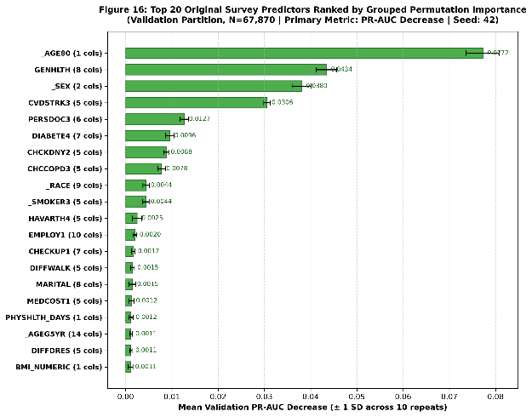
- Grouped permutation importance of original predictors ranked by mean decrease in validation PR-AUC, with repeated permutation results used to assess importance stability.

Partial Dependence Analysis
The risk scores were calculated using partial dependence analysis for age, physical-health limitations, and BMI. The age profile exhibited the trend of higher probabilities as the age increased for the models. The predicted probabilities of the physical-health profile showed variations in predicted probabilities of reported unhealthy physical-health days. The BMI profile was increasing in trend in the different parts of the BMI range observed and the increase was not as strong at higher BMI values.
These profiles help visualize the response of the model's predictions to the values of selected features. The profiles may be affected by correlations between the predictors and by the distribution of the population surveyed, since they are averaged over the distribution of the features observed. These are not to be viewed as estimates of the causal effects nor as a statement that altering one individual attribute would alter disease status by the same amount
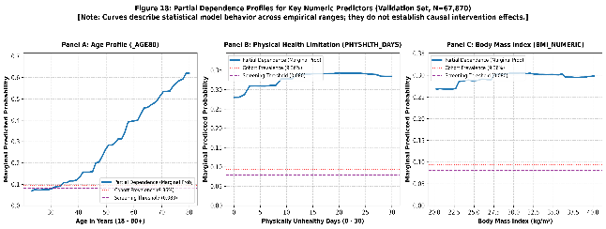
- Partial dependence profiles for age, physical-health limitations, and body mass index (BMI), showing changes in the model-predicted probability of coronary heart disease or myocardial infarction across the corresponding original feature units.

Local Explainability
Representative true-positive, false-positive, true-negative and false-negative cases were reviewed and discussed locally. A sensitivity analysis of the predicted probability was carried out using marginal perturbation analysis, where the information about a specific variable was replaced by information from an empirical background sample. The behaviour of the fitted model around selected observations was approximated by local Ridge surrogate models.
For the cases studied the local surrogate was reported with an R-squared value higher than 0.93. For the examples selected these values show that the behaviour of the local linear approximations was close to that of the model. They make no claim to establish correctness of the explanations offered, the causal validity of the model, or that the selected examples are representative of all respondents.
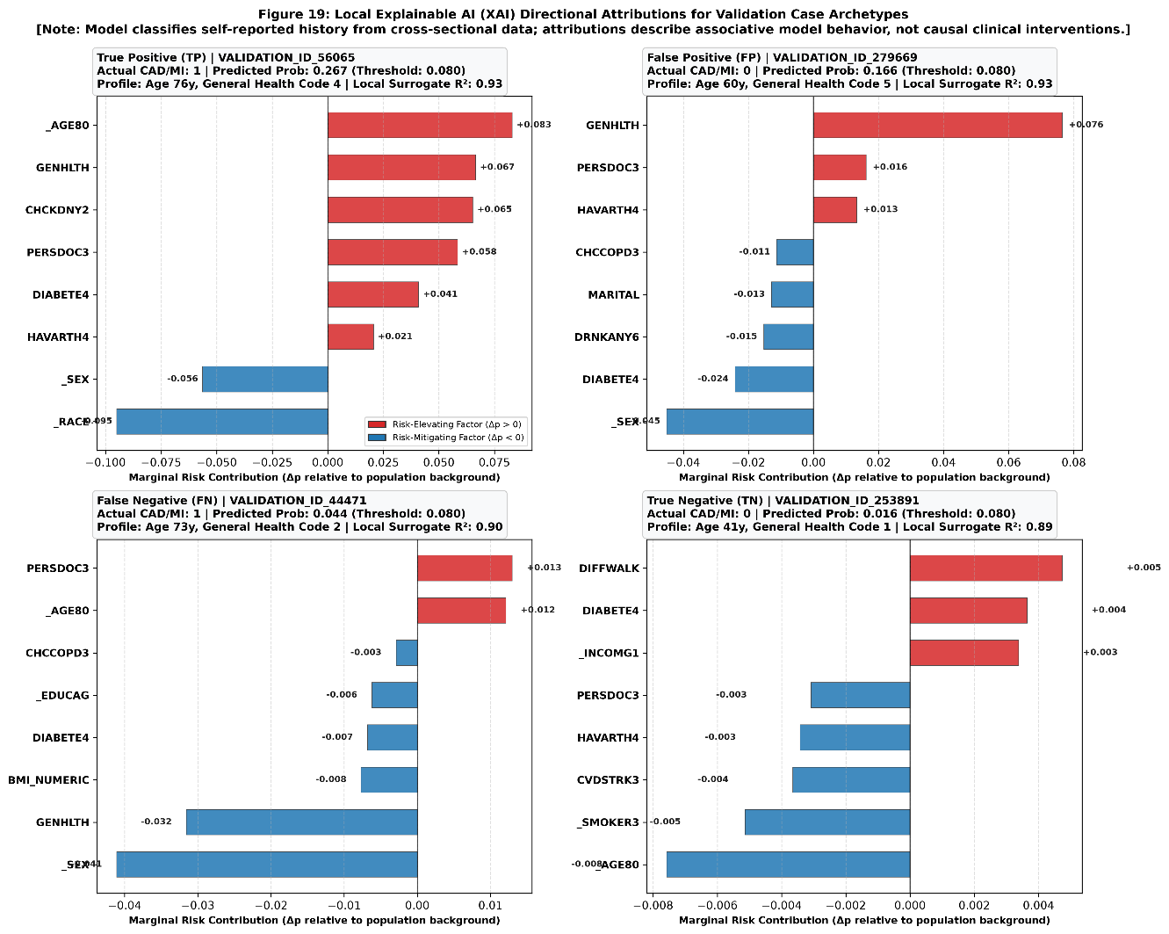
- Local explanation of a representative true-positive prediction, illustrating the feature contributions to the model output. This example demonstrates model behaviour and is not a clinical assessment.
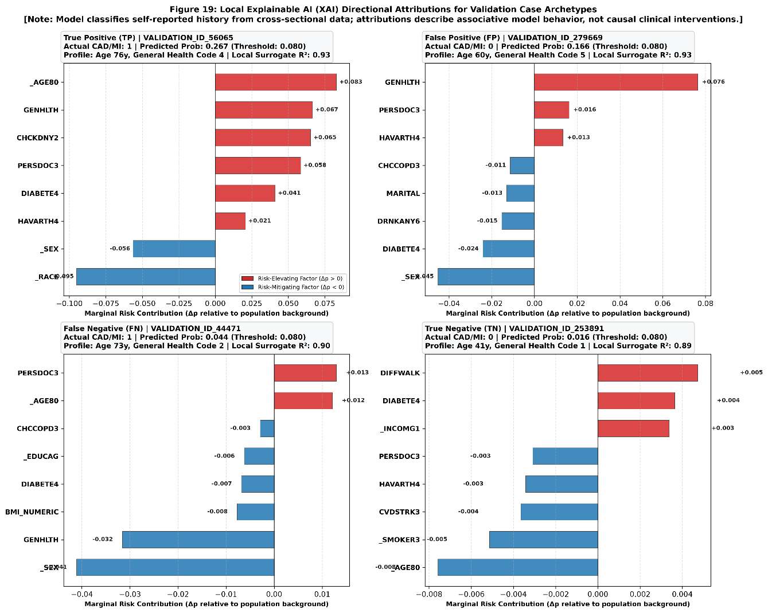
- Local explanation of a representative false-negative prediction, illustrating the feature contributions associated with a missed positive case. This example demonstrates model behaviour and is not a clinical assessment.

Techniques of Learning and Summary of Findings
The four main observations made from the experiments are: The first is that the evaluated candidates, HistGradientBoosting out-performed the rest in terms of validation PR-AUC. Second, the chosen threshold of 0.080 was much more sensitive than the default of 0.50, at the expense of reducing specificity. Third, the explainability analyses revealed that age, general health status, sex and stroke history were influential predictors in the fitted model. Fourth, sample-weighted and unweighted estimates of performance were not the same while using the survey, further emphasizing the importance of sample-level assessment.
The results validate the potential of embedding predictive modelling and model interpretation in a reproducible workflow for population health.

Limitations
The results should be interpreted with some limitations in mind.
- The analysis is based on cross section BRFSS data that was self-reported. The target is not for incident cardiovascular disease after the survey, but rather for reported historical cardiovascular disease status. The findings can thus not be used to predict future cardiovascular events.
- The self-reported responses may be influenced by recall error, differences in access to health care and variation in whether the individual has a diagnosis. The model is taught to recognize patterns in the survey results, but cannot give a diagnosis of the clinical condition.
- The positive outcome target class is a relatively minor of the analytical cohort which results in an imbalanced class distribution. While PR-AUC, sensitivity, specificity, precision, F1-score, and balanced accuracy are reported, the threshold trade-off comes with a significant number of false-positive classifications.
- The model was tested with a previously held-out sample of the same year of survey. There was no external validation with other survey years or other independent populations. Results might then vary if the model is used in a new population or in a new survey year.
- The model training process employed unweighted sample loss.
- The model training process was based on the unweighted sample loss. Performance measures were calculated descriptively and were survey weighted. Full design adjusted variance estimation was not completed using the sampling strata and primary sampling units from the survey. The weighted estimates should not be viewed as completely design adjusted inferential results.
- Explainability methods describe the behaviour of the fitted model. Permutation importance, partial dependence, and local surrogate models do not imply causal relationships, and may be impacted by correlation between predictors, model misspecification, and the choice of background observations.
- The study failed to demonstrate clinical utility, and did not assess a clinical decision-support intervention. An individual medical decision should not be made from classification metrics reported.

Conclusion and Future Work
This study created a machine learning model to classify self-reported history of myocardial infarction or coronary heart disease from the CDC BRFSS 2024 dataset and assessed its explainability. The workflow involved data quality assessment, eligibility filtering, target-leakage prevention, preprocessing, model comparison, threshold selection, holdout evaluation and model interpretation.
The unweighted HistGradientBoosting model had the best validation PR-AUC score of 0.3701, and was chosen as the champion model. It had a PR-AUC of 0.3808 and ROC-AUC of 0.8492 on the independent test partition. Test sensitivity was 83.91% and test specificity was 70.45% at the validation selected threshold of 0.080. The age, general health status, sex and history of stroke were identified as influential predictors in the fitted model by explainability analysis.
The results highlight the benefits of predictive performance evaluation and explainability as part of a reproducible population-health analytics workflow. The model, on the other hand, categorizes cross-sectional self-reported disease history, and should not be used as a future cardiovascular event predictor or as a clinical diagnostic system. Survey-weighted performance estimates are descriptive as variance estimation was not conducted for the full complex survey.
Future analysis should examine the framework with future years of the BRFSS survey and independent populations, use full statistical inference (survey design awareness), and explore temporal validation. Further research can include calibration methods, subgroup performance, fairness and stability of explanations for different model specifications and populations. The framework should also be tested further to see if it is capable of expanding the population-health discovery space without sacrificing the high standards of model validation, reporting, and output interpretation.

Acknowledgment
The authors thank the Centers for Disease Control and Prevention (CDC) for making the 2024 Behavioral Risk Factor Surveillance System (BRFSS) public-use data available for research. The authors acknowledge the use of publicly available survey data in conducting this study.

References
- C. R. Clark, M. J. Ommerborn, K. Moran, A. Wright, et al., “Predicting self-rated health across the life course: Health equity insights from machine learning models,” Journal of General Internal Medicine, vol. 36, no. 5, pp. 1181–1188, 2021, doi: 10.1007/s11606-020-06438-1.
- Z. Ullah, F. Saleem, M. Jamjoom, B. Fakieh, F. Kateb, A. M. Ali, and B. Shah, “Detecting high-risk factors and early diagnosis of diabetes using machine learning methods,” Journal of Healthcare Engineering, vol. 2022, Art. no. 2557795, 2022, doi: 10.1155/2022/2557795.
- M. M. Chowdhury, R. S. Ayon, and M. S. Hossain, “An investigation of machine learning algorithms and data augmentation techniques for diabetes diagnosis using class imbalanced BRFSS dataset,” Healthcare Analytics, vol. 5, Art. no. 100297, 2024, doi: 10.1016/j.health.2023.100297.
- N. Budhathoki, R. Bhandari, S. Bashyal, and C. Lee, “Predicting asthma using imbalanced data modeling techniques: Evidence from 2019 Michigan BRFSS data,” PLoS ONE, vol. 18, no. 12, Art. no. e0295427, 2023, doi: 10.1371/journal.pone.0295427.
- S. Kamal, C. Demetriades, A. Roy, and E. Garcia-Pittman, “Using machine learning to predict poor mental health status in the geriatric population,” The American Journal of Geriatric Psychiatry, vol. 31, no. 3, suppl., pp. S71–S72, 2023, doi: 10.1016/j.jagp.2022.12.234.
- A. M. Oladayo, H. W. M. Harishchandra, E. Zeng, D. J. Caplan, A. Butali, and L. Marchini, “Using machine learning algorithms to investigate factors associated with complete edentulism among older adults in the United States,” Special Care in Dentistry, vol. 44, no. 1, pp. 148–156, 2024, doi: 10.1111/scd.12832.
- Z. Xie, O. Nikolayeva, J. Luo, and D. Li, “Building risk prediction models for type 2 diabetes using machine learning techniques,” Preventing Chronic Disease, vol. 16, Art. no. 190109, 2019, doi: 10.5888/pcd16.190109.
- B. Wu, K. Huang, X. Hong, S.-S. Zhao, C. Yuan, X.-G. Li, C.-T. Peng, Y.-H. Li, Q.-C. Wu, and X.-L. Zhou, “Building and validating a machine learning model to predict coronary heart disease risk based on non-invasive indicators,” Computer Methods and Programs in Biomedicine, vol. 275, Art. no. 109186, 2026, doi: 10.1016/j.cmpb.2025.109186.
- M. Imani, A. Maroosi, S. Shojaei, K. Heidari, S. M. Hoseinzadeh, N. Daneshi, Z. Saber, N. Sajadi, and M. Mohammadzadeh, “Predicting cardiovascular diseases using imbalanced data: An XGBoost-based analysis of the 2022 BRFSS dataset,” American Heart Journal Plus: Cardiology Research and Practice, vol. 63, Art. no. 100719, 2026, doi: 10.1016/j.ahjo.2026.100719.
- M. H. N. Le, H. Q. Kha, H. H. Huynh, P. K. Huynh, P. K. Nguyen, et al., “Protective predictors of cardiovascular disease: An explainable AI approach,” Public Health, vol. 250, Art. no. 106050, 2026, doi: 10.1016/j.puhe.2025.106050.
- M. A. Muhammad, J. Sani, and M. M. Ahmed, “Exploring explainable machine learning for predicting and interpreting self-reported diabetes among Tennessee adults: Insights from the 2023 Behavioral Risk Factor Surveillance System (BRFSS),” Journal of Primary Care & Community Health, vol. 16, 2025, doi: 10.1177/21501319251400546.
- M. A. Muhammad, J. Sani, and S. Halane, “Integrating epidemiologic modeling and explainable machine learning to predict and identify factors associated with self-reported depression among adults in Tennessee, United States,” Discover Mental Health, vol. 6, Art. no. 151, 2026, doi: 10.1007/s44192-026-00506-4.
- M. M. Islam, T. N. Poly, A. N. Okere, and Y.-C. Wang, “Explainable machine learning model incorporating social determinants of health to predict chronic kidney disease in type 2 diabetes patients,” Journal of Diabetes and Metabolic Disorders, vol. 24, no. 1, Art. no. 115, 2025, doi: 10.1007/s40200-025-01621-9.
- J. Noh, Y. Kim, C. Lim, S.-Y. Cho, Y. Kwon, E.-S. Lee, W. K. Kim, and Y. H. Kim, “Occupational and socioeconomic predictors of myocardial infarction and coronary heart disease: A machine learning analysis,” BMC Public Health, vol. 26, Art. no. 2015, 2026, doi: 10.1186/s12889-026-27570-3.
- S. B. Akter, S. Akter, R. Hasan, M. M. Hasan, A. M. T. Islam, T. S. Pias, J. F. Fernandez, M. G. R. Alam, and D. Eisenberg, “Early detection of subjective cognitive decline from self-reported symptoms: An interpretable attention-cost fusion approach,” Journal of Biomedical Informatics, vol. 162, Art. no. 104770, 2025, doi: 10.1016/j.jbi.2024.104770.
- M. A. Shams, S. Fatema, D. M. H. Islam, A. Datta, D. Eisenberg, D. T. Mridula, J. Mawa, A. Sultana, N. Ahmed, M. Islam, and T. S. Pias, “Explainable machine learning revealing the impact of mental and physical health on arthritis,” BMJ Health & Care Informatics, vol. 33, no. 1, Art. no. e101955, 2026, doi: 10.1136/bmjhci-2025-101955.
- J. Islam, D. Datta, and F. Akhter, “Leakage-safe precision-aware dual-branch FT-Transformer for population-scale heart disease risk prediction,” Sensors, vol. 26, no. 11, Art. no. 3417, 2026, doi: 10.3390/s26113417.
- Q. T. Lam, F.-Y. Fan, Y.-L. Wang, C.-Y. Wu, Y.-S. Sun, T. T. T. Vo, H. Kuo, Q. H. Kha, M. H. N. Le, G. Vu, N. Q. K. Le, and I.-T. Lee, “Interpretable machine learning for population-level tooth loss prediction,” Journal of Dental Research, 2026, doi: 10.1177/00220345261464887.
- P. Tong, H. Hu, and L. Tong, “Explainable logistic regression for heart disease risk prediction in community and clinical populations: Development and external validation study,” JMIR Cardio, 2025, doi: 10.2196/82462.
- D. Majcherek, A. Ciesielski, and P. Sobczak, “AI-driven analysis of diabetes risk determinants in U.S. adults: Exploring disease prevalence and health factors,” PLoS ONE, vol. 20, no. 9, Art. no. e0328655, 2025, doi: 10.1371/journal.pone.0328655.
- W. Li, Y. Peng, and K. Peng, “Diabetes prediction model based on GA-XGBoost and stacking ensemble algorithm,” PLoS ONE, 2024, doi: 10.1371/journal.pone.0311222.
- D. Das, Aayushman, S. Kumar, M. A. Hussain, and B. R. Reddy, “Diabetes prediction using ensemble learning techniques,” Procedia Computer Science, vol. 258, pp. 3155–3164, 2025, doi: 10.1016/j.procs.2025.04.573.
- T. Lin and M. Fan, “FMI-CAECD: Fusing multi-input convolutional features with enhanced channel attention for cardiovascular diseases prediction,” Sensors, vol. 24, no. 22, Art. no. 7160, 2024, doi: 10.3390/s24227160.
- K.-V. Tompra, G. Papageorgiou, and C. Tjortjis, “Strategic machine learning optimization for cardiovascular disease prediction and high-risk patient identification,” Algorithms, vol. 17, no. 5, Art. no. 178, 2024, doi: 10.3390/a17050178.
- H. Alkaabi and A. Abugabah, “Smart health care application for predicting complications risk in type 2 diabetes management using personalized digital twins: A focus on early intervention and prevention strategies,” Procedia Computer Science, vol. 280, pp. 889–896, 2026, doi: 10.1016/j.procs.2026.04.111.
- A. Altamimi, A. Altamimi, O. Whitmore, M. G. Al-Bashayreh, P. Abbasi, and E. K. S. Limijadi, “Explainable machine learning-based decision support for diabetes risk screening using public health indicator data,” Journal of Intelligent Decision Making and Information Science, vol. 3, 2026, doi: 10.59543/jidmis.v3.1780.
- J. D. Morgenstern, E. Buajitti, M. O’Neill, T. Piggott, V. Goel, D. Fridman, K. Kornas, and L. C. Rosella, “Predicting population health with machine learning: A scoping review,” BMJ Open, vol. 10, no. 10, Art. no. e037860, 2020, doi: 10.1136/bmjopen-2020-037860.
- S. Kino, Y.-T. Hsu, K. Shiba, Y.-S. Chien, et al., “A scoping review on the use of machine learning in research on social determinants of health: Trends and research prospects,” SSM - Population Health, vol. 15, Art. no. 100836, 2021, doi: 10.1016/j.ssmph.2021.100836.
- S. Birdi, R. Rabet, S. Durant, A. Patel, T. Vosoughi, M. Shergill, C. Costanian, C. P. Ziegler, S. Ali, D. Buckeridge, M. Ghassemi, et al., “Bias in machine learning applications to address non-communicable diseases at a population-level: A scoping review,” BMC Public Health, vol. 24, Art. no. 3599, 2024, doi: 10.1186/s12889-024-21081-9.
- R. K. Mutharasan and J. Walradt, “Population health and artificial intelligence,” JACC: Advances, vol. 3, no. 8, Art. no. 101092, 2024, doi: 10.1016/j.jacadv.2024.101092.
- A. Caruana, M. Bandara, K. Musial, D. Catchpoole, and P. J. Kennedy, “Machine learning for administrative health records: A systematic review of techniques and applications,” Artificial Intelligence in Medicine, vol. 144, Art. no. 102642, 2023, doi: 10.1016/j.artmed.2023.102642.
- H. Abdulazeem, S. Whitelaw, G. Schauberger, and S. J. Klug, “A systematic review of clinical health conditions predicted by machine learning diagnostic and prognostic models trained or validated using real-world primary health care data,” PLoS ONE, vol. 18, no. 9, Art. no. e0274276, 2023, doi: 10.1371/journal.pone.0274276.
- L. Wang, Z. Zhang, D. Wang, W. Cao, X. Zhou, P. Zhang, J. Liu, X. Fan, and F. Tian, “Human-centered design and evaluation of AI-empowered clinical decision support systems: A systematic review,” Frontiers in Computer Science, vol. 5, Art. no. 1187299, 2023, doi: 10.3389/fcomp.2023.1187299.
- S. Ali, F. Akhlaq, A. S. Imran, Z. Kastrati, S. M. Daudpota, and M. Moosa, “The enlightening role of explainable artificial intelligence in medical and healthcare domains: A systematic literature review,” Computers in Biology and Medicine, vol. 166, Art. no. 107555, 2023, doi: 10.1016/j.compbiomed.2023.107555.
- J. Jung, H. Lee, H. Jung, and H. Kim, “Essential properties and explanation effectiveness of explainable artificial intelligence in healthcare: A systematic review,” Heliyon, vol. 9, no. 5, Art. no. e16110, 2023, doi: 10.1016/j.heliyon.2023.e16110.
- S. S. Band, A. Yarahmadi, C.-C. Hsu, M. Biyari, M. Sookhak, R. Ameri, I. Dehzangi, A. T. Chronopoulos, and H.-W. Liang, “Application of explainable artificial intelligence in medical health: A systematic review of interpretability methods,” Informatics in Medicine Unlocked, vol. 40, Art. no. 101286, 2023, doi: 10.1016/j.imu.2023.101286.
- M. M. Alsaleh, F. Allery, J. W. Choi, T. Hama, A. McQuillin, H. Wu, and J. H. Thygesen, “Prediction of disease comorbidity using explainable artificial intelligence and machine learning techniques: A systematic review,” International Journal of Medical Informatics, vol. 175, Art. no. 105088, 2023, doi: 10.1016/j.ijmedinf.2023.105088.
- J. Allgaier, L. Mulansky, R. L. Draelos, and J. Pryss, “How does the model make predictions? A systematic literature review on the explainability power of machine learning in healthcare,” Artificial Intelligence in Medicine, vol. 143, Art. no. 102616, 2023, doi: 10.1016/j.artmed.2023.102616.
- Z. Sadeghi, R. Alizadehsani, M. A. Cifci, M. Cifci, S. Kausar, R. Rehman, P. Mahanta, P. K. Bora, A. Almasri, R. S. Alkhawaldeh, S. Hussain, B. Alatas, A. Shoeibi, H. Moosaei, M. Hladík, S. Nahavandi, and P. M. Pardalos, “A review of explainable artificial intelligence in healthcare,” Computers and Electrical Engineering, vol. 118, pt. A, Art. no. 109370, 2024, doi: 10.1016/j.compeleceng.2024.109370.
- I. D. Mienye, G. Obaido, N. Jere, E. Mienye, K. Aruleba, I. D. Emmanuel, and B. Ogbuokiri, “A survey of explainable artificial intelligence in healthcare: Concepts, applications, and challenges,” Informatics in Medicine Unlocked, vol. 51, Art. no. 101587, 2024, doi: 10.1016/j.imu.2024.101587.
- Centers for Disease Control and Prevention, “2024 BRFSS Survey Data and Documentation,” 2025. [Online]. Available: https://www.cdc.gov/brfss/annual_data/annual_2024.html. Accessed: Oct. 23, 2026.

