Yukt Mitash

Professor Hrolenok

CS 4641

February 11, 2018

**Assignment 1: Supervised Learning**

This paper will discuss the performance of the following machine learning algorithms: Decision Trees, Neural Networks, Boosted Decision Trees, Support Vector Machines, and kNN (k-Nearest Neighbors). This paper will observe their performance under a variety of circumstances across two vastly different data sets. I will be using the Scikit learn library to implement all of these algorithms. For all the algorithms performed, the data will be split as such: 85% training and 15% testing.

**Data Set 1 Spotify Song Attributes:**

This data was collected by someone using Spotify’s API. Essentially, it contains 2017 songs with the following information on each song: *Acousticness* (confidence measure of 0.0 to 1.0), *Danceability* (confidence measure of 0.0 to 1.0), *duration* (in milliseconds), *energy* (confidence measure of 0.0 to 1.0), *instrumentalness* (confidence measure of 0.0 to 1.0), *key* (an estimated overall key with integers mapping to keys using standard pitch class notation), *liveness* (confidence measure of 0.0 to 1.0 of whether or not the track is live), *loudness* (measured in decibels averaged across the track form -60 to 0), *speechiness* (the amount of speech used in the track measure form 0.0 to 1.0), *valence* (measure from 0/0 to 1.0 of positivity), *tempo* (estimated in Beats per Minute), *modality* (major is represented by 1 and minor by 0), and *time_signature*  (a measure of meter). In addition, each entry in the data contains a classification value of 1 or 0, respectively pertaining to whether the user liked the song or not. All algorithms for this data set will focus on learning/predicting whether or not the user liked the song based on the 13 above characteristics. All data pertaining to a given song is determined by the Spotify API which one can learn about here: <https://developer.spotify.com/documentation/web-api/reference/tracks/get-audio-features/>. The data set is found on kaggle.com and you can learn about that here: <https://www.kaggle.com/geomack/spotifyclassification>. This data set is very interesting because it examines the makings of how a single person can come to like or dislike a song unconsciously because of 10 different features. The purpose of using this many features is to see how the algorithms perform classification when given many attributes to view the data by.

**Data Set 2 Graduate College Admissions:**

This data was posted on kaggle and includes the following features: *GRE Score, TOEFL Score, University Rating* (rated from 1-5*), SOP* (rated from 1-5), *LOR* (rated from 1-5), *CGPA,* *Research* (1 or 0 respectively pertaining the whether or not an applicant had done research), and *Chance of Admit* (represented as a decimal). The size of the dataset is 500. To turn this into classification problem from a regression problem, the algorithms must be testing/predicting a binary output (admit or not). To do this, I modified the data set so that all chances of admission greater than or equal to 0.725 were represented by a 1 and all chances of admission below that were represented by a 0. Rather than predicting whether or not an applicant with certain scores will be admitted or not (a difficult task), algorithms will be predicting whether or not an applicant has a chance of being admitted that is greater than or equal to 0.75. In addition to this, I wanted to change the structure of this problem from the last one to examine how the five algorithms perform under different conditions. To do this, I decided to only look at three factors: CGPA, GRE score, and University Rating. This allows more variety across problem sets. In addition, it gives us the chance to watch how the training times, training scores, learning scores, and confusion matrices change when a smaller number of features are given. Learn more about the data here: <https://www.kaggle.com/mohansacharya/graduate-admissions>.

**Decision Trees**

**Overview:** Essentially, a decision tree is a supervised learning will continuously split a set of test data according to the “best” attribute at each turn. It will continue to do this until all of the data is divided into two groups based on the “target” attribute. In the following cases the target attributes are whether or not a certain song is liked and whether or not a person with a certain profile has a acceptance chance greater than or equal to 0.75. The “best” attribute is generally the one that most accurately splits the data by the classification attribute. The nodes used to split the training data are then applied to the test data. Because decision trees are designed to keep splitting the data until they have classified everything according to the classifying attribute, it will always have perfect or near perfect accuracy with training data. As the tree gets bigger it becomes more and more accurate with training data, but less accurate with testing data that it has not seen because the tree is becoming much less generalized. This undoubtedly results in overfitting, a phenomenon in which an ML algorithm becomes overly specified to the training data and as a result less accurate on new data. This can be fixed with pruning. Pruning is when, after growing the tree, the algorithm gets rid of nodes that produce data that is too specific, thereby reducing the complexity of the tree. I implemented pruning by “borrowing” some code from stackoverflow. Essentially, I traverse the tree and find which nodes have a minimum class count below n and remove their children. I implemented this twice on the first data set: once with an n value of 100 and again with one of 2000 to show the dangers of over-pruning. For the second data set I used n values of 40 and 300 to reflect the smaller dataset. Below are pictures/graphs.

**Decision Trees W/O Pruning**

**Data Set 2:**

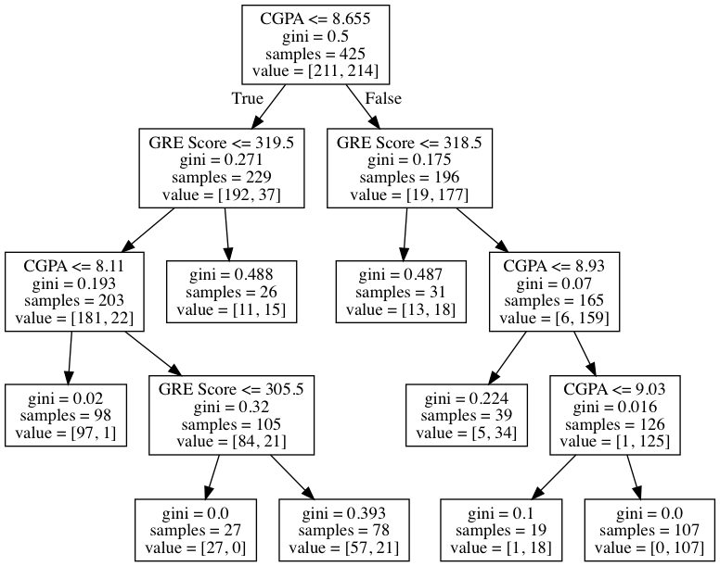

**Figure 1**

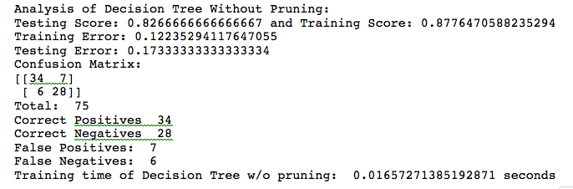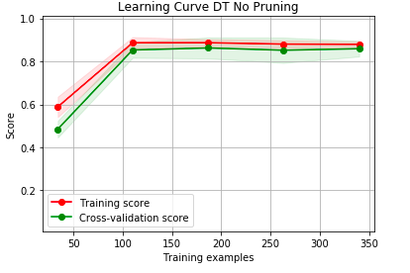

**Figure 2**

**Data Set 1:**

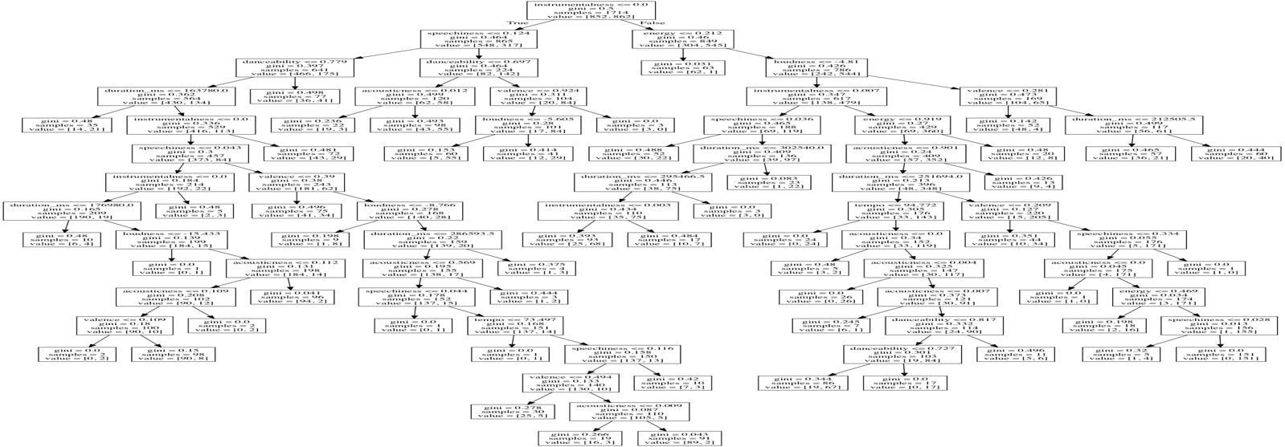

Analysis of Decision Tree Without Pruning:

Testing Score: 0.6732673267326733 and Training Score: 0.7893815635939323

Training Error: 0.2106184364060677

Testing Error: 0.3267326732673267

Confusion Matrix

[[ 89 56]

[ 43 115]]

Total: 303

Correct Positives 89

Correct Negatives 115

False Positives: 56

False Negatives: 43

Training time of Decision Tree w/o pruning: 0.032201290130615234

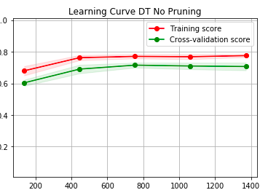

**Figure 3**

**Written Analysis:**

Overfitting seems more apparent in the tree for the second data set than for the first data set. The tree looks very large and possibly over-specified to the training data. One indicator of overfitting is that as the training data set increases, the training score will also increase, but the testing score will drop marginally. This is not overly apparent in Figure 3, but there seems to be some degree of it. Another indicator is a training score that is much higher than the testing score. There is some degree of this in data set 2 with respective rounded training and testing scores at 0.88 and 0.83, but it is much more apparent with data set 1 with respective rounded training and test scores at 0.79 and 0.67. This shows that the Decision Tree is definitely specified to the training data, which makes sense given the shape of the tree. It is somewhat surprising that the data set two shows a much higher accuracy with the Decision tree algorithm when it is given much fewer attributes to partition the data with. Perhaps this is due to the nature of the problem. The confusion matrices show nothing notable.

**Decision Trees W/ Pruning**

For the pruning algorithm the threshold separating classes will be 100 and 30 for data set 1 and data set 2 respectively. Therefore, nodes that split fewer than 100 and 30 data respectively will be removed.

**Data Set 2:**

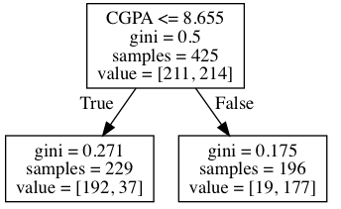

**Figure 4**

Analysis of Decision Tree With Pruning:

Testing Score: 0.84 and Training Score: 0.8682352941176471

Training Error: 0.1317647058823529

Testing Error: 0.16000000000000003

Confusion Matrix

[[36 5]

[ 7 27]]

Total: 75

Correct Positives 36

Correct Negatives 27

False Positives: 5

False Negatives: 7

Training time of Decision Tree w/o pruning: 0.029604196548461914

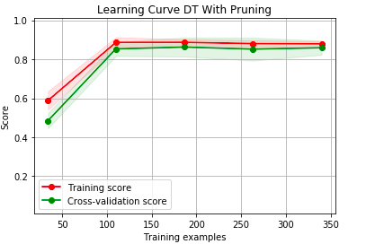

**Figure 5**

**Data Set 1:**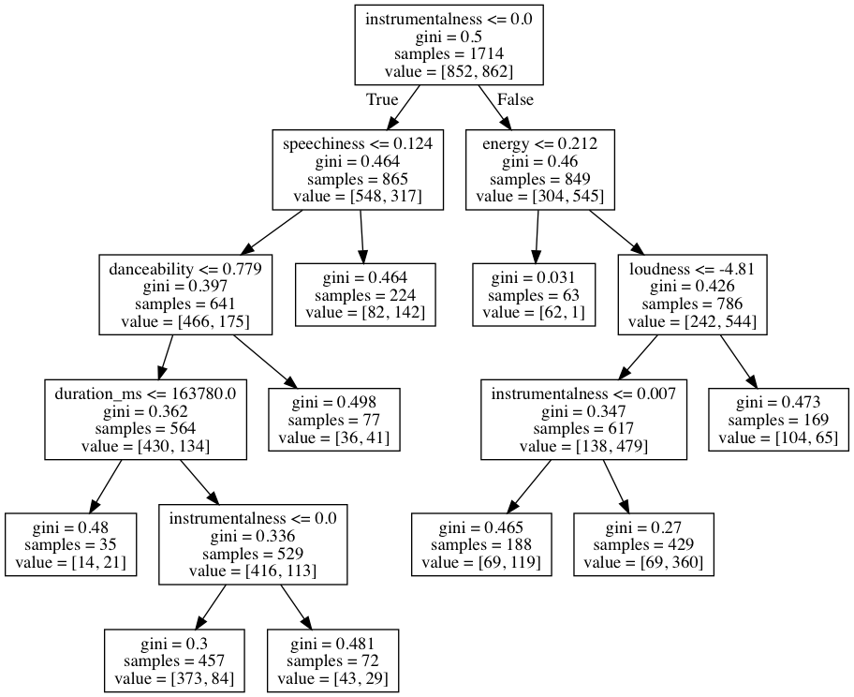

**Figure 6**

Analysis of Decision Tree With Pruning:

Testing Score: 0.7161716171617162 and Training Score: 0.7380396732788798

Training Error: 0.26196032672112024

Testing Error: 0.2838283828382838

Confusion Matrix

[[ 92 53]

[ 33 125]]

Total: 303

Correct Positives 92

Correct Negatives 125

False Positives: 53

False Negatives: 33

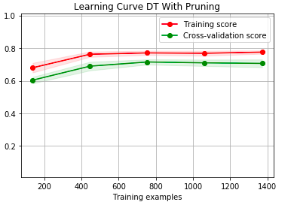

**Figure 7**

**Written Analysis**

It is visually apparent that pruning generalizes a decision tree. The number of partition nodes was decreased aggressively for each decision tree. In fact, for data set 2, it was reduced to the point which the only splitting factor was CGPA. One would think this generalizes the splitting too much, but it increased the testing score from 0.83 to 0.84. In both cases the training score decreased, as one would expect happens when you remove nodes from the tree. For data set 1 it went from 0.79 to 0.74 and for data set 2 it went from 0.88 to 0.87. This is evidence of the algorithm become less specified to the training data and more generalized. Unfortunately, the learning curve does not change as much as one would expect. Ideally it would show the cross-validation score increasing at a faster rate and the training score increasing at a slower rate. Again, the confusion matrix shows nothing interesting. It is worth noting that the difference in training times is 0.03 with data set 1 taking longer. Data set 1 has roughly four times as much data.

**Decision Trees With Aggressive Pruning**

For the pruning algorithm the threshold separating classes will be 300 and 2000 for data set 1 and data set 2 respectively. Therefore, nodes that split fewer than 300 and 2000 data respectively will be removed. Doing this had essentially the same effect on each data set, so we will only be looking at Data Set 2.

**Data Set 2:**

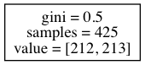

**Figure 8**

Analysis of Decision Tree With Too Much Pruning:

Testing Score: 0.4666666666666667 and Training Score: 0.5011764705882353

Training Error: 0.49882352941176467

Testing Error: 0.5333333333333333

Confusion Matrix

[[ 0 40]

[ 0 35]]

Total: 75

Correct Positives 0

Correct Negatives 35

False Positives: 40

False Negatives: 0

**Written Analysis:**

Essentially, over aggressive pruning will get rid of all nodes in the tree and randomly divide the data, causing a Testing Score of roughly 0.47.

**Neural Networks**

**Overview:** A neural network is a supervised learning algorithm that uses a series of neurons and layers with weights and biases to make a prediction based on some data. Essentially, a neural network starts off with random weights and biases and uses those to determine an output based on an input training data. If the output is off, the neural network will back propagate and adjust the weights and biases. This is done repeatedly on the training data. We will implement this using skLearn’s Neural Network. Here, I have compared the performance of the network for both data sets based on the number of hidden layers that the network has. A neural network will be created and tested with varying number of layers. The optimal number of layers will be determined based on the testing score and further analysis shall be done on the neural network with the optimal layers. Below are some graphs.

**Data Set 1:**

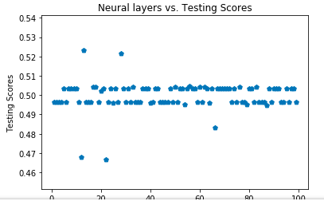

**Figure 9**

Best Score: 0.5233372228704785

Optimal Layers: 13

Analysis of Neural Network With 13 layers:

Testing Score: 0.5643564356435643 and Training Score: 0.5233372228704785

Training Error: 0.47666277712952154

Testing Error: 0.4356435643564357

Confusion Matrix

[[75 71]

[61 96]]

Total: 303

Correct Positives 75

Correct Negatives 96

False Positives: 71

False Negatives: 61

Training Time of Neural Net With 13 layers: 0.34138917922973633

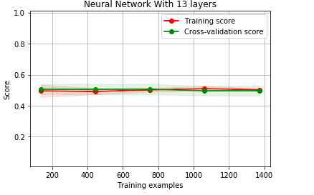

**Figure 10**

**Data Set 2:**

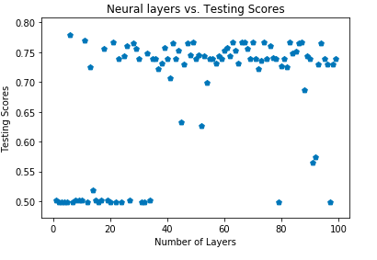

**Figure 11**

Best Score: 0.7788235294117647

Optimal Layers: 6

Testing Score: 0.6933333333333334 and Training Score: 0.72

Training Error: 0.28

Testing Error: 0.30666666666666664

Confusion Matrix

[[20 20]

[ 3 32]]

Total: 75

Correct Positives 20

Correct Negatives 32

False Positives: 20

False Negatives: 3

Training Time of Neural Net With 6 layers: 0.30724191665649414

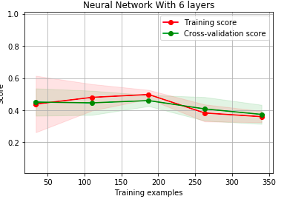

**Figure 12**

**Written Analysis**

Although neither graph shows a clear relationship between the number of layers and Neural Network performance, it seems that the best performance generally occurs at a mid-size number relative to the inputs/outputs. This makes sense as a large number of layers will likely cause overfitting because the model would become over-adjusted to the training data and the weights and biases would be very niche. Both confusion matrices showed a higher likelihood of a correct response when the correct response was negative. In both cases, the learning curves showed that the training scores and cross-validation scores were almost identical. This is evidence of little overfitting. Both the learning curves show that this algorithm does not require very much data to properly train. Finally, unlike other algorithms, data set 2 performed significantly better than data set 1 (0.72 and 0.52) with rounding. This shows that neural networks perform a lot better with fewer inputs. Also given the largely mathematical nature of neural networks as opposed to decision trees (I am not saying decision trees do not operate on a mathematical basis. I am only saying that the Neural Network algorithm is likely better at determining relationships that directly involve numbers due to the weights and biases system), Neural Networks are likely better at solving problems with a clearer numbers-based relationship like graduate admissions than problems that are subjective like enjoying music.

**Boosted Decision Trees**

**Overview:** The biggest problem with decision trees is their inflexibility in classifying data they were not trained with. Boosting algorithms aim to make decision trees more adaptable. The two algorithms we will analyze are Random Forests and AdaBoost. Random Forest creates bootstrapped subsets of the original data set and uses a subset of the parameters for each bootstrapped set to create a tree. This results in many trees. When classifying a datum, the datum is run through each tree and whichever classification receives the most “votes” is the output. AdaBoost uses a similar approach. It uses all the parameter in isolation and determines how good each parameter is at classifying the training data. Based on this each parameter is given a weight. The aggregate of the outputs and weights of each single classifying parameter determines the output. Let’s use the SkLearn library to examine these algorithms. Below is the data.

**Data Set 2:**

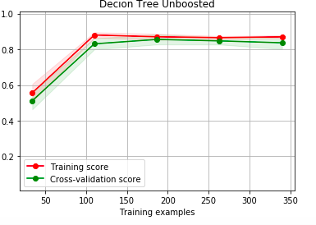

**Testing Score: 0.8666666666666667 and Training Score: 0.8635294117647059**

**Training Error: 0.13647058823529412**

**Testing Error: 0.1333333333333333**

**Training time of unboosted Decision Tree: 0.003609895706176758**

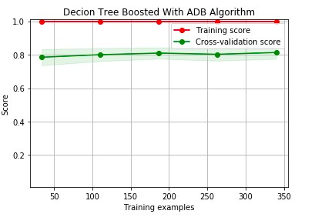

**Testing Score: 0.76 and Training Score: 1.0**

**Training Error: 0.0**

**Testing Error: 0.24**

**Training time of Decision Tree with ADA Algorithm Boosting: 0.005786895751953125**

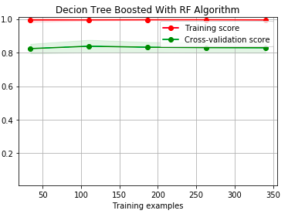

**Testing Score: 0.84 and Training Score: 0.9929411764705882**

**Training Error: 0.007058823529411784**

**Testing Error: 0.16000000000000003**

**Training time of Decision Tree with RF Algorithm Boosting: 0.09227180480957031**

**Data Set 1:**

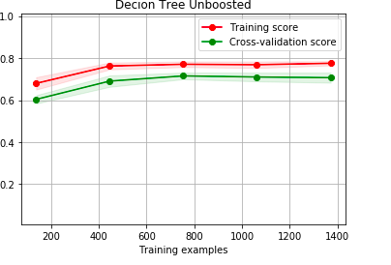

**Testing Score: 0.6732673267326733 and Training Score: 0.7893815635939323**

**Training Error: 0.2106184364060677**

**Testing Error: 0.3267326732673267**

**Training time of unboosted Decision Tree: 0.020224571228027344**

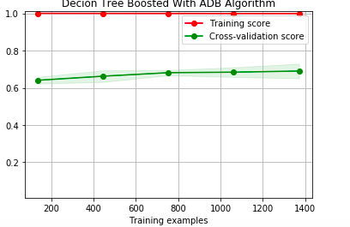

**Testing Score: 0.6864686468646864 and Training Score: 0.9982497082847142**

**Training Error: 0.0017502917152858455**

**Testing Error: 0.31353135313531355**

**Training time of Decision Tree with ADA Algorithm Boosting: 0.16762995719909668**

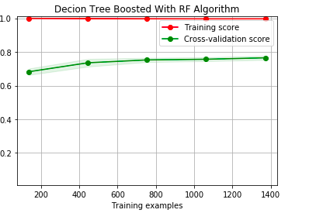

**Testing Score: 0.7623762376237624 and Training Score: 0.9970828471411902**

**Training Error: 0.0029171528588097795**

**Testing Error: 0.2376237623762376**

**Training time of Decision Tree with RF Algorithm Boosting: 0.10079216957092285**

**Written Analysis:** It is interesting to note that both boosting algorithms made the decision tree for data set #2 perform worst. In both cases, the RF algorithm was the better algorithm. All boosting reduced the number of training samples required for the algorithm to reach peak performance as evidenced by the learning curves of boosting compared to the upboosted learning curve. The Random Forest algorithm caused a ten percent boost in the accuracy of data set #1. This is very impressive and likely due to the fact that the second data set has many parameters. This allowed the algorithm to create many subtrees and create a more accurate estimate. Finally, it is clear that boosting works best for problems with a large number of features. In fact, both algorithms reduced performance for data set #2. This is due to the fact that both of these algorithms create subtrees by examining subsets of the parameters. This will obviously work better with many parameters. It is important to note that all boosting algorithms cause a greater accuracy with training data. This likely lead to overfitting with data set #2.

**Support Vector Machines**

**Overview:**