functions and variables
function(verbs) arguments(input) side effects
return values(get the user’s input and then hand it back to me)
variables(store a value)
a single equal sign(assignment)
comments(notes to yourself in your code) --include comments by the hash symbol(#)
(The computer actually ignores your comments.)
- A good habit to remind yourself and others what it is your intent and your code is doing
- A nice way to structuring your to-do list(pseudocode)--breaks a bigger program down into small bite-sized tasks
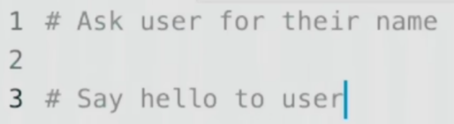
Some functions, “print” among them, actually take multiple arguments.(separate the arguments to a function with a comma )
When you pass multiple arguments to “print”, it automatically inserts a space for you.
or passing in one bigger argument to print all at once by using
“+” operator(concatenation-to join the thing on the left and the thing on the right)
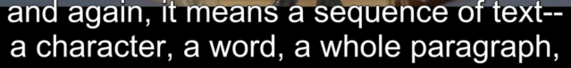STR for short, for string
is where all of Python’s official documentation lies
parameters--arguments
(what the function can take versus what you’re actually passing into the function)
positional parameters--*objects--can take any number of objects
named parameters(optional):
sep(short for separator)-- the default is “ ”(why automatically inserts a space)
end--the default value of that parameter is “\n”(backslash n)--the line ending(new line)
(why be ended with a new line )
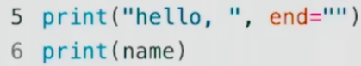 Override the def ault value, so there is no new line.
output will be: hello, name
eg:
print(“hello, ”, name, sep=“???”) is equal to
print(“hello, ”, end=”???”)
print(name)
Their output both will be (hello, ???name)
You can use either double quotes or single quotes, so long as you’re consistent.

If you use single quotes on the outside, you can then use double quotes on the inside and you’ll see them literally.
\(backslash) is actually represents what’s called an escape character.
An escape character is one that you can’t just type necessarily once on the keyboard, you need to express it with multiple characters.
I can put backslashes in front of the inner double quotes, so that the computer realizes those aren’t quotes that finish or start the thought, they’re literal quotes.
eg:
print(‘hello, “friend”’) is equal to print(“hello, \“friend\””)
F string(format string): print(f”hello, {name}”) (curly braces)

A method(change the value of variables by using the assignment operator):

name = name.strip()--(removes from the right and the left but not in between)
lstrip / rstrip
name = name.capitalize()--(just the very first letter)
name = name.title()--(capitalize the first letter of each word)
simplify?
- name = name.capitalize().title()
- name = input(“what’s your name? ”).strip().title()
print(f“hello, {name}”)/(“hello,”, name) .
Is the longer sentence better or not? getting your own sense of style
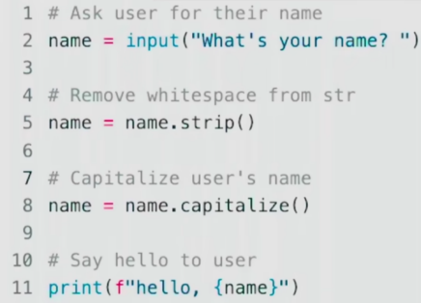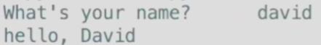
split(split a string into multiple smaller substrings)
first, last = name.split(“ ”)
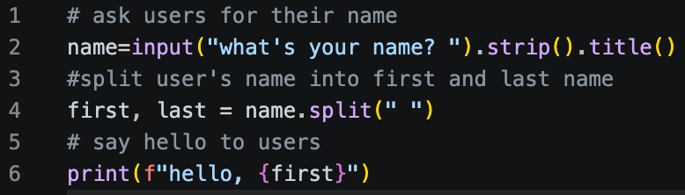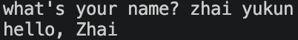

interactive mode for Python(execute immediately, don’t have to keep running over again)
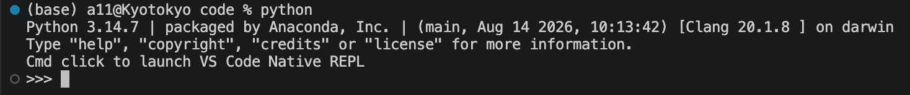
int(integers)
(INT is not only a type of data in Python. It’s also a function that if you passing an input, like a string, so long as that string looks like a number like 1 or 2, it’ll convert it to an actual number you can perform mathematics.)
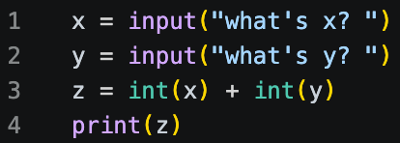
nest functions:
x = int(input(“what is x? ”))
y = int(input(“what is y? ”))
print(x + y) (no need for an extra variable “z”)
even? print(int(input(“what is x? ”) + int(input(“what is y? ”))) unreadable

float
(A float is a number with a decimal point, properly called a floating point value)
Floats can not represent numbers infinitely precisely.
(Square brackets and documentation like this means that you’re about to see something optional.)
[ndigits]--Specify more precisely the number of digits that you want the round function to round to.

1000→1,000: (what it really means to format a string)
z = round(x + y)
print(f”{z:,}”) (use of f string)

z = round(x/y, 2) is equal to z=x/y
print(z) print(f”{z:.2f}”)
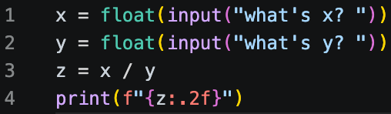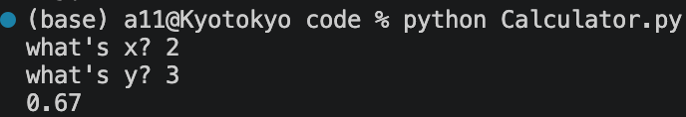
def(calling your own function, short for define)
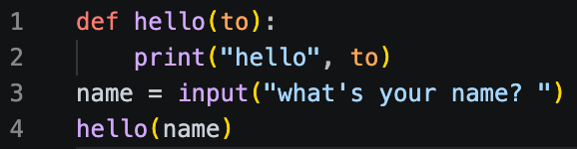
1.The function ”hello” has been designed to take a parameter ”to” as input.
4.I’m passing as input the “name” variable as an argument so that that’s what gets passed into “hello”

Assigning parameter with a equal sign, a default value of ”world”, just in case the programmer doesn’t call hello with an argument.
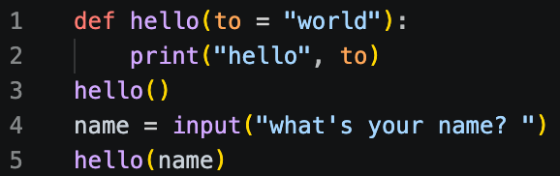
what if?
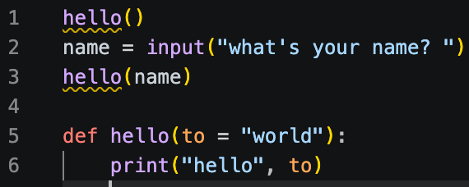
How to solve this to make it possible to code logically, top to bottom?
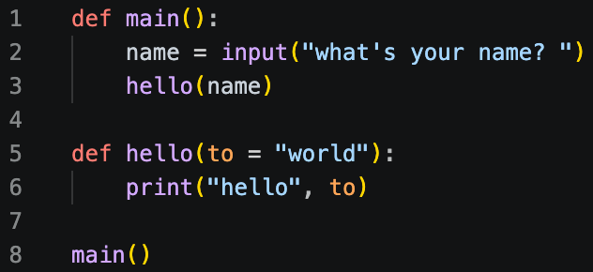
What if?
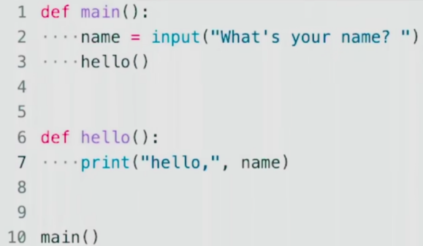
This is actually an issue of what’s called “scope” .
Scope refers to a variable only existing in the context in which you defined it.

Experiment:
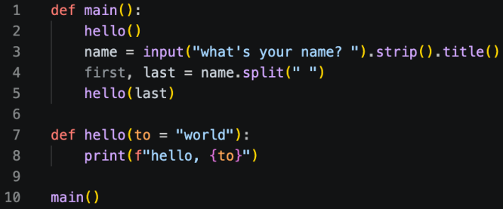

return:
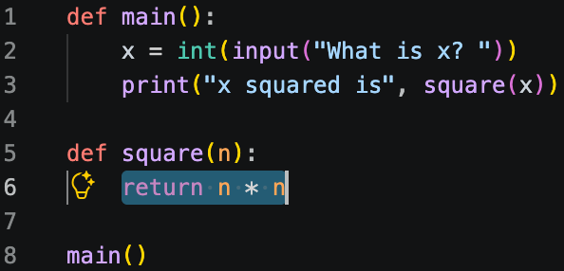
note: n * n is equal to n ** 2 or pow(n, 2) .

Conditionals
> >= < <= == !=
if elif(short for else if) else or
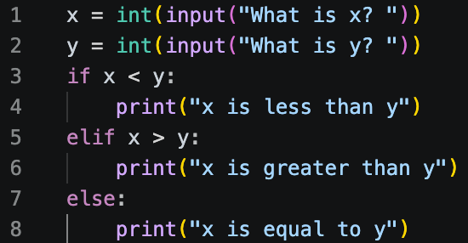
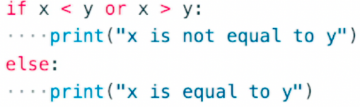
if x != y:

and
(some improvements to make code more readable and more maintainable long term)
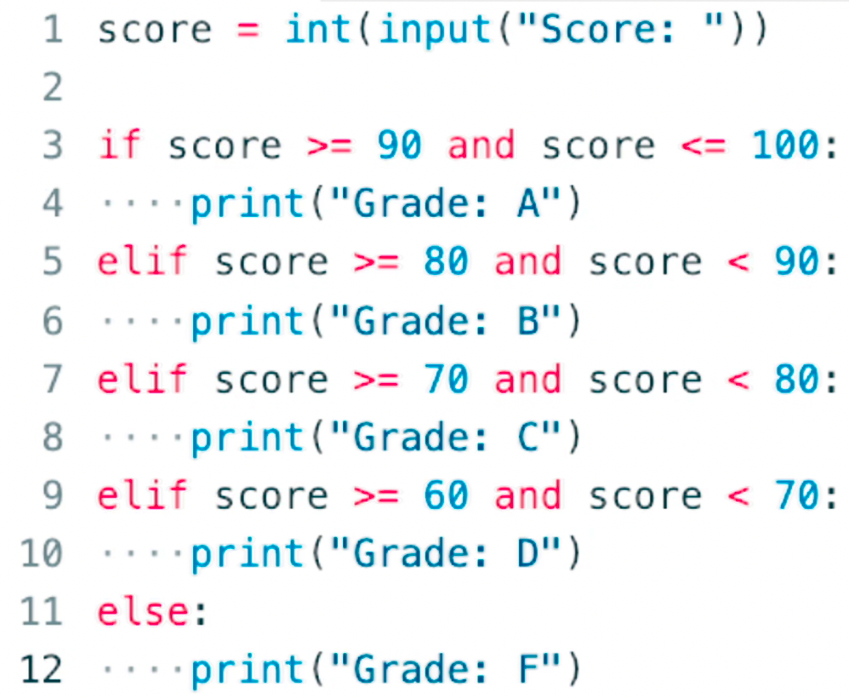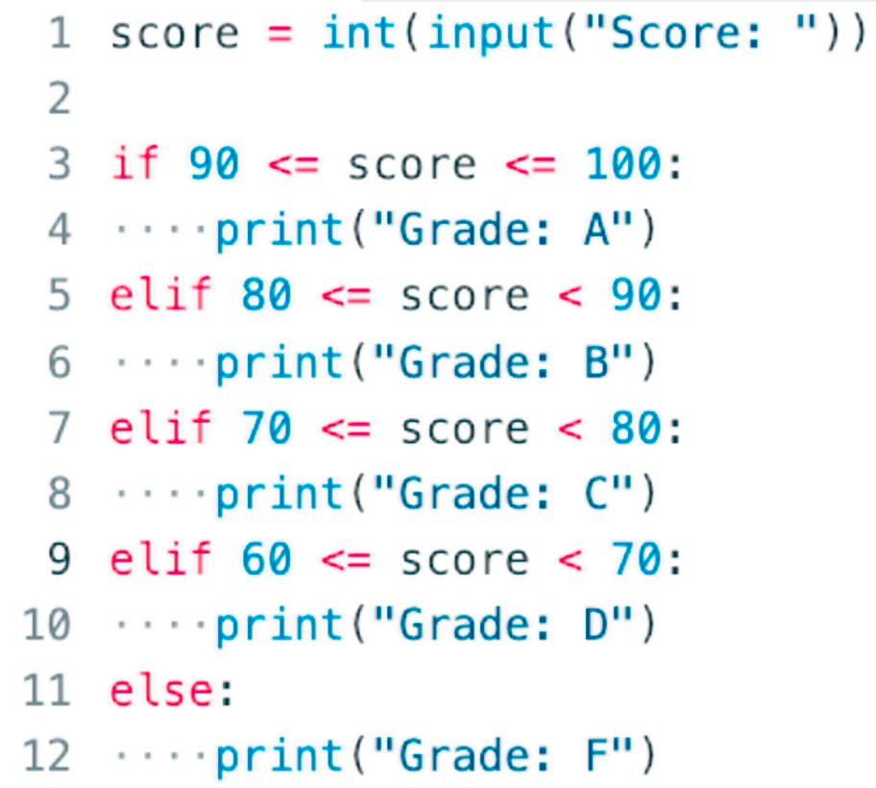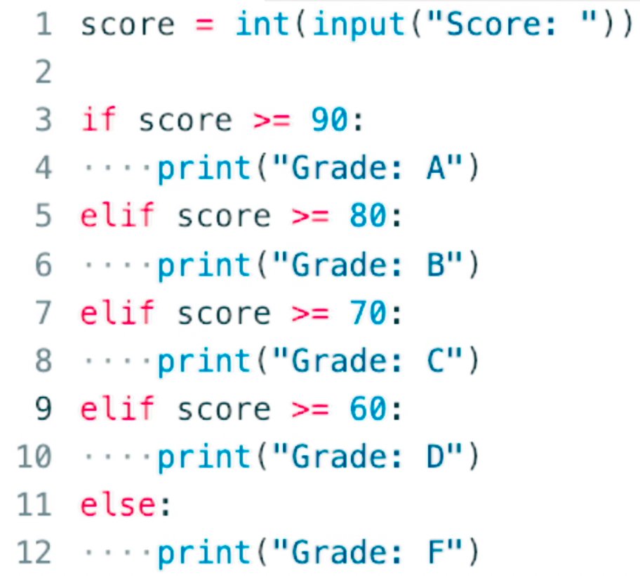
+ - * / %(modulo operator)
bool (a data type, short for Boolean value--can only be True or False) str, int, float, bool
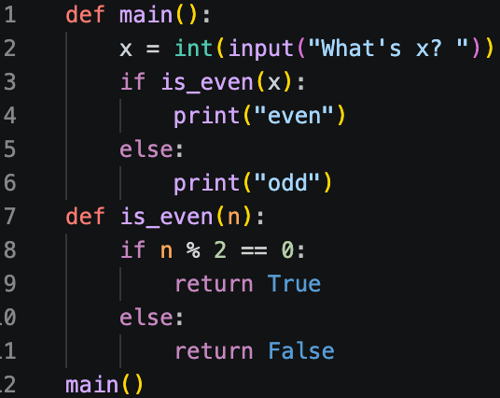
refine it by Pythonic expressions
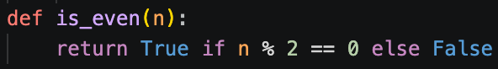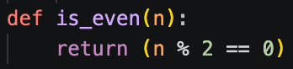
If your Boolean expression has a true or false answer itself, why are you even asking a question in the first place? Why ask if? Why say else?
Just return the value of your own Boolean expression.(most elegant way to implement)

match case _:(means all of which not be handled)
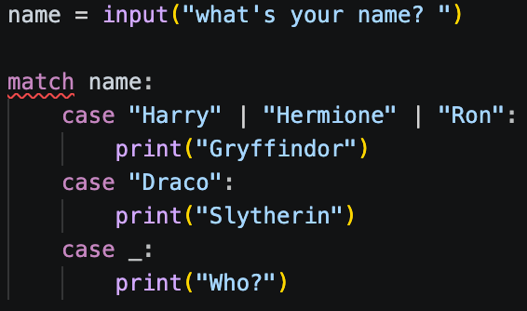
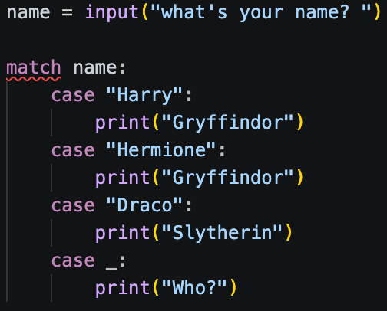

tighten things up by using ” | ”
loops
while a minor pythonic improvement
(“i” is not required, “_”)
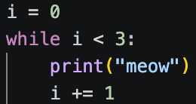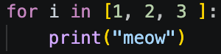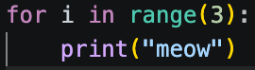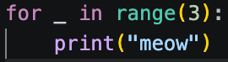
for
list (another type of data,”[ ]”) range (returns to a range of values)
A pythonic way:
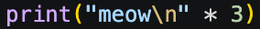
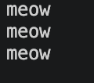 (additional black line)
while True:(make the loop infinite)
n = int(input("what's n? "))
if n < 0:
continue (continue to stay within the loop)
else:
break (break out the loop altogether)
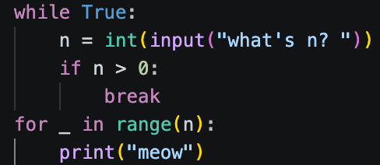
def main():
number = get_number()
meow(number)
def get_number():
while True:
n = int(input("what's n? "))
if n > 0: if n > 0:
return n or break
return n
#(return in the loop instead of break or outside the loop but still in the function)
def meow(n):
for _ in range(n):
print("meow")
main()

list
