2016-10-19日报

Android基本架构

应用程序层

应用程序架构层

系统运行库层

linux核心层

Android四大组件

Activity

service(服务)

Broadcast Receiver(广播接收器)

Content Provider

Android项目结构

src/ | 存放源代码的地方
bin/ | 编译后的输出目录，可以找到.apk文件和其他编译后的资源.
res/ | 包含应用程序的资源，如drawable文件, layout文件, string值.
anim/ | 这里可以放入动画XML文件
color/ | 这里可以放入颜色XML文件
drawable/ | 这里可以放入位图（PNG,JPEG,GIF）还有9-Patch图片文件，并且也能放置XML文件用来描述Drawable形状和Drawable对象的多种状态切换
layout/ | 这里可以放入布局XML文件
menu/ | 这里可以放入定义菜单的XML文件
values/ | 这里可以放入许多种类的XML文件。不同于其他res/目录下的资源。这个文件夹下的XML文件不能由文件名直接引用。但XML文件中的节点可以控制R文件定义的名字。
raw/ | 这里和assets/差不多都是放入原始的asset文件。但访问的方式与assets/不同。这里必须用R文件来引用，例如如果需要在这里放入一个bg.ogg音频文件，那么请这样调用R.id.bg 。一般来说这里都是放多媒体文件

Android运行机制

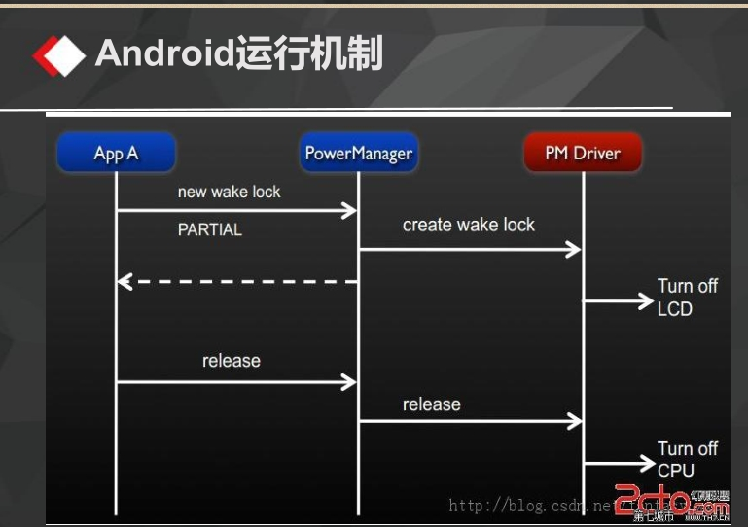

Android生命周期

onCreate(Bundle savedInstanceState)

onStart()

onRestart()

onResume()

onPause()

onStop()

onDestroy()

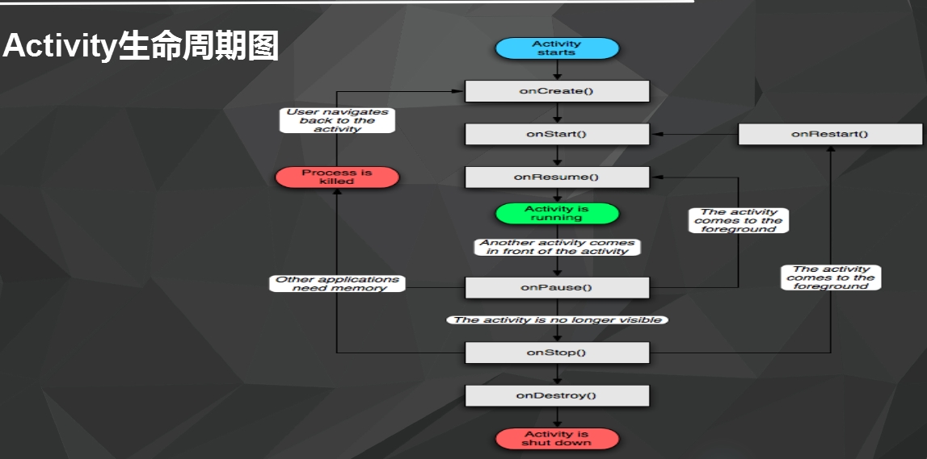

Activity经历3个阶段：

开始Activity:依次执行onCreate、onStart、onResume

Activity重新获得焦点：依次执行onRestart、onStart、onResume

关闭Activity：依次执行onPause、onStop、onDestory

View组件的布局方式

Java代码布局的方式（计算器）

XML布局的方式

常用ViewGroup子类 五大布局

LinearLayout 线性布局

FrameLayout 帧布局

TableLayout 表格布局

AbsoluteLayout 绝对布局

RelativeLayout 相对布局

TextView常用属性

android:layout_width=""---控件宽

android:layout_height=""---控件高

android:layout_weight=""---控件权重

android:text=""---控件上的文本内容

android:textColor=""---文本颜色

android:textSize=""---字体大小

ImageView常用属性

android:layout_width=""---控件宽

android:layout_height=""---控件高

android:layout_weight=""---控件权重

andorid:src 设置图片来源。属性值为android:src="@drawable/图片名称"

android:adjustViewBounds 用于设置 ImageView 是否调整自己的边界，来保持所显示图片的长宽比例。属性值为true或false

Java代码布局——相对布局

package com.feicuiedu.android.calculatorjava;

​

import android.os.Bundle;

import android.support.annotation.Nullable;

import android.support.v7.app.AppCompatActivity;

import android.widget.Button;

import android.widget.RelativeLayout;

import android.widget.TextView;

​

/**

* Created by Administrator on 2016/10/19.

*/

​

public class Main extends AppCompatActivity {

​

private Button myButton_C;

//C键

private Button myButton_CE;

//CE键

private Button myButton_Esc;

//Esc键

private Button myButton_Add;

//+键

private Button myButton_Minus;

//-键

private Button myButton_Multiply;

//*键

private Button myButton_Divide;

///键

private Button myButton_EqualSign;

//=键

private Button myButton_Parenthese;

//()键

private Button myButton_Point;

//.键

//0~9

private Button myButton_Zero;

private Button myButton_One;

private Button myButton_Two;

private Button myButton_Three;

private Button myButton_Four;

private Button myButton_Five;

private Button myButton_Six;

private Button myButton_Seven;

private Button myButton_Eight;

private Button myButton_Nine;

//显示屏

private TextView mytextview;

​

​

​

@Override

protected void onCreate(@Nullable Bundle savedInstanceState) {

super.onCreate(savedInstanceState);

​

//定义20个Button控件

myButton_C = new Button(this);

myButton_C.setText("C");

myButton_CE = new Button(this);

myButton_CE.setText("CE");

myButton_Esc = new Button(this);

myButton_Esc.setText("Esc");

myButton_Add = new Button(this);

myButton_Add.setText("+");

myButton_Minus = new Button(this);

myButton_Minus.setText("-");

myButton_Multiply = new Button(this);

myButton_Multiply.setText("*");

myButton_Divide = new Button(this);

myButton_Divide.setText("/");

myButton_EqualSign = new Button(this);

myButton_EqualSign.setText("=");

myButton_Parenthese = new Button(this);

myButton_Parenthese.setText("()");

myButton_Point = new Button(this);

myButton_Point.setText(".");

myButton_Zero = new Button(this);

myButton_Zero.setText("0");

myButton_One = new Button(this);

myButton_One.setText("1");

myButton_Two = new Button(this);

myButton_Two.setText("2");

myButton_Three = new Button(this);

myButton_Three.setText("3");

myButton_Four = new Button(this);

myButton_Four.setText("4");

myButton_Five = new Button(this);

myButton_Five.setText("5");

myButton_Six = new Button(this);

myButton_Six.setText("6");

myButton_Seven = new Button(this);

myButton_Seven.setText("7");

myButton_Eight = new Button(this);

myButton_Eight.setText("8");

myButton_Nine = new Button(this);

myButton_Nine.setText("9");

mytextview = new TextView(this);

​

//为空间设置ID

// (数字1~9,id为1~9;

// 加减乘除为10~13,=为14;

// C,CE,Dsc,(),.为15~19；

// 数字0，id为20

//显示屏为21

myButton_Zero.setId(20);

myButton_One.setId(1);

myButton_Two.setId(2);

myButton_Three.setId(3);

myButton_Four.setId(4);

myButton_Five.setId(5);

myButton_Six.setId(6);

myButton_Seven.setId(7);

myButton_Eight.setId(8);

myButton_Nine.setId(9);

myButton_Add.setId(10);

myButton_Minus.setId(11);

myButton_Multiply.setId(12);

myButton_Divide.setId(13);

myButton_EqualSign.setId(14);

myButton_C.setId(15);

myButton_CE.setId(16);

myButton_Esc.setId(17);

myButton_Parenthese.setId(18);

myButton_Point.setId(19);

mytextview.setId(21);

​

​

//定义好父容器并设置相关属性(相对布局)

RelativeLayout myLayout = new RelativeLayout(this);

​

//设置TextView的布局参数

RelativeLayout.LayoutParams mytableParams =

new RelativeLayout.LayoutParams(

RelativeLayout.LayoutParams.MATCH_PARENT,

RelativeLayout.LayoutParams.WRAP_CONTENT

);

mytableParams.addRule(RelativeLayout.ABOVE,myButton_C.getId());

​

//设置Button的布局参数

​

//15 C

RelativeLayout.LayoutParams buttonCParams =

new RelativeLayout.LayoutParams(

RelativeLayout.LayoutParams.WRAP_CONTENT,

RelativeLayout.LayoutParams.WRAP_CONTENT

);

buttonCParams.addRule(RelativeLayout.CENTER_VERTICAL);

//16 CE

RelativeLayout.LayoutParams buttonCEParams =

new RelativeLayout.LayoutParams(

RelativeLayout.LayoutParams.WRAP_CONTENT,

RelativeLayout.LayoutParams.WRAP_CONTENT

);

buttonCEParams.addRule(RelativeLayout.CENTER_VERTICAL);

buttonCEParams.addRule(RelativeLayout.RIGHT_OF,myButton_C.getId());

//17 Esc

RelativeLayout.LayoutParams buttonEscParams =

new RelativeLayout.LayoutParams(

RelativeLayout.LayoutParams.WRAP_CONTENT,

RelativeLayout.LayoutParams.WRAP_CONTENT

);

buttonEscParams.addRule(RelativeLayout.CENTER_VERTICAL);

buttonEscParams.addRule(RelativeLayout.RIGHT_OF,myButton_CE.getId());

//13 /

RelativeLayout.LayoutParams buttonDivideParams =

new RelativeLayout.LayoutParams(

RelativeLayout.LayoutParams.WRAP_CONTENT,

RelativeLayout.LayoutParams.WRAP_CONTENT

);

buttonDivideParams.addRule(RelativeLayout.CENTER_VERTICAL);

buttonDivideParams.addRule(RelativeLayout.RIGHT_OF,myButton_Esc.getId());

​

//7 7

RelativeLayout.LayoutParams buttonSevenParams =

new RelativeLayout.LayoutParams(

RelativeLayout.LayoutParams.WRAP_CONTENT,

RelativeLayout.LayoutParams.WRAP_CONTENT

);

buttonSevenParams.addRule(RelativeLayout.BELOW,myButton_C.getId());

//8 8

RelativeLayout.LayoutParams buttonEightParams =

new RelativeLayout.LayoutParams(

RelativeLayout.LayoutParams.WRAP_CONTENT,

RelativeLayout.LayoutParams.WRAP_CONTENT

);

buttonEightParams.addRule(RelativeLayout.BELOW,myButton_C.getId());

buttonEightParams.addRule(RelativeLayout.RIGHT_OF,myButton_Seven.getId());

//9 9

RelativeLayout.LayoutParams buttonNineParams =

new RelativeLayout.LayoutParams(

RelativeLayout.LayoutParams.WRAP_CONTENT,

RelativeLayout.LayoutParams.WRAP_CONTENT

);

buttonNineParams.addRule(RelativeLayout.BELOW,myButton_C.getId());

buttonNineParams.addRule(RelativeLayout.RIGHT_OF,myButton_Eight.getId());

//12 *

RelativeLayout.LayoutParams buttonMultiplyParams =

new RelativeLayout.LayoutParams(

RelativeLayout.LayoutParams.WRAP_CONTENT,

RelativeLayout.LayoutParams.WRAP_CONTENT

);

buttonMultiplyParams.addRule(RelativeLayout.BELOW,myButton_C.getId());

buttonMultiplyParams.addRule(RelativeLayout.RIGHT_OF,myButton_Nine.getId());

​

//4 4

RelativeLayout.LayoutParams buttonFourParams =

new RelativeLayout.LayoutParams(

RelativeLayout.LayoutParams.WRAP_CONTENT,

RelativeLayout.LayoutParams.WRAP_CONTENT

);

buttonFourParams.addRule(RelativeLayout.BELOW,myButton_Seven.getId());

//5 5

RelativeLayout.LayoutParams buttonFiveParams =

new RelativeLayout.LayoutParams(

RelativeLayout.LayoutParams.WRAP_CONTENT,

RelativeLayout.LayoutParams.WRAP_CONTENT

);

buttonFiveParams.addRule(RelativeLayout.BELOW,myButton_Seven.getId());

buttonFiveParams.addRule(RelativeLayout.RIGHT_OF,myButton_Four.getId());

//6 6

RelativeLayout.LayoutParams buttonSixParams =

new RelativeLayout.LayoutParams(

RelativeLayout.LayoutParams.WRAP_CONTENT,

RelativeLayout.LayoutParams.WRAP_CONTENT

);

buttonSixParams.addRule(RelativeLayout.BELOW,myButton_Seven.getId());

buttonSixParams.addRule(RelativeLayout.RIGHT_OF,myButton_Five.getId());

//10 +

RelativeLayout.LayoutParams buttonAddParams =

new RelativeLayout.LayoutParams(

RelativeLayout.LayoutParams.WRAP_CONTENT,

RelativeLayout.LayoutParams.WRAP_CONTENT

);

buttonAddParams.addRule(RelativeLayout.BELOW,myButton_Seven.getId());

buttonAddParams.addRule(RelativeLayout.RIGHT_OF,myButton_Six.getId());

​

//1 1

RelativeLayout.LayoutParams buttonOneParams =

new RelativeLayout.LayoutParams(

RelativeLayout.LayoutParams.WRAP_CONTENT,

RelativeLayout.LayoutParams.WRAP_CONTENT

);

buttonOneParams.addRule(RelativeLayout.BELOW,myButton_Four.getId());

//2 2

RelativeLayout.LayoutParams buttonTwoParams =

new RelativeLayout.LayoutParams(

RelativeLayout.LayoutParams.WRAP_CONTENT,

RelativeLayout.LayoutParams.WRAP_CONTENT

);

buttonTwoParams.addRule(RelativeLayout.BELOW,myButton_Four.getId());

buttonTwoParams.addRule(RelativeLayout.RIGHT_OF,myButton_One.getId());

//3 3

RelativeLayout.LayoutParams buttonThreeParams =

new RelativeLayout.LayoutParams(

RelativeLayout.LayoutParams.WRAP_CONTENT,

RelativeLayout.LayoutParams.WRAP_CONTENT

);

buttonThreeParams.addRule(RelativeLayout.BELOW,myButton_Four.getId());

buttonThreeParams.addRule(RelativeLayout.RIGHT_OF,myButton_Two.getId());

//11 -

RelativeLayout.LayoutParams buttonMinusParams =

new RelativeLayout.LayoutParams(

RelativeLayout.LayoutParams.WRAP_CONTENT,

RelativeLayout.LayoutParams.WRAP_CONTENT

);

buttonMinusParams.addRule(RelativeLayout.BELOW,myButton_Four.getId());

buttonMinusParams.addRule(RelativeLayout.RIGHT_OF,myButton_Three.getId());

​

//18 ()

RelativeLayout.LayoutParams buttonParentheseParams =

new RelativeLayout.LayoutParams(

RelativeLayout.LayoutParams.WRAP_CONTENT,

RelativeLayout.LayoutParams.WRAP_CONTENT

);

buttonParentheseParams.addRule(RelativeLayout.BELOW,myButton_One.getId());

//0 0

RelativeLayout.LayoutParams buttonZeroParams =

new RelativeLayout.LayoutParams(

RelativeLayout.LayoutParams.WRAP_CONTENT,

RelativeLayout.LayoutParams.WRAP_CONTENT

);

buttonZeroParams.addRule(RelativeLayout.BELOW,myButton_Two.getId());

buttonZeroParams.addRule(RelativeLayout.RIGHT_OF,myButton_Parenthese.getId());

//19 .

RelativeLayout.LayoutParams buttonPointParams =

new RelativeLayout.LayoutParams(

RelativeLayout.LayoutParams.WRAP_CONTENT,

RelativeLayout.LayoutParams.WRAP_CONTENT

);

buttonPointParams.addRule(RelativeLayout.BELOW,myButton_One.getId());

buttonPointParams.addRule(RelativeLayout.RIGHT_OF,myButton_Zero.getId());

//14 =

RelativeLayout.LayoutParams buttonEqualSignParams =

new RelativeLayout.LayoutParams(

RelativeLayout.LayoutParams.WRAP_CONTENT,

RelativeLayout.LayoutParams.WRAP_CONTENT

);

buttonEqualSignParams.addRule(RelativeLayout.BELOW,myButton_Minus.getId());

buttonEqualSignParams.addRule(RelativeLayout.RIGHT_OF,myButton_Point.getId());

​

​

​

​

​

​

//将布局添加到父容器中,按照控件的顺序

​

myLayout.addView(myButton_C,buttonCParams);

myLayout.addView(mytextview,mytableParams);

myLayout.addView(myButton_CE,buttonCEParams);

myLayout.addView(myButton_Esc,buttonEscParams);

myLayout.addView(myButton_Divide,buttonDivideParams);

myLayout.addView(myButton_Seven,buttonSevenParams);

myLayout.addView(myButton_Eight,buttonEightParams);

myLayout.addView(myButton_Nine,buttonNineParams);

myLayout.addView(myButton_Multiply,buttonMultiplyParams);

myLayout.addView(myButton_Four,buttonFourParams);

myLayout.addView(myButton_Five,buttonFiveParams);

myLayout.addView(myButton_Six,buttonSixParams);

myLayout.addView(myButton_Add,buttonAddParams);

myLayout.addView(myButton_One,buttonOneParams);

myLayout.addView(myButton_Two,buttonTwoParams);

myLayout.addView(myButton_Three,buttonThreeParams);

myLayout.addView(myButton_Minus,buttonMinusParams);

myLayout.addView(myButton_Parenthese,buttonParentheseParams);

myLayout.addView(myButton_Zero,buttonZeroParams);

myLayout.addView(myButton_Point,buttonPointParams);

myLayout.addView(myButton_EqualSign,buttonEqualSignParams);

​

​

//设置显示父容器

setContentView(myLayout);

}

}

