20161020日报

Intent(意图)——完成跳转

显示跳转

//声明并初始化一个意图Intent intent = new Intent();//设置跳转从MainActivity跳转到SecondActivityintent.setClass(MainActivity.this, SecondActivity.class);//启动这个意图startActivity(intent);

隐式跳转

//声明并初始化一个意图Intent intent = new Intent();//通过设置跳转动作（action） 跳转到打电话界面intent.setAction(android.intent.action.SECOND);//启动这个意图startActivity(intent);

隐式Intent传递的特点

没有明确的目标组件名称

利用Intent Filter过滤器选择要跳转页面

自定义隐式Intent

<activity

​ //目标Activity

​ android:name = "com.example.clouddemo.SecondActivity"

​ android:label = "@string/title_activity_second">

​ <intent-filter>

​ //操作名称

​ <action android:name = "android.intent.action.SECOND"/>

​ //操作类型

​ <category android:name = "android.intent.category.DEFAULT"/>

</intent-filter>

ListView

列表组件（ListView）在使用时，需要提供如下数据

需要显示的数据数量

需要显示的数据内容

需要显示的数据显示方式

并通过Adpater（适配器），传递给Listview组件

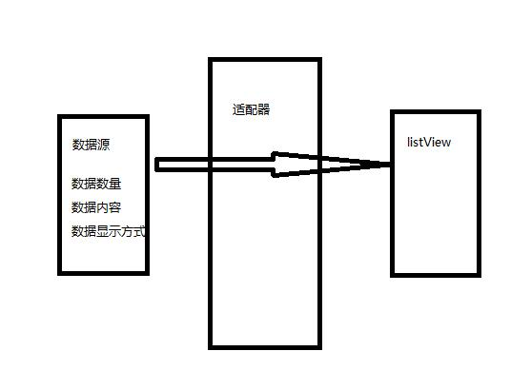

ListView在绘制的过程中主要分如下2步

调用getCount方法来获取Item的个数循环

调用getView方法绘制每个Item

代码

package com.feicuiedu.android.listviewdemo;

​

import android.os.Bundle;

import android.support.annotation.Nullable;

import android.support.v7.app.AppCompatActivity;

import android.view.View;

import android.view.ViewGroup;

import android.widget.AdapterView;

import android.widget.BaseAdapter;

import android.widget.ListView;

import android.widget.TextView;

import android.widget.Toast;

​

import java.util.ArrayList;

import java.util.HashMap;

import java.util.List;

import java.util.Map;

​

/**

* Created by chenyan on 2016/10/20.

*/

​

public class MainAcitivity extends AppCompatActivity {

​

private ListView listView1;

private List<Map<String,String>> list;

​

@Override

protected void onCreate(@Nullable Bundle savedInstanceState) {

super.onCreate(savedInstanceState);

setContentView(R.layout.main_layout);

​

listView1 = (ListView) findViewById(R.id.listView1);

list = getData();

​

// 绑定适配器

listView1.setAdapter(baseAdapter);
// 监听事件

listView1.setOnItemClickListener(oicl);

}

​

private AdapterView.OnItemClickListener oicl = new AdapterView.OnItemClickListener() {

@Override

public void onItemClick(AdapterView<?> parent, View view, int position, long id) {

Toast.makeText(MainAcitivity.this,"position="+position+",id="+id,Toast.LENGTH_LONG).show();

}

};

​

private List<Map<String,String>> getData() {

​

List<Map<String,String>> tmp = new ArrayList<Map<String,String>>();

​

for (int i = 0; i < 20; i++) {

Map<String,String> map = new HashMap<String,String>();

map.put("id",i+"");

map.put("createDate","2016-10-"+i);

map.put("name","2016-10-"+i+"日报");

tmp.add(map);

}

​

return tmp;

}

​

private BaseAdapter baseAdapter = new BaseAdapter() {

​

// 定义数据的个数

@Override

public int getCount() {

return list.size();

}

​

// 定义每行数据的对象

@Override

public Map<String,String> getItem(int position) {

return list.get(position);

}

​

// 定义每行的id值

@Override

public long getItemId(int position) {

return position;

}

​

// 定义每行都 是什么样的布局,如何展示数据

@Override

public View getView(int position, View convertView, ViewGroup parent) {

Map<String,String> tmpMap = getItem(position);

​

String id = tmpMap.get("id");

String createDate = tmpMap.get("createDate");

String name = tmpMap.get("name");

​

​

View view = getLayoutInflater().inflate(R.layout.main_item_layout,null);

​

TextView tvId = (TextView) view.findViewById(R.id.tvId);

TextView tvName= (TextView) view.findViewById(R.id.tvName);

TextView tvDate = (TextView) view.findViewById(R.id.tvDate);

​

tvId.setText(id);

tvDate.setText(createDate);

tvName.setText(name);

​

return view;

}

};

​

​

}

