MM 333 – Advanced Data Analytics
Week 4 – Workshop 4
Theme: Mediation and Moderation

- Structure and Descriptive Statistics
Staff: 120 observations; each row represents data for each staff member with a unique IDs
Regions: 150 observations, each row represents data for 150 regions.

Training hours: mean – 10.22; min – 5.20; max – 16.70
Confidence: mean – 6.73; min – 2.80; max – 9.90
Performance: mean – 72.16; min – 25.10, max – 106.10
Ad spend: mean – 24.34, sd – 7.27
Loyalty: mean – 4.94; sd – 1.74
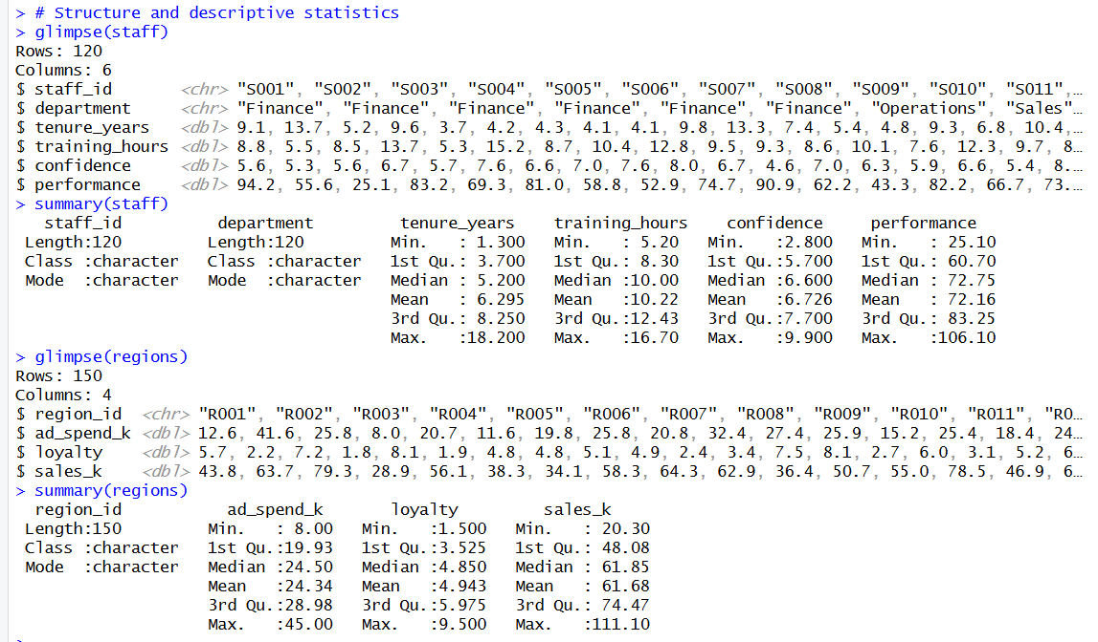
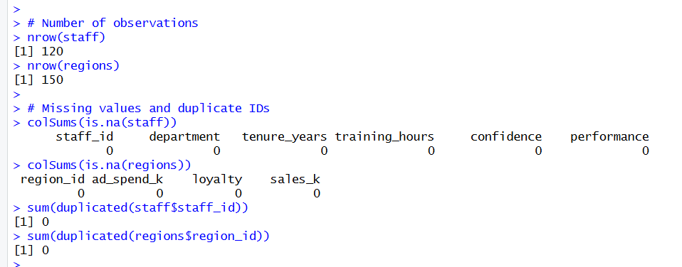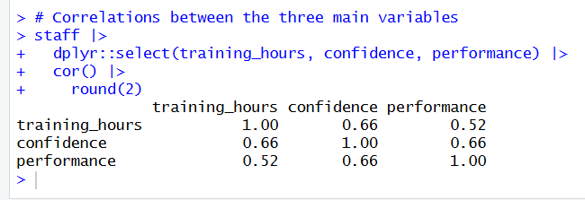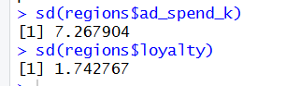

- Mediation Analysis
  - Each relationship is positive, as predictor (X) increases, the outcome (Y) increases.
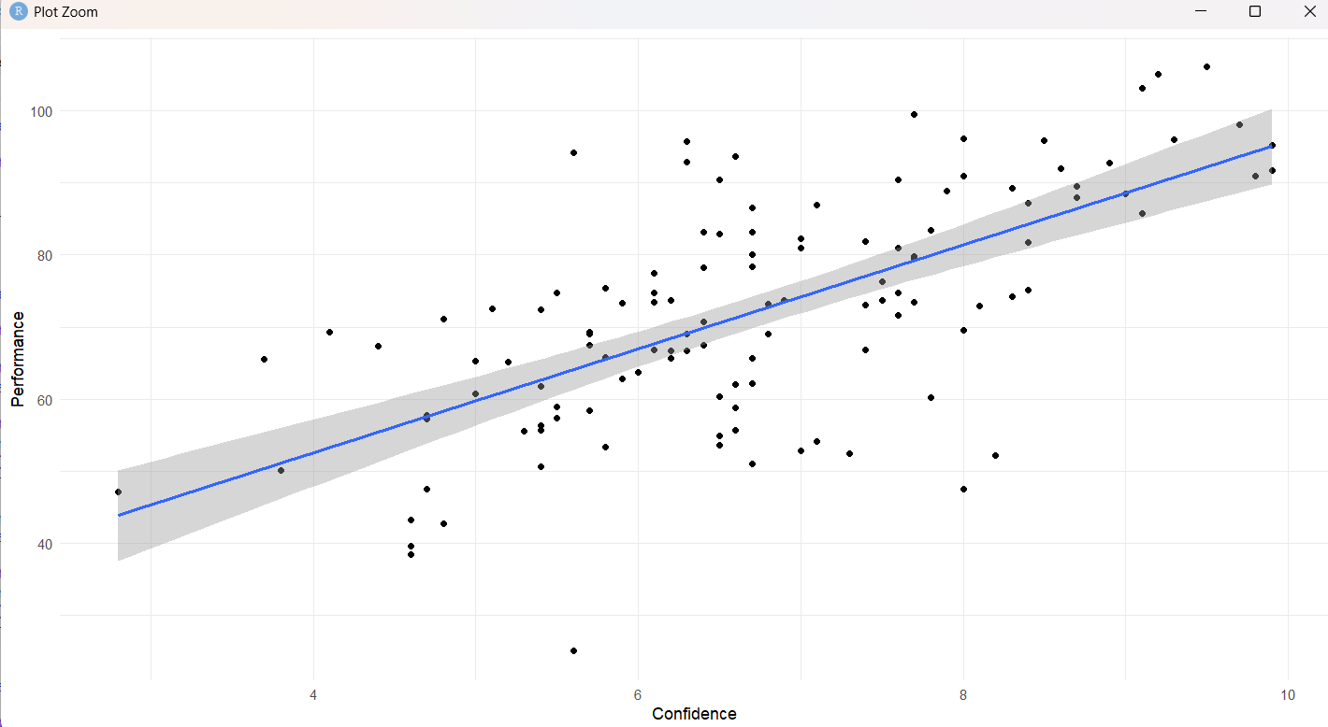
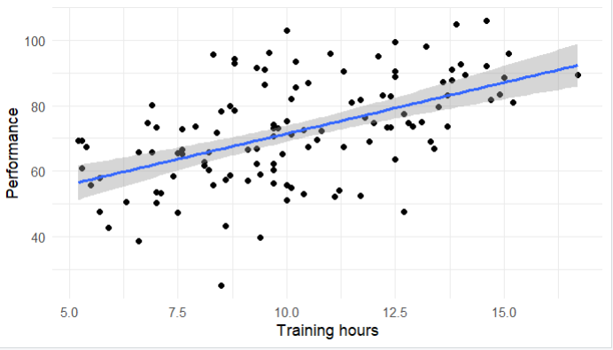
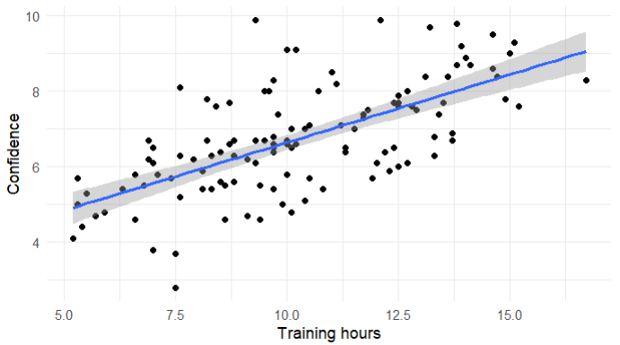

Direct effect -> in path_b, controlled training_hours, so 0.9347, p-value 0.0907
c′ = 0.935 versus c = 3.123, so the coefficient falls by 2.189, or about 70% (0.935 / 3.123 ≈ 0.30).
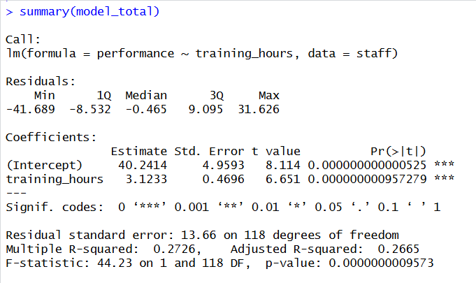
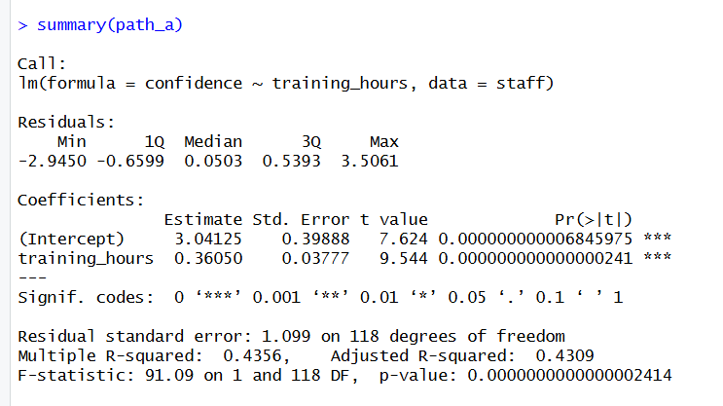
Once confidence is in the model, most of training’s association with performance disappears. This is the pattern of mediation: training raises confidence (path a = 0.3605, p < .001), and confidence in turn predicts performance (path b = 6.0712, p < .001), so most of training’s effect runs through confidence rather than directly
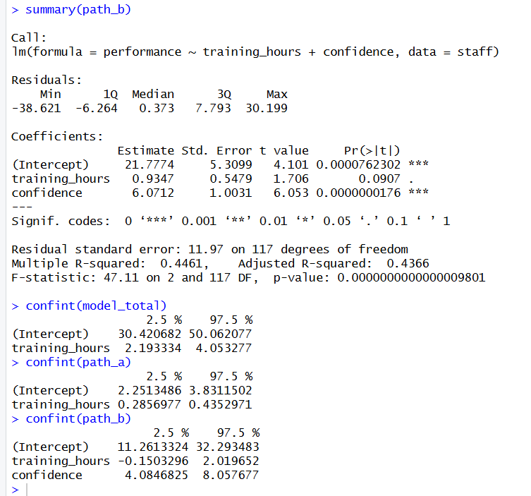

  - Indirect effect: Each extra hour of training is associated with about 2.19 more performance points that operate through confidence.
70 % of the total effect is mediated.
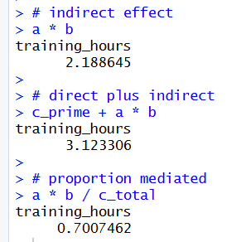
  - ACME = 2.19 [1.49, 2.93]; ADE = 0.93 [0.13, 1.74]; total effect = 3.12 [2.37, 3.89], proportion mediated = 0.70 [0.50, 0.95].
ADE = 0.93, 95% CI [0.13, 1.74]. The lower bound (0.13) is just above zero, so the direct effect is statistically significant. After accounting for confidence, each extra training hour is still associated with roughly 0.9 more performance points, and a plausible range is about 0.1 to 1.7.
Across the 120 staff in our data, each additional hour of training is associated with about 3.1 more performance points.
Most of that benefit, about 70% (plausibly between 50% and 95%), works by building confidence.
What this means for decisions: Training is worth the investment, and its value comes largely from the confidence it builds. Training programmes should therefore be designed to build confidence deliberately (practice, feedback, and visible successes), not only to transfer skills.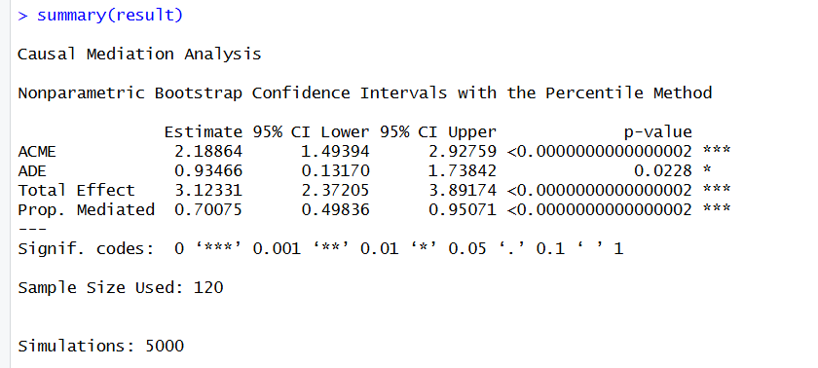
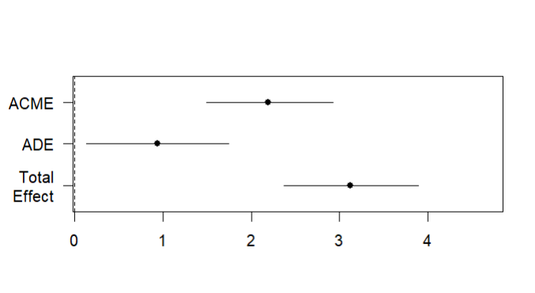
  - Assumptions
Assumption | Diagnostic method | Result | Conclusion
Linearity | Residuals vs fitted plot | Mostly horizontal plot around 0 | Satisfied
Independence of errors | Durbin-Watson test | p-value>0.05, and the D-W statistic is close to 2 (1.89), however, it checks only serial correlation (arbitrary ordering) | satisfied
Normality of residuals | Q-Q plot and Shapiro-Wilk test | The residuals follow the diagonal line most of the time, except for some outliers (3 and 73), and the Shapiro-Wilk test p-value >0.05 suggests there is not sufficient evidence to reject normality | satisfied
Homoscedasticity | Scale-location plot and Breusch-Pagan test | The line is not straight horizontal; it is skewed on the right end to 0.5 as fitted values increase (residual spread shrinks at higher fitted values), but the B-P test p-value > 0.05; there is not sufficient evidence of heteroscedasticity | no material violation
Multicollinearity | VIF | Two values are the same; that is, moderate correlation but well below the usual cutoffs of 5 or 10, so it is not a concern. | satisfied
Influential observations | Cook’s distance (4/n guideline) | 4/n = 0.033  5 of 120 cases exceed 4/n = 0.033; max Cook’s D = 0.049; well below 0.5 and 1. | satisfied

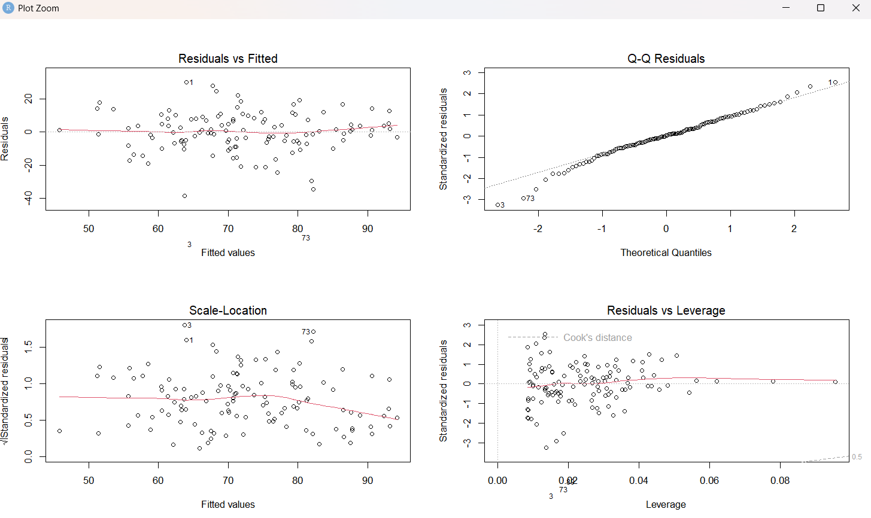
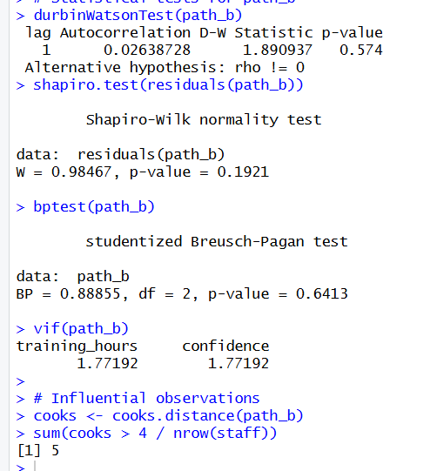
Because confidence should increase first before performance increase to be a mediator. But as they were measured at the same time, we couldn’t decide which one increased first and second. (Mediation implies a sequence: training → confidence → performance. Because training, confidence, and performance were measured at the same time, temporal precedence cannot be established. Confidence may be a consequence of performance (reverse causation) rather than its cause, so the data are equally consistent with alternative causal orderings.)
Prior experience could confound the relationship: more experienced staff tend to be both more confident and better performers, so the confidence-performance association could reflect experience rather than any effect of confidence.

For a manager:
The indirect effect of training hours on performance through confidence is a 2.19-point increase in performance score for every one-hour increase in training hours, with a 95% CI [1.49, 2.93]. The proportion mediated 70% of the total effect of training on performance passes through confidence. (95% CI roughly 50% to 95%). This suggests that training designed to build confidence, for example through practice and feedback, is worth piloting. However, confidence and performance were measured at the same time, so we cannot be sure confidence drives performance rather than the reverse, and these results are consistent with mediation but do not prove it; so it should be treated as supportive evidence rather than proof.

- Moderation Analysis
  - Visualising the interaction
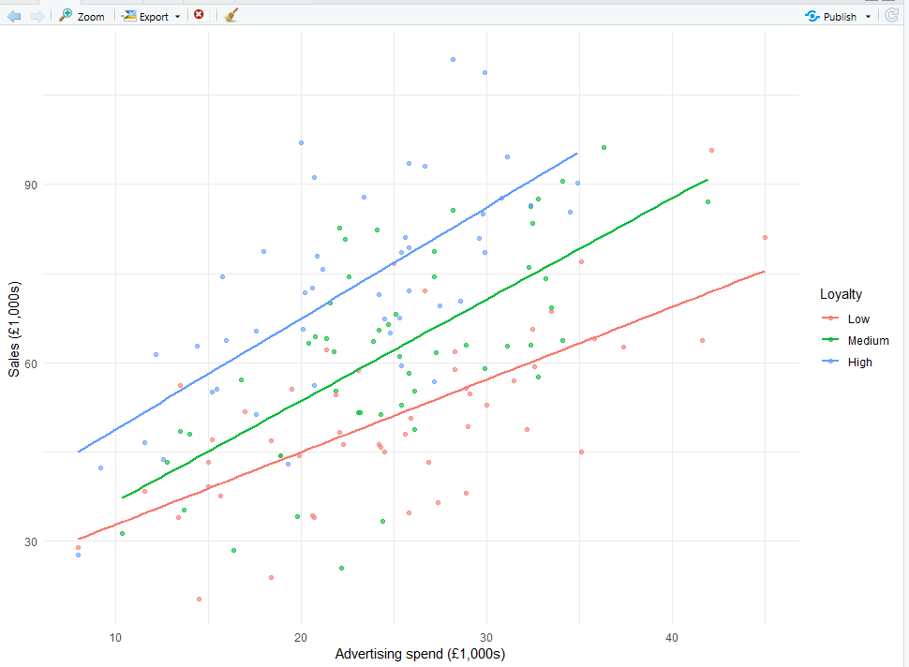
As advertising spend increases, all three loyalty groups' sales increase. All three fitted lines slope upward, so higher advertising spend is associated with higher sales in every loyalty group.
The lines are not perfectly parallel. High and Medium have similar slopes, while Low is visibly flatter. Parallel lines mean the slope of advertising is the same in every group, so loyalty does not change the advertising-sales relationship, and suggests no moderation. The differing slopes here suggest possible moderation.
  - Fitting the interaction model
The fitted equation:
$$y=15.814+0.578x_{i}+ 1.454 W_{i}+0.207 \left(x_{i}+ W_{i}\right)+8.901$$
b₃ = 0.207, meaning the slope of X increases by 0.207 units as W increases by one unit; it is statistically significant (p < 0.05) and positive, so X becomes more positive as W increases.
The slope of the ad_spend_k is 0.578 + 0.207 W_i. Because the slope of ad_spend_k changes as W changes, it is the coefficient plus 0.207W; if W=0, the slope equals the coefficient, 0.578.
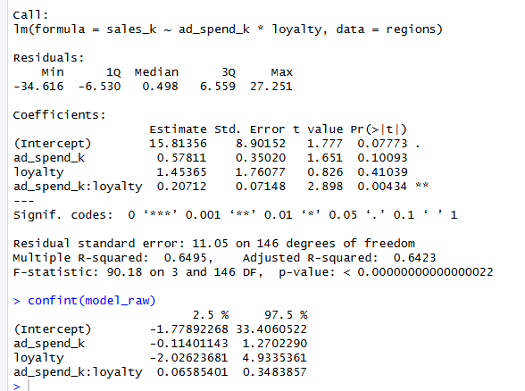
  - Mean-centering
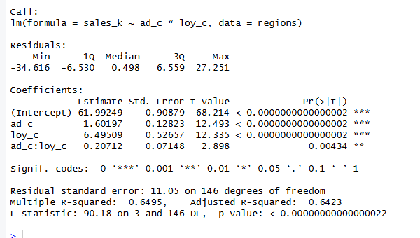
  - Assumptions
Assumption | Diagnostic method | Result | Conclusion
Linearity | Residuals vs fitted plot | Mostly horizontal line with a slight upward drift at the highest fitted values where data are sparse | satisfied
Independence of errors | Durbin-Watson test | p-value >0.05, D-W statistic around 2; it is not significant at 5% but borderline, however, the test checks for serial correlation, arbitrary ordering | satisfied
Normality of residuals | Q-Q plot and Shapiro-Wilk test | The residuals follow mostly the diagonal line except for some outliers on both ends (116, 161, 72), Sh-W test p-value > 0.05, so no evidence of rejecting the normality | satisfied
Homoscedasticity | Scale-location plot and Breusch-Pagan test | The line is mostly horizontal, mild, non-systematic curvature (about 0.65 to 0.85, then flat). The B-P test shows no evidence of heteroscedasticity (p-value > 0.05) | satisfied
Influential observations | Cook’s distance (4/n guideline) | 4/n = 0.0267  6 observations out of 150 (4%) are higher than the guideline | No material violation
Adequate coverage | Scatterplot of X against W | Points are spread across advertising from about £8k to £45k and loyalty from about 1.5 to 9.5, with no obvious empty large regions. corners are sparse: high advertising with high loyalty (above 35k, above 6), and very low advertising with low loyalty | No material violation
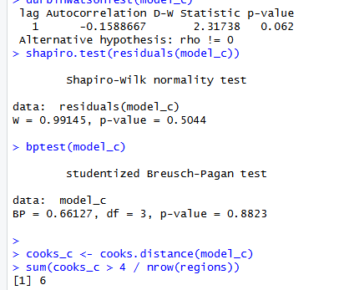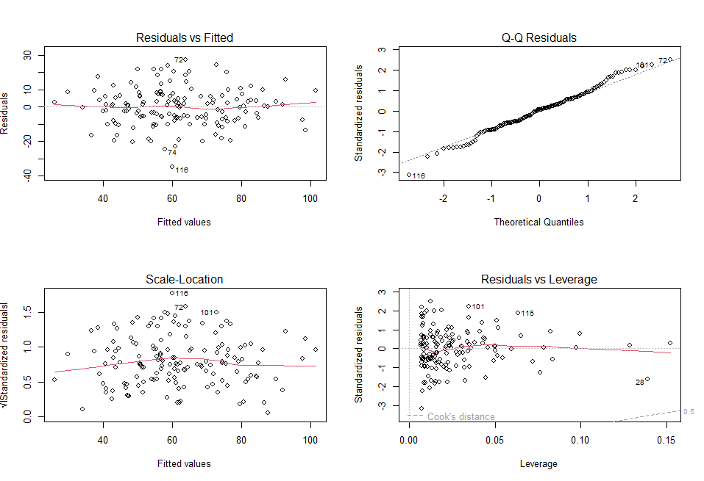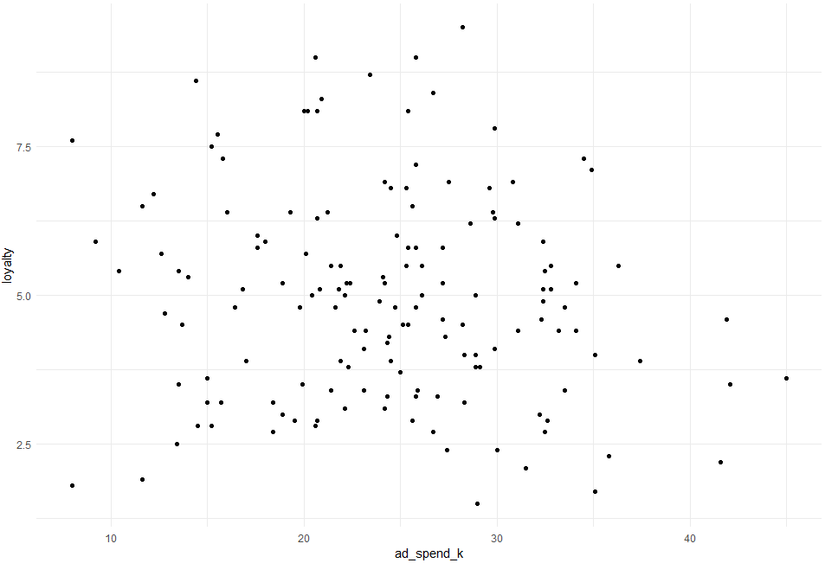
  - Simple slopes and probing the interaction
When loyalty = 2: simple slope is 0.99 [0.55, 1.43]
When it is 5, the simple slope is 1.61 [1.35, 1.87]
When it is 8, the simple slope is 2.24 [1.69, 2.79]
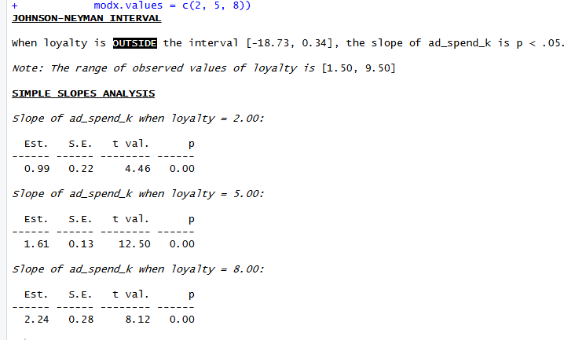

  - Plotting the interaction
The high loyalty line is the steepest.
From 8k to 45k in advertising spend, there is no extrapolation; the line is not predicted in the model in the range the data don’t include.
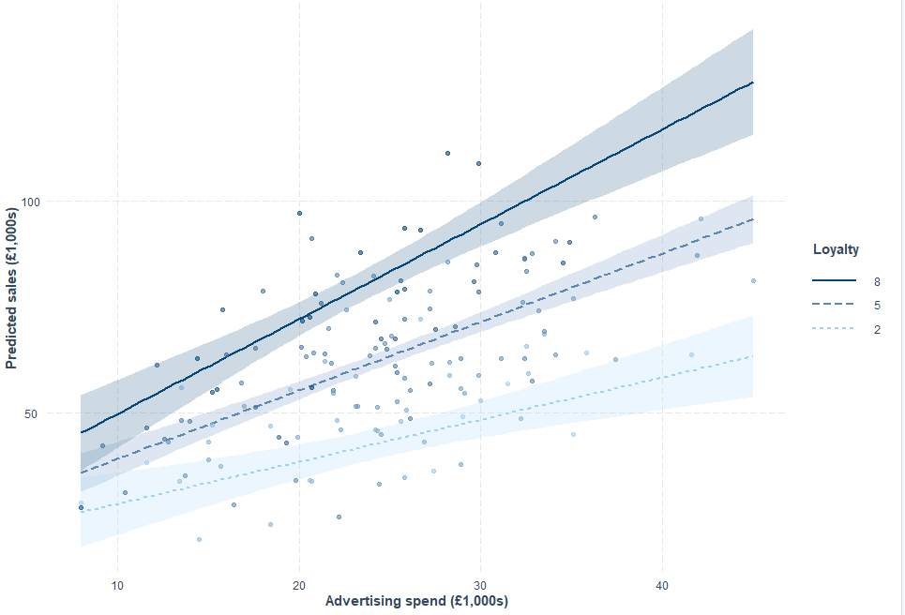
  - Reporting
The advertising effect on sales changes in terms of customer loyalty, the interaction is positive and significant: the change in the effect of advertising spend for each unit increase in loyalty is 0.207 with p = 0.004, (advertising spend effect on sales increases by 0.207 for each increase in loyalty); the effect of advertising spend is greatest when loyalty is 8 (2.24k increase in sales for 1k increase in advertising), medium when loyalty is 5 (1.61k increase in sales for a 1k increase in advertising) and the lowest but significant (0.99k increase in sales for a 1k increase in advertising) when loyalty is 2. However, the model is limited to the range of observations from 8k to 45k advertising spendings, and can’t predict outside this range.
In plain terms, advertising works in every type of region, but it pays back more than twice as much where customers are most loyal. This suggests prioritising advertising in high-loyalty regions, while not cutting it elsewhere. However, the data are observational, so these are associations rather than proof that advertising causes the sales gains, since high-loyalty regions may differ in other ways.

 | Mediation (Part A) | Moderation (Part B)
Key question | Does training improve employees’ performance through confidence? | Does the effect of advertising on sales depend on the level of customer loyalty?
Key quantity and estimate | The indirect effect = 2.19 | Interaction coefficient = 0.207
How big is the effect? | 70% of the effect is proportionately mediated | Significant
Main assumption checked | Linearity, independence of errors, normality of residuals, homoscedasticity, influential outliers, multicollinearity | Linearity, independence of errors, normality of residuals, homoscedasticity, influential outliers, average coverage
Key plot | Plot with three dots and lines | interact_plot
Main limitation | Confidence and performance were measured at the same time, so we cannot be sure confidence drives performance rather than the reverse | Data are observational, so no proof of causation

