O‘ZBEKISTON RESPUBLIKASI OLIY TA‘LIM, FAN VA INNOVATSIYA VAZIRLIGI
ABU RAYXON BERUNIY NOMIDAGI URGANCH DAVLAT UNIVERSITETI

Kompyuter injineringgi fakulteti
„Kompyuter ilmlari va dasturlash texnologiyalari” yo‘nalishi 234-guruh
Omonboyeva Yulduzxonning
“Web texnologiya ” fanidan
3 - laboratoriya mashg‘uloti

Qabul qildi: ________________________________________________

Urganch-2025
Mavzu:PHP massivlar va funksiyalar bilan ishlash
Ishdan maqsad:PHP dasturlash tilida massivlar (array) bilan ishlashni o‘rganish.Massiv elementlarini qayta ishlash, saralash va filtrlashni amaliy bajarish.PHP funksiyalaridan foydalanib yangi massiv hosil qilish ko‘nikmasini shakllantirish.
Nazariy qism:
PHP dasturlash tilida massiv — bu bir nechta qiymatlarni bitta o‘zgaruvchida saqlash imkonini beruvchi ma’lumotlar tuzilmasidir.
PHP da massivlar 3 turga bo‘linadi:
- Indeksli massiv – elementlari raqamli indeks orqali chaqiriladi.
- Assotsiativ massiv – kalit (key) va qiymat (value) juftligidan iborat.
- Ko‘p o‘lchamli massiv – ichida boshqa massivlarni saqlaydi.
Massiv bilan ishlashda quyidagi funksiyalar keng qo‘llaniladi:
- count() – massiv elementlari sonini aniqlaydi.
- array_push() – massiv oxiriga element qo‘shadi.
- array_pop() – oxirgi elementni olib tashlaydi.
- array_filter() – shart asosida elementlarni filtrlash.
- foreach – massiv elementlarini ko‘rib chiqish uchun ishlatiladi.
PHPda Massivlar bilan ishlash:
- Massiv yaratish: $mevalar = ["Olma", "Banan", "Uzum"];
- Elementga murojaat: $mevalar[0] (indeks 0 dan boshlanadi)
- Element qo'shish: array_push($mevalar, "Nok"); yoki $mevalar[] = "Nok";
- Elementlar soni: count($mevalar);
- Massivni aylanib chiqish: foreach($mevalar as $meva) { echo $meva; }
Asosiy massiv funksiyalari:
- sort($arr): Massivni o'sish tartibida saralaydi.
- array_merge($a1, $a2): Ikkita massivni birlashtiradi.
- in_array($n, $arr): Massiv ichida element borligini tekshiradi
Ko'p o'lchovli massivlar (Massivlar massivi):
$userlar = [
["id" => 1, "ism" => "Ali"],
["id" => 2, "ism" => "Vali"]
];echo $userlar[0]["ism"]; // Ali
Funksiyalar bilan ishlash:
Funksiyalar qayta ishlatiladigan kod bloklarini yaratish uchun ishlatiladi:
phpfunction salomBer($ism) {
return "Salom, " . $ism;
}echo salomBer("Aziz");
Massivlarni funksiyalarga parametr sifatida uzatish va qaytarish orqali murakkab ma'lumotlar strukturalarini samarali boshqarish mumkin.

Kerakli dasturiy vositalar:
- Kompyuter
- PHP 7 yoki undan yuqori versiya
- Web server (Apache yoki Nginx)
- XAMPP / OpenServer / Denwer
- Matn muharriri (VS Code, Sublime Text va boshqalar)
- Brauzer (Google Chrome, Firefox va boshqalar)

Laboratoriya ishining bajarilish tartibi:
13 - topshiriq.Massivdan manfiy sonlarni olib tashlab yangi massiv hosil qiling.
project3.html
<!DOCTYPE html>
<html lang="uz">
<head>
<meta charset="UTF-8">
<meta name="viewport" content="width=device-width, initial-scale=1.0">
<title>3-Amaliy Loyiha | Mening Saytim</title>
<!-- Google Fonts -->
<link rel="preconnect" href="https://fonts.googleapis.com">
<link rel="preconnect" href="https://fonts.gstatic.com" crossorigin>
<link href="https://fonts.googleapis.com/css2?family=Merriweather&family=Roboto:wght@300;400;500;700&display=swap"
rel="stylesheet">
<!-- Font Awesome -->
<link rel="stylesheet" href="https://cdnjs.cloudflare.com/ajax/libs/font-awesome/6.4.0/css/all.min.css">
<!-- Custom CSS -->
<link rel="stylesheet" href="style.css">
<script src="https://unpkg.com/docx@8.5.0/build/index.js" defer></script>
<script src="script.js" defer></script>
<style>
body {
font-family: 'Roboto', sans-serif;
background-color: #f5f5f5;
margin: 0;
padding: 0;
color: #333;
}
h1 {
color: #4c1d95;
text-align: center;
font-size: 24px;
margin-top: 20px;
font-family: 'Merriweather', serif;
}
.form-container {
background: #fff;
padding: 22px;
border-radius: 10px;
box-shadow: 0 6px 18px rgba(16,24,40,0.08);
max-width: 560px;
margin: 18px auto 0;
border: 1px solid rgba(124,58,237,0.06);
}
.form-container h3 {
margin: 0 0 12px 0;
font-size: 20px;
color: var(--primary-color, #4c1d95);
}
.project-form label {display:block; font-size:14px; color: #333; margin-bottom:6px}
.project-form input,
.project-form textarea,
.project-form select {
width:100%;
padding:10px 12px;
border-radius:8px;
border:1px solid #e6e6f2;
font-size:14px;
box-sizing:border-box;
margin-bottom:12px;
}
.project-form textarea{min-height:100px}
.project-form .form-actions{display:flex; gap:10px; align-items:center}
.project-form .action-btn{background:var(--secondary-color,#6c63ff); color:#fff; padding:10px 16px; border-radius:8px; border:none}
@media (max-width:600px){ .form-container{padding:16px} }
</style>
</head>
<body>
<h1>Massivdan manfiy sonlarni olib tashlash</h1>

<div class="form-container">
<header style="margin-bottom: 20px;">
<a href="index.html" class="action-btn back-btn"
style="float: left; background-color: var(--secondary-color); margin-bottom: 20px;">
<i class="fas fa-arrow-left"></i> Orqaga
</a>
<div style="clear: both;"></div>
<h1>3-Amaliy Loyiha</h1>
<p style="color: var(--light-text);">Mavzu bo'yicha batafsil ma'lumot</p>
</header>
<form class="project-form" method="post" action="result3.php">
<label for="numbers">Sonlarni vergul bilan ajrating:</label>
<input type="text" name="numbers" id="numbers">
<div class="form-actions">
<button type="submit" class="action-btn">Jo'natish</button>
</div>
</form>
</div>
</body>
</html>
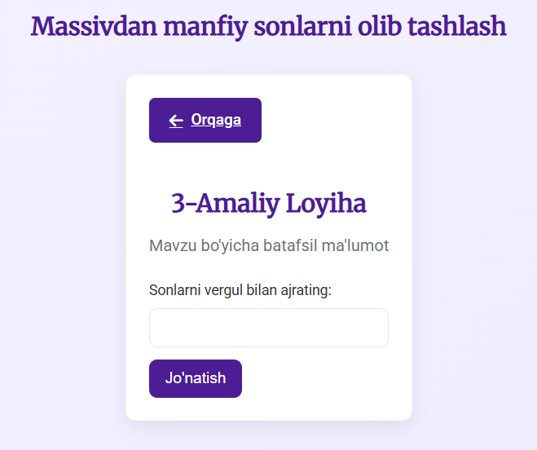
result3.php
<?php
// result3.php: kiruvchi massivdan manfiy sonlarni olib tashlash va natijani chiqarish
// Expect POST with 'numbers' field containing comma-separated values

if ($_SERVER['REQUEST_METHOD'] === 'POST') {
$input = trim($_POST['numbers']);
if ($input !== '') {
$parts = array_map('trim', explode(',', $input));
$nums = array_map('floatval', $parts);

// manfiylarni olib tashlash
$filtered = array_values(array_filter($nums, function($n) {
return $n >= 0;
}));

// Build an HTML response with shared styles
echo '<!DOCTYPE html>';
echo '<html lang="uz">';
echo '<head>';
echo ' <meta charset="UTF-8">';
echo ' <meta name="viewport" content="width=device-width, initial-scale=1.0">';
echo ' <title>Natija</title>';
echo ' <link rel="stylesheet" href="style.css">';
echo ' <link rel="preconnect" href="https://fonts.googleapis.com">';
echo ' <link rel="preconnect" href="https://fonts.gstatic.com" crossorigin>';
echo ' <link href="https://fonts.googleapis.com/css2?family=Merriweather&family=Roboto:wght@300;400;500;700&display=swap" rel="stylesheet">';
echo '</head>';
echo '<body>';
echo ' <div class="container">';
echo ' <header>';
echo ' <h1>Natija</h1>';
echo ' </header>';
echo ' <section class="result-box">';
echo ' <pre>' . htmlspecialchars(print_r($filtered, true)) . '</pre>';
echo ' </section>';
echo ' <footer style="margin-top:20px; text-align:center;">';
echo ' <a href="project3.html" class="action-btn back-btn">&larr; Ortga</a>';
echo ' </footer>';
echo ' </div>';
echo '</body>';
echo '</html>';
}
} else {
// POST bo'lmasa yuborish sahifasiga qayt
header('Location: project3.html');
exit;
}
