5-Lobaratoriya.PHP orqali CRUD (Create, Read, Update, Delete) amallarini bajarish

Ishdan maqsad
- PHP va MySQL yordamida ma’lumotlar bazasi bilan ishlashni o‘rganish
- CRUD (Create, Read, Update, Delete) amallarini amalda bajarish
- HTML forma orqali ma’lumotlarni kiritish va qayta ishlash
- Ma’lumotlar bazasidagi yozuvlarni chiqarish, tahrirlash va o‘chirish

Kerakli dasturiy vositalar
- XAMPP / OpenServer / Denwer
- PHP 7.x yoki yuqori
- MySQL
- Brauzer (Chrome, Edge va h.k.)
- Kod muharriri (VS Code, Sublime va boshqalar)

Nazariy qism
CRUD tushunchasi
CRUD – bu ma’lumotlar bazasida bajariladigan 4 asosiy amal:
Amal | Tavsif
Create | Yangi ma’lumot qo‘shish
Read | Ma’lumotlarni o‘qish (ko‘rish)
Update | Ma’lumotni tahrirlash
Delete | Ma’lumotni o‘chirish

1-qadam: Ma’lumotlar bazasini yaratish
phpMyAdmin orqali quyidagi SQL so‘rovni bajaring:
CREATE DATABASE talaba_db;
USE talaba_db;
CREATE TABLE talabalar (
id INT AUTO_INCREMENT PRIMARY KEY,
ism VARCHAR(50) NOT NULL,
familiya VARCHAR(50) NOT NULL,
yosh INT NOT NULL
);

2-qadam: Loyihaning fayl tuzilmasi
crud/
│
├── db.php
├── index.php
├── add.php
├── edit.php
├── delete.php

3-qadam: Ma’lumotlar bazasiga ulanish (db.php)
<?php
$conn = new mysqli("localhost", "root", "", "talaba_db");
if ($conn->connect_error) {
die("Ulanishda xatolik: " . $conn->connect_error);
}
?>

4-qadam: CREATE – Ma’lumot qo‘shish (add.php)
<?php
include 'db.php';
if(isset($_POST['submit'])){
$ism = $_POST['ism'];
$familiya = $_POST['familiya'];
$yosh = $_POST['yosh'];
$sql = "INSERT INTO talabalar (ism, familiya, yosh)
VALUES ('$ism', '$familiya', '$yosh')";
$conn->query($sql);
header("Location: index.php");
}
?>
<form method="POST">
Ism: <input type="text" name="ism"><br>
Familiya: <input type="text" name="familiya"><br>
Yosh: <input type="number" name="yosh"><br>
<button type="submit" name="submit">Saqlash</button>
</form>

5-qadam: READ – Ma’lumotlarni chiqarish (index.php)
<?php include 'db.php'; ?>
<a href="add.php">Yangi talaba qo‘shish</a>
<table border="1">
<tr>
<th>ID</th>
<th>Ism</th>
<th>Familiya</th>
<th>Yosh</th>
<th>Amallar</th>
</tr>
<?php
$result = $conn->query("SELECT * FROM talabalar");
while($row = $result->fetch_assoc()){
echo "<tr>
<td>{$row['id']}</td>
<td>{$row['ism']}</td>
<td>{$row['familiya']}</td>
<td>{$row['yosh']}</td>
<td>
<a href='edit.php?id={$row['id']}'>Tahrirlash</a>
<a href='delete.php?id={$row['id']}'>O‘chirish</a>
</td>
</tr>";
}
?>
</table>

6-qadam: UPDATE – Ma’lumotni tahrirlash (edit.php)
<?php
include 'db.php';
$id = $_GET['id'];
$result = $conn->query("SELECT * FROM talabalar WHERE id=$id");
$row = $result->fetch_assoc();
if(isset($_POST['update'])){
$ism = $_POST['ism'];
$familiya = $_POST['familiya'];
$yosh = $_POST['yosh'];
$conn->query("UPDATE talabalar
SET ism='$ism', familiya='$familiya', yosh='$yosh'
WHERE id=$id");
header("Location: index.php");
}
?>
<form method="POST">
Ism: <input type="text" name="ism" value="<?php echo $row['ism']; ?>"><br>
Familiya: <input type="text" name="familiya" value="<?php echo $row['familiya']; ?>"><br>
Yosh: <input type="number" name="yosh" value="<?php echo $row['yosh']; ?>"><br>
<button type="submit" name="update">Yangilash</button>
</form>

7-qadam: DELETE – Ma’lumotni o‘chirish (delete.php)
<?php
include 'db.php';
$id = $_GET['id'];
$conn->query("DELETE FROM talabalar WHERE id=$id");
header("Location: index.php");
?>

Topshiriqlar:
13.TOPSHIRIQ: “Farmatsiya Dorilar”
Database: pharmacy_supply_db
Jadval: medication_catalog
Ustunlar:
- medication_id
- medicine_name
- dosage_form
- active_component
- manufacturer_brand
- batch_number
- production_date
- expiry_limit
- ation_type
- available_slots
project5.php
<?php include 'db.php'; ?>
<!DOCTYPE html>
<html lang="uz">
<head>
<meta charset="UTF-8">
<meta name="viewport" content="width=device-width, initial-scale=1.0">
<title>Dorilar katalogi</title>
<link rel="stylesheet" href="style.css">
</head>
<body>

<div class="container">
<h1>Dorilar katalogi</h1>
<a href="add.php" class="add-link">+ Yangi dori qo'shish</a>
<div class="medication-table-wrapper">
<table class="medication-table medication-table-hover">
<thead>
<tr>
<th>ID</th>
<th>Nomi</th>
<th>Shakli</th>
<th>Faol komponent</th>
<th>Ishlab chiqaruvchi</th>
<th>Partiya</th>
<th>Ishlab chiqarilgan sana</th>
<th>Yaroqlilik muddati</th>
<th>Amallar</th>
</tr>
</thead>
<tbody>
<?php
$result = $conn->query("SELECT * FROM medication_catalog");
while($row = $result->fetch_assoc()): ?>
<tr>
<td><?= $row['medication_id'] ?></td>
<td><?= $row['medicine_name'] ?></td>
<td><?= $row['dosage_form'] ?></td>
<td><?= $row['active_component'] ?></td>
<td><?= $row['manufacturer_brand'] ?></td>
<td><?= $row['batch_number'] ?></td>
<td><?= $row['production_date'] ?></td>
<td><?= $row['expiry_limit'] ?></td>
<td>
<div class="action-buttons">
<a class='edit-btn' href='edit.php?id=<?= $row['medication_id'] ?>'>Edit</a>
<a class='delete-btn' href='delete.php?id=<?= $row['medication_id'] ?>'>Delete</a>
</div>
</td>
</tr>
<?php endwhile; ?>
</tbody>
</table>
</div>
</div>
</body>
</html>

<?php include 'db.php'; ?>
- db.php faylni ulaydi (include qiladi)
- Bu faylda odatda ma’lumotlar bazasiga ulanish ($conn) yozilgan bo‘ladi.
PHP orqali ma’lumot olish
- $result = $conn->query("SELECT * FROM medication_catalog");
medication_catalog jadvalidan barcha dorilar olinadi
Edit.php
<?php
include 'db.php';

$id=$_GET['id'];

$result=$conn->query("SELECT * FROM medication_catalog WHERE medication_id=$id");

$row=$result->fetch_assoc();

if(isset($_POST['update'])){

$medicine_name=$_POST['medicine_name'];
$dosage_form=$_POST['dosage_form'];
$active_component=$_POST['active_component'];
$manufacturer_brand=$_POST['manufacturer_brand'];
$batch_number=$_POST['batch_number'];
$production_date=$_POST['production_date'];
$expiry_limit=$_POST['expiry_limit'];

$conn->query("UPDATE medication_catalog SET

medicine_name='$medicine_name',
dosage_form='$dosage_form',
active_component='$active_component',
manufacturer_brand='$manufacturer_brand',
batch_number='$batch_number',
production_date='$production_date',
expiry_limit='$expiry_limit'

WHERE medication_id=$id");

header("Location:project5.php");
}
?>

<!DOCTYPE html>
<html lang="uz">
<head>
<meta charset="UTF-8">
<meta name="viewport" content="width=device-width, initial-scale=1.0">
<title>Dorini tahrirlash</title>
<link href="https://cdn.jsdelivr.net/npm/bootstrap@5.3.0/dist/css/bootstrap.min.css" rel="stylesheet">
<link rel="stylesheet" href="style.css">
</head>
<body class="bg-light">

<div class="container my-5">
<div class="row justify-content-center">
<div class="col-md-8">
<div class="card shadow-sm border-light">
<div class="card-body p-4">
<a href="project5.php" class="btn btn-outline-secondary btn-sm mb-3">&larr; Orqaga</a>
<h1 class="card-title mb-4">Dorini tahrirlash</h1>

<form method="POST">
<div class="mb-3">
<label for="medicine_name" class="form-label">Dori nomi:</label>
<input type="text" class="form-control" name="medicine_name" id="medicine_name" value="<?php echo $row['medicine_name']; ?>" required>
</div>

<div class="mb-3">
<label for="dosage_form" class="form-label">Dori shakli:</label>
<input type="text" class="form-control" name="dosage_form" id="dosage_form" value="<?php echo $row['dosage_form']; ?>" required>
</div>

<div class="mb-3">
<label for="active_component" class="form-label">Faol komponent:</label>
<input type="text" class="form-control" name="active_component" id="active_component" value="<?php echo $row['active_component']; ?>" required>
</div>

<div class="mb-3">
<label for="manufacturer_brand" class="form-label">Ishlab chiqaruvchi:</label>
<input type="text" class="form-control" name="manufacturer_brand" id="manufacturer_brand" value="<?php echo $row['manufacturer_brand']; ?>" required>
</div>

<div class="mb-3">
<label for="batch_number" class="form-label">Partiya raqami:</label>
<input type="text" class="form-control" name="batch_number" id="batch_number" value="<?php echo $row['batch_number']; ?>" required>
</div>

<div class="mb-3">
<label for="production_date" class="form-label">Ishlab chiqarilgan sana:</label>
<input type="date" class="form-control" name="production_date" id="production_date" value="<?php echo $row['production_date']; ?>" required>
</div>

<div class="mb-3">
<label for="expiry_limit" class="form-label">Yaroqlilik muddati:</label>
<input type="date" class="form-control" name="expiry_limit" id="expiry_limit" value="<?php echo $row['expiry_limit']; ?>" required>
</div>

<button name="update" class="btn btn-primary btn-lg w-100">Yangilash</button>
</form>
</div>
</div>
</div>
</div>
</div>
delete.php
<script src="https://cdn.jsdelivr.net/npm/bootstrap@5.3.0/dist/js/bootstrap.bundle.min.js"></script>
</body>
</html>
<?php
include 'db.php';

$id=$_GET['id'];
$conn->query("DELETE FROM medication_catalog WHERE medication_id=$id");
header("Location:project5.php");
?>
db.php
<?php
$conn = new mysqli("localhost","root","","pharmacy_supply_db");

if($conn->connect_error){
die("Ulanishda xatolik: ".$conn->connect_error);
}
?>
add.php
<?php
include 'db.php';

if(isset($_POST['submit'])){
$medicine_name=$_POST['medicine_name'];
$dosage_form=$_POST['dosage_form'];
$active_component=$_POST['active_component'];
$manufacturer_brand=$_POST['manufacturer_brand'];
$batch_number=$_POST['batch_number'];
$production_date=$_POST['production_date'];
$expiry_limit=$_POST['expiry_limit'];
$sql="INSERT INTO medication_catalog
(medicine_name,dosage_form,active_component,manufacturer_brand,batch_number,production_date,expiry_limit)
VALUES
('$medicine_name','$dosage_form','$active_component','$manufacturer_brand','$batch_number','$production_date','$expiry_limit')";
$conn->query($sql);
header("Location:project5.php");
}
?>
<!DOCTYPE html>
<html lang="uz">
<head>
<meta charset="UTF-8">
<meta name="viewport" content="width=device-width, initial-scale=1.0">
<title>Yangi dori qo'shish</title>
<link href="https://cdn.jsdelivr.net/npm/bootstrap@5.3.0/dist/css/bootstrap.min.css" rel="stylesheet">
<link rel="stylesheet" href="style.css">
</head>
<body class="bg-light">
<div class="container my-5">
<div class="row justify-content-center">
<div class="col-md-8">
<div class="card shadow-sm border-light">
<div class="card-body p-4">
<a href="project5.php" class="btn btn-outline-secondary btn-sm mb-3">&larr; Orqaga</a>
<h1 class="card-title mb-4">Yangi dori qo'shish</h1>
<form method="POST">
<div class="mb-3">
<label for="medicine_name" class="form-label">Dori nomi:</label>
<input type="text" class="form-control" id="medicine_name" name="medicine_name" required>
</div>
<div class="mb-3">
<label for="dosage_form" class="form-label">Dori shakli:</label>
<input type="text" class="form-control" id="dosage_form" name="dosage_form" required>
</div>
<div class="mb-3">
<label for="active_component" class="form-label">Faol komponent:</label>
<input type="text" class="form-control" id="active_component" name="active_component" required>
</div>
<div class="mb-3">
<label for="manufacturer_brand" class="form-label">Ishlab chiqaruvchi:</label>
<input type="text" class="form-control" id="manufacturer_brand" name="manufacturer_brand" required>
</div>
<div class="mb-3">
<label for="batch_number" class="form-label">Partiya raqami:</label>
<input type="text" class="form-control" id="batch_number" name="batch_number" required>
</div>
<div class="mb-3">
<label for="production_date" class="form-label">Ishlab chiqarilgan sana:</label>
<input type="date" class="form-control" id="production_date" name="production_date" required>
</div>
<div class="mb-3">
<label for="expiry_limit" class="form-label">Yaroqlilik muddati:</label>
<input type="date" class="form-control" id="expiry_limit" name="expiry_limit" required>
</div>
<button type="submit" name="submit" class="btn btn-primary btn-lg w-100">Saqlash</button>
</form>
</div>
</div>
</div>
</div>
</div>
<script src="https://cdn.jsdelivr.net/npm/bootstrap@5.3.0/dist/js/bootstrap.bundle.min.js"></script>
</body>
</html>
Bu loyihaning ko’rinishi

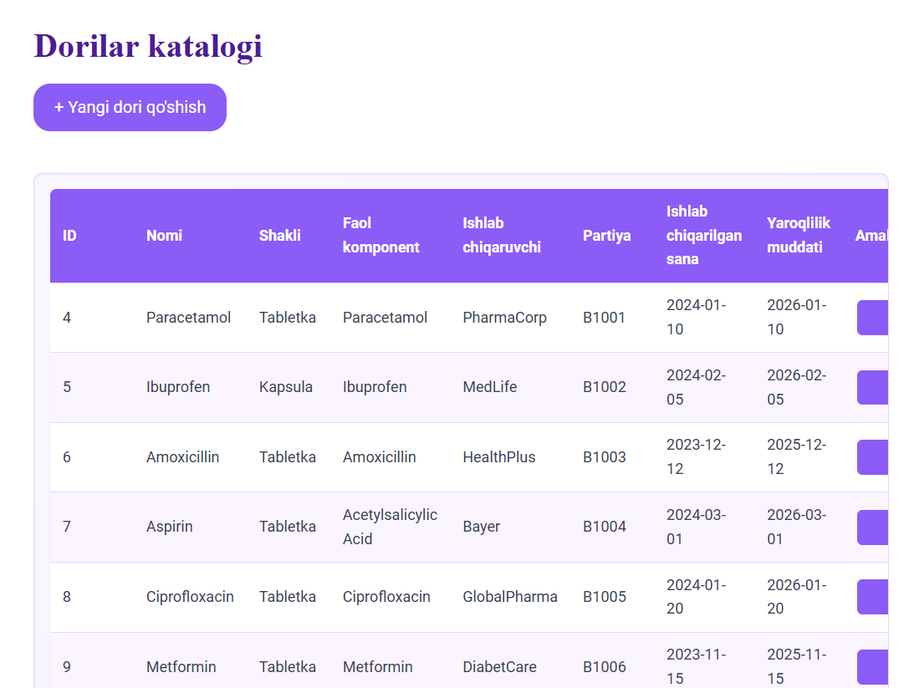
Bu loyihada CRUD amallaridan foydalanilgan.Edit bu yerda Tahrirlash uchun Delete esa o’chirish uchun buttonlar bu buttonlar dorini istiga borganda matnlari chiqadi show animatsiyasidan foydalanilgan.
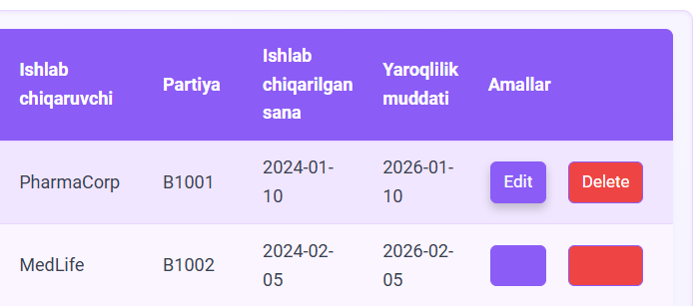

Yangi dori qo’shish uchun es alohida button bor va bu yerda jadavalga yangi dori qo’shish mumkin

