Introduction in Brief

Chapter-1 Home Page

1. Default as home page

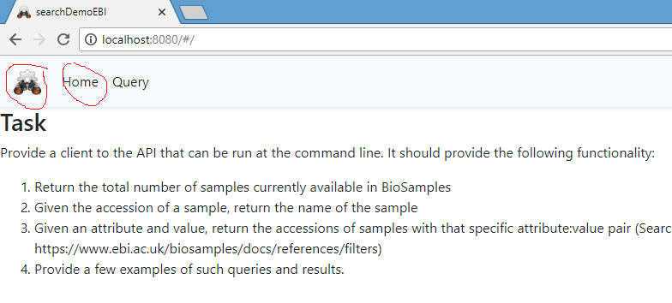

1. After click on Home or logo, change to home page

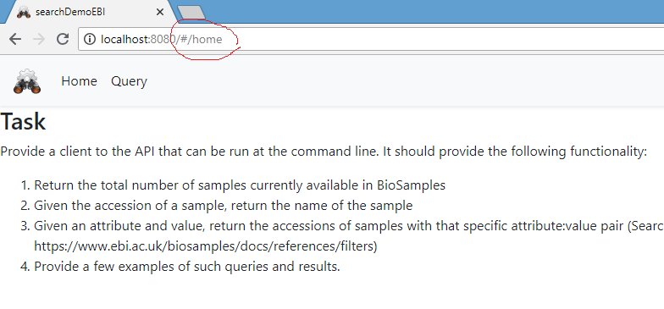

Chapter-2 Query Page

1. Click on Query to open Query page

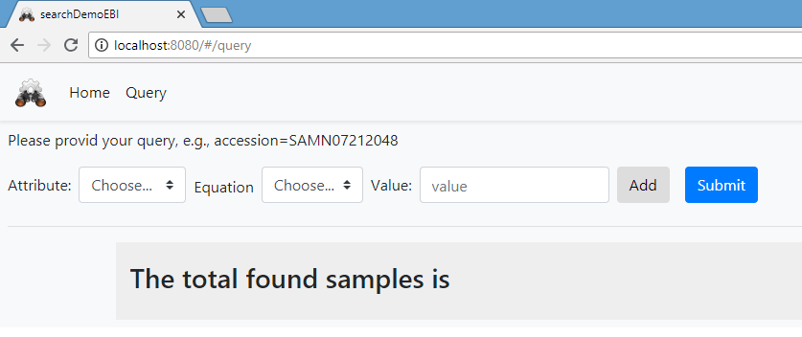

1. When click on Submit button to search all, by default search by accession all, here just display 20

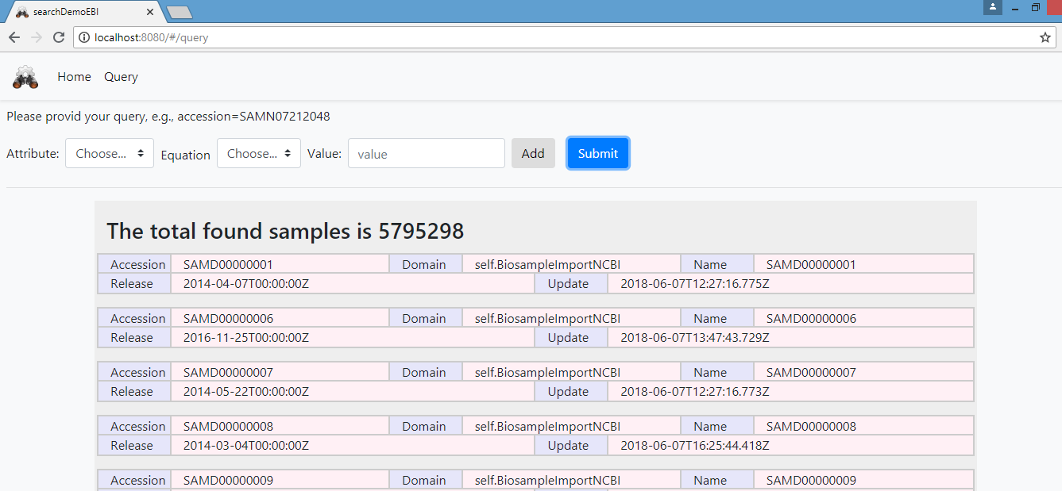

1. Change query condition by giving an attribute name and the value, for example, choose attribute name as accession, equation is ‘=’, and value is ‘SAMN07212048’, then click on button Add

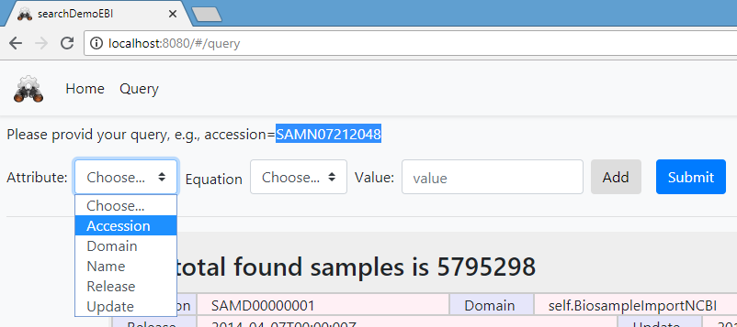

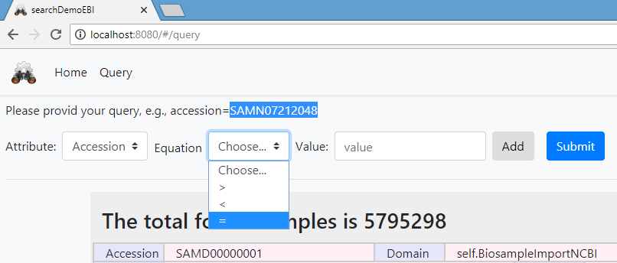

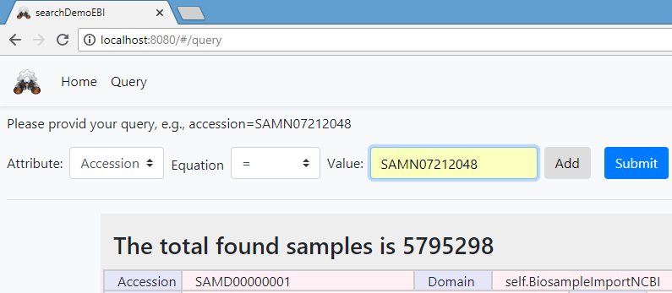

1. After click on button Add, the query condition is shown below.

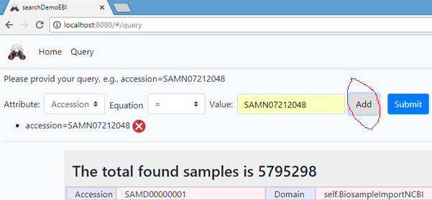

Click on the Submit button to find the sample by the given query

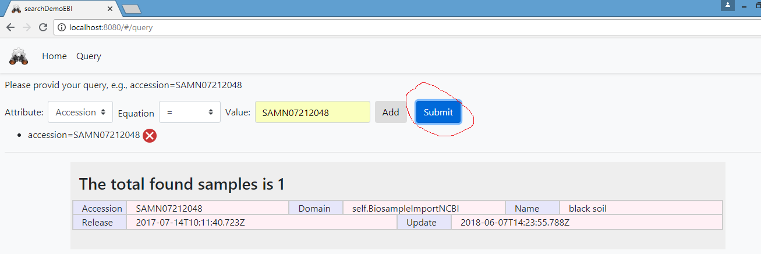

1. Add more query conditions and remove

Choose an attribute and a given value, then click button add to add one query condition, for example, “release>2014-10-01”

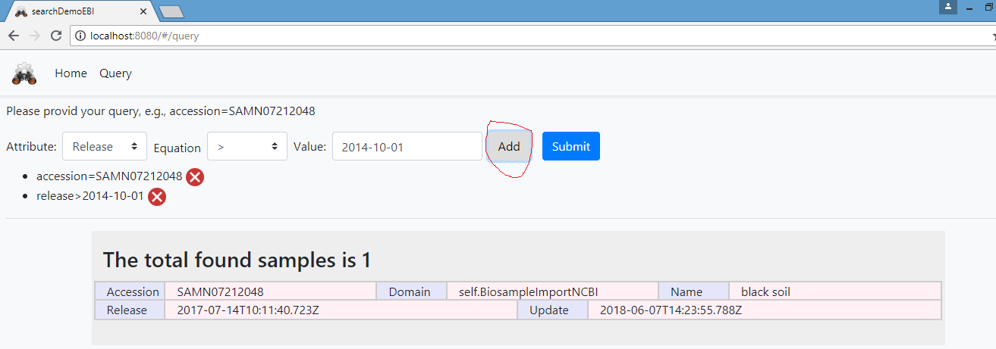

Another example of “update<2015-12-01”

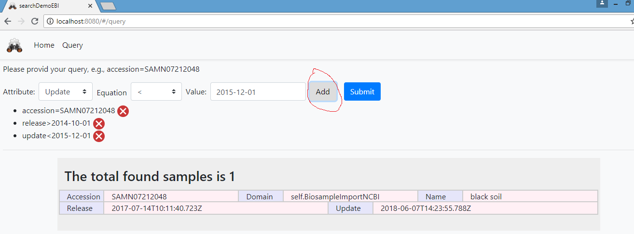

Click on the red delete icon to remove one, for example, remove “accession= SAMN07212048”

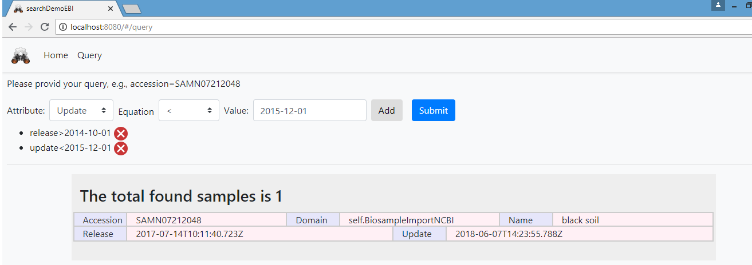

1. Search by the combination of query conditions

In the step5, we can design a complex query, then click on Submit to find, for example,

“release>2014-10-01 and update<2015-12-01”

However, the search with a combination of query conditions needs EBI service support. So far to my knowledge, I don’t know where to found out the document about the combination query search.

1. The code content is shown below:

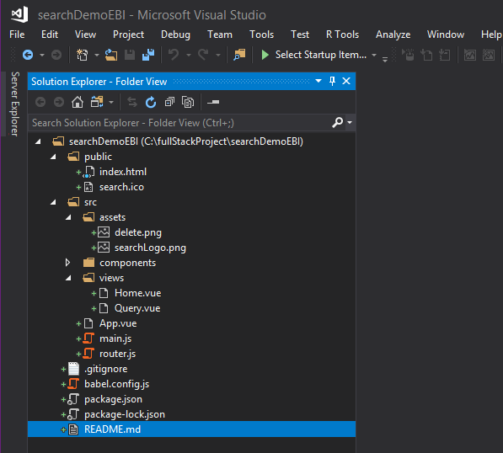

Chapter-3 Summary

This is an outline of a client site to search samples through EBI API. About searching with complex queries, it needs EBI API detail document and EBI API server support.