IT5514 Applied Machine Learning
Assignment

Explainable Boosting Machine for Sri Lankan Used Vehicle Listing Prices
Index Number: 269112B
An interpretable additive model with comparison against the historical five model study

Abstract
This study uses an Explainable Boosting Machine (EBM) to predict Sri Lankan used vehicle advertised prices and explain its estimates. The verified dataset contains 9,770 cleaned observations and 13 predictors. Six additive configurations are compared through 30 grouped validation fits on 7,811 development rows. On the previously inspected 1,959-row holdout, the selected EBM achieves MAE 9.7644, RMSE 23.9079 and R² 0.6875; its grouped CV MAE is 10.3020. Its error is higher than the historical Random Forest’s MAE of 4.9093. Global feature effects and a local contribution sum show how the EBM forms predictions. Negative estimates, sparse categories and large expensive-vehicle errors limit its use. Results describe historical asking prices in unresolved dataset units, not current sale values.

1 Introduction
Used vehicle prices vary with model, age, engine capacity, location and equipment. Regression can help compare advertisements, but a predicted price alone does not show how the inputs contributed to it. I chose EBM to examine both prediction error and the model’s learned feature effects. Its separate functions can capture nonlinear patterns, such as changes with manufacturing year, and each prediction can be broken into signed contributions. This makes it useful for studying price patterns and explaining individual estimates, even when another model predicts more accurately.
EBM was not mentioned in the supplied eleven-lecture transcript. It is a generalized additive model whose training uses gradient boosting, which was covered in class. This study focuses on its additive architecture and direct explanations [2], [3]. Formal lecturer eligibility has not been confirmed. EBM is the new algorithm investigated; Random Forest remains the historical accuracy-selected winner.

2 Dataset and data quality
Prasad Nirmal’s Kaggle version 3 dataset contains 9,788 records and 17 columns [1]. Project provenance records advertisements from ikman.lk and Riyasewana.com between 3 December 2024 and 5 February 2025. The loader verifies the approved SHA256. Removing the exported index and 18 exact duplicate rows leaves 9,770 observations with no missing values in this version. The target is advertised Price; the currency scale remains unconfirmed.
Table 1. The thirteen retained predictors
Type | Retained predictors
Continuous | YOM; Engine (cc)
Nominal | Brand; Model; Gear; Fuel Type; Town; Leasing; Condition; AIR CONDITION; POWER STEERING; POWER MIRROR; POWER WINDOW

Millage(KM) = (2025 − YOM) × 11,000
This relationship holds for all cleaned rows. Mileage adds no independent odometer information and is excluded. This establishes redundancy, not target leakage by itself. Date is also excluded. Development prices are right-skewed: median 43.00, 95th percentile 123.84 and maximum 575. Of 1,379 development model names, 1,122 occur fewer than five times. Rare categories and extreme prices are retained.

3 Model and evaluation methodology

Additive prediction and native inputs
With interactions disabled, the EBM predicts a price by adding thirteen learned feature contributions to an intercept, which is the model’s starting value [2], [3]:
ŷ(x) = β₀ + f₁(x₁) + f₂(x₂) + … + f₁₃(x₁₃)
During boosting, small trees repeatedly adjust the feature functions to reduce prediction error. Conventional gradient boosting, XGBoost and CatBoost can learn interactions by combining inputs within trees. Here, each EBM function uses one feature, so its contribution can be inspected separately. This restriction may miss useful combinations of attributes. The configured regression objective is RMSE. The identity link means no final nonlinear transformation is applied: the intercept and contributions add directly in dataset price units. Numeric ranges and category bins avoid a large one-hot matrix.
The input schema keeps the approved names and order, converts numeric inputs and maps missing categories to native missing bins. Bin boundaries and category mappings are learned from the current outer training partition, without using outer validation or holdout rows. Missing and unseen values produce finite estimates in the compatibility tests, but there are no observed training examples for those bins, so the estimates remain uncertain.

Reuse of saved outer partitions
The historical split reserved 20% of exact predictor groups with seed 42, producing 7,811 development and 1,959 holdout rows. This extension reads the saved row IDs, group hashes and five development GroupKFold assignments; it does not regenerate them. The data contain 8,912 exact predictor groups, including 479 groups with conflicting prices. Price and date do not enter group keys. Every outer training/validation pair and the development/holdout boundary has zero shared groups [4].
Identical attributes do not prove that advertisements describe the same physical vehicle, and near-duplicates may remain. The dataset and holdout results had already been inspected in the historical study. This extension therefore does not provide an untouched independent benchmark. EBM selection uses development MAE only; its configuration is frozen before the final holdout evaluation.

Group preserving internal validation
Each EBM fit uses four internal bags, meaning four training and validation assignments. Each assignment reserves 15% of the current training partition’s groups for validation, using seeds 42–45. A group cannot appear in both roles within a bag, and outer validation rows never enter fitting. The supplied assignments and returned training weights were checked. This supports group-preserving early stopping, although each bag trains on fewer rows than the complete outer training partition.
The historical median and Ridge models provide constant and regularized linear references. RF averages randomized trees [5]; XGBoost and CatBoost add trees sequentially [6], [7]. These tree ensembles can learn interactions. The original study tested 34 configurations through 170 CV fits and selected RF using development CV. This later extension adds six EBM configurations and 30 CV fits. The five historical models were not refitted. Their outer folds are reused, but their learning procedures differ. The historical random-split sensitivity study remains separate and does not select EBM or revise the RF winner.

Supporting implementation
The notebook explains the study while supporting Python modules implement validation, training and inference. Completed folds are saved so an interrupted run can resume. The exported models are checked by checksum and by comparing their predictions after reloading.

4 Hyperparameter engineering and computation
The EBM search was fixed before tuning: six configurations and five saved folds, giving 30 outer fits. Bins control numeric resolution, learning rate controls the size of each update, and minimum leaf support limits small partitions. The additive structure, four outer bags, no inner bags and one worker are fixed. Mean grouped CV MAE selects the configuration; RMSE is the training objective. The sample fold standard deviation (SD) describes variation across the five validation folds, not a confidence interval.
Table 2. Predeclared candidates and actual five-fold results
ID | Bins | Rate | Leaf | CV MAE | SD | Fit s
C0 | 128 | 0.04 | 10 | 10.3697 | 0.7604 | 21.86
C1 | 256 | 0.04 | 10 | 10.3306 | 0.7302 | 19.01
C2 | 128 | 0.02 | 10 | 10.3142 | 0.7452 | 32.45
C3 | 128 | 0.04 | 20 | 10.3715 | 0.7377 | 22.35
C4 | 256 | 0.02 | 20 | 10.3020 | 0.7134 | 34.38
C5 | 256 | 0.04 | 20 | 10.3460 | 0.7238 | 19.42

All candidates use interactions 0, max_leaves 3, max_rounds 2,000, outer_bags 4, inner_bags 0, early_stopping_rounds 50, smoothing_rounds 100, greedy_ratio 0, min_cat_samples 10, cat_smooth 10 and random_state 42. n_jobs is 1; BLAS/OpenMP thread limits are 2. Full parameters and dependency versions are saved with the experiment.
C4 was selected with 256 bins, learning rate 0.02 and minimum leaf support 20. Its CV MAE is 10.3020 ± 0.7134. C2 is close at 10.3142, so the small gap should not be overinterpreted. No configuration was added after holdout inspection. Five of 120 CV bag counters and one of four final bags reached the configured limit. The bounded experiment therefore does not show that every bag had fully converged; the stopping records are retained.

Pilot and resource safeguards
Experiments ran locally in an isolated Python 3.12.10 environment with interpret-core 0.7.8. A development-only pilot used 2,000 rows and a 200-round limit. It fitted in 0.92 seconds, with sampled peak process memory of 156.06 MiB, and verified native input handling and export/reload. The original accepted environment was unchanged.
Training ran sequentially on the approximately 8 GB laptop, with one EBM worker and limited numerical-library threads. A safeguard stopped the first run after three saved folds when available RAM fell below 512 MiB. After other applications were closed, those fits were reused and the remaining 27 completed without changing the experiment. Total measured CV fit time was 149.47 seconds and sampled peak process memory was 204.93 MiB. Detailed monitoring and interruption evidence are retained in the verification documentation.

5 Evaluation and historical comparison
MAE (mean absolute error) averages absolute price errors. RMSE (root mean squared error) gives larger errors more weight. Both use original price units. R² compares squared error with predicting the test-set mean for every listing; it can be negative and is not percentage accuracy. Table 3 separates historical accepted results from the EBM extension, rather than presenting a new joint six-model selection experiment.
Table 3. Historical five-model results and subsequent EBM extension
Model | CV MAE | Test MAE | RMSE | R²
Median | 28.3609 | 27.8855 | 44.0346 | -0.0602
Ridge | 8.5247 | 8.4133 | 21.4865 | 0.7476
Random Forest | 5.6002 | 4.9093 | 19.0170 | 0.8023
XGBoost | 6.3770 | 5.9851 | 19.5078 | 0.7919
CatBoost | 6.8716 | 6.5747 | 19.9406 | 0.7826
EBM | 10.3020 | 9.7644 | 23.9079 | 0.6875

RF remains the historical selected model, with CV MAE 5.6002 and test MAE 4.9093. EBM’s test MAE 9.7644, RMSE 23.9079 and R² 0.6875 are worse than Ridge and the historical tree ensembles. Its value here is direct inspection of feature effects and prediction contributions. The additive restriction and small search may limit performance; this does not show that interpretability always reduces accuracy.
Table 4. Recorded final development fit cost and exported size
Model | Final fit s | Bundle MiB
Median | 0.083 | 0.010
Ridge | 0.203 | 0.023
Random Forest | 52.429 | 20.499
XGBoost | 1.753 | 1.195
CatBoost | 28.656 | 3.792
EBM | 7.870 | 0.141

The final EBM fit took 7.87 seconds and exported a 147,531-byte model. Reloading reproduced the holdout predictions. Timing comparisons are approximate because runs occurred at different times. Historical bundles may include companion native exports; file size does not measure inference memory.

Errors and implausible outputs
For the 20 holdout listings above 200 units, EBM MAE is 91.51 and mean residual is +88.01. Residual means actual minus predicted price, so the positive mean shows substantial underprediction. MAE is 8.35 for prices up to 25, 8.74 for over 25 to 50, 7.50 for over 50 to 100, and 17.66 for over 100 to 200. Different group sizes and compositions limit comparisons across these bands.
Of 1,959 holdout estimates, 38 are negative (1.94%). The identity link does not force positive prices. Negative estimates remain in the metrics and are flagged in the UI without clipping. Changing the target, link or constraints would require another development study and independent evaluation.

6 Global explanations and manufacturing year
Native term importance is the development-weighted mean absolute contribution. Year contributes most (23.39), followed by Brand (11.26), engine capacity (8.09), Model (6.36) and Gear (3.42). It measures typical contribution magnitude, not an error increase or a causal effect.
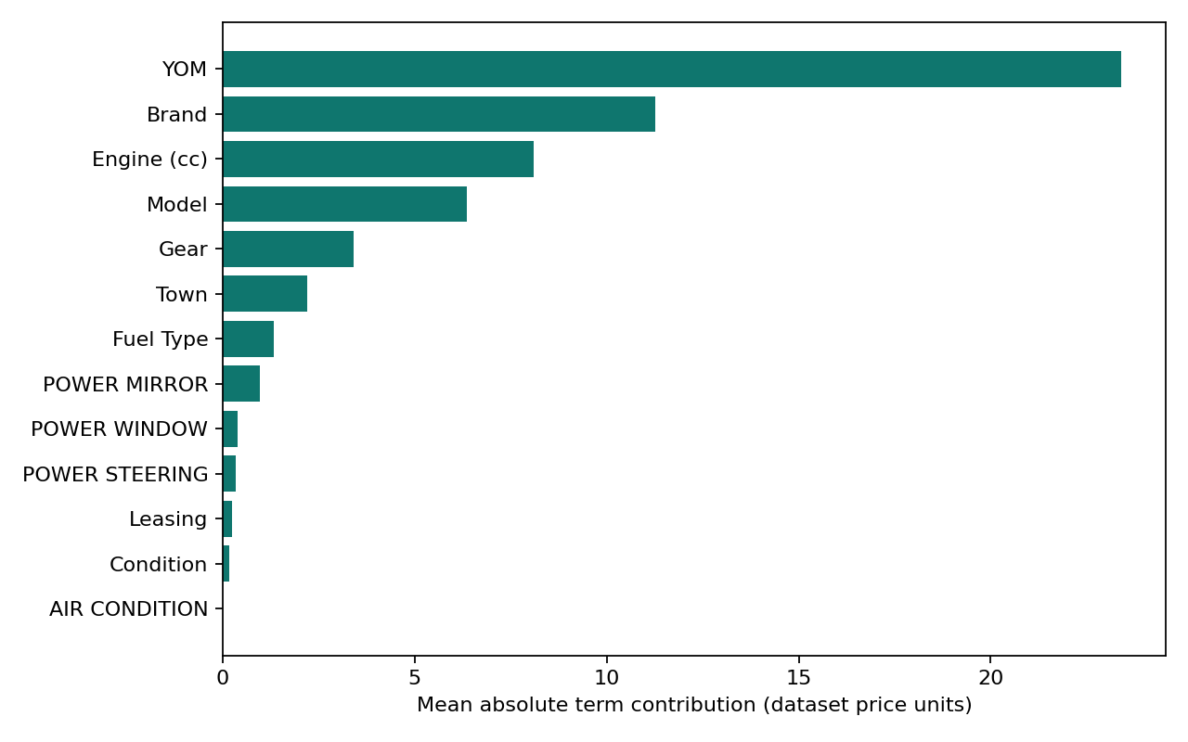
Figure 1. Native EBM importance from the actual selected model.
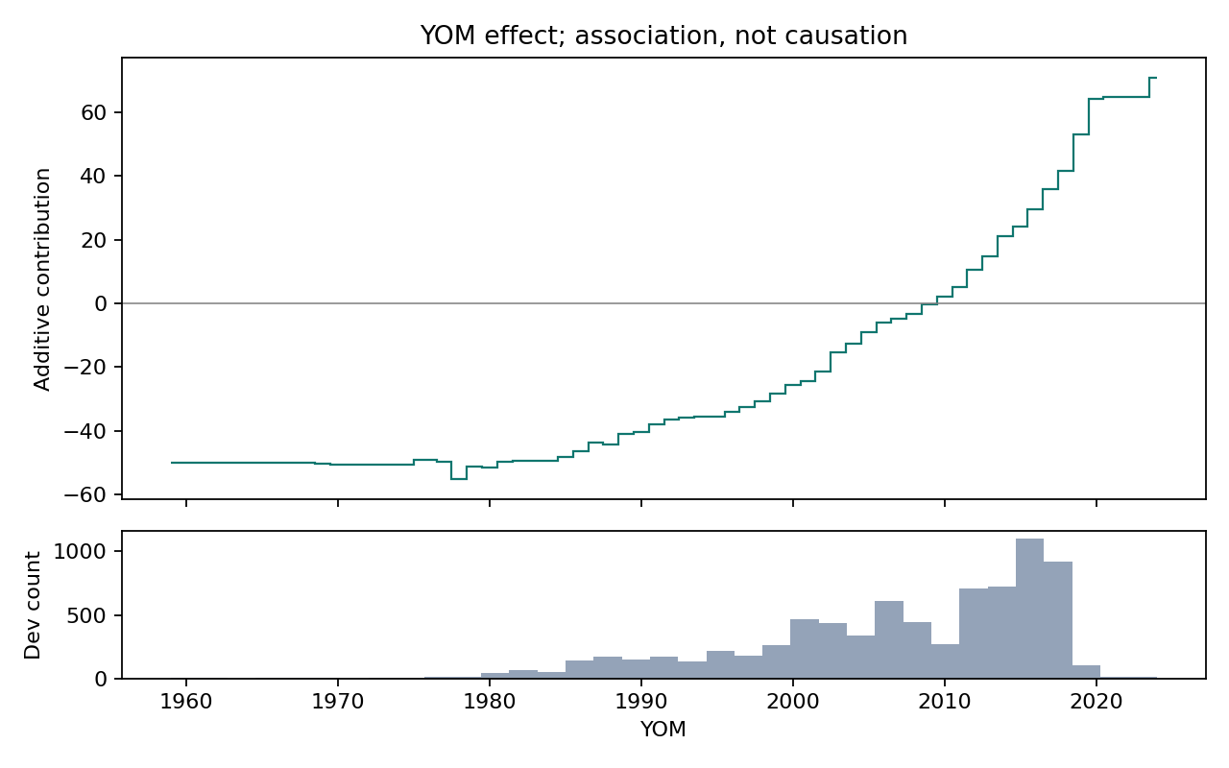
Figure 2. Manufacturing-year term with development support counts.
Newer manufacturing years generally receive more positive contributions, which is consistent with age-related asking prices. Recent years have much more data than the oldest vehicles. The old-year plateau is therefore weak evidence about older cars. Year, brand and model are also related, so the functions should not be read as independent causal effects.

7 Engine and categorical explanations
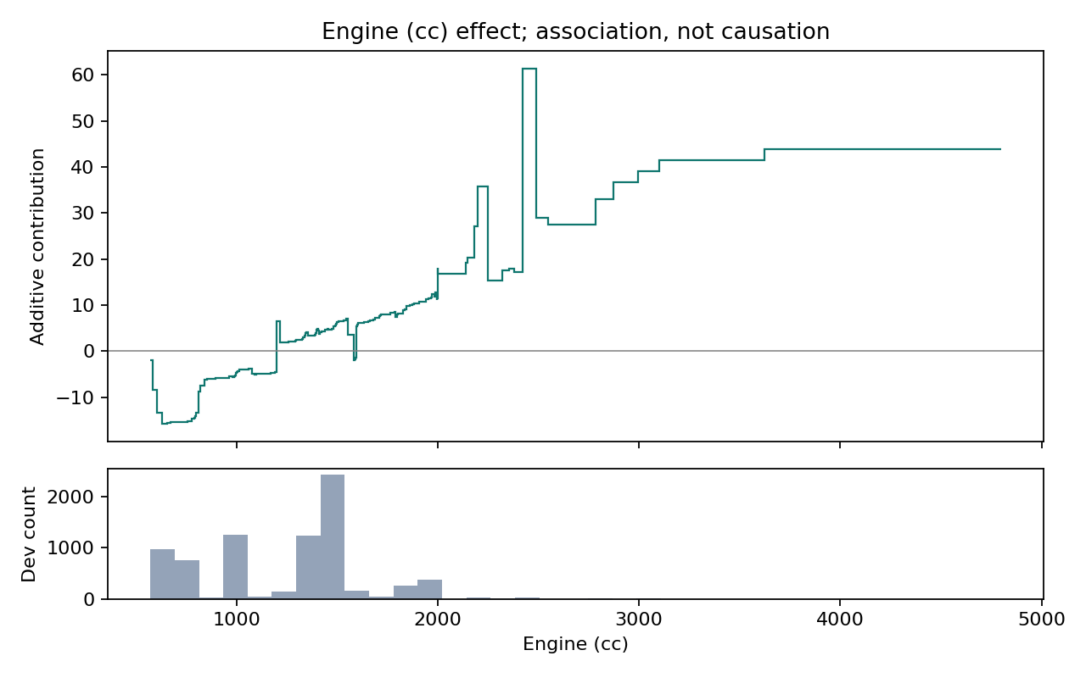
Figure 3. Engine-capacity contribution and development histogram.
Engine effects generally rise, but there are sharp jumps and plateaus above about 2,000 cc, where data support is sparse. These irregular steps need caution. The curve describes the fitted model’s association with engine capacity, not the value added by changing an engine.
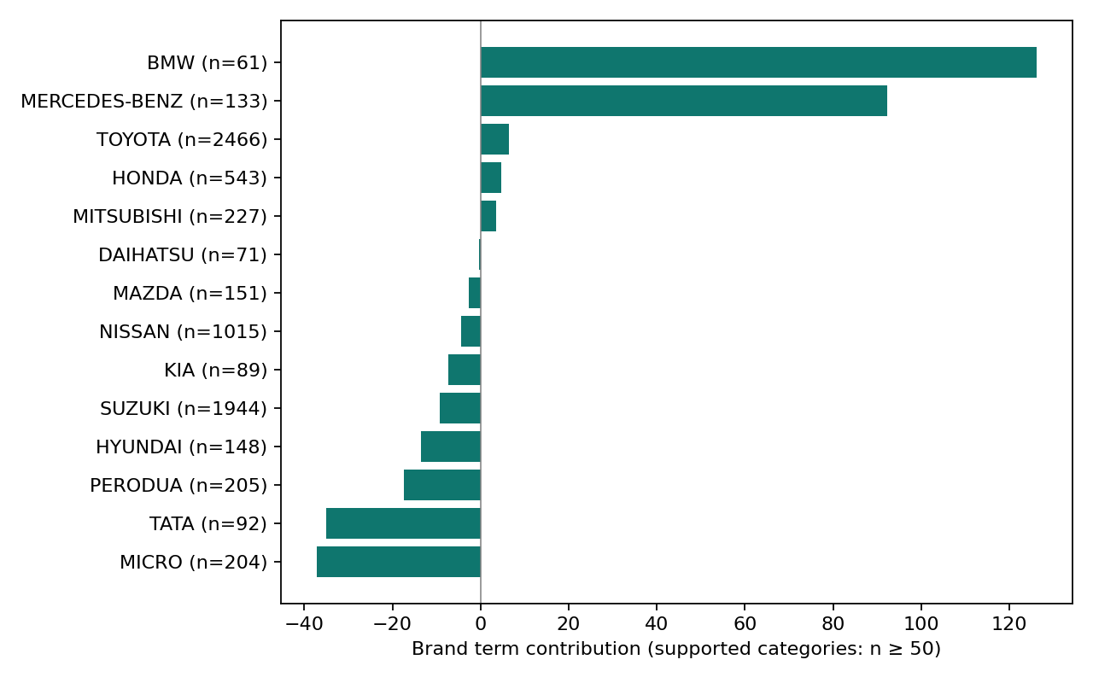
Figure 4. Brand effects for categories with at least 50 development rows.
BMW (n = 61) and Mercedes-Benz (n = 133) have large positive Brand terms, while Toyota has much more data (n = 2,466). The support threshold filters only this plot; no categories were removed from training. Brand effects reflect the mix of cars and related attributes in the data, not a guaranteed price premium.

8 Local explanation and complementary XAI
Cleaned row 11, the historical demonstration observation, was declared in the EBM protocol before its EBM error was inspected. It is an Audi A3 manufactured in 2018 with a 1,000 cc petrol engine, automatic transmission and Kandy location. Its advertised price is 139.00. The new EBM prediction is 149.4042, giving absolute error 10.4042; the historical RF prediction remains 141.4569.
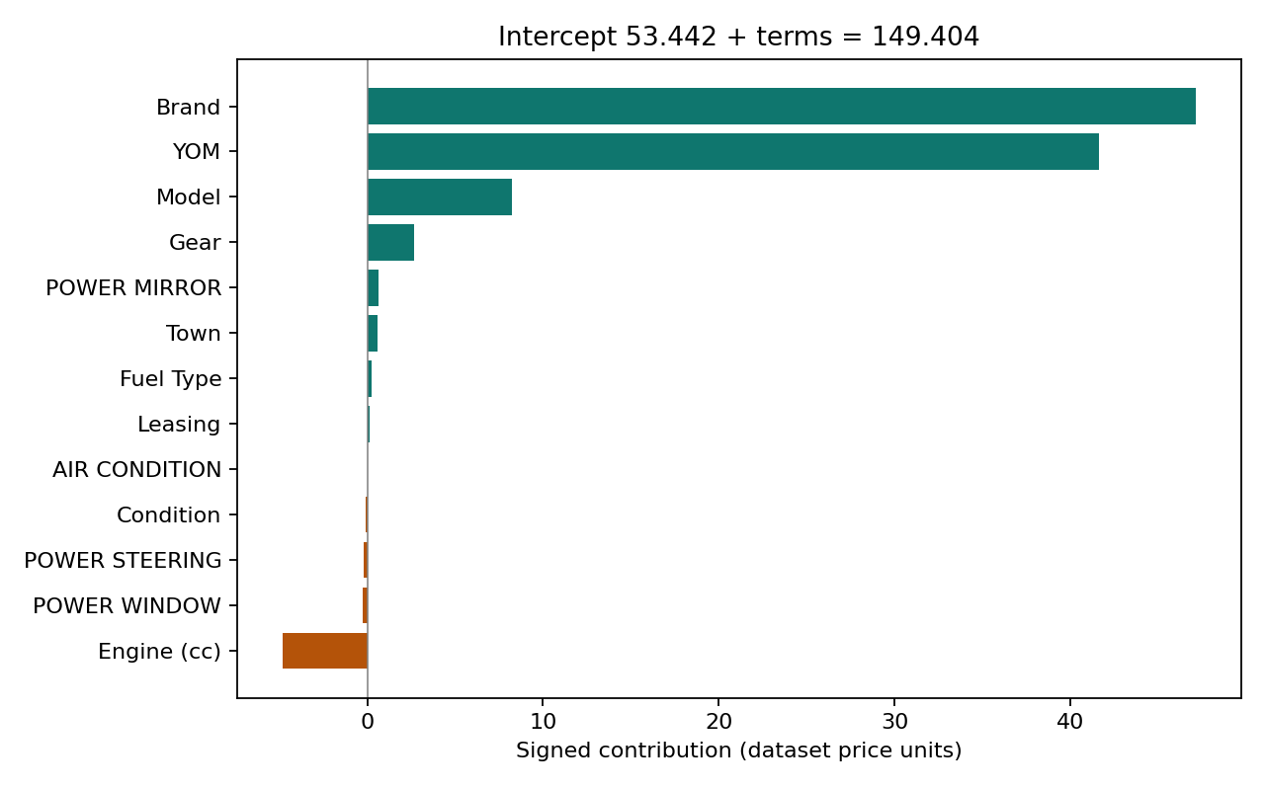
Figure 5. All thirteen signed EBM contributions for the predeclared Audi example.
Table 5. Numerical verification of the additive explanation
Component | Dataset units
Intercept | 53.441960
Sum of positive terms | 101.272019
Sum of negative terms | -5.309775
Intercept plus all terms | 149.404204
Raw EBM prediction | 149.404204
Absolute numerical difference | 2.84e-14

The explanation starts at the intercept of 53.441960. All signed terms together add about 95.962244, giving the raw EBM prediction of 149.404204. For this Audi, Brand (+47.1135) and year (+41.5978) are the largest positive terms, while engine capacity contributes −4.8009. These values explain the fitted estimate; they do not show what would happen if a vehicle attribute were changed. The sum matches the prediction within floating-point tolerance.
The historical RF permutation analysis provides a different view. Shuffling year increases MAE by 20.25, Brand by 8.92 and engine capacity by 7.40. These values measure loss after disturbing an input. EBM native importance measures average contribution magnitude instead. The measures cannot be compared numerically as equivalent effects, and neither establishes causation.

9 Local demonstration and responsible use
The Streamlit interface retains RF inference and adds an EBM prediction, signed waterfall and full contribution table. Both use saved fitted models, and performance values come from recorded results. The two studies are labelled separately. The form guides users with observed brand/model choices and numeric ranges, and warns about rare values. Tests also cover missing and unseen inputs. A negative EBM estimate is shown unchanged with a warning, preserving the contribution sum.
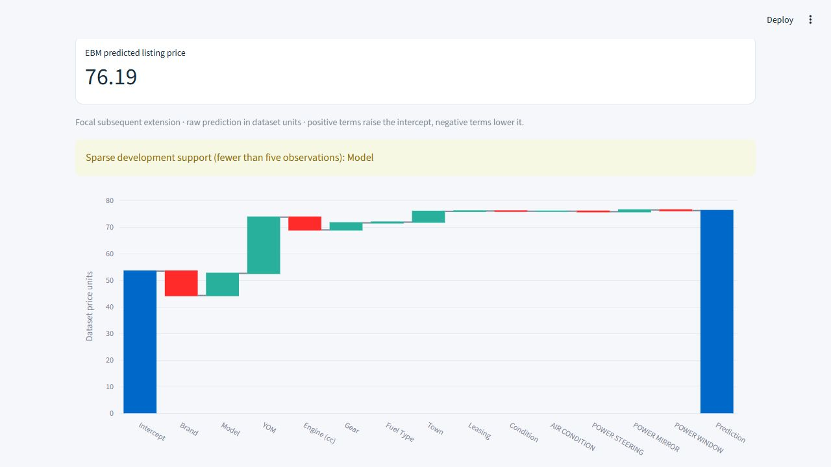
Figure 6. Verified Streamlit EBM prediction and contributions for a Suzuki A Star form input.

Limitations bias and data rights
The data contain historical asking prices, not verified sales or current valuations, and their currency scale is unresolved. Rare categories, missing condition details and prior dataset exposure limit generalization. Grouping identical attributes does not identify physical vehicles or eliminate near-duplicates. The holdout had already been inspected. The additive search is small and provides no calibrated uncertainty interval. Negative estimates and expensive-vehicle errors make the app unsuitable as an authoritative pricing service.
Town, brand and equipment may reflect social or geographic market differences. Demographic labels are absent, so the study cannot establish demographic fairness. Overstating these predictions could mislead buyers or sellers. Dataset and marketplace rights also constrain redistribution. The proposed submission provides acquisition instructions and a checksum rather than the raw CSV; source attribution is retained.

Conclusion and future work
EBM provides feature effects and individual predictions that can be examined directly, although its errors here were higher than those of RF and Ridge. The study shows how this interpretable model behaves and where its estimates are limited. Future work could use verified mileage, transaction prices and later independent listings, then investigate positivity constraints or interactions using development data. Those extensions were not performed. The existing holdout should not guide repeated model revisions.

References
[1] P. Nirmal, “SriLankan Vehicle(Car) Price Dataset,” Kaggle, version 3. Available: https://www.kaggle.com/datasets/prasadnirmal/srilankan-second-vehiclecar-price-dataset
[2] InterpretML developers, “Explainable Boosting Machine,” official documentation. Available: https://interpret.ml/docs/ebm.html
[3] InterpretML developers, “ExplainableBoostingRegressor,” API documentation; implementation used interpret-core 0.7.8. Available: https://interpret.ml/docs/python/api/ExplainableBoostingRegressor.html
[4] scikit-learn developers, “Cross-validation: evaluating estimator performance,” official documentation. Available: https://scikit-learn.org/stable/modules/cross_validation.html
[5] L. Breiman, “Random Forests,” Machine Learning, vol. 45, pp. 5–32, 2001. doi: 10.1023/A:1010933404324.
[6] T. Chen and C. Guestrin, “XGBoost: A Scalable Tree Boosting System,” arXiv:1603.02754, 2016. Available: https://arxiv.org/abs/1603.02754
[7] L. Prokhorenkova et al., “CatBoost: unbiased boosting with categorical features,” Advances in Neural Information Processing Systems, vol. 31, 2018. Available: https://proceedings.neurips.cc/paper/2018/hash/14491b756b3a51daac41c24863285549-Abstract.html

