1. **查理的新一天**  
   查理穿着条纹衬衫、吊带裤和圆形眼镜，笑容满面地从床上跳下来。他兴奋地说：“今天会是充满乐趣的一天！”  
   **Charlie’s New Day**  
   Charlie, wearing a striped shirt, suspenders, and round sunglasses, jumps out of bed with a big smile. He excitedly says, “Today is going to be a fun day!”



1. **查理在公园**  
   查理来到了公园，他看到远处有一个小女孩正坐在秋千上，看起来有点孤单。查理走过去，笑着说：“嗨！我叫查理，想一起玩吗？”  
   **Charlie in the Park**  
   Charlie arrives at the park and notices a little girl sitting alone on a swing, looking a bit lonely. Charlie walks over, smiling, and says, “Hi! I’m Charlie. Want to play with me?”

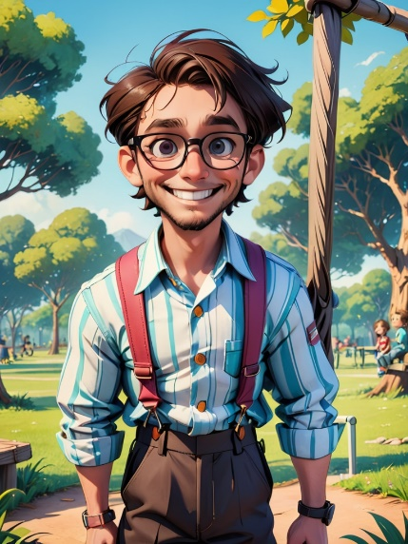

1. **新的朋友**  
   小女孩笑了，点了点头：“你好！我叫小雪。”查理高兴地牵着她的手，带她去玩跳绳。  
   **New Friends**  
   The little girl smiles and nods, “Hi! I’m Snow.” Charlie happily takes her hand and leads her to play jump rope.



1. **一起游戏**  
   查理和小雪开始玩跳绳，跳得又快又开心。查理笑着说：“跳绳真的好好玩！”  
   **Playing Together**  
   Charlie and Snow start jumping rope together, laughing and having fun. Charlie says, “Jump rope is so much fun!



1. **伸出援手**  
   查理注意到一位老奶奶在公园长椅上休息，她的购物袋看起来很沉。查理走过去，轻声问：“奶奶，我可以帮您提一下袋子吗？”  
   **Lending a Hand**  
   Charlie notices an elderly lady sitting on a park bench, and her shopping bags look heavy. Charlie walks over and gently asks, “Can I help you with your bags, Grandma?”



1. **帮忙的小行动**  
   查理帮助老奶奶提起购物袋，一起走到她的家门口。老奶奶感谢地说：“谢谢你，查理，真是个善良的孩子！”  
   **A Little Act of Help**  
   Charlie helps the elderly lady carry her shopping bags, walking her to her doorstep. The lady thanks him, saying, “Thank you, Charlie. You’re such a kind boy!” 
2. **查理和小雪的合作**  
   查理和小雪一起开始搭建一个沙堡，他们一起动手堆沙子、挖沟，团队合作让他们完成了一个大沙堡。  
   **Charlie and Snow Working Together**  
   Charlie and Snow start building a sandcastle together. They work as a team, piling up sand and digging trenches, and soon they have built a big sandcastle.



1. **分享零食**  
   查理从背包里拿出自己喜欢的饼干，递给小雪：“你喜欢这些吗？一起吃吧！”小雪开心地接过零食：“谢谢你，查理！”  
   **Sharing Snacks**  
   Charlie takes out his favorite cookies from his backpack and offers them to Snow, “Do you like these? Let’s share!” Snow happily takes the snack, “Thank you, Charlie!”



1. **帮助小动物**  
   查理和小雪看到一只小鸟飞到了低矮的树枝上，看起来有点困。他们小心翼翼地帮助小鸟飞走，查理说：“每一个生命都值得我们关心！”  
   **Helping a Little Animal**  
   Charlie and Snow see a little bird stuck on a low branch. They carefully help the bird fly away, and Charlie says, “Every living creature deserves our care!”

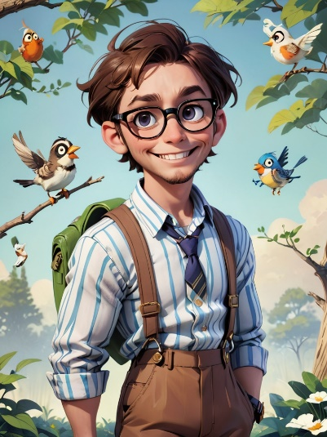

1. **告别与期待**  
   夕阳渐渐落下，查理和小雪站在公园的草地上，互相挥手告别。查理说：“明天见！我们再一起玩吧！”  
   **Saying Goodbye and Looking Forward**  
   As the sun begins to set, Charlie and Snow stand on the grass in the park, waving goodbye to each other. Charlie says, “See you tomorrow! Let’s play again!”

