***Racing Game Design***

**1. General Info:**

Racing Game web application developed on base of Java 7, using Servlet 3 container as server site technology, and combination of HTML5 CSS and JavaScript on client site. For transferring data between server and client JSON data structure was used.

All the "logic" performed by server, the client side deals with display issues only and gets all calculated data from server.

The game has one html page that includes 3 layers – registration, play zone and the results. To manipulate presentation view JQuery library used.

**2. Package Diagram:**

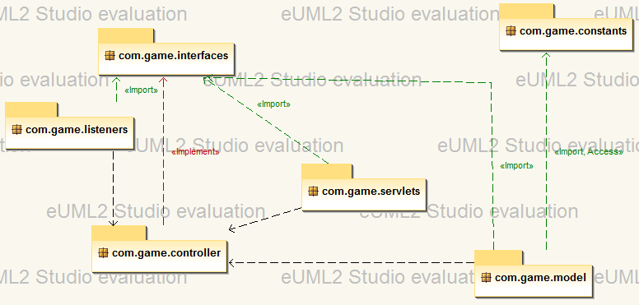

**3. Class Diagrams:**

***com.game.constants***

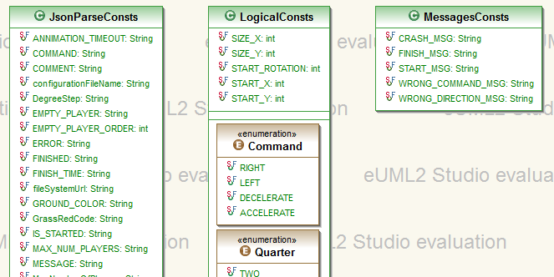

These 3 classes serve the whole project with different type of constant parameters.

***com.game.listeners***

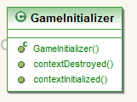

***com.game.servlets***

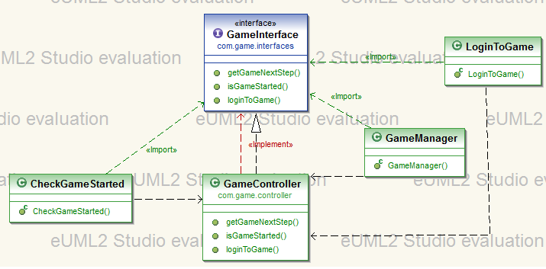

***com.game.interfaces***

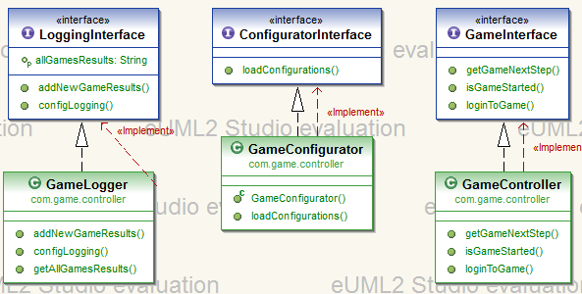

***com.game.controller***

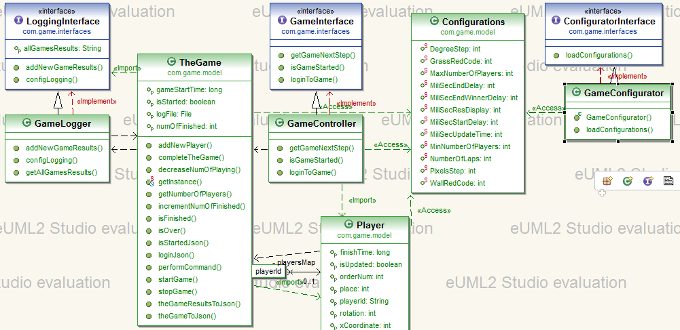

***com.game.model***

