**Yuliang Jin 986381**

**Problem 1**

A. Is the graph G connected? If not, what are the connected components for G? No, connected components are: (A, B, C, F, H, G),(D, E, I)

B. Draw a spanning tree/forest for G

C. Is G a Hamiltonian graph? No, because there is no Hamiltonian cycle in this graph.

D. Is there a Vertex Cover of size less than or equal to 5 for G? If so, what is the Vertex Cover? Yes, the Vertex cover is (D, E, F, A, G).

**Problem 2**

Hamiltonian Graphs. The following graph has a Hamiltonian cycle. Find it.

**Problem 3**

Vertex Covers. Create an algorithm for computing the smallest size of a vertex cover for a graph. The input of your algorithm is a set V of vertices along with a set E of edges. Assume you have the following functions available (no need to implement these): • computeEndpoints(edge) – returns the vertices that are at the endpoints of the input edge • belongsTo(vertex, set) – returns true if the input vertex is a member of the given set [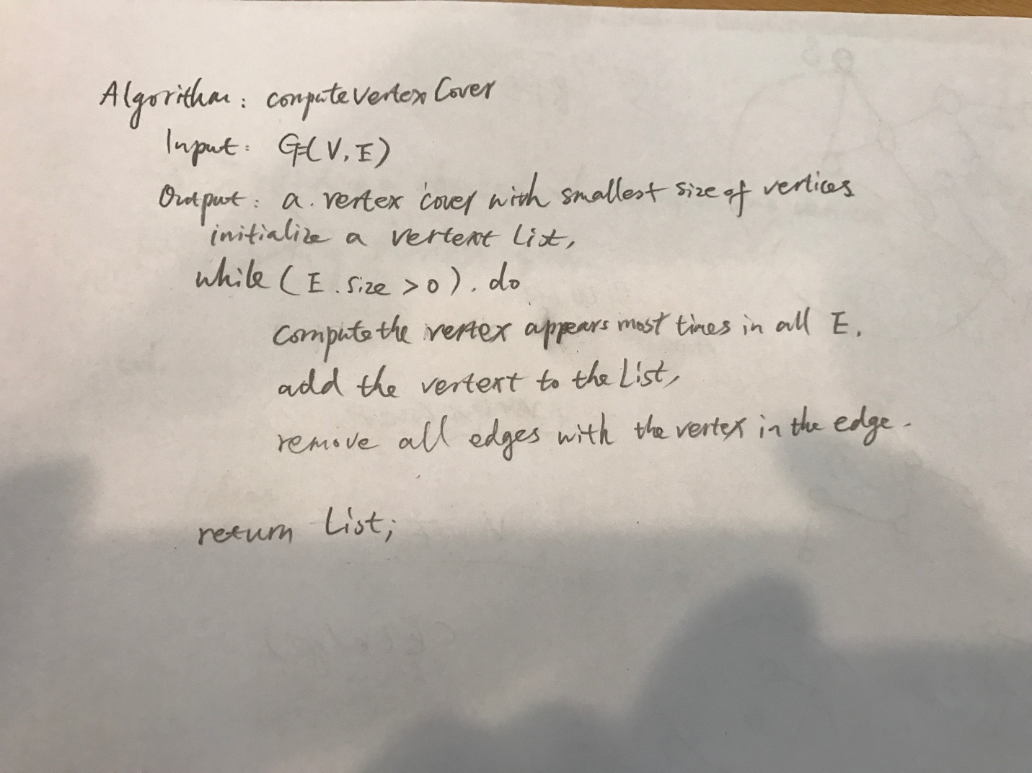](https://github.com/yuliangjin1985/mum-algorithm/blob/master/assignments/pics/IMG_4270.JPG)

**Problem 4**

[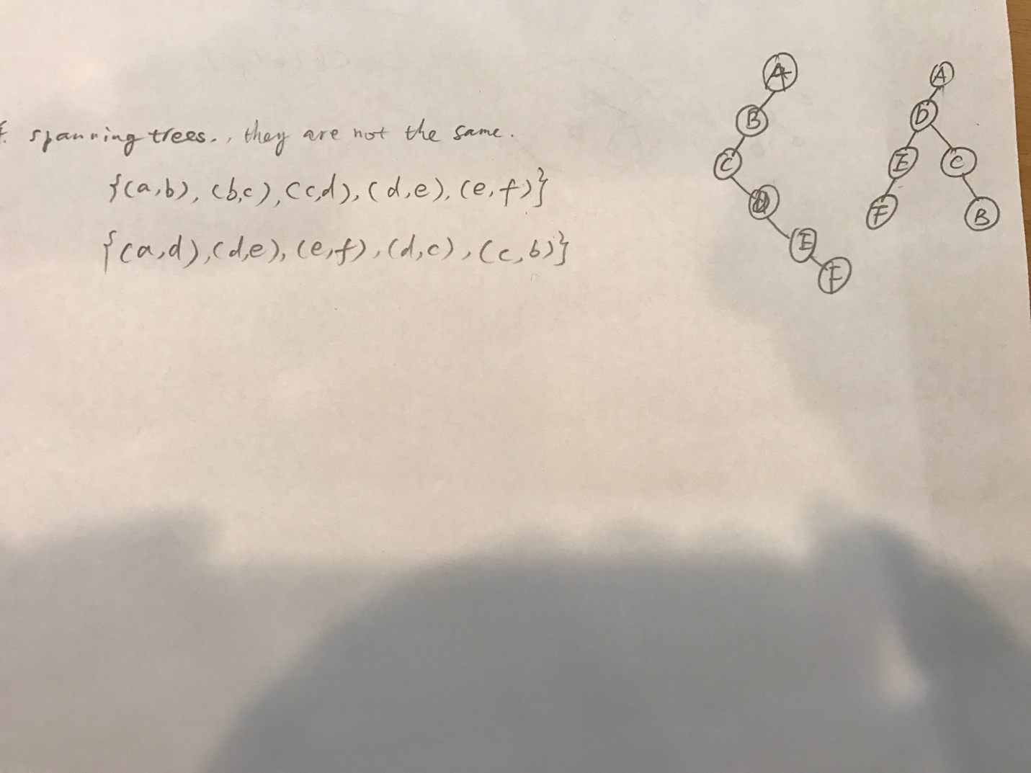](https://github.com/yuliangjin1985/mum-algorithm/blob/master/assignments/pics/IMG_4271.JPG)

**Problem 5**

Write the pesudo-code for compute connected components algorithm discussed in class. Your algorithm can be built on top of DFS discussed in the slides.

[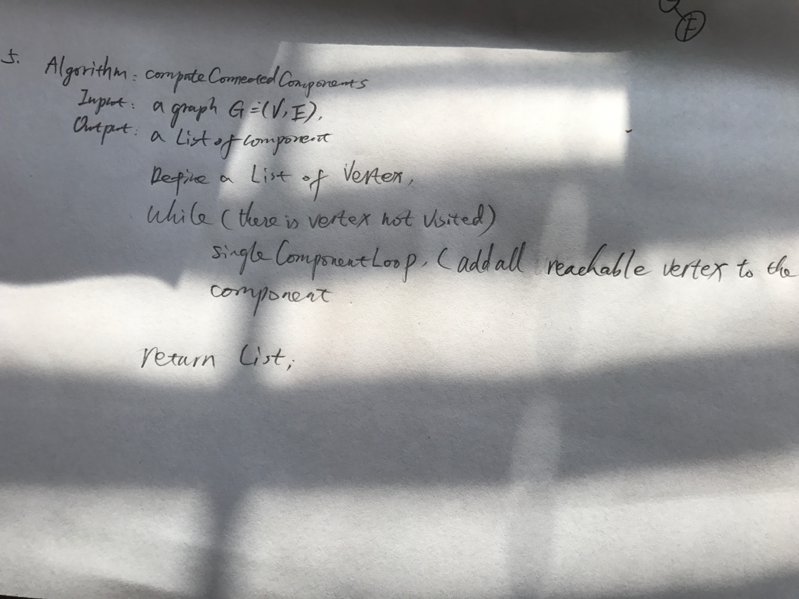](https://github.com/yuliangjin1985/mum-algorithm/blob/master/assignments/pics/IMG_4274.JPG)

**Problem 6**

Write the pesudo-code for the algorithm, discussed in class, that computes the shortest path length between two vertices in a graph. You can assume that: a. The graph is connected. b. A version of BFS is provided that accepts a specified starting vertex. [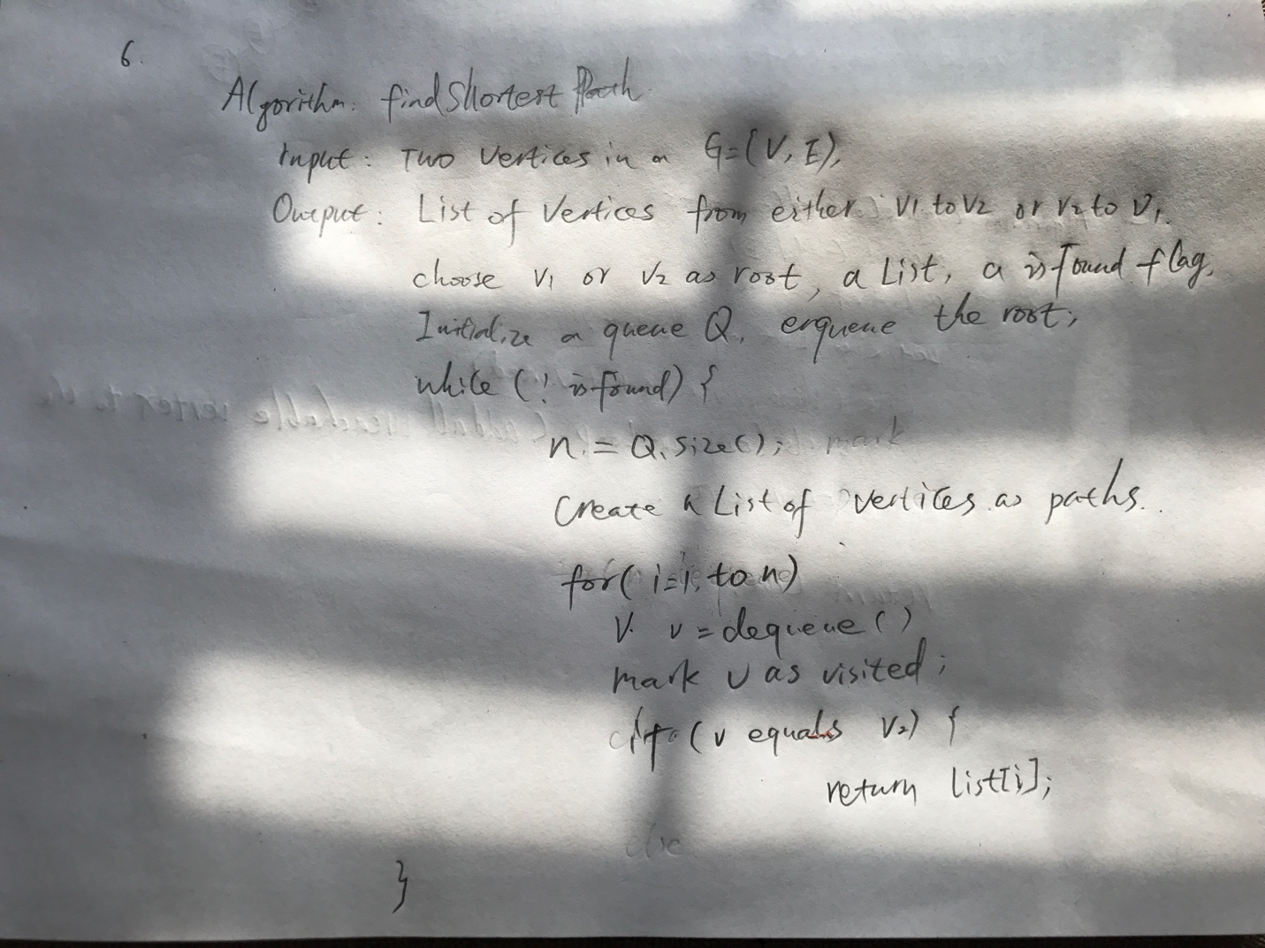](https://github.com/yuliangjin1985/mum-algorithm/blob/master/assignments/pics/IMG_4275.JPG)