**Lab 12 YuliangJin 986381**

**Problem 1**

Perform the General Topological Sort algorithm on the following graph.

[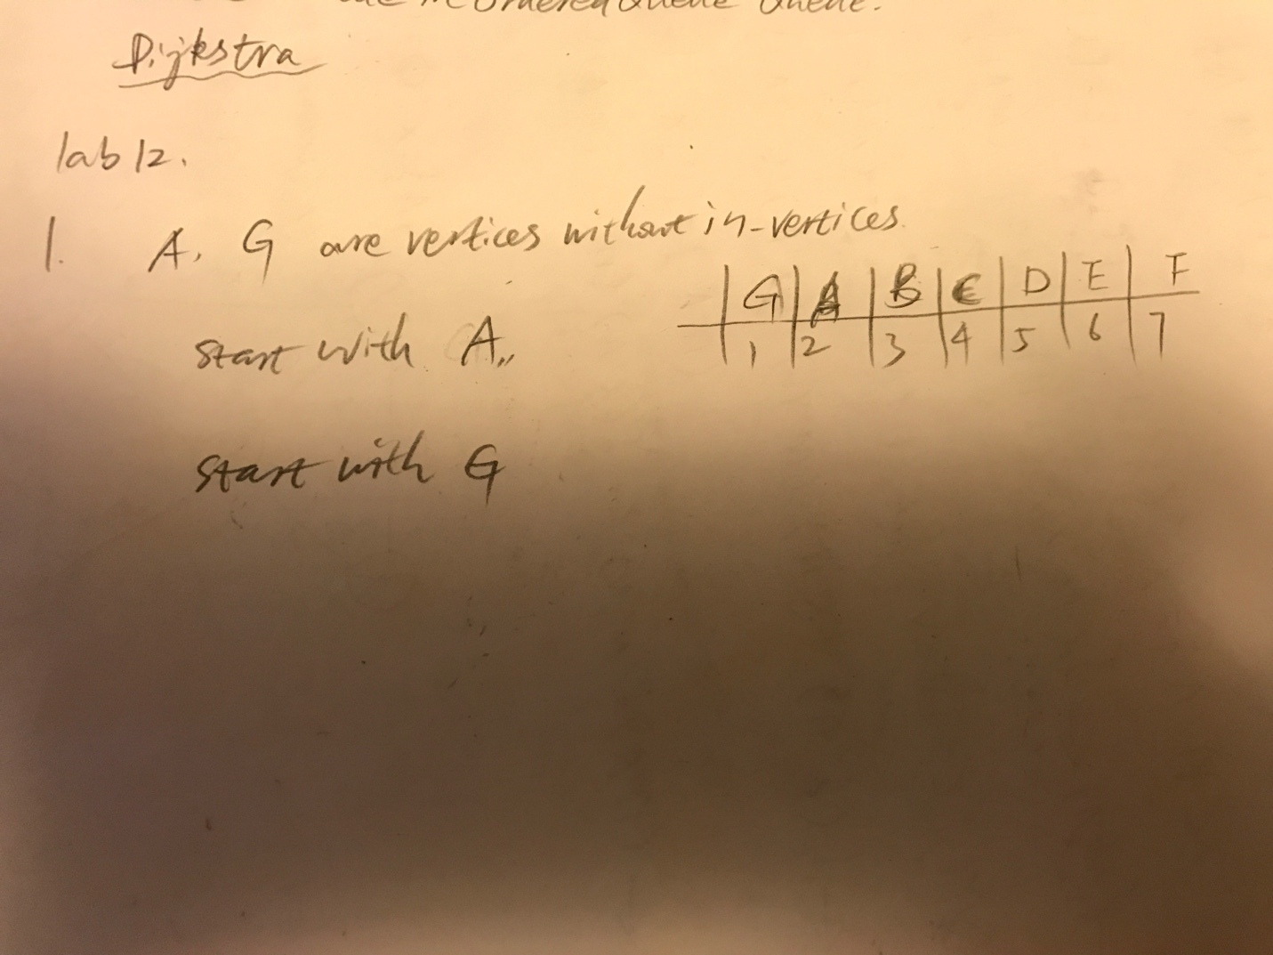](https://github.com/yuliangjin1985/mum-algorithm/blob/master/assignments/pics/IMG_4287.JPG)

**Problem 2**

Devise an algorithm for the following problem. Then give the asymptotic running time of your algorithm, including an explanation of how you arrived at this running time. Algorithm: IsReachableFrom(G, u, v) Input: A directed graph G, vertices u, v in G Output: TRUE if there is a directed path from u to v in G, false otherwise. [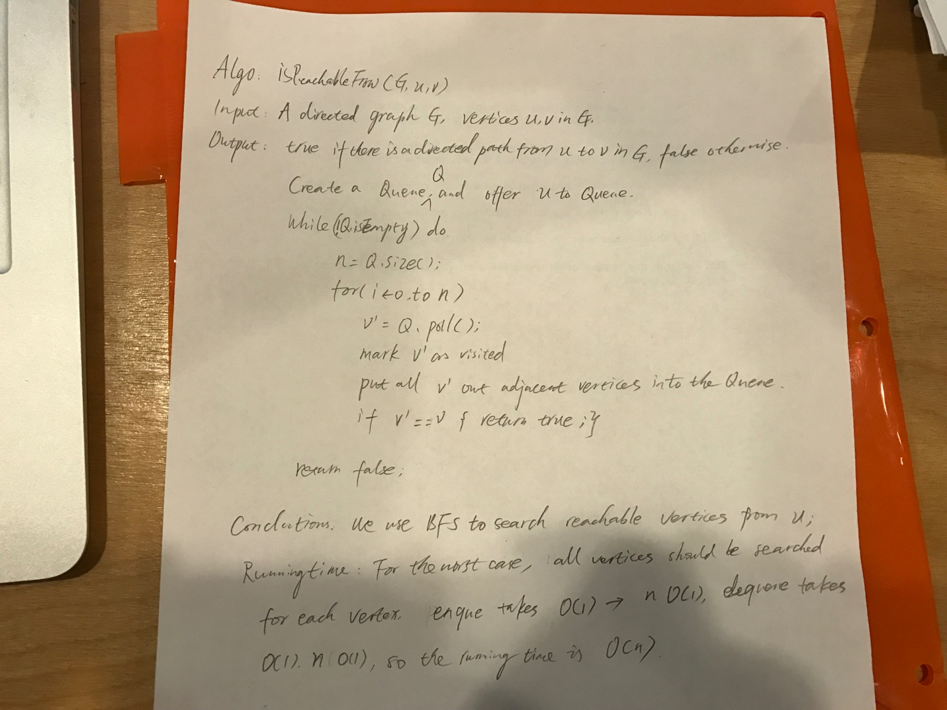](https://github.com/yuliangjin1985/mum-algorithm/blob/master/assignments/pics/IMG_4289.JPG)