**靳玉亮 986381**

**Problem 1**

Answer the following questions about the graph G having n = 6 vertices, below. a. Is G Hamiltonian? Yes b. Any two non adjacent vertices. c. No

**Problem 2**

[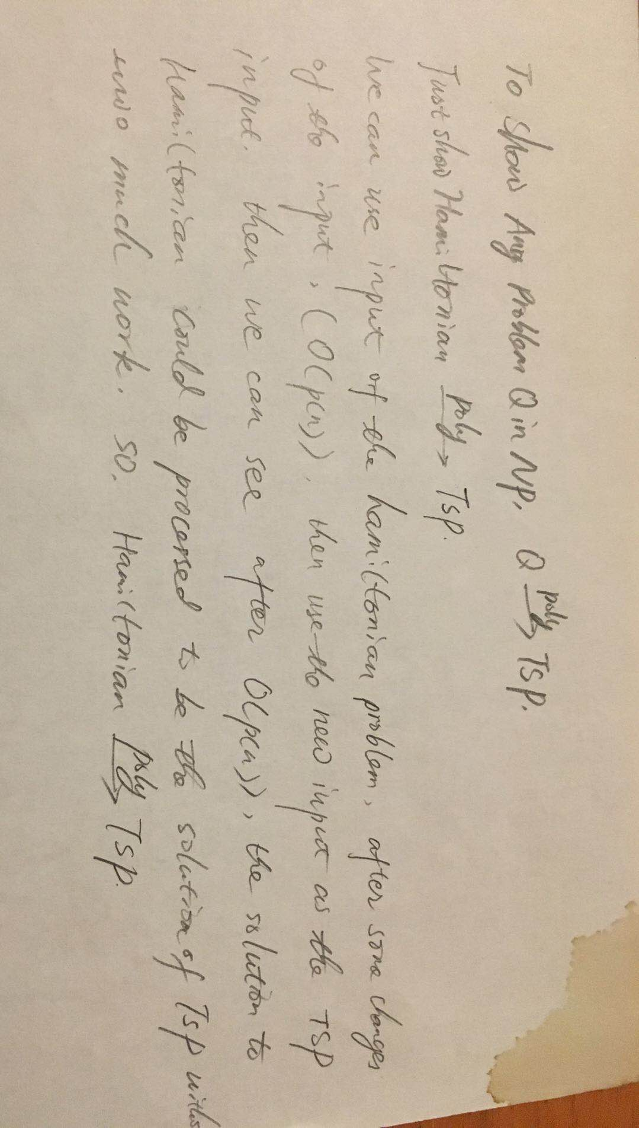](https://github.com/yuliangjin1985/mum-algorithm/blob/master/assignments/pics/WechatIMG27.jpeg)

**Problem 3**

[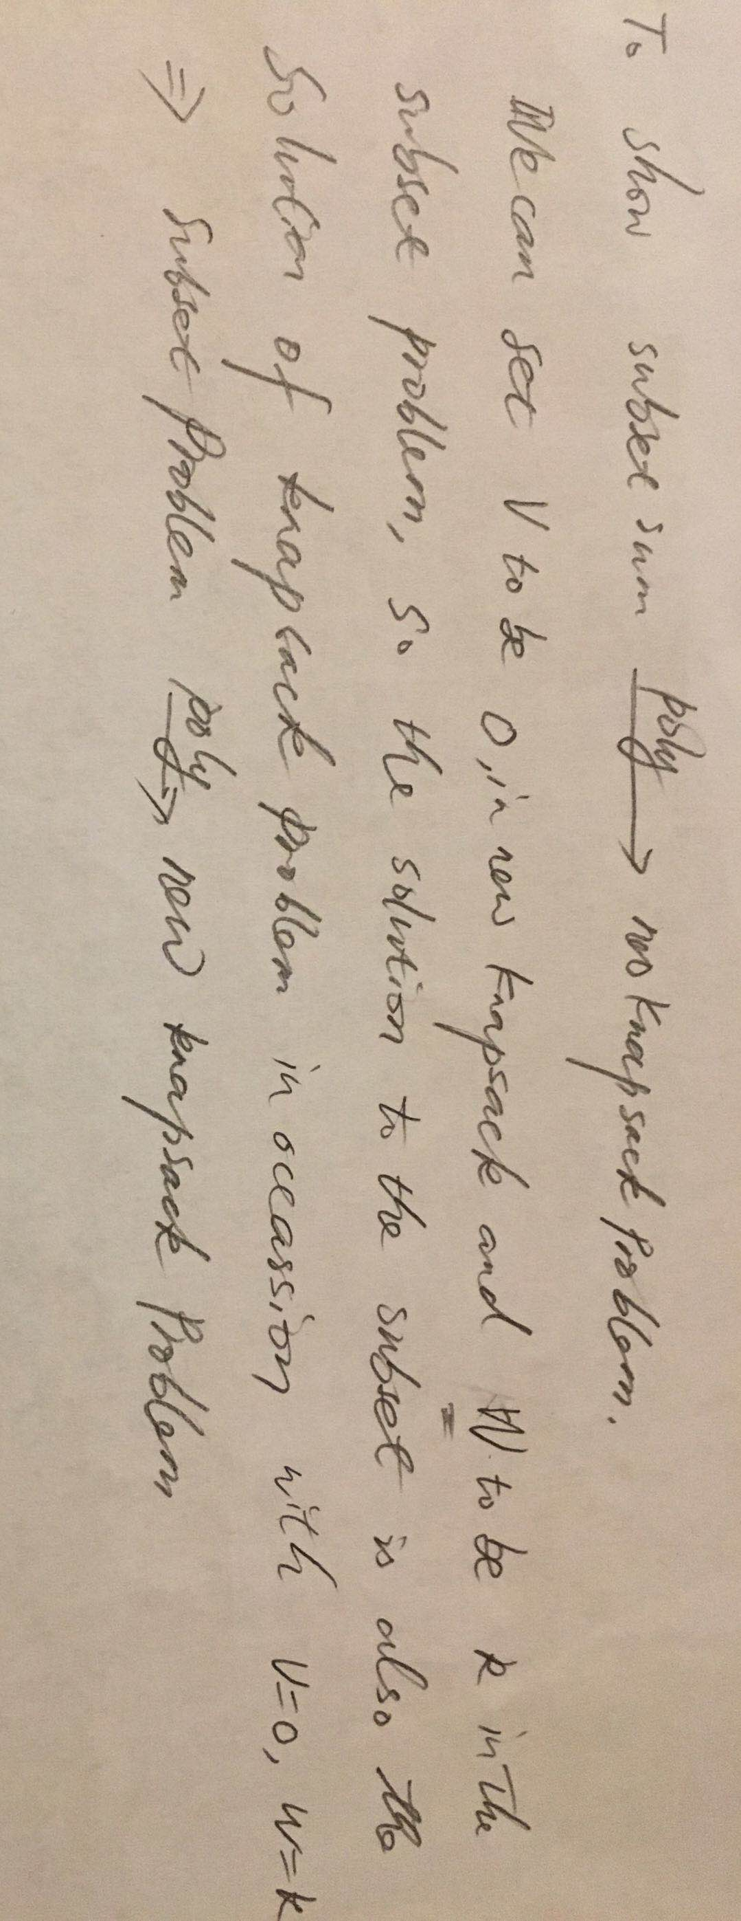](https://github.com/yuliangjin1985/mum-algorithm/blob/master/assignments/pics/WechatIMG28.jpeg)

**Problem 4**

[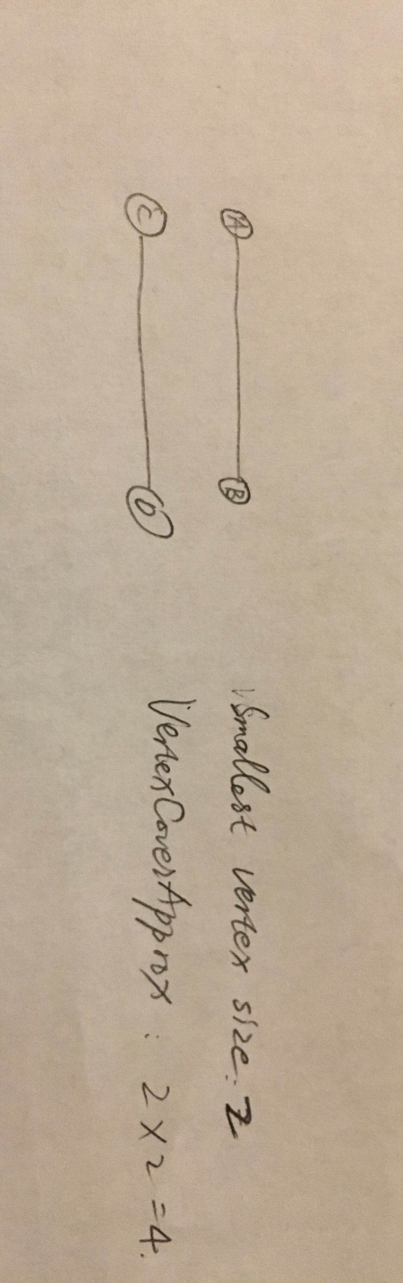](https://github.com/yuliangjin1985/mum-algorithm/blob/master/assignments/pics/WechatIMG29.jpeg)

**Problem 5**

Use dynamic programming, B[i, j] denotes whether there is a subset with previous i integers in the set whose sum is j. We can build such an array from B[0, 1] to B[n, 10], then iterate over the B[0, 10] to B[n, 10] and return the i with the first i that makes B[i][10] to be true.

**Problem 6**

[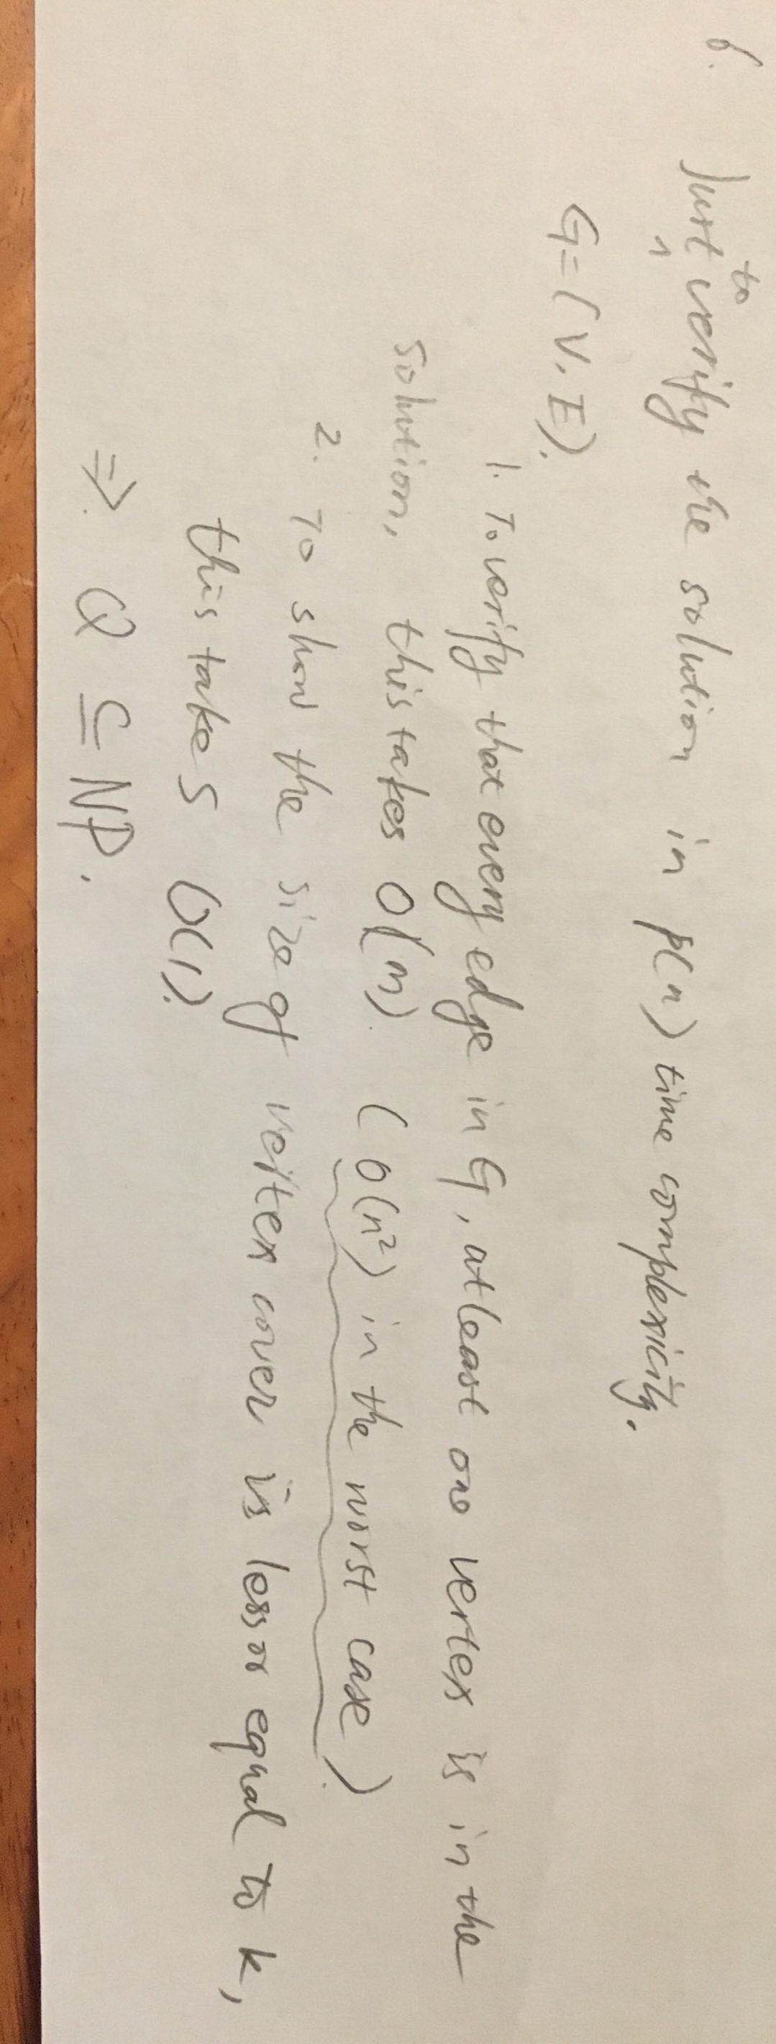](https://github.com/yuliangjin1985/mum-algorithm/blob/master/assignments/pics/WechatIMG30.jpeg)