**roblem 1**

Show that any comparison-based algorithm to sort 4 elements requires at least 5 comparisons in the worst case. Decision tree has the least comparisons and the rest comparison-based algorithms have at least comparisons as decision tree. For four elements, there are 4! permutations, and for the worst case, there are at least log(4!) comparisons needed which is 5.

**Problem 2**

[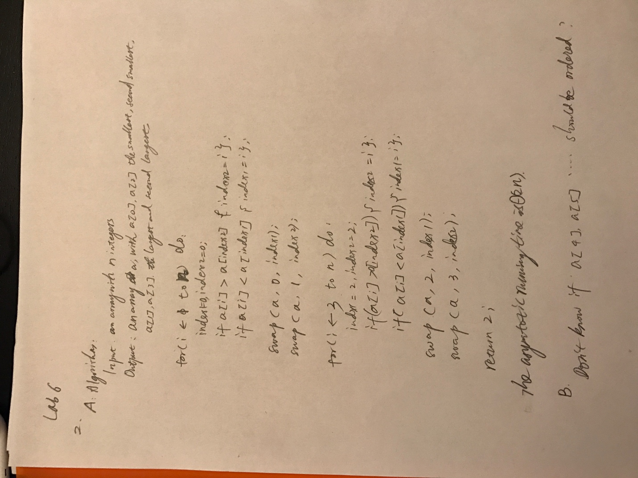](https://github.com/yuliangjin1985/mum-algorithm/blob/master/assignments/pics/IMG_4230.JPG)

**Problem 3**

[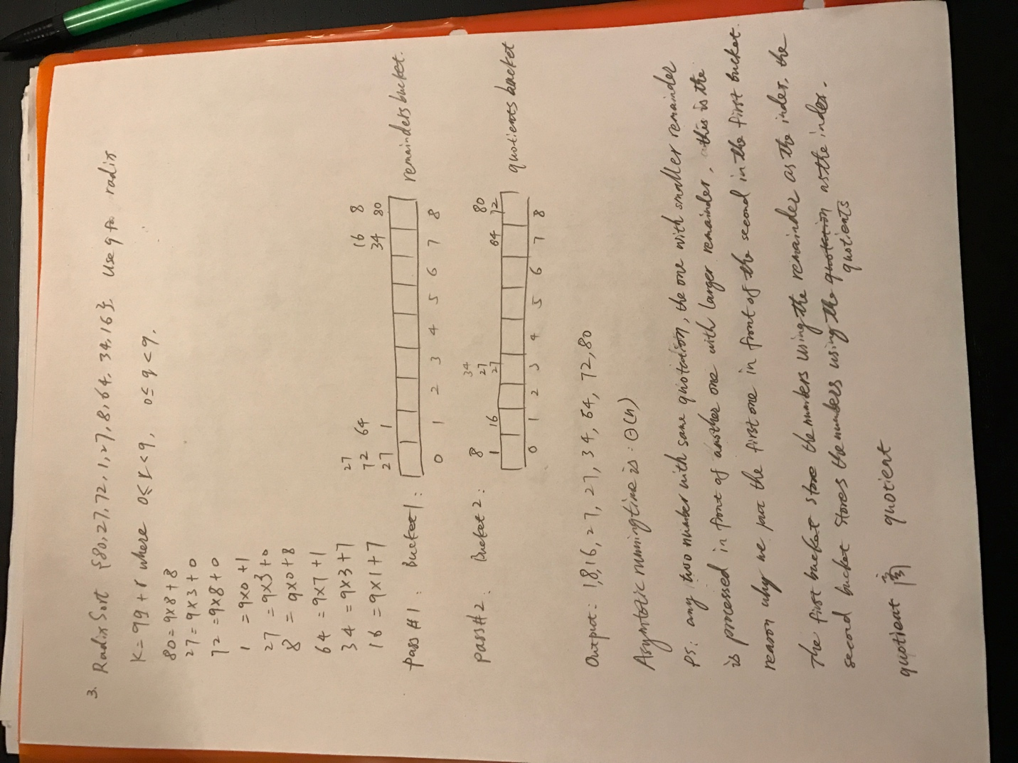](https://github.com/yuliangjin1985/mum-algorithm/blob/master/assignments/pics/IMG_4231.JPG)

**Problem 4**

[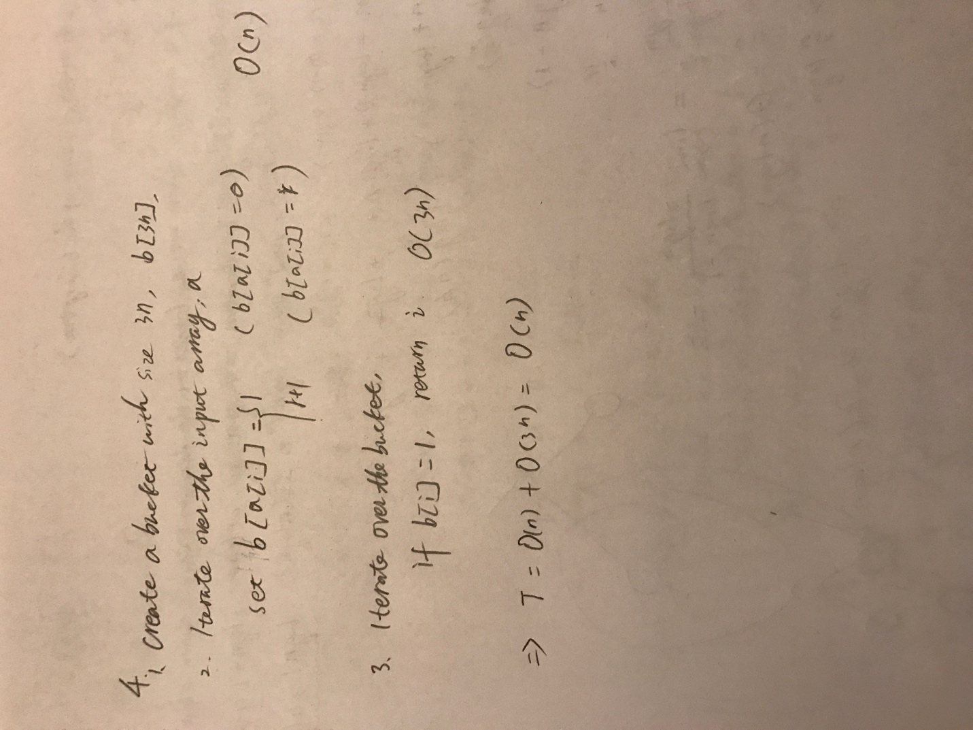](https://github.com/yuliangjin1985/mum-algorithm/blob/master/assignments/pics/IMG_4232.JPG)