**Yuliang Jin 986381**

**Problem 1**

[Interview Question] Devise an O(n) algorithm to accomplish this task: Given a none-empty string S of length n, S consists some words separated by spaces. We want to reverse every word in S. For example, given S = “we test coders”, your algorithm is going to return a string with every word in S reversed and separated by spaces. So the result for the above example would be “ew tset sredoc”.

public static String reverseByStack(String s) {

StringBuilder stringBuilder = new StringBuilder();

Stack<Character> characters = new Stack<Character>();

char[] chars = s.toCharArray();

for(int i=0;i<chars.length;i++) {

if(' ' != chars[i]) {

characters.push(chars[i]);

} else {

while (!characters.isEmpty()) {

stringBuilder.append(characters.pop());

}

stringBuilder.append(' ');

}

}

while (!characters.isEmpty()) {

stringBuilder.append(characters.pop());

}

return stringBuilder.toString();

}

**Problem 2**

[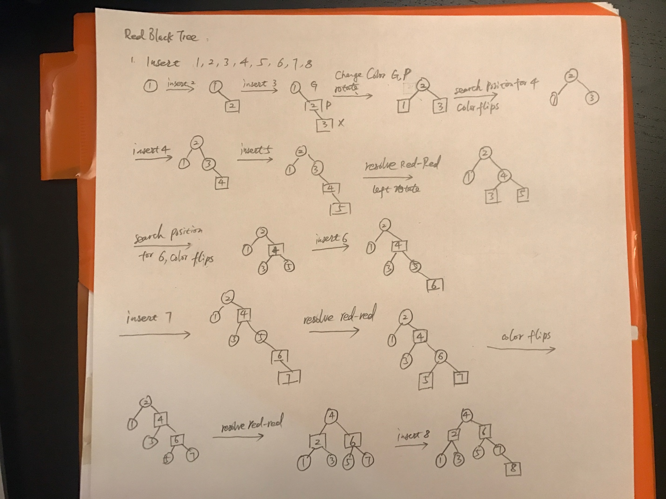](https://github.com/yuliangjin1985/mum-algorithm/blob/master/assignments/pics/IMG_4245.JPG)

[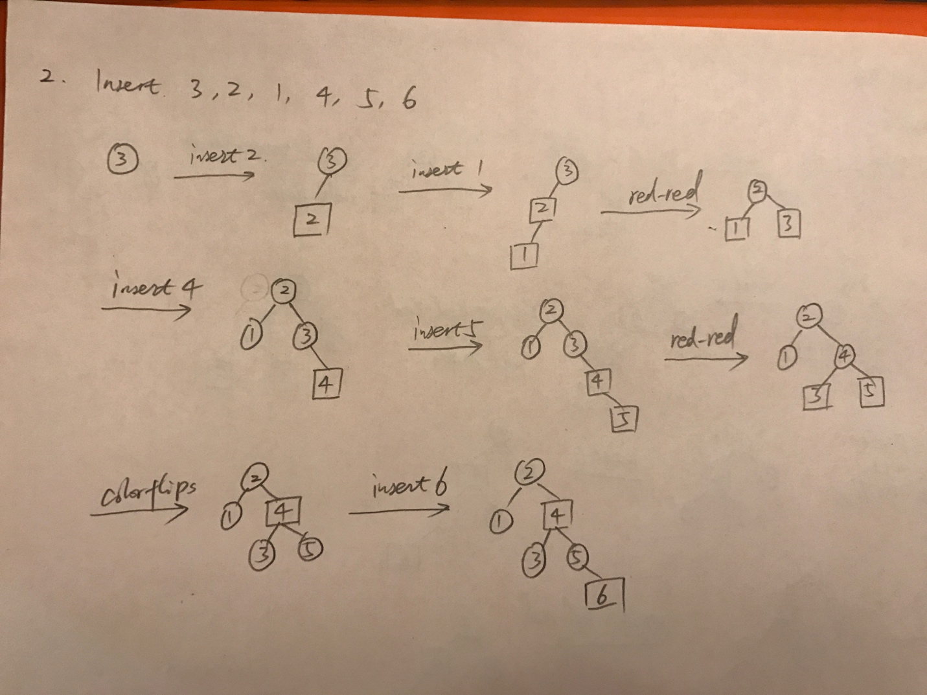](https://github.com/yuliangjin1985/mum-algorithm/blob/master/assignments/pics/IMG_4246.JPG)

**Problem 3**

public static boolean isPrime(int number) {

int sqrt = (int) Math.sqrt(number) + 1;

for (int i = 2; i < sqrt; i++) {

if (number % i == 0) {

return false;

}

}

return true;

}

Time time complexity is O(n ^ (1/2)).

**Problem 4**

A. IsPrime(n) is O(L) in terms of input size.

B.