**Problem 1**

[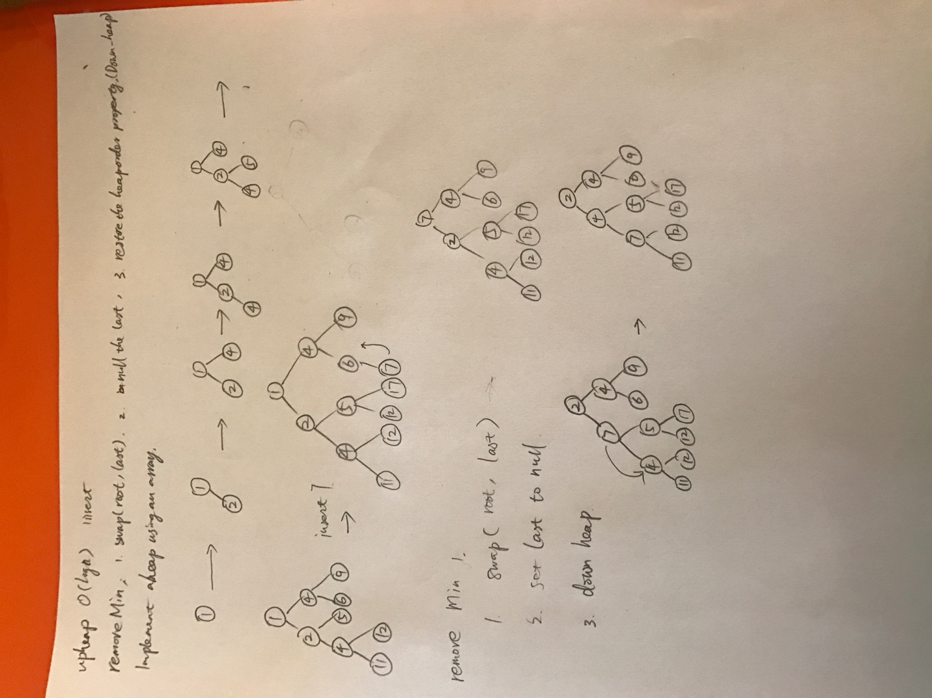](https://github.com/yuliangjin1985/mum-algorithm/blob/master/assignments/pics/IMG_4248.JPG)

**Problem 2**

[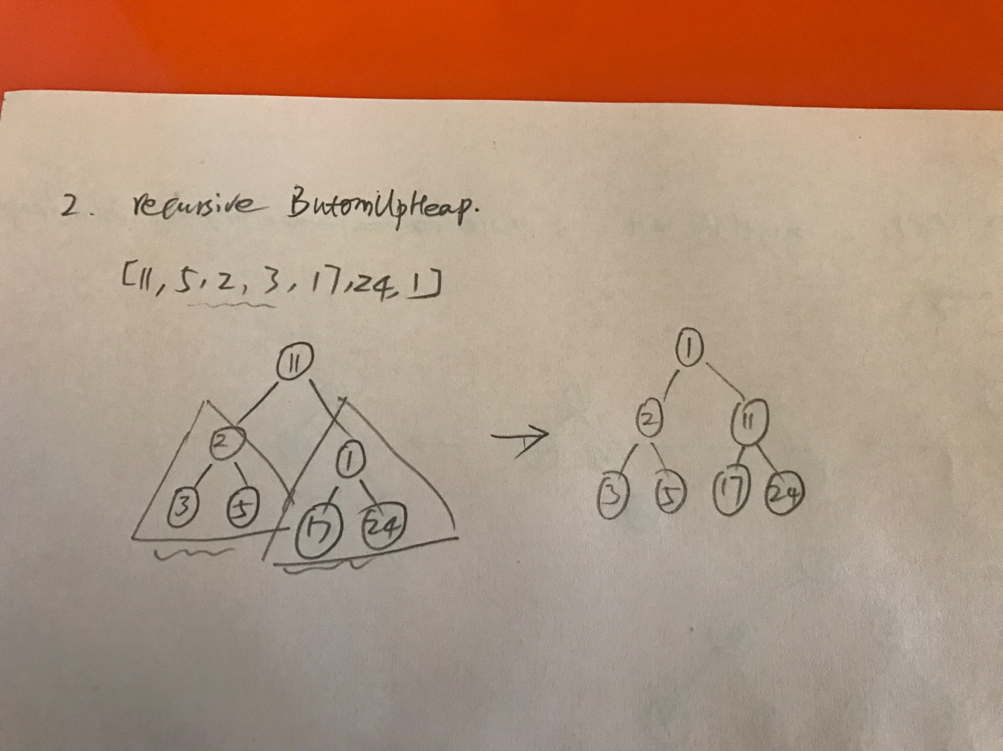](https://github.com/yuliangjin1985/mum-algorithm/blob/master/assignments/pics/IMG_4249.JPG)

**Problem 3**

[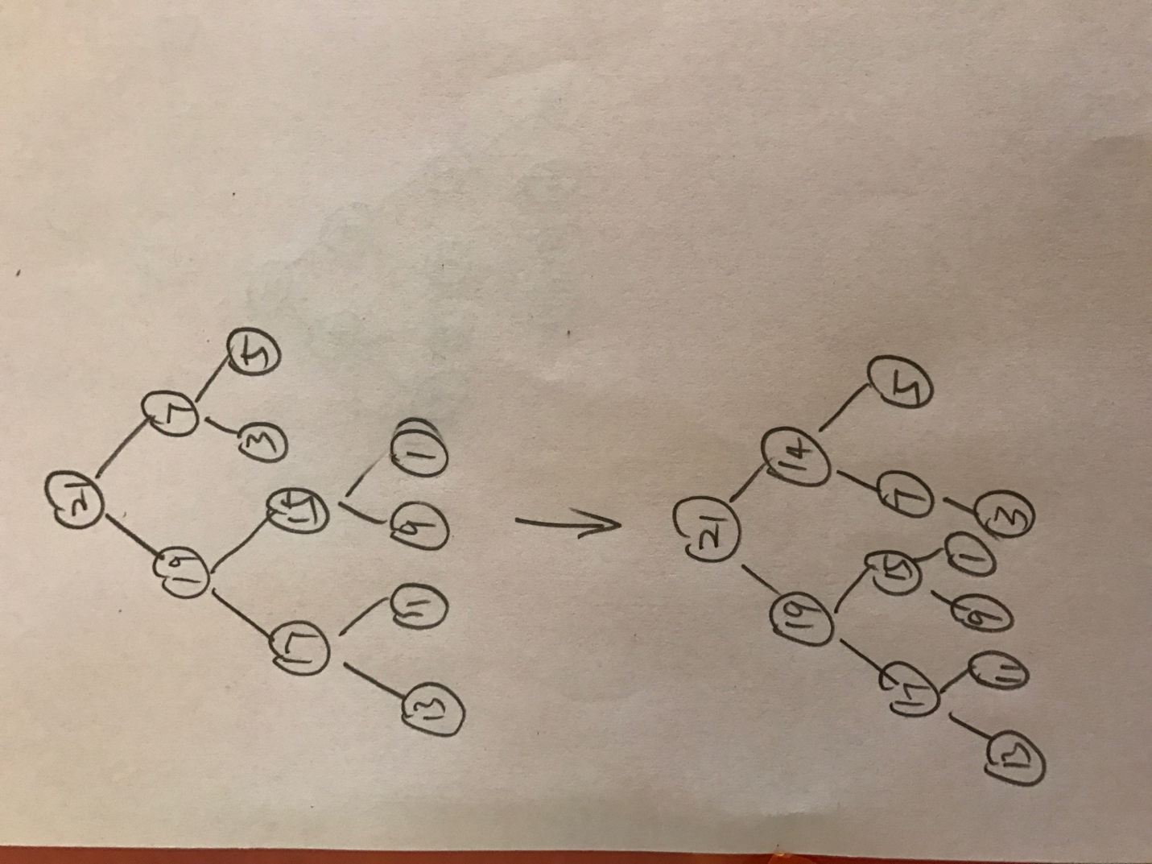](https://github.com/yuliangjin1985/mum-algorithm/blob/master/assignments/pics/IMG_4250.JPG)