**Questions and Answers of Lab 2**

**Yuliang Jin 986381**

**1**

Determine the asymptotic running time of the following procedure (an exact computation of number of basic operations is not necessary):

int[] arrays(int n) {

int[] arr = new int[n];

for(int i = 0; i < n; ++i){

arr[i] = 1;

}

for(int i = 0; i < n; ++i) {

for(int j = i; j < n; ++j){

arr[i] += arr[j] + i + j;

}

}

return arr;

}

The asymptotic running time of the above procedure is $O(n^2)$.

**2**

Consider the following problem: As input you are given two sorted arrays of integers. Your objective is to design an algorithm that would merge the two arrays together to form a new sorted array that contains all the integers contained in the two arrays. For example, on input [1, 4, 5, 8, 17], [2, 4, 8, 11, 13, 21, 23, 25] the algorithm would output the following array: [1,2,4,4,5,8,8, 11, 13, 17, 21, 23, 25] For this problem, do the following:

1. Design an algorithm Merge to solve this problem and write your algorithm description using the pseudo-code syntax discussed in class.
2. Examining your pseudo-code, determine the asymptotic running time of this merge algorithm [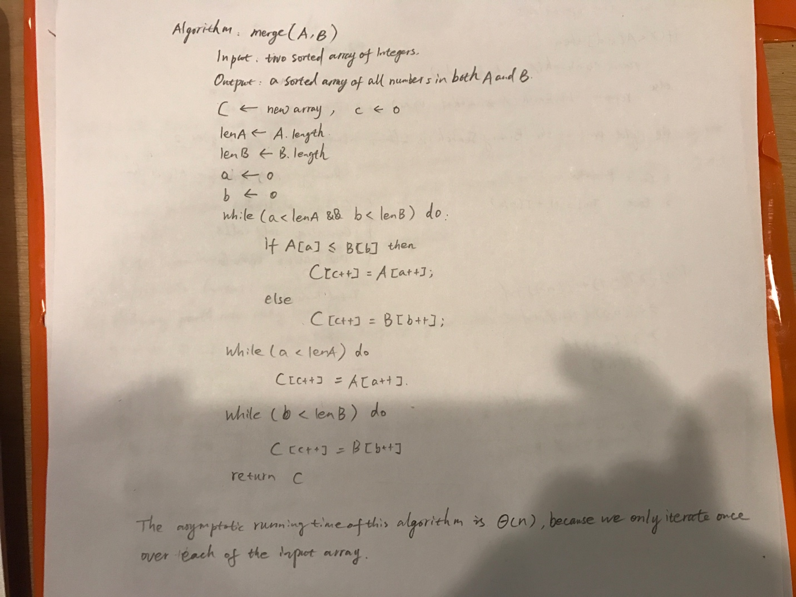](https://github.com/yuliangjin1985/mum-algorithm/blob/master/assignments/pics/IMG_4151.JPG)
3. Implement your pseudo-code as a Java method merge having the following signature: int[] merge(int[] arr1, int[] arr2). Be sure to test your method in a main method to be sure it really works!

public static int[] merge(int[] arr1, int[] arr2) {

int len1 = arr1.length;

int len2 = arr2.length;

int[] arr3 = new int[len1 + len2];

int a=0, b=0, c=0;

while(a<len1 && b<len2) {

if(arr1[a] <= arr2[b]) {

arr3[c++] = arr1[a++];

} else {

arr3[c++] = arr2[b++];

}

}

while(a<len1) {

arr3[c++] = arr1[a++];

}

while (b<len2) {

arr3[c++] = arr2[b++];

}

return arr3;

}

**3**

Use the limit definitions of complexity classes given in class to decide whether each of the following is true or false, and in each case, prove your answer. [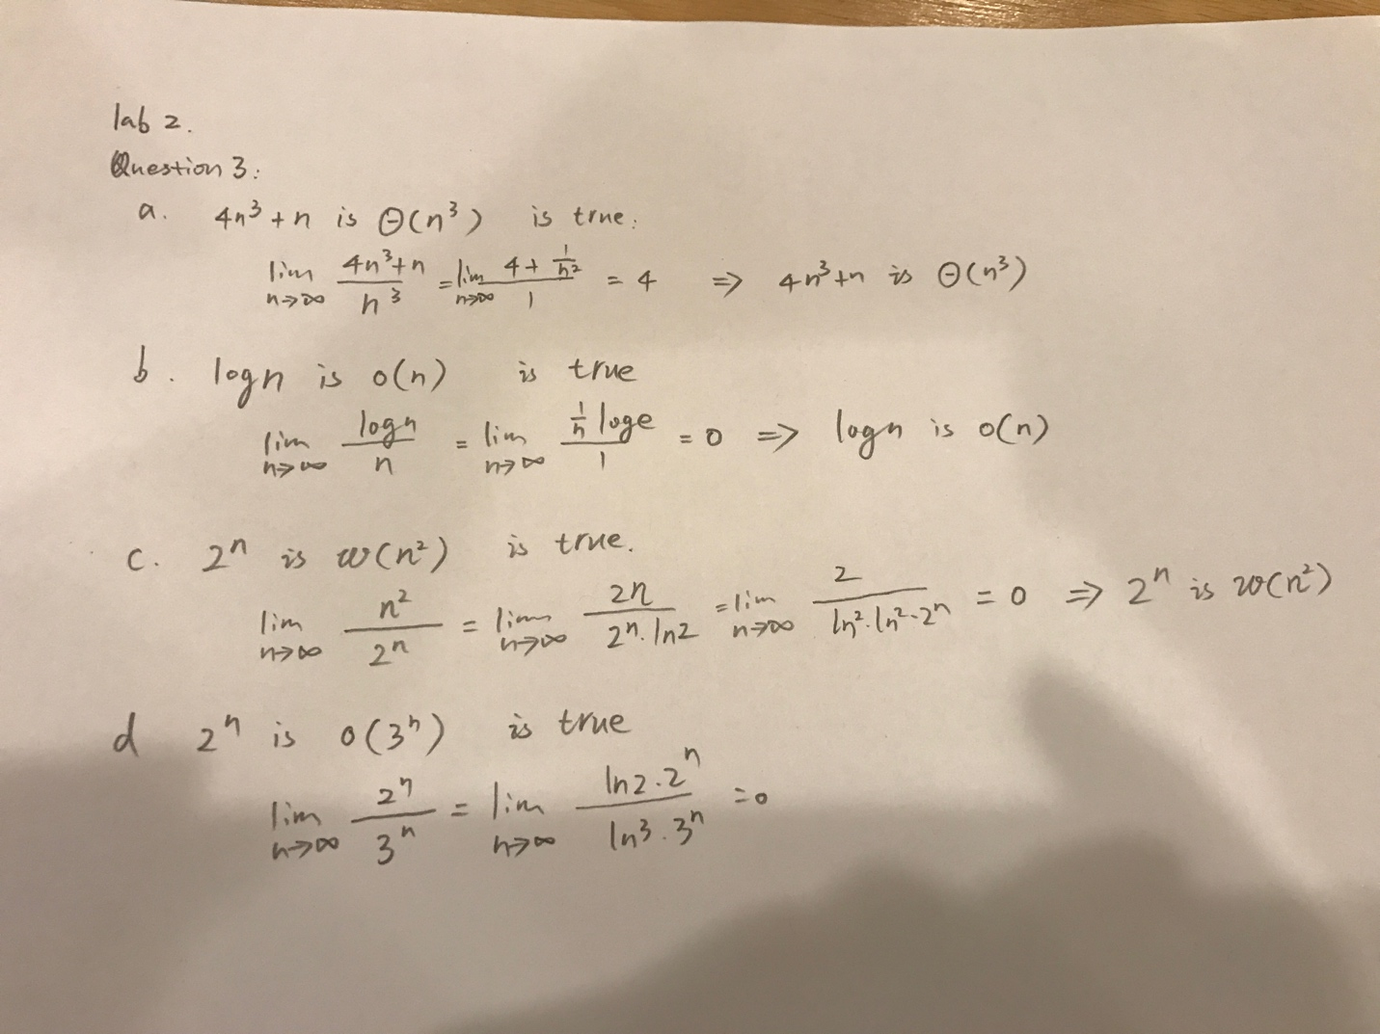](https://github.com/yuliangjin1985/mum-algorithm/blob/master/assignments/pics/IMG_4153.JPG)

**4 Power Set Algorithm**

Given a set X, the power set of X, denoted P(X), is the set of all subsets of X. Below, you are given an algorithm for computing the power set of a given set. This algorithm is used in the brute-force solution to the SubsetSum Problem, discussed in the first lecture. Implement this algorithm in a Java method:

public static List<Set<Integer>> powerSet(List<Integer> X) {

List<Set<Integer>> P = new ArrayList<Set<Integer>>();

HashSet<Integer> S = new HashSet<Integer>();

P.add(S);

HashSet<Integer> T = new HashSet<Integer>();

while(!X.isEmpty()) {

List<Set<Integer>> temp = new ArrayList<Set<Integer>>();

Integer f = X.remove(0);

//When iterate over P, P should not be modified(like adding elements or delete elements during the process of

// iteration) at the same time, otherwise ConcurrentModificationException will be thrown.

for (Set<Integer> x : P) {

T = new HashSet<Integer>(x);

T.add(f);

temp.add(T);

}

for (Set<Integer> integers : temp) {

P.add(integers);

}

}

return P;

}

**5**

In the slides, an algorithm removeDups was given for extracting a list of all the distinct elements of a given input list L.

**Explain why the running time of removeDups is O(n^2)**

Because in the contains method of the ArrayList, it iterates over the list data using a for loop. Therefor, this algorithm is actually a nested for loop. So the running time is O(n^2).

**Try using the technique shown in the solution to the Sum of Two problem (i.e. a HashMap) to improve running time of removeDups to O(n)**

public static List<Integer> removeDups(List<Integer> L) {

ArrayList<Integer> list = new ArrayList<Integer>();

HashMap<Integer, Integer> map = new HashMap<Integer, Integer>();

for (Integer integer : L) {

if(!map.containsKey(integer)) {

map.put(integer, 1);

list.add(integer);

}

}

return list;

}