Item | Index
Size | length: 175mm, width: 170mm, high: 145mm
Net weight | ≤3KG (including battery pack)
Battery | 18650 power 4 series, rated voltage: 14.8V, capacity: 2600mAH
Communication interface | 2.4GHz, Bluetooth 4.0, USB
Integrated linear speed | 3.6m/s(max)
Angular velocity | 500rad/s
Shoot | velocity: 8.5m/s(max)
Chip | height: 650mm、distance: 2000mm
Chassis motor | speed:3000r/min、power: 30W
Ball control motor | speed: 20000r/min、power: 12W
Total power | 150W
Product parameter list
Introduction of equipment components
This section describes the various components of the robot. Before the operation of the robot is recommended, please be familiar with the various components.
Schematic diagram of the front and back
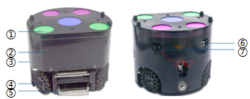
Figure 1-1 robot closes the front and back sides
1.Color card 4. The Universal wheel 6. Charging interface 2.LED 5. The-IR 7. Power switch
3.Shell

Robot in the shell
Turn off the power before removing the robot and pull out the battery
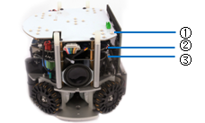
1.LED 2. Control 3.Power
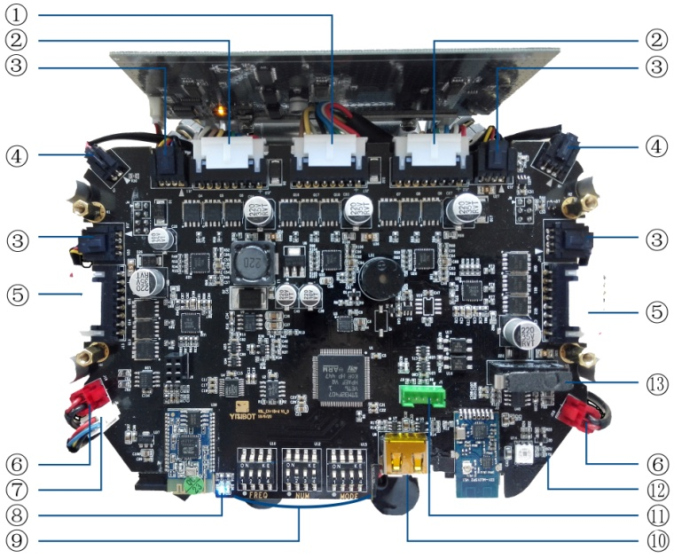
■①Ball control motor interface
■②Chassis motor interface
■③encode interface
■④Infrared sensor interface
■⑤Chassis motor interface
■⑥Speaker interface
■⑦LED interface
■⑧Bluetooth Indicator light：The indicator light alternate flashes on behalf of Bluetooth to start working, The right indicator light flashes on behalf of Bluetooth connection success
■⑨Mode setting button
■⑩USB interface
■⑪Download Interface
■⑫RGB LED
■⑬Boost switch

Left and right views
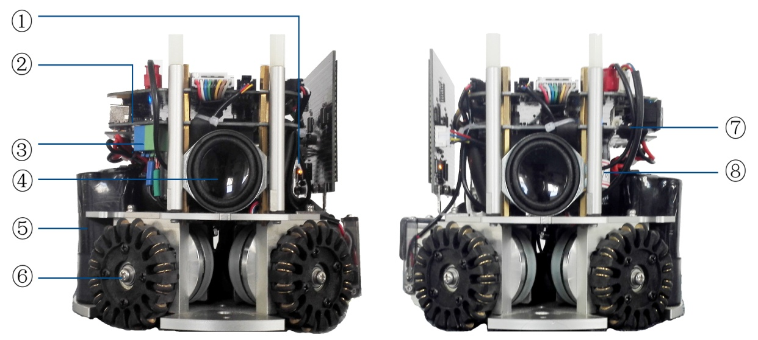
■①LED indicator light：LED indicator light when used in LED
■②Charging indicator light
■③chip and shoot coil interface
■④Bluetooth Speaker
■⑤Battery
■⑥Universal wheel
■⑦On-off indicator: the on-off indicator lights when the power is turned on
■⑧Capacitance

Preparation before use
Preparation steps and basic operation
■ To charge the battery
■ Set the working mode of the robot.
■ Expanding function introduction

To charge the battery
Connect the YISI power adapter to charge the battery.
1. Connect the power cord to the power adapter 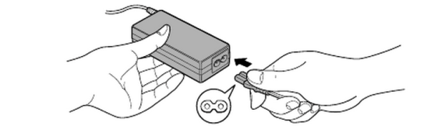
2. Plug in the output plug of the power adapter into the charging interface. Charging lamp light red.
3. Charging indicator lights red light into green when it is full of electricity. 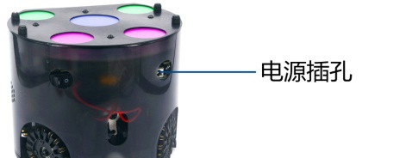
Charging interface
* Do not use when charging, When the speed of the robot is obviously decreased or the buzzer continues to ring, the battery should be replaced immediately.

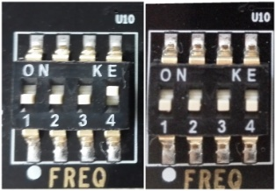
Set working mode
Set frequency point
frequency encoder（FERO）：The robot with the same team should be set at the same frequency.。The participating parties in the frequency (4) toggle settings。
Figure 2-3 schematic diagram of the robot frequency point

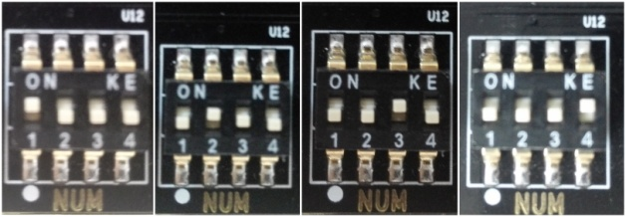
Set robot number
robot number encoder（NUM）: The setting of robot number is related to binary.，Dial up is 1，On the contrary is 0，So the numbers of right were 1000 (8), 0100 (4), 0010 (2), 0001 (1)。
Figure 2-4 schematic diagram of robot number

Set operation mode
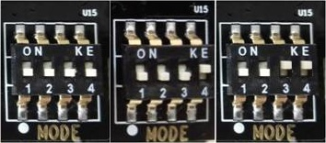
mode encoder（MODE）: Confirm the operation mode of the robot,
The right is rhe self checking mode.
The middle is the handle mode.
The left is the game mode.
Figure 2-5 Schematic diagram of the robot operation mode
Handle control
In the robot off state, dial "MODE" to "0001"，Insert USB into the Key interface on the robot control panel, plug in the battery, and then open the robot，Then we can control the robot by the handle.The function of each button is illustrated in the figure below.
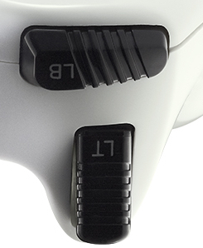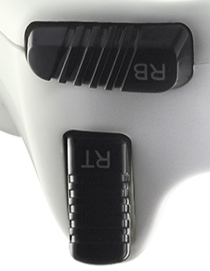
Boost and Saving strength
Suction ball
start
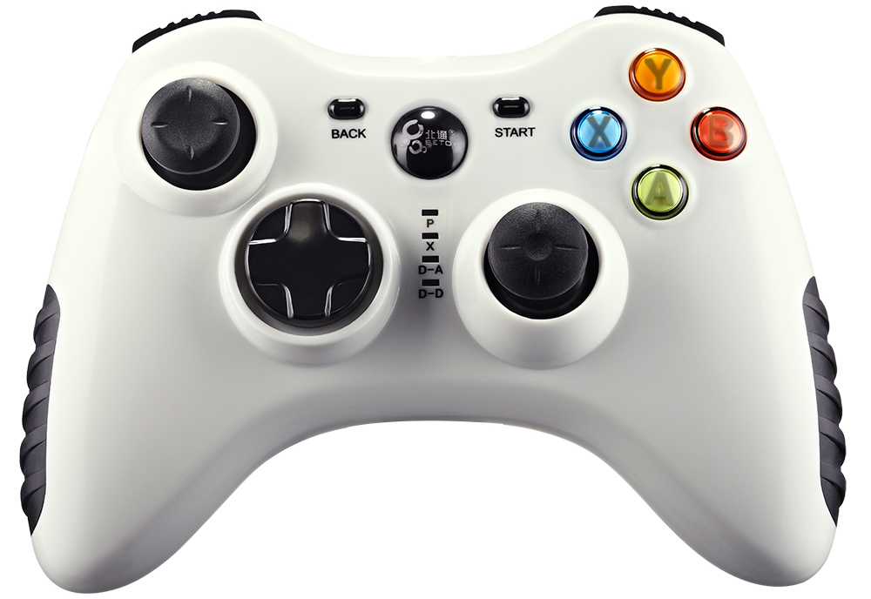
Right shift
Forward
left shift
backward
turn left
turn right
shoot
chip
Figure 2-6 Handle button instructions
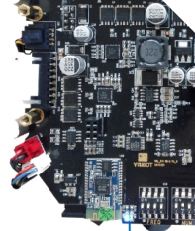
Expanding function introduction
Bluetooth Speaker
1. Turn on the robot, the Bluetooth indicator light
2. Open the phone (or notebook) to be matched.
3. Turn on the phone's Bluetooth switch, use Bluetooth
search Bluetooth speaker
Figure 2-7 Schematic diagram of Bluetooth indicator

4. Robot's Bluetooth number is located on the chassis of the robot.，
Bluetooth number is ID after 4 (Figure 2-8)
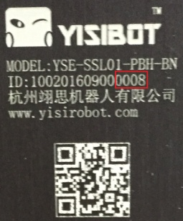
5、After docking success by using the phone to play voice,
music and other audio files.
Figure 2-8 Robot’s Bluetooth number

communication protocol
hardware interface：UART
baud rate：115200
stop bit：1
Parity checksum：NONE
Frame Package Type
0: status of Normal mode for competition
1: status of the PID Writing mode for adjustment parameters of motor
2: status of the PID Reading mode for adjustment parameters of motor
3: status of the Single Vehicle testing mode，Only send the velocity command to the Single Vehicle, and the Single Vehicle, need return the rotate speed of the motor
4: status of checking mode when the Vehicle receive this command , the Vehicle stop acting, and return the voltage of batter ,the voltage of capacity and the error information.
5: status of KickParamSet mode not open at presen ,use for setting parameter of shooting and chipping.
6: status of KickParamSet mode not open at presen ,use for reading parameter of shooting and chipping.
7: status of OutPut mode not open at presen ,
8: status of ParameterWrite mode
9: status of ParameterRead mode

The length of structure of each kind Frame Packages are not same, but the length of all kind of the Frame Package is always 25 bytes. If the frame package is longer than 25 bytes please fill it with 0x00; the length of upload data of each kind is 16 bytes.
Vehicle speed command:
x
y
rotate
CAR
R=75mm

Notice: The unit of measurement of each type of velocity, for example if velocity_x = 10 then the velocity of the Vehicle in X way is 10 * 4 cm/s = 40 cm/s, the velocity of the Vehicle in Y way is is same with it in X way, if velocity_rotate = 10 , then the Linear Velocity of the wheel at the edge of connecting ground is 0 * 1/10 rad/s * R = 0.075 m/s。
The date filed of length does not have any function, because all the protocal of every work mode has defined, the upper unit should not check this data field.
1 2 3 4

1、Structure of Frame Package for competition（Normal）:（Not Return on realtime , ruturn only when isBallDetected or ShootChec or PowerLow
bit  byte（fuction） |  | 7 |  |  | 6 |  | 5 |  |  | 4 |  | 3 |  | 2 |  | 1 |  | 0
0（Header） |  | 1 |  |  | 1 |  | 1 |  |  | 1 |  | 1 |  | 1 |  | 1 |  | 1
1 (Func) |  | 0 |  |  |  |  |  |  |  |  |  | Robot12 |  | Robot11 |  | Robot10 |  | Robot9
2 Robots ID[2] |  | Robot8 |  | Robot7 |  |  | Robot6 |  | Robot5 |  |  | Robot4 |  | Robot3 |  | Robot2 |  | Robot1
3（misc） |  | 0 ball control forward  1 ball control reversal |  | shoot(0)  chip(1) |  |  | Control grading （0-3）
4（velocity_x） |  | + x（0）  - x（1） |  | the abslute value of x way velocity （0-126），unit of measurement：1cm/s
5（velocity_y） |  | + y（0）  - y（1） |  | the abslute value of y way velocity （0-126），unit of measurement：1cm/s
6（velocity_rotate） |  | Forward （0）  Negative（1） |  | the abslute value of axial speed（0-126），unit of measurement：1/40 rad/s
7（misc） |  | 0 ball control forward  1 ball control reversal |  | shoot(0)  chip(1) |  |  | Control grading（0-3）
8（velocity_x） |  | + x（0）  - x（1） |  | the abslute value of x way velocity （0-126），unit of measurement：1cm/s
9（velocity_y） |  | + y（0）  - y（1） |  | the abslute value of y way velocity （0-126），unit of measurement：1cm/s
10（velocity_rotate） |  | Forward （0）  Negative（1） |  | the abslute value of axial speed（0-126），unit of measurement：1/40 rad/s
11（misc） |  | 0 ball control forward  1 ball control reversal |  | shoot(0)  chip(1) |  |  | Control grading（0-3）
12（velocity_x） |  | + x（0）  - x（1） |  | the abslute value of x way velocity （0-126），unit of measurement：1cm/s
13（velocity_y） |  | + y（0）  - y（1） |  | the abslute value of y way velocity （0-126），unit of measurement：1cm/s
14（velocity_rotate） |  | Forward （0）  Negative（1） |  | the abslute value of axial speed（0-126），unit of measurement：1/40 rad/s
15 | R1_Vx8 |  | R1_Vx7 |  |  | R1_Vy8 |  | R1_Vy7 |  |  | R1_Vr8 |  | R1_Vr7
16 | R2_Vx8 |  | R2_Vx7 |  |  | R2_Vy8 |  | R2_Vy7 |  |  | R2_Vr8 |  | R2_Vr7
17 | R3_Vx8 |  | R3_Vx7 |  |  | R3_Vy8 |  | R3_Vy7 |  |  | R3_Vr8 |  | R3_Vr7
18  Shoot power 1 |  |  | R1_pow6 |  |  | R1_pow5 |  | R1_pow4 |  |  | R1_pow3 |  | R1_pow2 |  | R1_pow1 |  | R1_pow0
19  Shoot power 2 |  |  | R2_pow6 |  |  | R2_pow5 |  | R2_pow4 |  |  | R2_pow3 |  | R2_pow2 |  | R2_pow1 |  | R2_pow0
20  Shoot power 3 |  |  | R3_pow6 |  |  | R3_pow5 |  | R3_pow4 |  |  | R3_pow3 |  | R3_pow2 |  | R3_pow1 |  | R3_pow0

The information of number of the vehicle is not same with it in the other modes，which presents which vehicles that the commands is sent to , the location in the whole fame package implies the command for the specific vehicle
For example ,if the bit i is set to 1，that means the vehicle which ID quals i+1 is exsiting，otherwise it means the vehicle which ID quals i+1is not existing。
So the vehicle which ID equals i+1 can fetch the command for itself， and the vehicle also need count the number of 1 till the bit i, the count result is the number，with means the sequence of command for itself .

2、Strature of the Return Frame Package for Normal status
bit  byte（fuction） | 7 |  | 6 |  | 5 |  | 4 | 3 |  | 2 |  | 1 | 0
0（preamble） | 1 |  | 1 |  | 1 |  | 1 | 1 |  | 1 |  | 1 | 1
1 (Func) | 0 |  |  |  |  |  |  | 2
2 | Robot ID（1~12）
3 | 0 | IR |  | shoot |  | chip |  | Whether Control ball
4 | m：Number of changes in the State(if==127，Zero)
5 | The N upload（n<=5）
6 | Battery voltage
7 | Capacitor voltage
Notice:Only in infrared detection,pley action for a period of time,when the battery voltage is too low to upload

0.3 Game time frame to send packet format (Normal)
bit  byte（fuction） | 7 | 6 | 5 | 4 | 3 | 2 | 1 | 0
0（preamble） | 1 | 1 | 1 | 1 | 1 | 1 | 1 | 1
1（misc） | command
2 | ACC (1)  DEC (2) |  | Robot ID
3 | cycle
4 | Forward（0）  Negative（1） | Control grading（0-127）
5（misc） | shoot(0)  chip(1) | Shot power（0-127）
6（velocity_x） | + x（0）  - x（1） | the abslute value of x way velocity （high byte）
7 | the abslute value of x way velocity （low byte）
8（velocity_y） | + x（0）  - x（1） | the abslute value of y way velocity （high byte）
9 | the abslute value of y way velocity （low byte）
10（velocity_rotate） | Forward （0）  Negative（1） | R axial speed abslute（high byte）
11 | R axial speed abslute（high byte）
12-13（crc） | 16bit CRC

三 The transmitter
Booting normally：start data package --> config data package
Config parameters：start→config→config data，change parameters in file config data the system will automate reboot when parameter changing is finished, and the use command start→config.
ff b0 01 02 03 00 00 00 00 00 00 00 00 00 00 00 00 00 00 00 00 00 00 00 31 //start
ff b0 04 05 06 00 00 00 00 00 00 00 00 00 00 00 00 00 00 00 00 00 00 00 a0 //config
ff b0 07 08 09 00 00 00 00 00 00 00 00 00 00 00 00 00 00 00 00 00 00 00 3b //defualt
ff 10 04 05 06 00 00 00 00 00 00 00 00 00 00 00 00 00 00 00 00 00 00 00 9c //send data
ff b0 21 cf 53 d3 21 82 56 a9 11 10 71 45 98 00 00 00 00 00 00 00 00 00 54 //config data,25 byte
ff b0 21 af 50 d0 21 82 56 a9 11 10 71 45 98 00 00 00 00 00 00 00 00 00 e6 //config data，set parameters to 21 bytes
ff b0 21 af 53 d3 21 82 56 a9 11 10 71 45 98 00 00 00 00 00 00 00 00 00 d0 //config data，set parameters to 21 bytes
ff b0 01 02 03 00 00 00 00 00 00 00 00 00 00 00 00 00 00 00 16 //start
ff b0 04 05 06 00 00 00 00 00 00 00 00 00 00 00 00 00 00 00 a6 //config
ff b0 21 cf 53 d3 21 82 56 a9 11 10 71 45 98 00 00 00 00 00 13
The former five bits of the third byte is the length of communication, the last three bits of the third byte is the speed of UART
The last four bits of the fourth byte is the first frequency of 2401, The last four bits of the fifth byte is the second frequency of 2401
ff 00 08 00 10 00 00 00 00 00 00 00 00 00 00 00 00 00 10 00 00 00 00 00 22

