**HOMEWORK – EXCEL**

1. **Given the provided data, what are three conclusions we can draw about Kickstarter campaigns?**

* Kickstarter campaigns don't work for journalism.
* Kickstarted campaigns work with lot of success for cultural entertainment campaigns, such as film&video, music and theater.
* Kickstarted campaigns work also for other categories, but having a high percentage of failed at the same time (>50% in comparison with success).

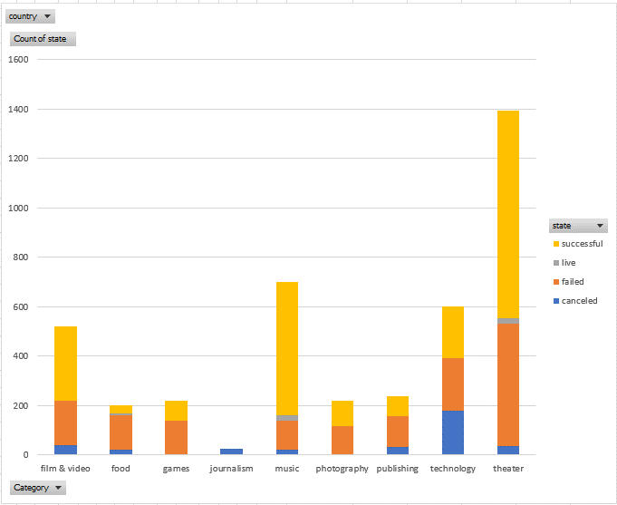

* Plays is the sub-category with the highst success using Kickstarter
* Rock is the subcategory with the hight success and with no canceled or failed using Kickstarter

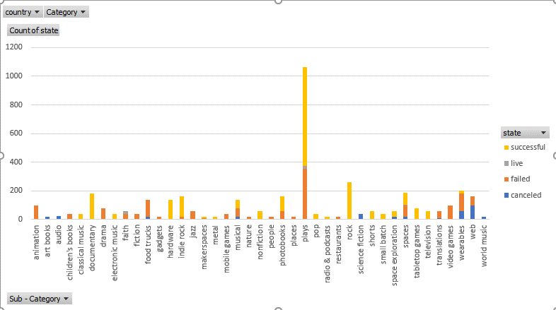

* May is the month when Kickstarter campaigns shows the highest success.
* December is the month with the lowest success for Kickstarter campaigns.

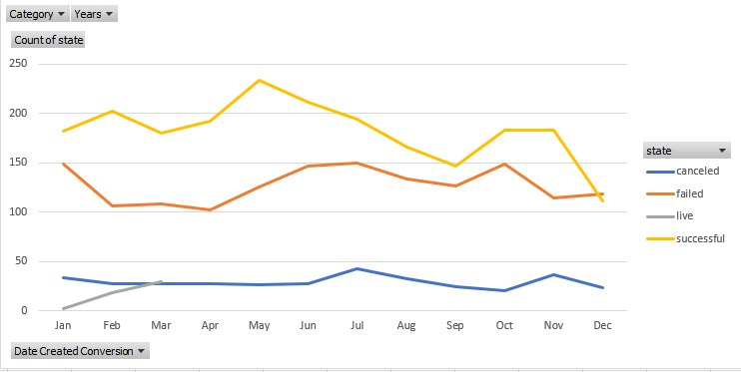

1. **What are some limitations of this dataset?**

* Missing to include some other important and big countries.
* Missing to include also the ages of the people to whom the campaign where directed

1. **What are some other possible tables and/or graphs that we could create?**

**States vs Status**

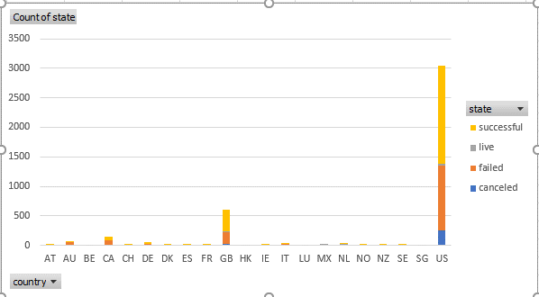

**Category vs Backer (Sum or Average) stacked by state**

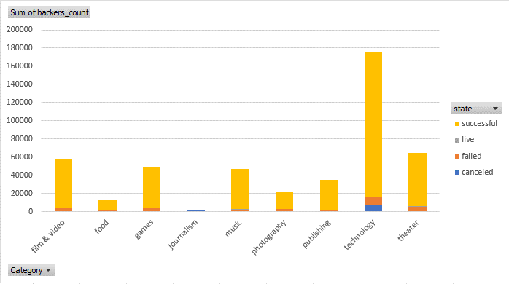

**Subcategory vs Backer (Sum or Average) stacked by state**

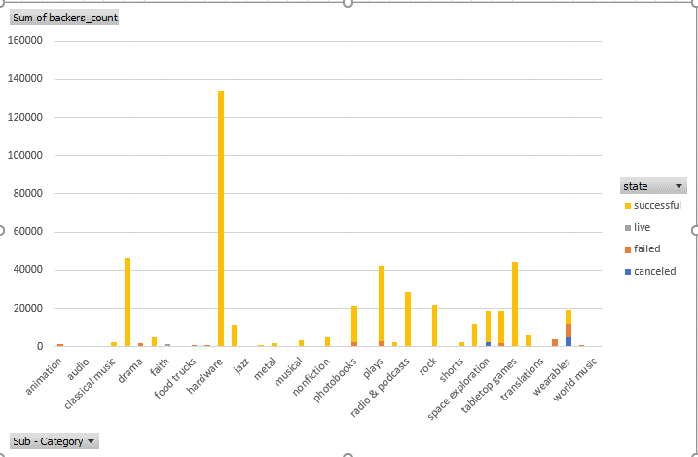

**Subcategory vs Pledge (Sum or Average) stacked by state**

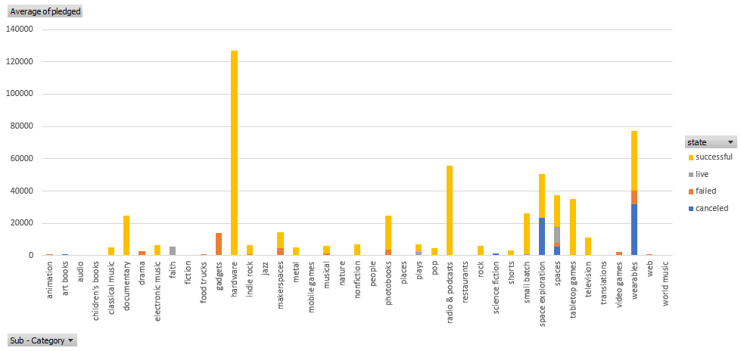

**Subcategory vs Goal (Sum or Average) stacked by state**

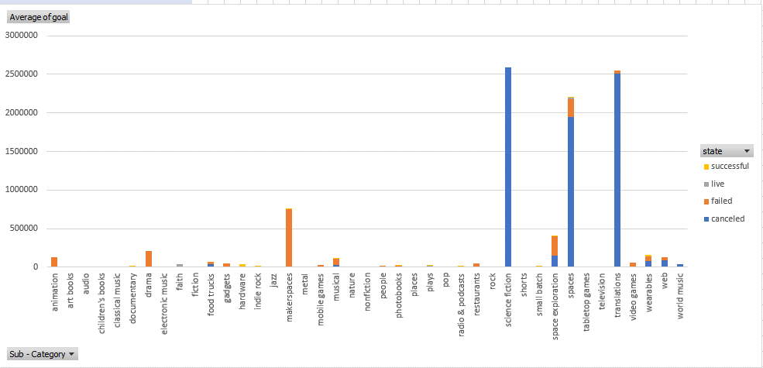

**Category vs Goal (Sum or Average) stacked by state**

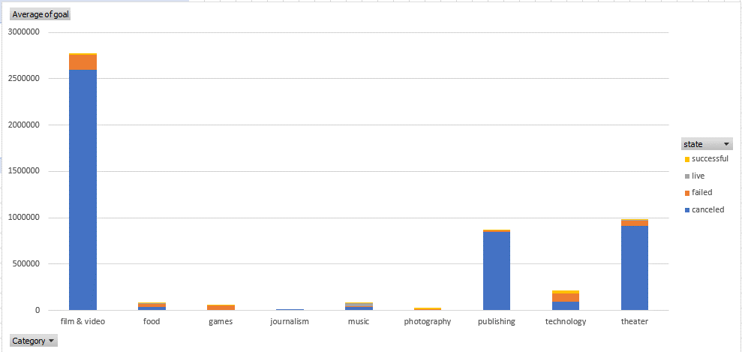

**Category vs Pledge (Sum or Average) stacked by state**

