**DSO 562 Assignment 4**

**Yu Liu**

**Algorithm Modifications**

* P for score 1: 3
* P for score 2: 3
* # PCs kept: 8
* Autoencoder: encoded dimension:4

96% records in the top 100 that are the same as the original run before making the algorithm changes, 4% differ from part 1. (Calculation see excel sheet attached.)

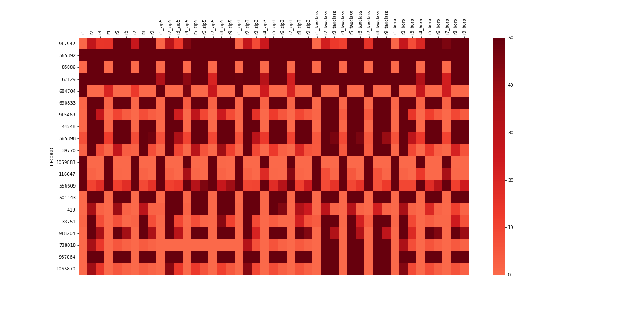

**Anomaly Records Analysis**

1. **917942**
   1. Has a larger z score in variables associated with r5, r6, r8, r9
   2. It has a relatively larger AVLAND(Assessed land value), AVTOT(Assessed total value, which indicate a higher value of building.
   3. According to the address, Holiday Inn New York JFK Airport Area, a commercial building, which may have a higher value.
2. **565392**
   1. All variables have a higher z score
   2. Extreme High FULLVAL (Total market value of the land), and relatively higher AVLAND(Assessed land value), AVTOT(Assessed total value)
   3. Owned by US Government
3. **85886**
   1. Has a larger z score in all variables associated with r2,r3, r5, r6, r8, r9
   2. It has a relatively lower *S2* (BLDFRONT * BLDDEPTH), *S3* (*S2*\* STORIES), which indicate a smaller building area and building volume.
   3. Highway property owned by Parks and Recreations
4. **67129**
   1. All variables have a higher z score
   2. Extreme High FULLVAL (Total market value of the land), and relatively higher AVLAND(Assessed land value), AVTOT(Assessed total value)
   3. According to the address, it indicates The Metropolitan Museum of Art Fifth Owned by Cultural Affairs, which is a high value museum.
5. **684704**
   1. Has a larger z score in variables associated with r1, r4, r7, and their zip code, tax class and borough Code.
   2. Missing entire value in FULLVAL, AVLAND, AVTOT, BLDFRONT, BLDDEPTH, and untreated possible missing value in LTFRONT, LTDEPTH
6. **690833**
   1. Has a larger z score in all variables associated with r2,r3, r5, r6, r8, r9
   2. It has a relatively larger AVLAND(Assessed land value), AVTOT(Assessed total value, lower *S2* (BLDFRONT * BLDDEPTH), *S3* (*S2*\* STORIES), which indicate a higher value of building, smaller building area and building volume.
   3. Parkway property owned by Parks and Recreations
7. **915469**
   1. Has a larger z score in all variables associated with r2, and especially a larger z score in r2,r3, r5, r6, r8, r9 associated with tax class (1B)
   2. It has a relatively larger AVLAND(Assessed land value) and lower *S2* (BLDFRONT * BLDDEPTH), which indicate a higher value of building, smaller building area.
   3. Bay Boulevard owned by US
8. **44248**
   1. Has a larger z score in all variables associated with r2,r3, r5, r6, r8, r9
   2. It has a relatively larger AVLAND(Assessed land value), AVTOT(Assessed total value, lower *S2* (BLDFRONT * BLDDEPTH), *S3* (*S2*\* STORIES), which indicate a higher value of building, smaller building area and building volume.
   3. Parkway property owned by Parks and Recreations
9. **565398**
   1. Has a larger z score in all variables associated with r2,r3, r5, r6, r8, r9
   2. It has a relatively larger AVLAND(Assessed land value), AVTOT(Assessed total value, lower *S2* (BLDFRONT * BLDDEPTH), *S3* (*S2*\* STORIES), which indicate a higher value of building, smaller building area and building volume.
   3. Parkway property owned by Department of General Service
10. **39770**
    1. Has a larger z score in all variables associated with r2, r5, r7, and especially a larger z score in r2,r3, r5,r6, r7, r8 associated with tax class (Apartments)
    2. It has a relatively larger AVLAND(Assessed land value) and lower *S2* (BLDFRONT * BLDDEPTH), which indicate a higher value of building, smaller building area.
    3. Extreme high value of FULLVAL, AVLAND, AVTOT for apartments
    4. Apartment owned by Greenhorn Development