**AVISO MAIN WORKFLOW**

1. User runs parcer and system collects information about objects in the tab ‘Версии источников’ by pushing the button ‘Обновить’.

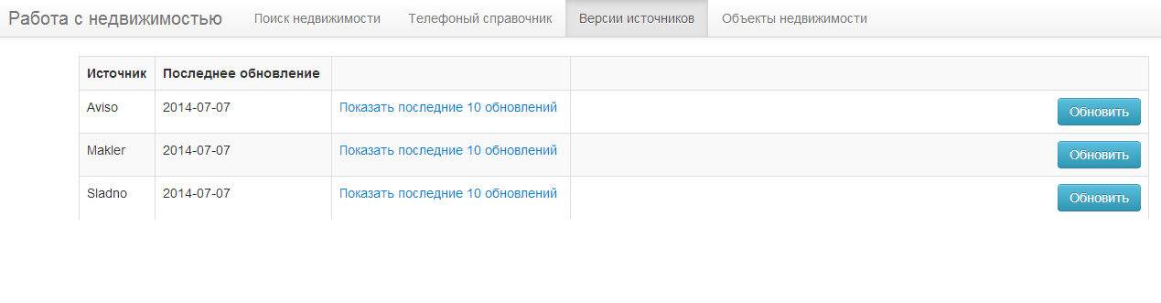

1. User selects setting on the page ‘Поиск недвижимости’ and pushs the button ‘Поиск’ .

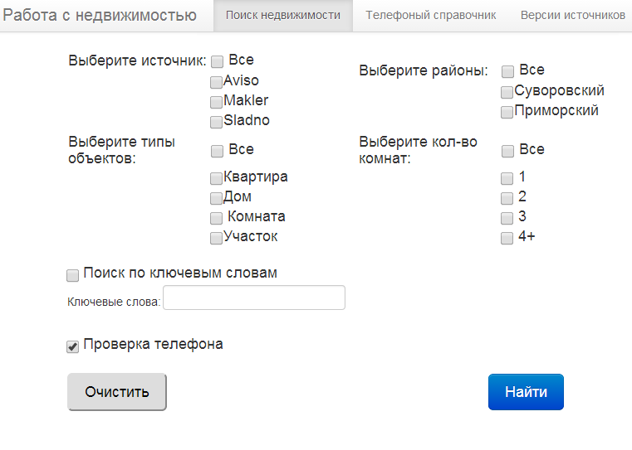

1. System proposes found results on the tab ‘Объекты недвижимости’.
2. User can mark object as ‘not unique’and system inserts phone numbers of this object into database.

**Phone managing workflow**

1. User types phone number and push the button ‘Найти’ on the page ‘Телефонный справочник’.

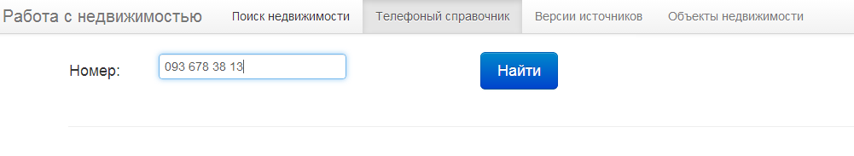

1. If the phone number wasn’t found system proposes to add it.

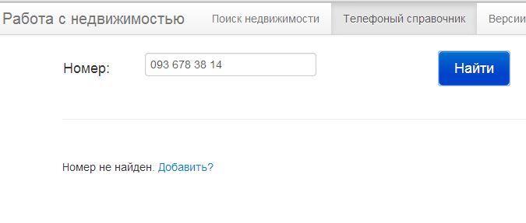

In case user pushes link ‘Добавить?’ form with disable phone number and editable description is displayed.

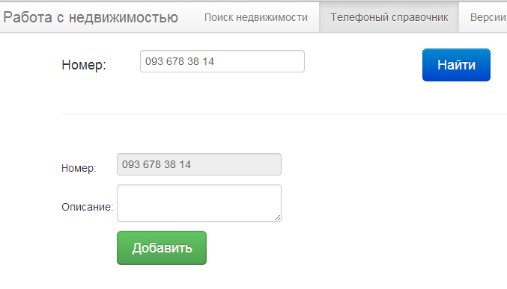

1. If phone number was found in the database system displays information about it with editiable only field ‘Описание’ and options ‘Изменить’ and ‘Удалить’.

