Binary Search

Two pointers:

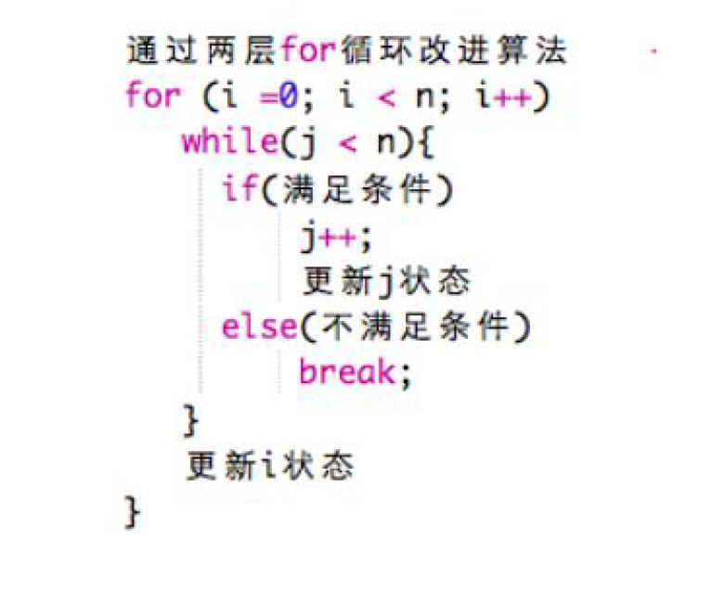

**public** **int** lengthOfLongestSubstring(String s) {

// write your code here

**int** n = s.length();

**int** [] map = **new** **int** [256];

**int** max = 0;

**for**(**int** i=0,j=0;i<n;i++){

**while**(j<n && map[s.charAt(j)]==0){

map[s.charAt(j)] =1;//更新j状态

max = Math.*max*(max, j-i+1);

j++;//移动j下标

}

map[s.charAt(i)]--;//更新i

}

**return** max;

}