
HitnScore

RcktScore Apple Subscription Sandbox Test Report
TestFlight purchase verification and subscription lifecycle evidence
Test period: 10 to 11 September 2026
Environment: Apple Sandbox through TestFlight, RcktScore iOS 1.0.2 build 49
Report prepared: 11 September 2026
Purpose: Record the manual purchase and lifecycle tests completed in this test session, the defects found, the corrective actions applied, and the evidence supporting each result.

Executive outcome
Outcome: The Test A, Test B, Test C and Test D scenarios executed in this session passed. They demonstrated initial monthly purchase, voluntary cancellation with access through paid expiry, stable renewal, account-bound purchase protection, failed renewal, grace-period access, grace expiry, billing retry expiry, and successful billing recovery without entitlement churn.
The report signs off the manual Sandbox suite performed here. It does not by itself close every item in the broader production-release checklist. Refund and revocation, refund reversal, cross-device restore, deliberate missed-notification repair, and several negative security cases still require separate end-to-end evidence before production purchasing is declared fully ready.
Tester | Organisation | Product | Primary scenario | Result
Test A | 50006 | Personal Plus monthly | Purchase, voluntary cancellation and paid-expiry downgrade | Passed
Test B | 50007 | Personal Plus yearly | Continuous renewal and stable refresh | Passed
Test C | 50008 | Personal Plus monthly | Failed renewal through grace and final expiry | Passed
Test D | 50009 | Personal Plus monthly | Failed renewal followed by billing recovery in grace | Passed

Scope and evidence method
The iOS app was installed through TestFlight and used with dedicated HitnScore personal accounts and Apple Sandbox testers. Apple lifecycle notifications were verified against Supabase records in app_store_subscriptions and app_store_subscription_events. Entitlement changes were checked in SkwshOrgSettings and the append-only subscription_entitlement_audit table. Device screenshots, database result screenshots, and implementation evidence were retained together.
- The server-side plan was treated as authoritative; the device display was checked after database state was confirmed.
- All displayed lifecycle processing_error and reconciliation_error values were NULL.
- An audit row was expected only when the effective HitnScore plan changed.
- Times in this report are Europe London local time as selected in the SQL evidence.

Rectifications made during the test programme

Renewal boundary entitlement race
A renewal-boundary risk was identified in which a locally elapsed transaction could be downgraded before Apple's delayed renewal notification or server reconciliation arrived. This could produce an incorrect temporary Personal Plus to Personal Free to Personal Plus sequence.
The backend was changed so elapsed subscriptions are reconciled with Apple before local expiry is applied. Verified active Apple status remains entitled even when the previous signed transaction has just elapsed, and a bounded 15-minute fallback now applies only when notifications and reconciliation remain unavailable. Elapsed active, grace-period, and billing-retry rows are prioritised for reconciliation.

iOS refresh and subscription management handling
SwiftUI cancellation of an in-flight pull-to-refresh was previously capable of appearing as a user-facing dashboard error. CancellationError and URLError.cancelled are now treated as non-failures. The dashboard also reloads the server-authoritative plan when Apple's Manage Subscription sheet closes so expiry or revocation can be reflected promptly.
This was exercised during Test A. A transient Unable to fetch dashboard data banner and stale subscription presentation were observed around the accelerated Sandbox expiry boundary. The refresh cancellation handling and post-Manage-Subscription reload were rectified so a cancelled request is not reported as a lifecycle failure and the next completed refresh takes the authoritative plan from the server.

Regression verification
Regression coverage was added for active entitlement during Apple's transaction-delivery window, the 15-minute fallback, reconciliation-before-expiry ordering, and successful state application. The backend automated suite completed with 79 passing tests, and Python compilation plus AWS SAM build and validation completed successfully before deployment.

Sandbox account mismatch
Test C initially invoked the personal Media and Purchases Apple account yulunga@gmail.com even though the Sandbox settings displayed testc@hitnscore.com. The personal Media and Purchases session was signed out and the dedicated Sandbox tester was reselected under Developer settings. The subsequent TestFlight purchase sheet correctly displayed testc@hitnscore.com. The backend also rejected the transaction when it belonged to another HitnScore account, confirming account binding protection.

Billing grace and accelerated timing
Billing Grace Period was confirmed and then restricted to the Sandbox environment with a three-day production-duration setting and eligibility limited to paid-to-paid renewals. The Sandbox renewal rate was set to five minutes for Test D. Test C's already-created monthly cycle retained its earlier 30-minute timing; later cycles followed the accelerated Sandbox schedule.

Programme configuration evidence
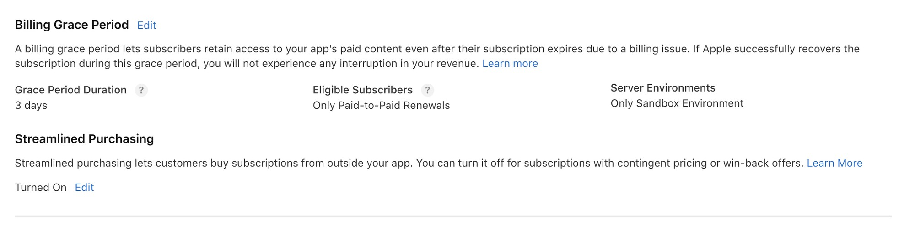
Configuration evidence 1 Billing Grace Period restricted to paid-to-paid renewals in Sandbox
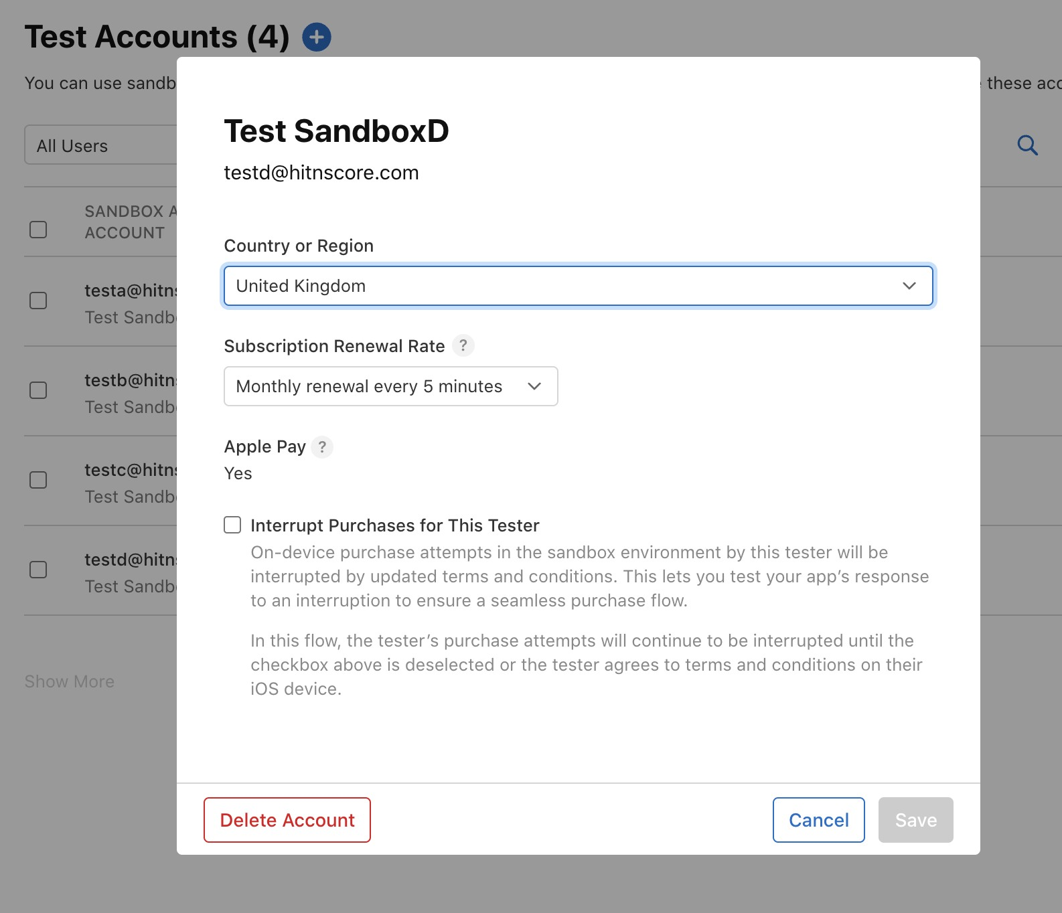
Configuration evidence 2 Test D Sandbox tester set to five-minute monthly renewals

Test A monthly purchase and voluntary cancellation
Test A used HitnScore account testa@hitnscore.com and organisation 50006 with the monthly product com.hitnscore.personalplus.monthly. The objective was to prove the initial Free to Plus purchase, continuing paid access after auto-renew was disabled, and the final Plus to Free transition when the paid Sandbox period ended. The cancellation path was repeated once after resubscription to confirm the same terminal behaviour.
Checkpoint | Observed evidence | Outcome
Initial state | Personal was Current and no subscription row existed | Passed
Monthly purchase | Apple-signed Sandbox purchase created the subscription and upgraded Free to Plus | Passed
Normal renewal | Successive five-minute transactions advanced the paid-through time | Passed
Cancellation | DID_CHANGE_RENEWAL_STATUS set auto-renew false without removing current access | Passed
Paid-through access | HitnScore continued to display Personal Plus Current before expiry | Passed
Voluntary expiry | EXPIRED VOLUNTARY changed active to expired and Plus to Free | Passed
Audit integrity | Each effective Free to Plus and Plus to Free change was recorded once | Passed
Refresh defect | A transient dashboard fetch error was observed and the cancellation/reload handling was rectified | Rectified

Test A purchase and entitlement activation
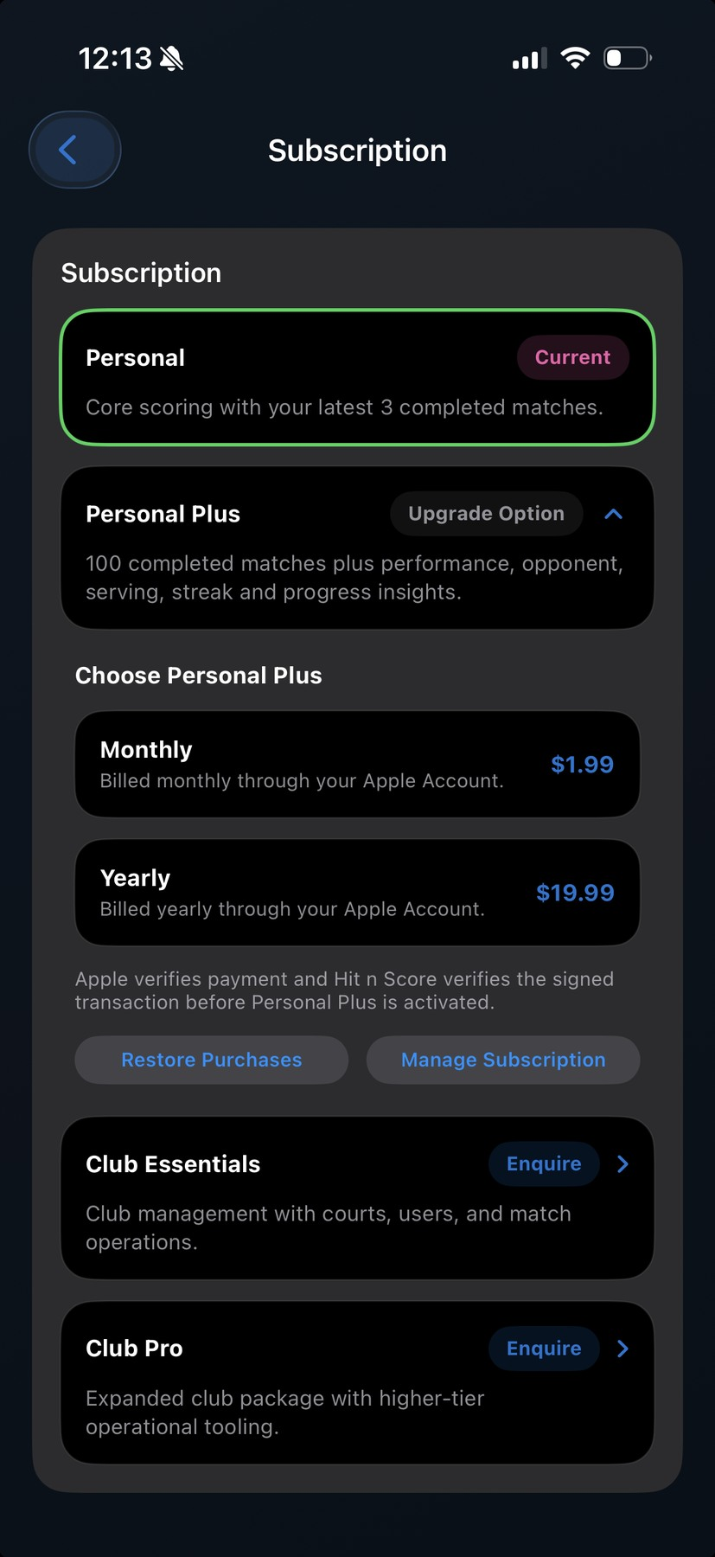
Figure A1 Test A began with Personal current and the monthly and yearly upgrade choices available
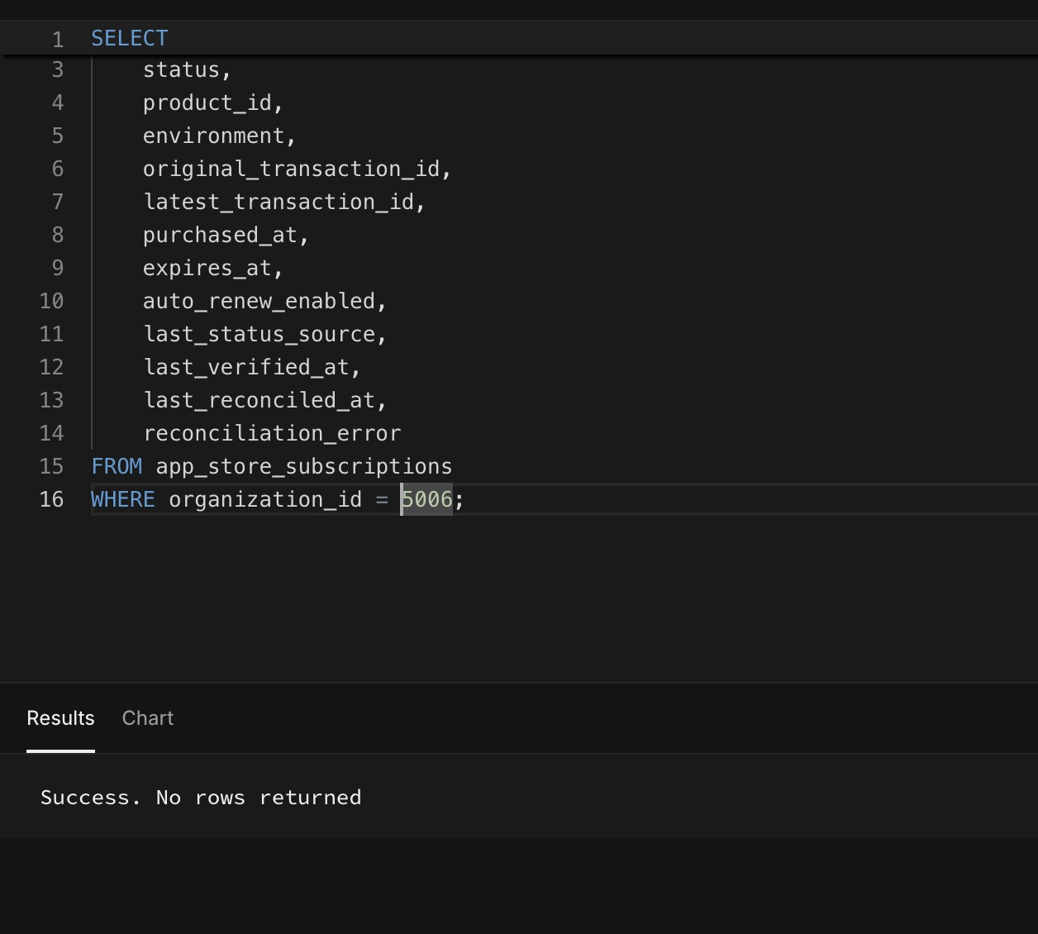
Figure A2 Baseline query returned no Apple subscription row for organisation 50006
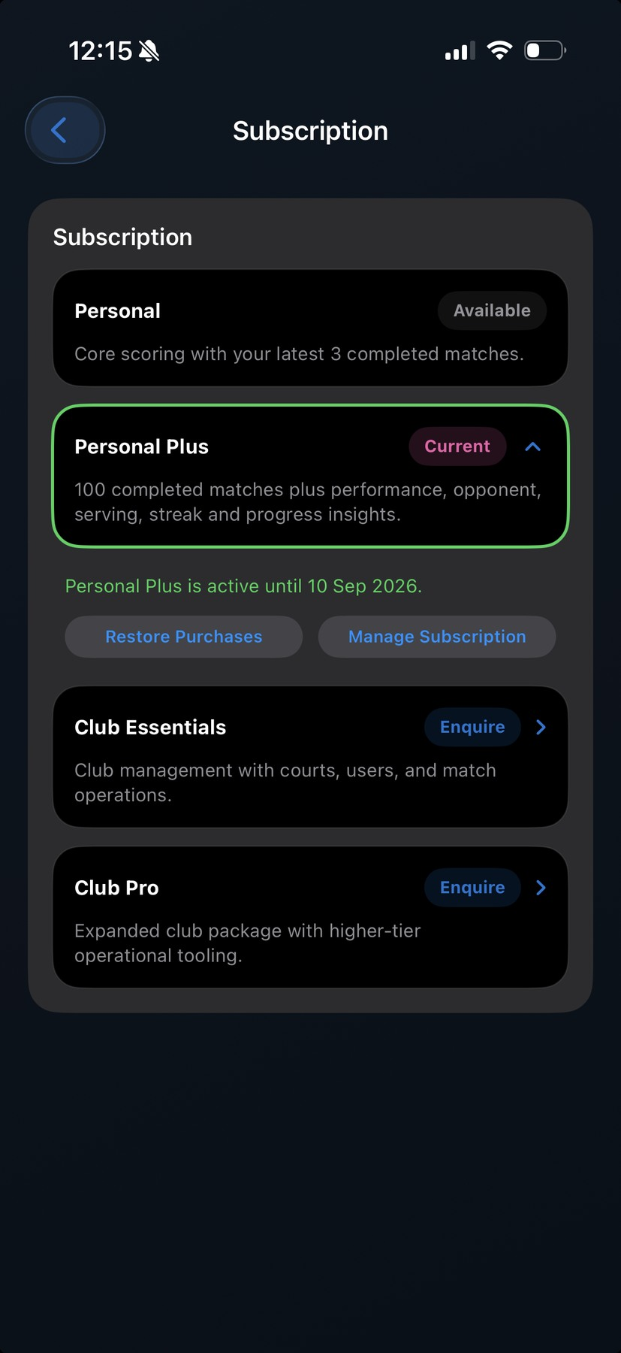
Figure A3 The monthly purchase completed and Personal Plus became Current
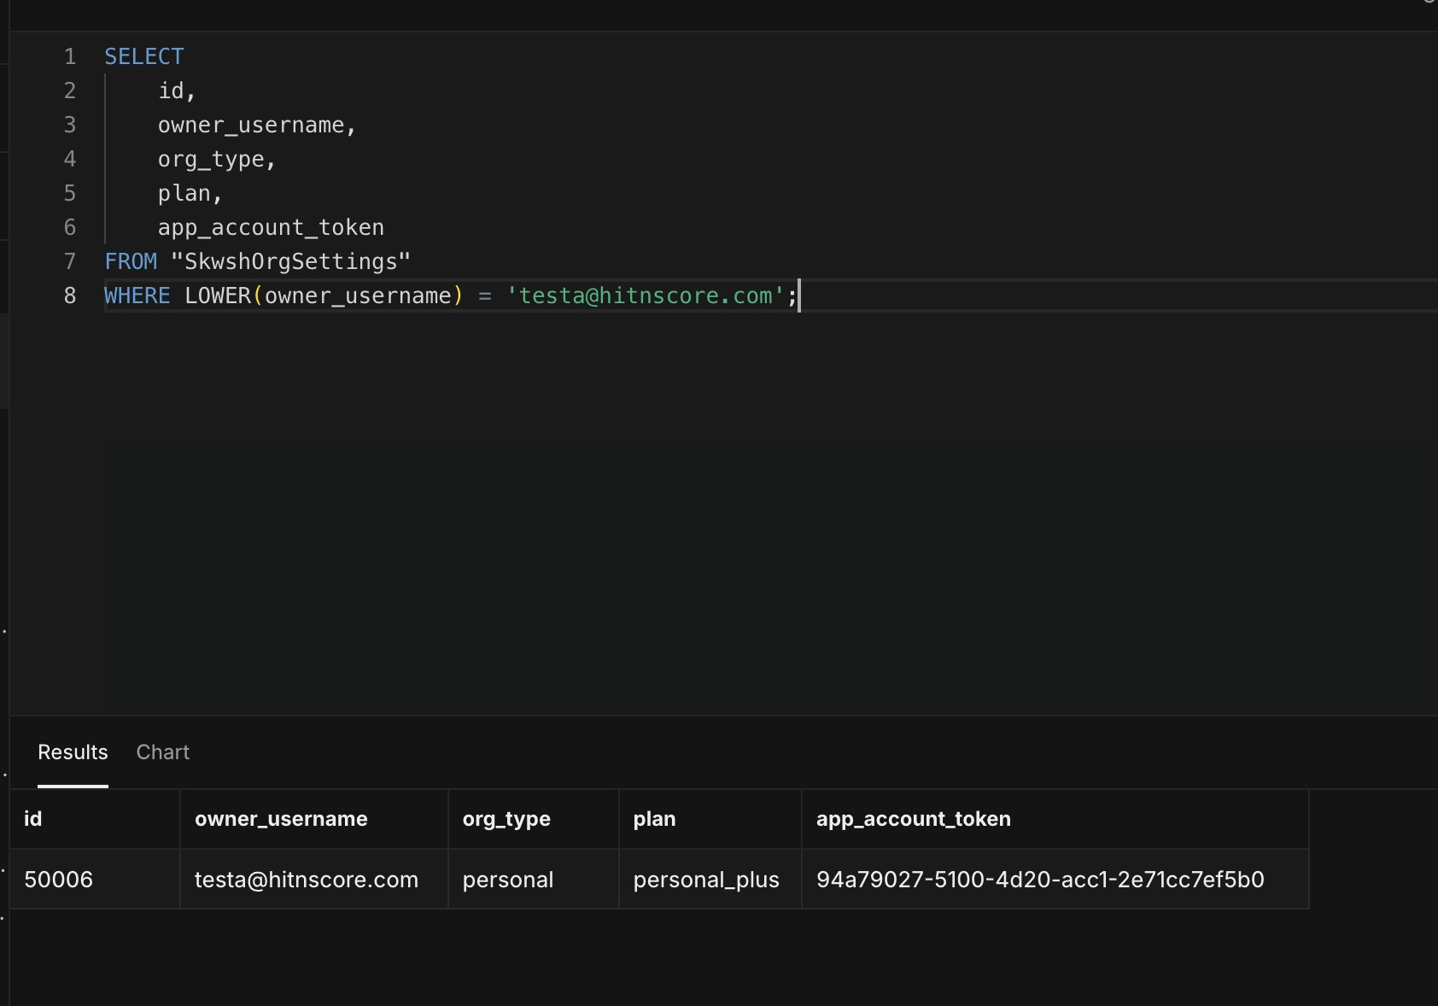
Figure A4 Organisation 50006 was bound to testa and upgraded to Personal Plus
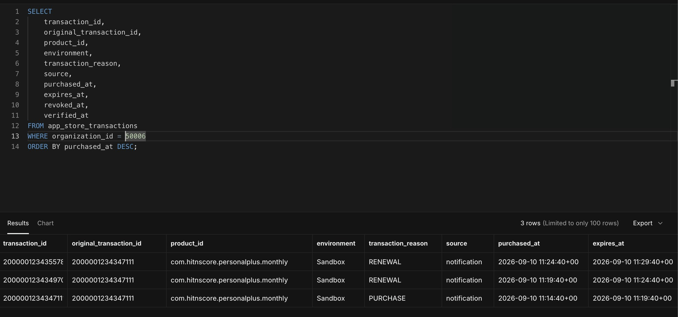
Figure A5 Initial monthly purchase and successive renewal transactions were verified in Sandbox
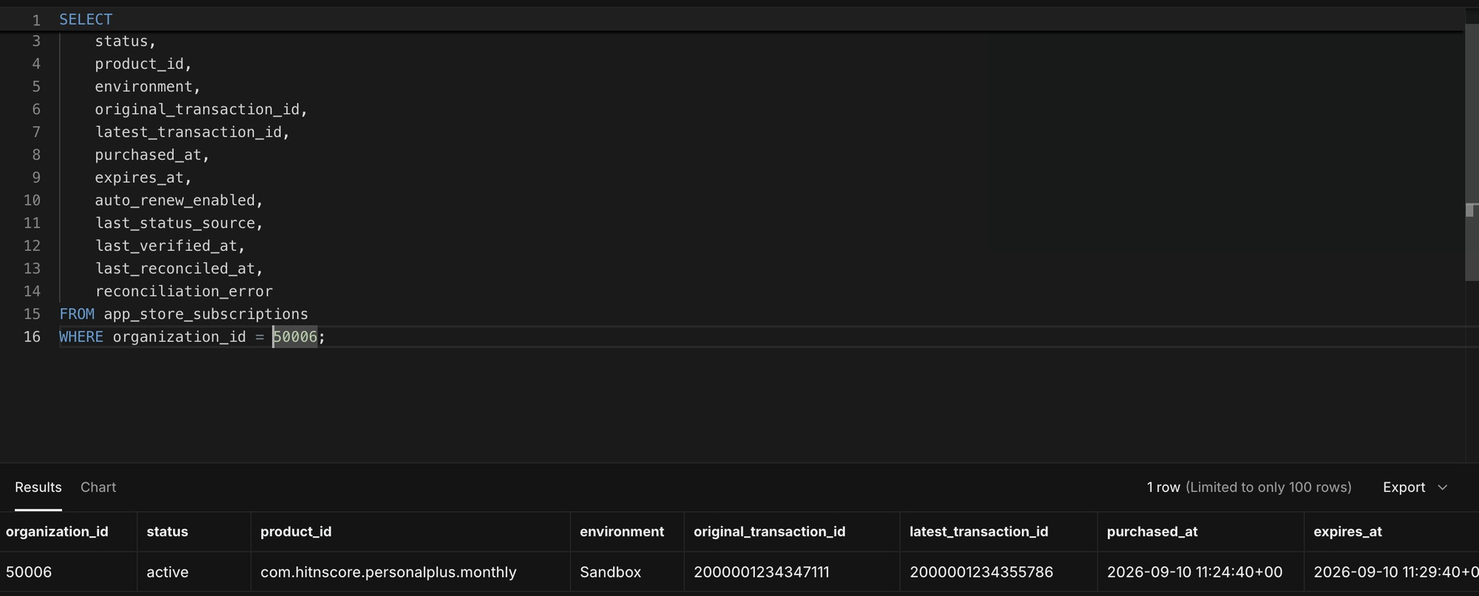
Figure A6 Authoritative subscription row was active with the latest transaction and advanced expiry
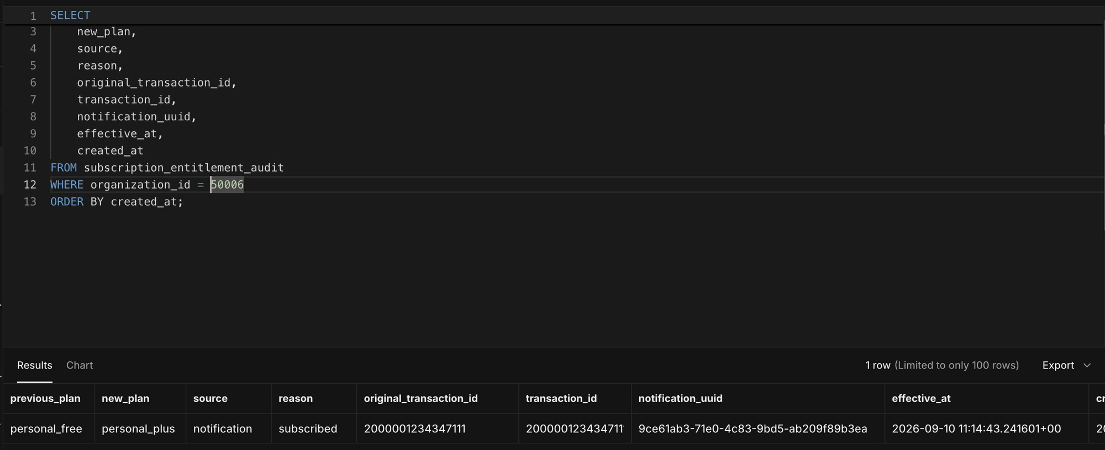
Figure A7 Initial entitlement audit recorded Personal Free to Personal Plus exactly once

Test A cancellation and paid expiry
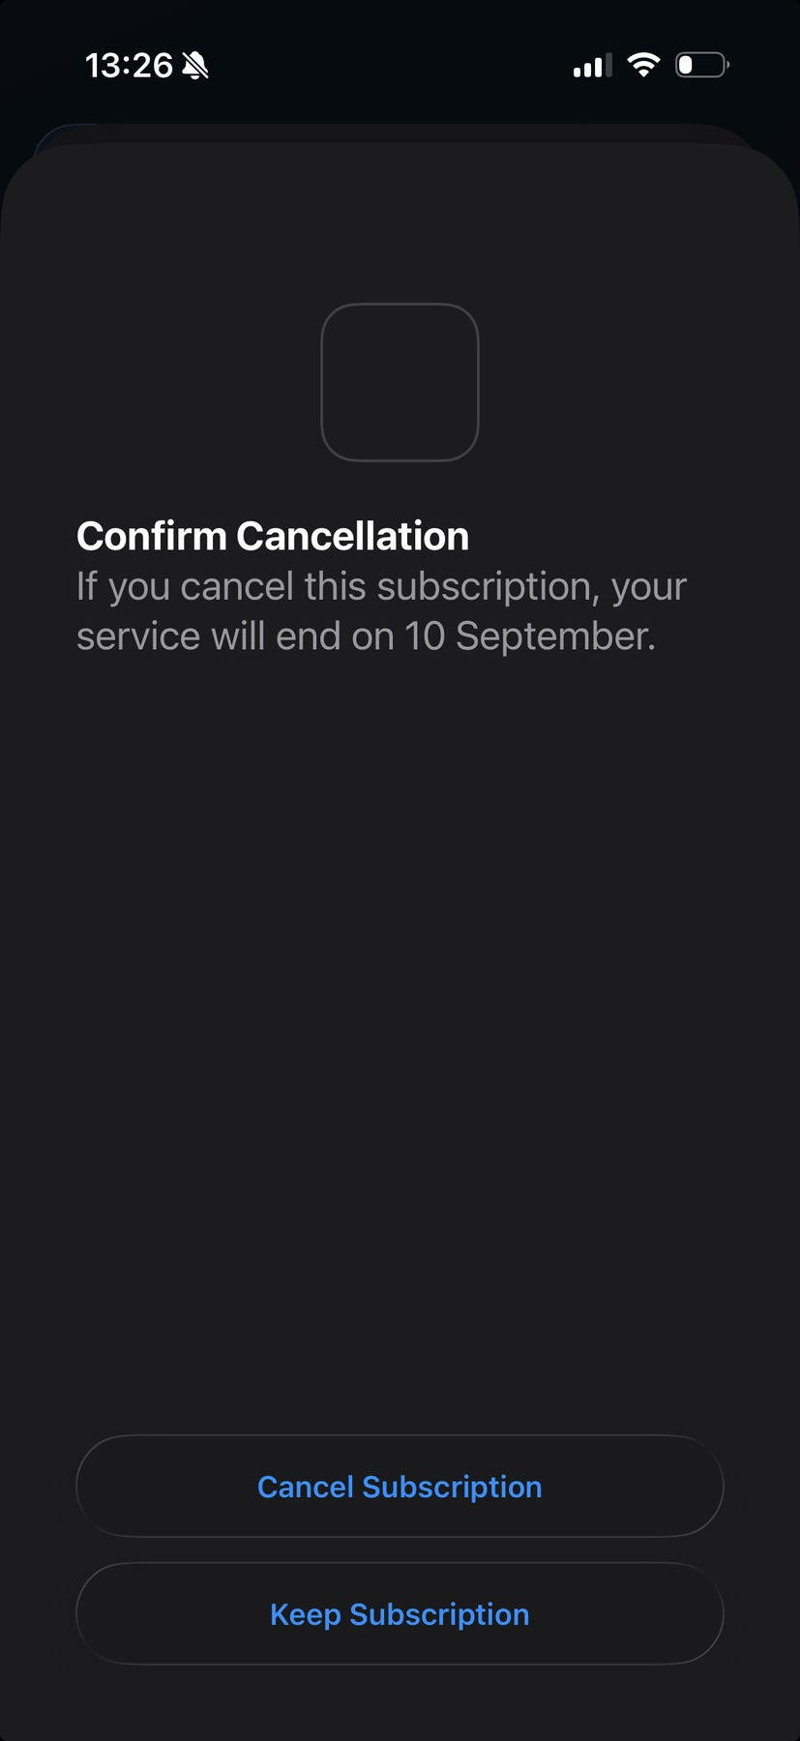
Figure A8 Apple requested explicit confirmation before cancelling the subscription
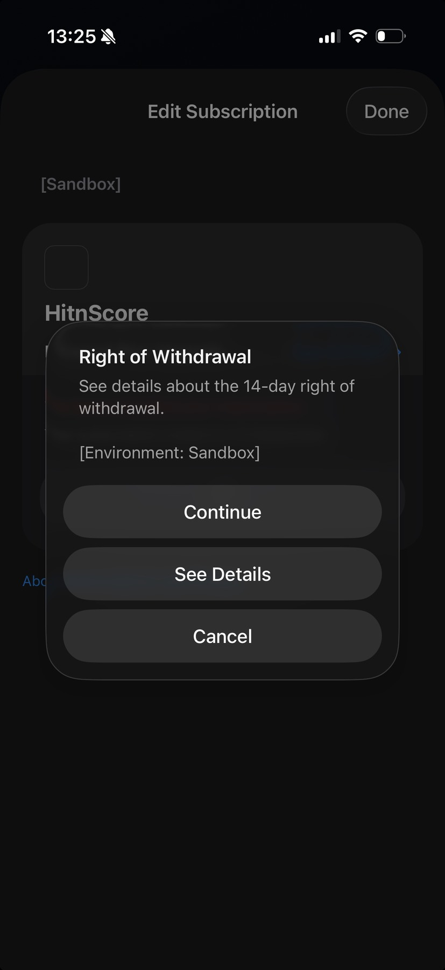
Figure A9 Apple displayed the Sandbox right-of-withdrawal step in the cancellation flow
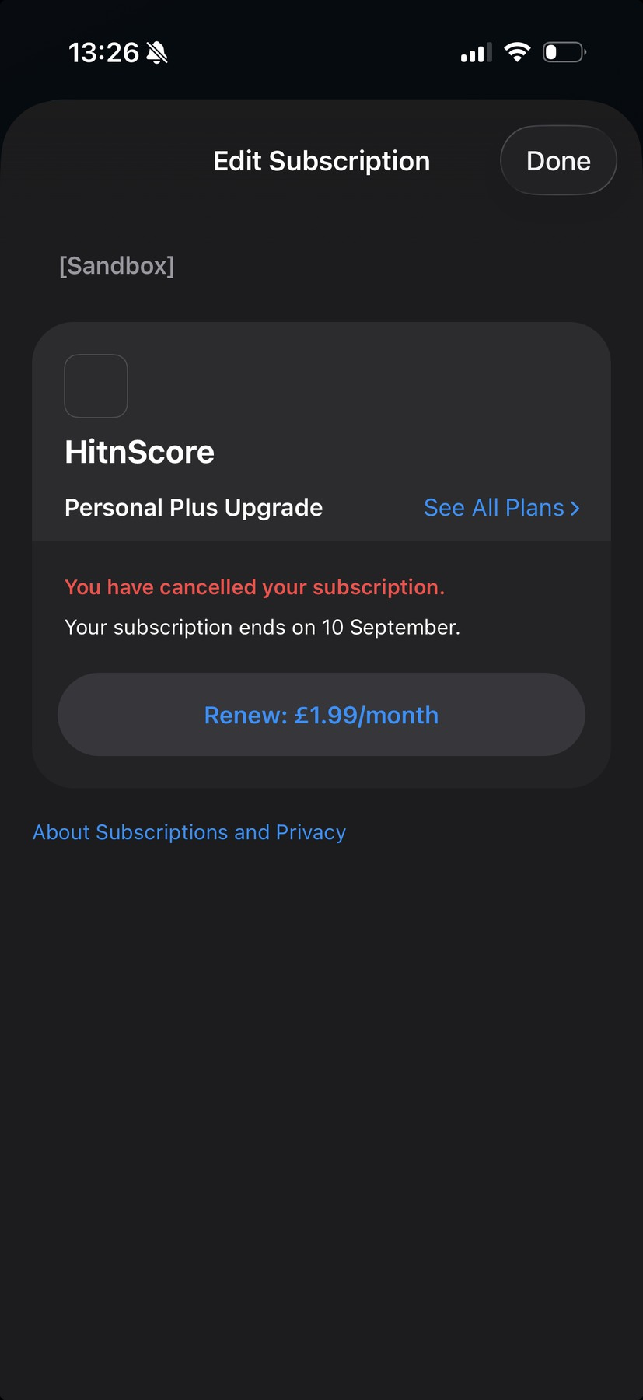
Figure A10 Apple confirmed auto-renew was cancelled while showing the paid-through end date
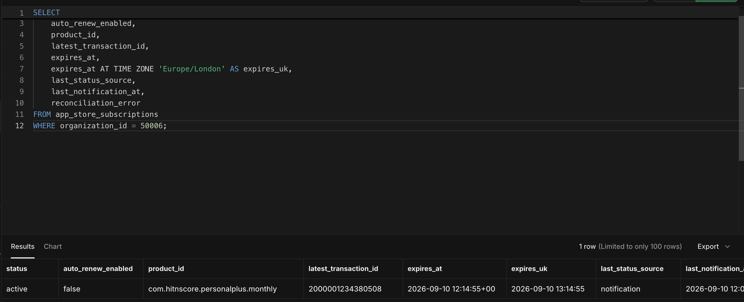
Figure A11 Server state remained active with auto-renew false until the paid expiry
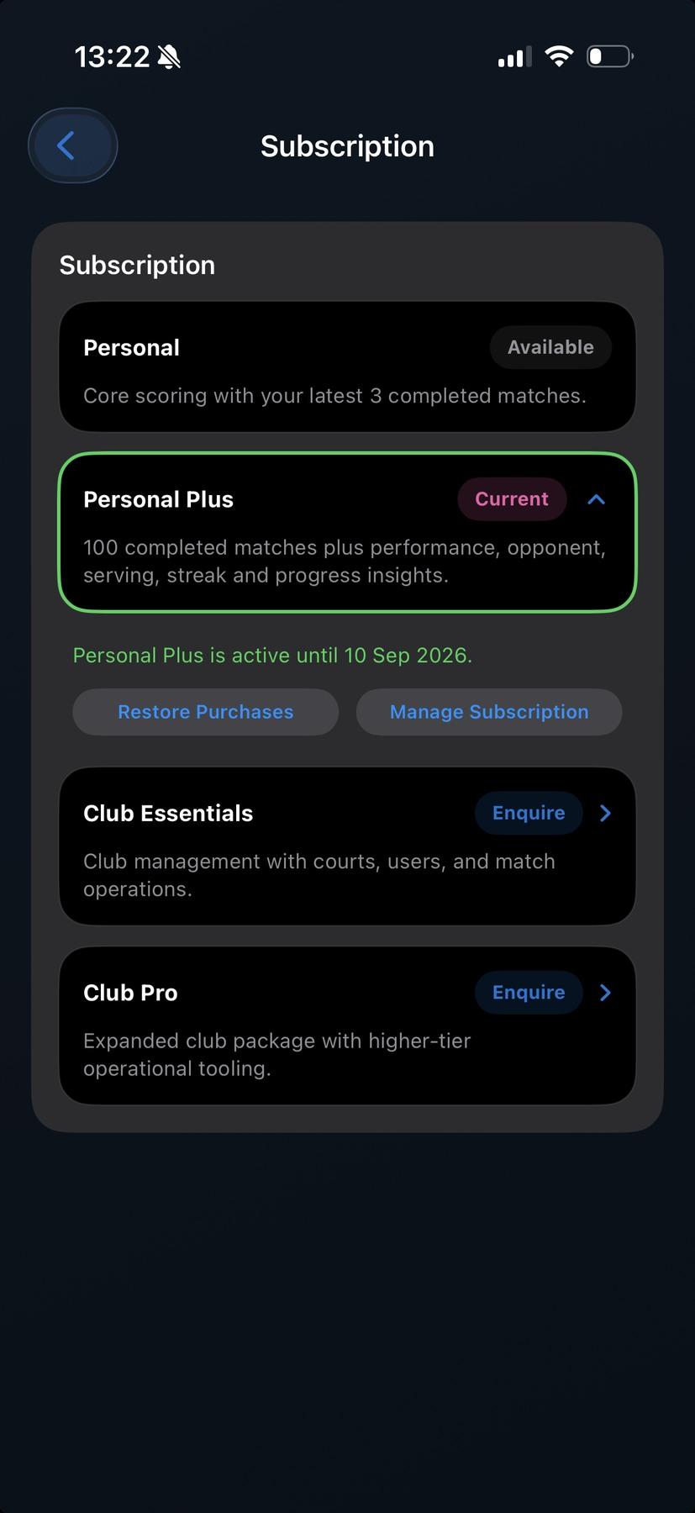
Figure A12 HitnScore retained Personal Plus while the cancelled subscription was still paid through
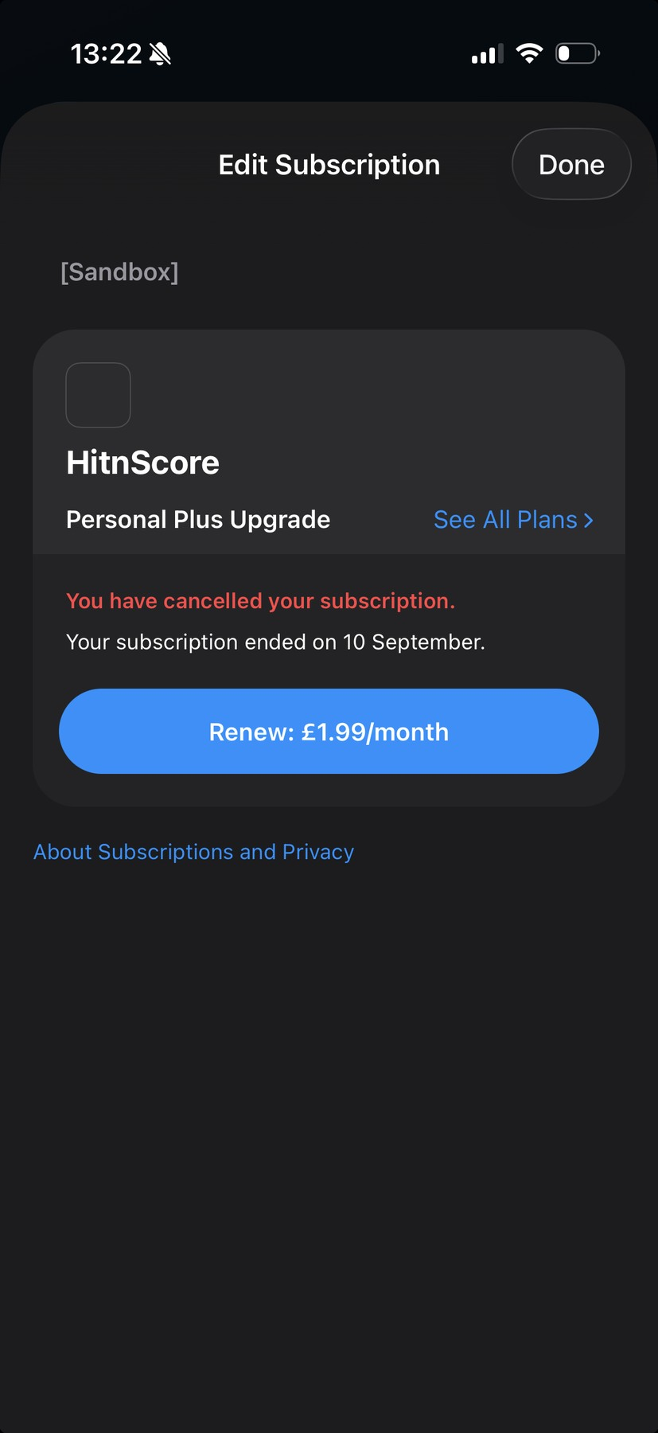
Figure A13 Apple displayed the ended state after voluntary expiry
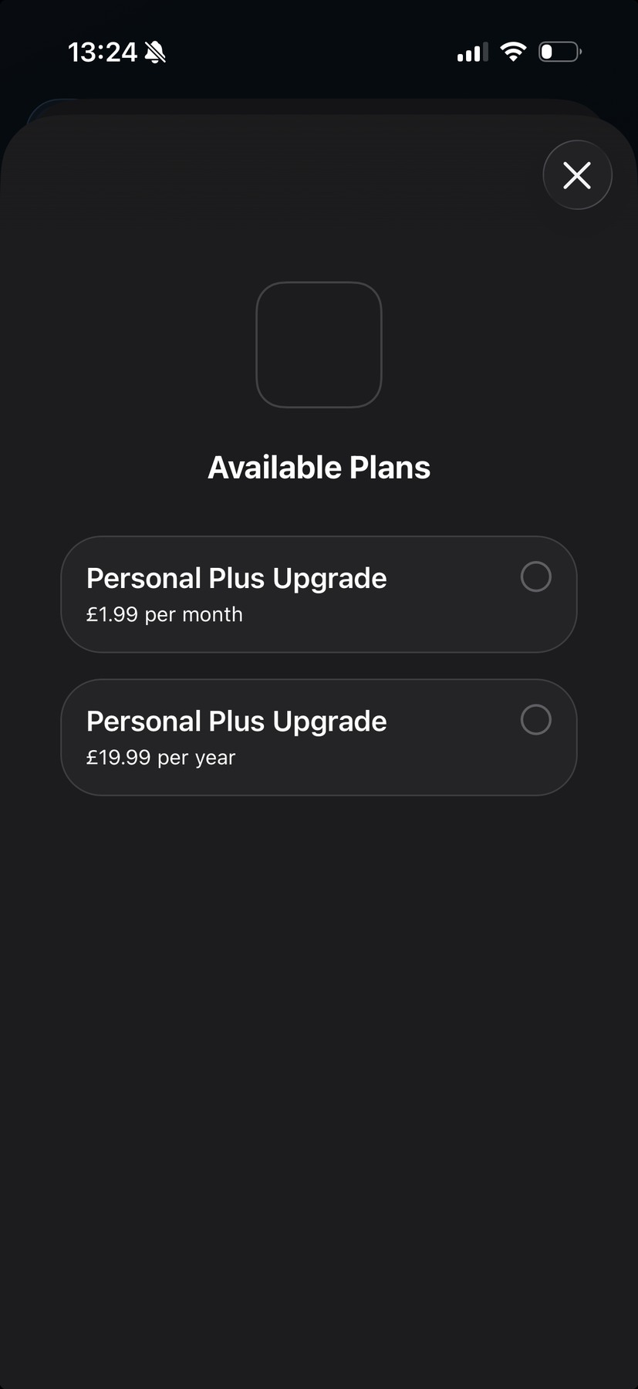
Figure A14 Apple retained both monthly and yearly plans as available repurchase choices

Test A repeat cycle and final audit
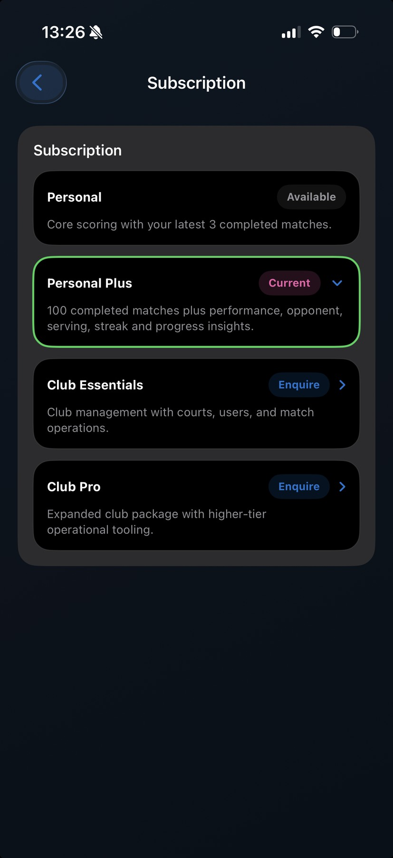
Figure A15 After resubscription the app again showed Personal Plus Current during the paid period
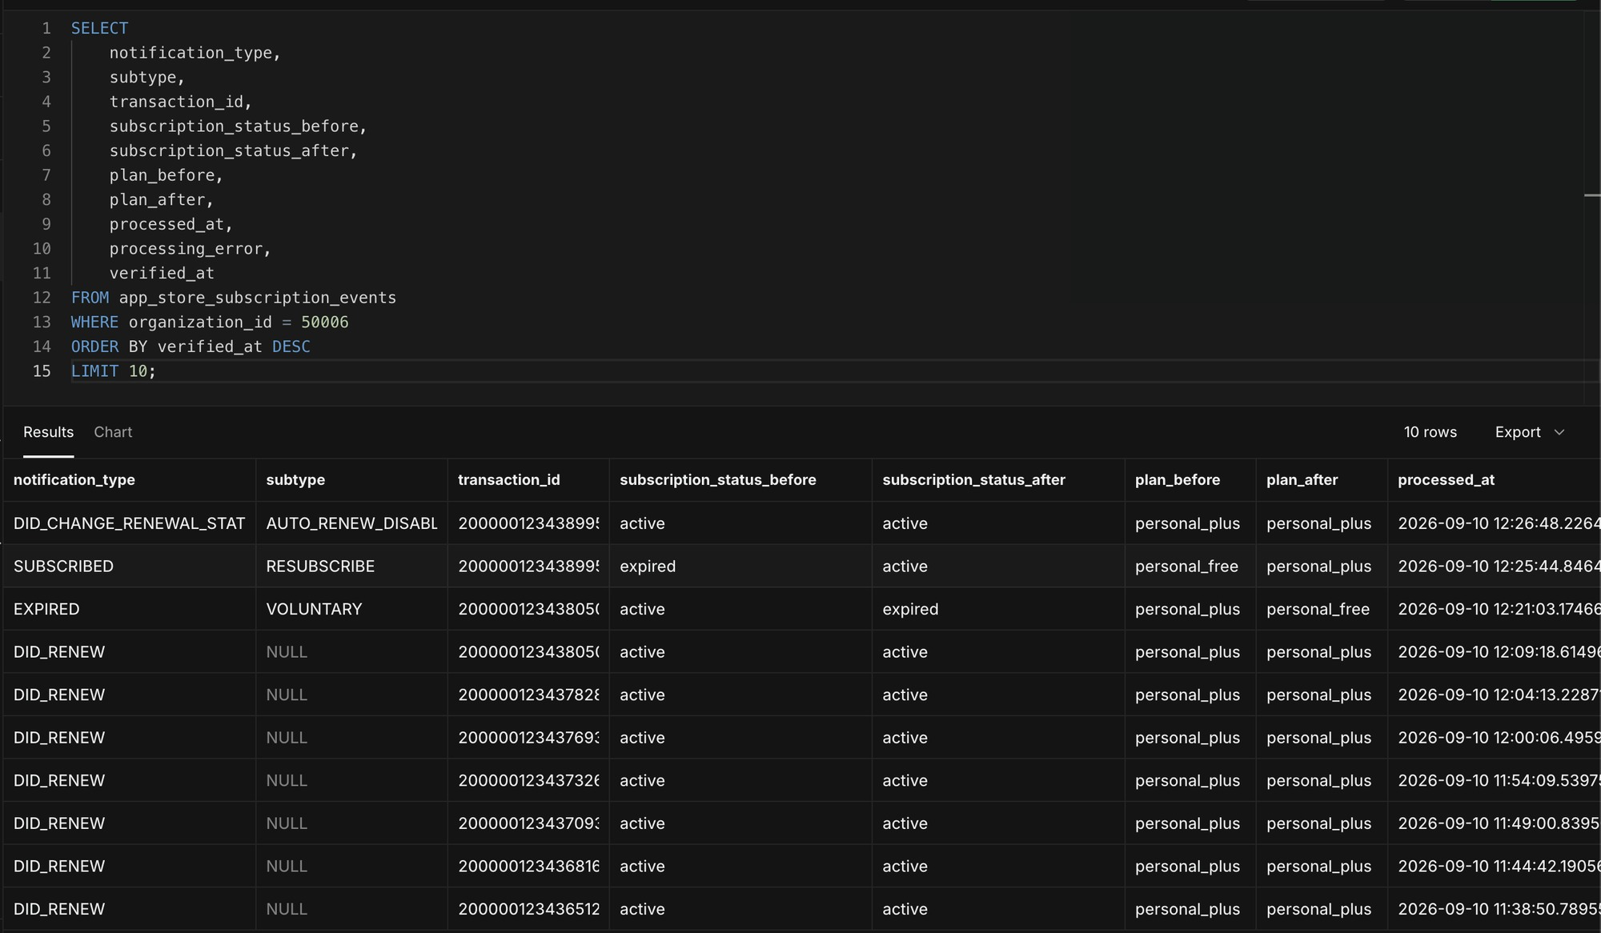
Figure A16 Event chain captured renewals, voluntary expiry, resubscription, and auto-renew disablement
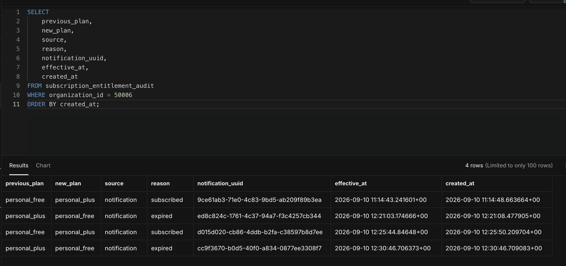
Figure A17 Audit trail recorded both completed Free to Plus to Free cycles without duplicate changes
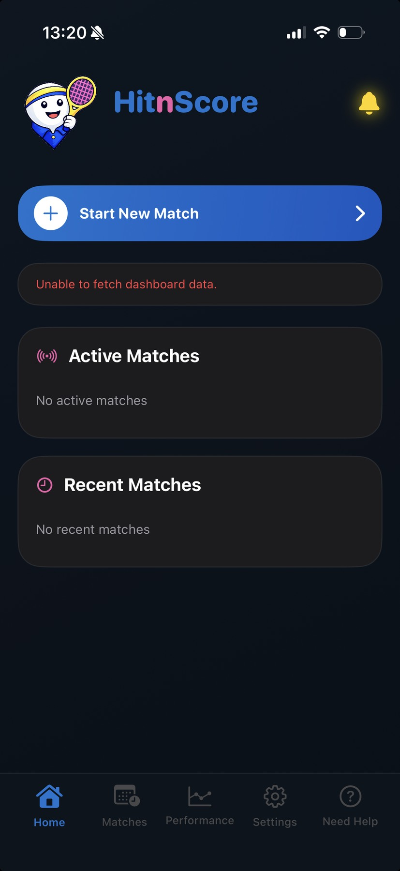
Figure A18 Transient dashboard fetch error observed at the accelerated expiry boundary
Rectification: cancellation itself was processed correctly, but the device could display a cancelled refresh as an error and could retain the last loaded plan until a completed reload. The iOS refresh path now ignores request cancellation as a non-failure and reloads the dashboard after the Apple subscription-management sheet closes.
Test A result: Passed after rectification. The monthly purchase upgraded the correct organisation, cancellation disabled renewal without prematurely removing paid access, voluntary expiry downgraded the server entitlement to Personal Free, and the append-only audit contained one row for each genuine plan change.

Test B stable yearly renewal
Test B used organisation 50007 and the yearly product com.hitnscore.personalplus.yearly. The objective was to prove that normal renewals advance the Apple transaction and expiry while Personal Plus remains continuously current and the refresh path produces no false error.
Checkpoint | Observed evidence | Outcome
Subscription state | active; auto-renew true; source notification | Passed
Product | com.hitnscore.personalplus.yearly | Passed
Latest renewal | DID_RENEW with active to active and Plus to Plus | Passed
Expiry movement | Latest transaction and expiry advanced | Passed
Errors | Reconciliation and latest event processing errors NULL | Passed
Device refresh | Personal Plus remained Current; no upgrade choices or refresh error | Passed

Test B evidence
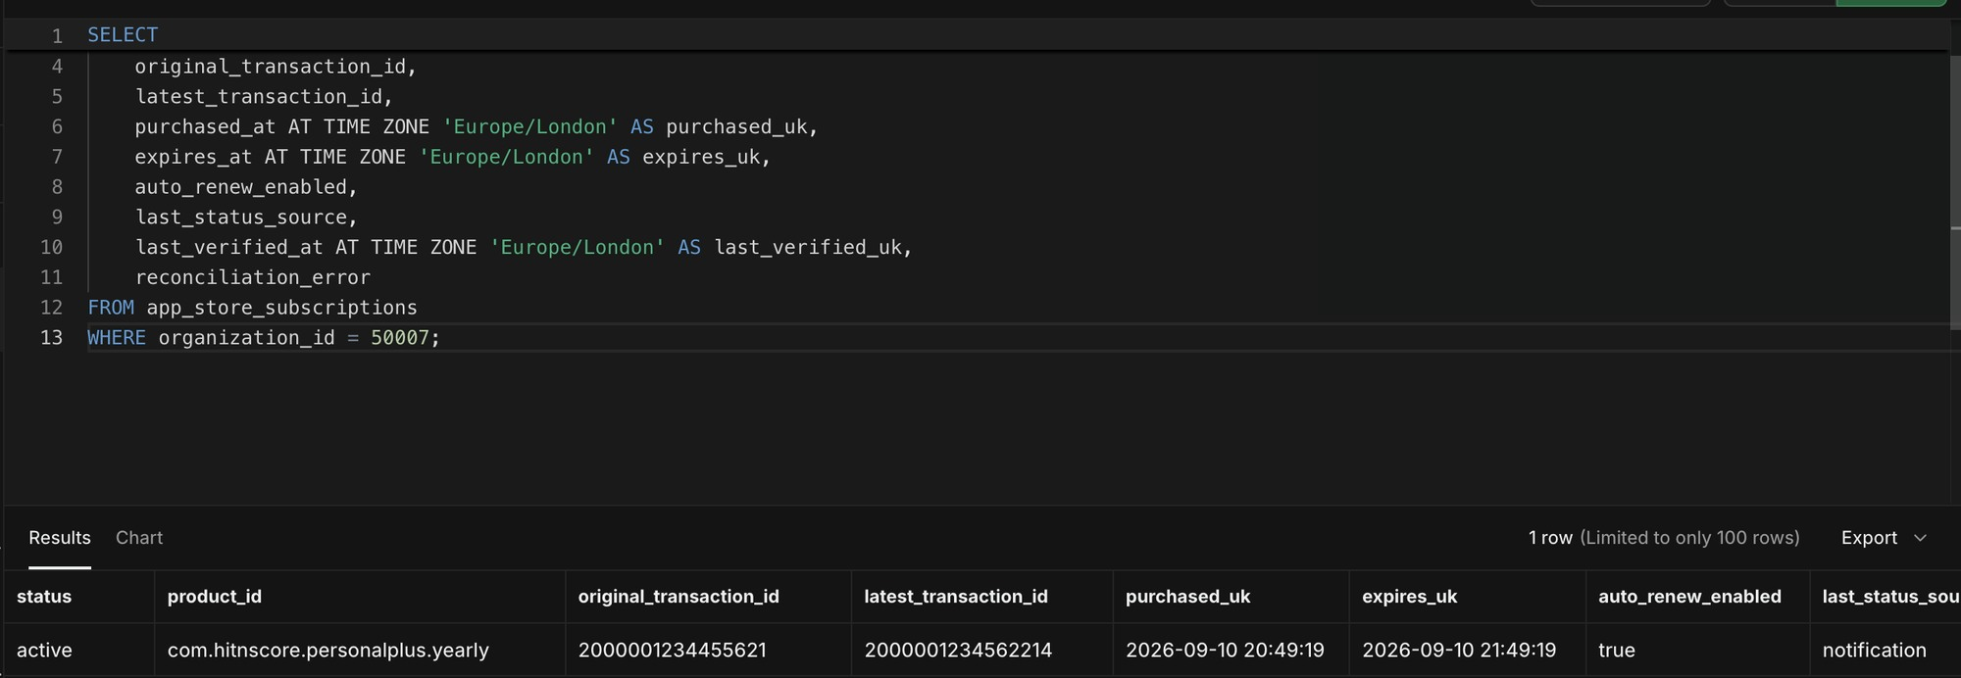
Figure B1 Active yearly subscription for organisation 50007 with the renewed transaction and expiry
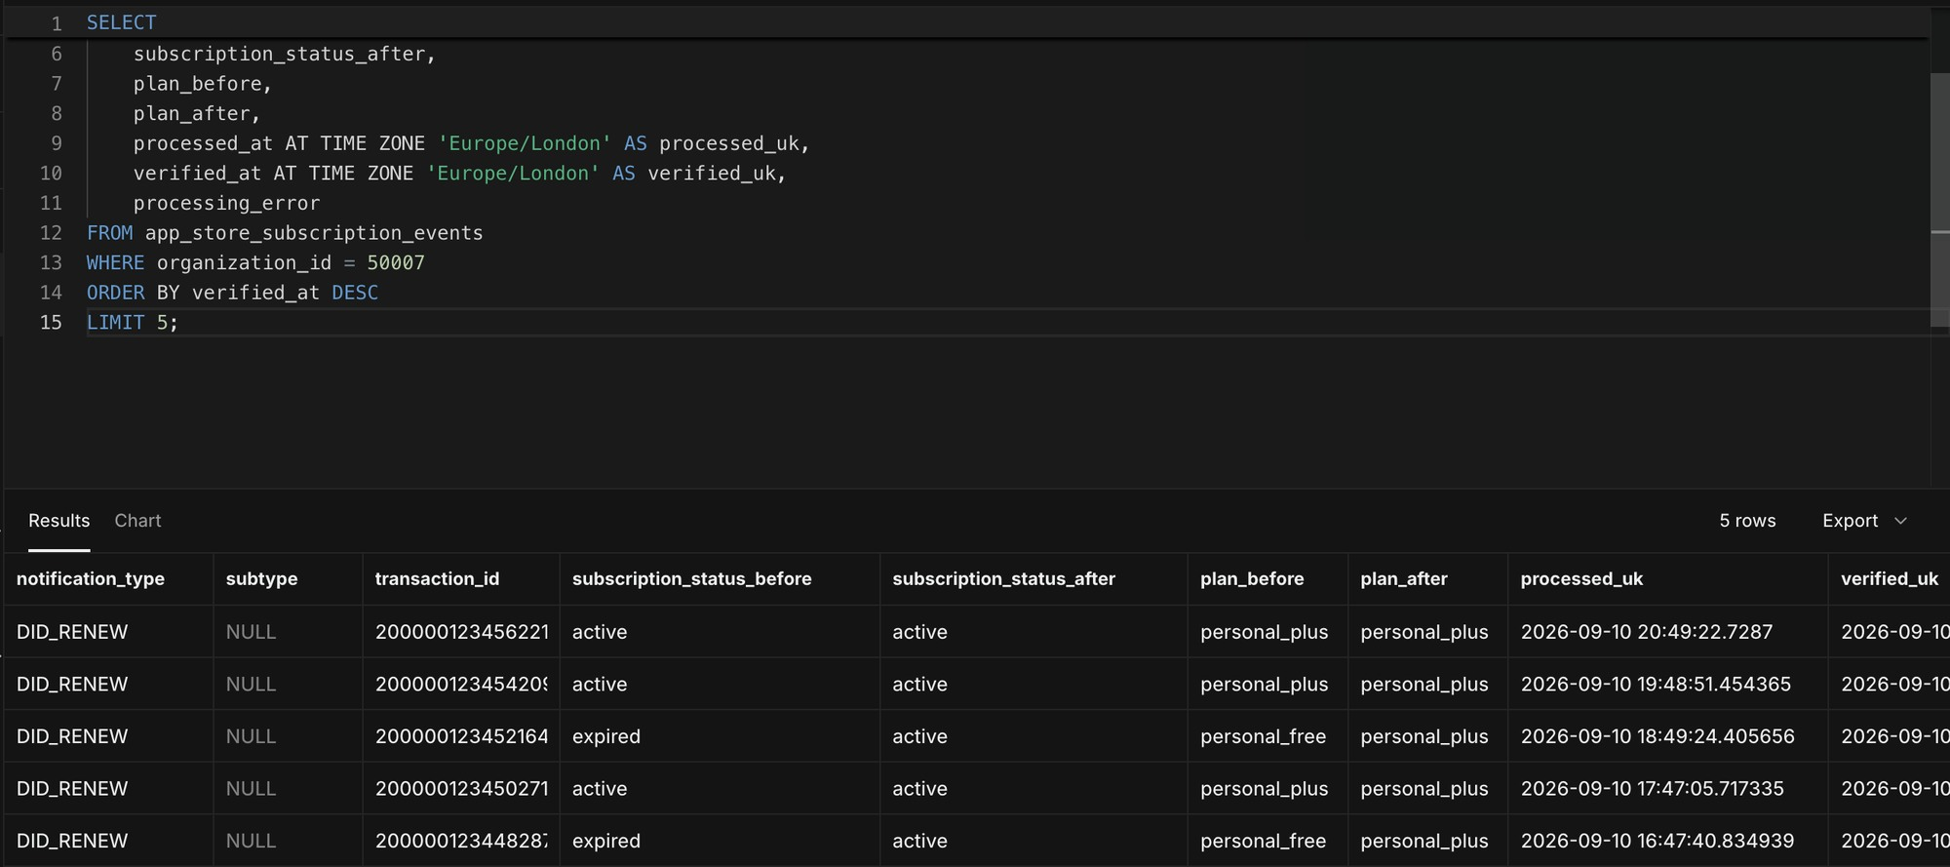
Figure B2 Latest Test B DID_RENEW events showing active to active and Personal Plus to Personal Plus
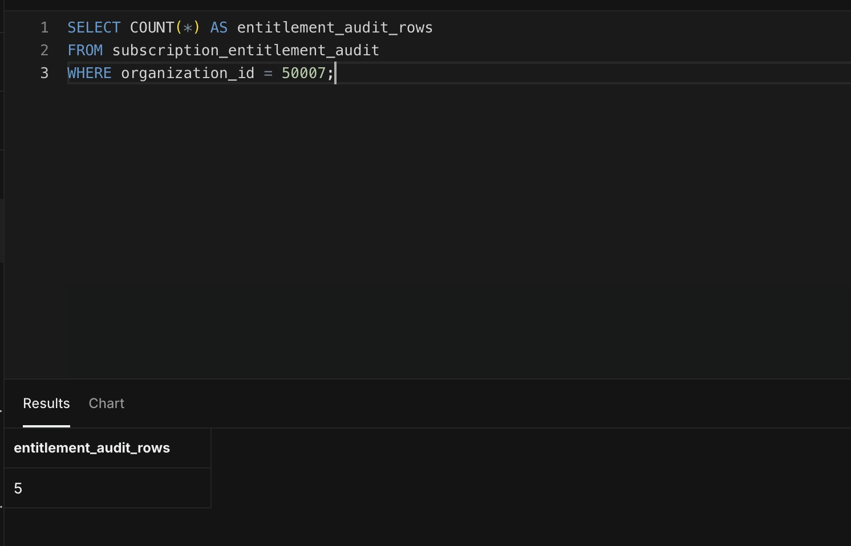
Figure B3 Test B entitlement audit row count retained for comparison
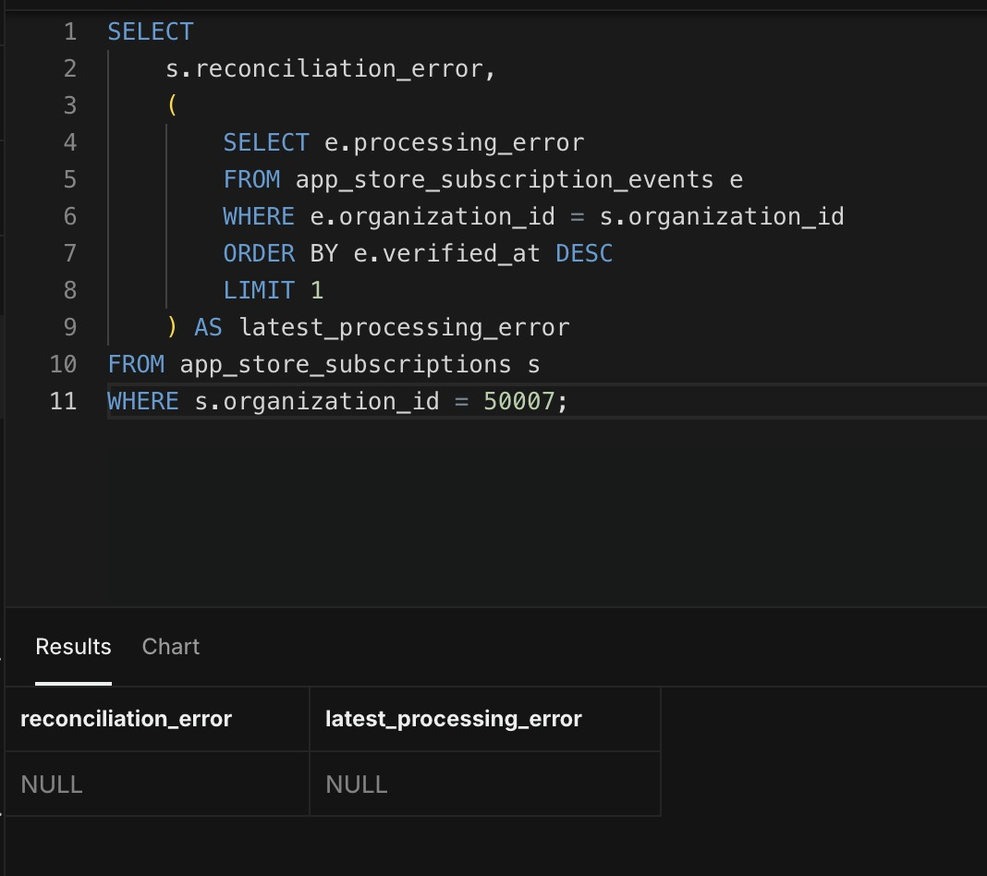
Figure B4 Subscription reconciliation error and latest processing error both NULL
Test B result: Passed. The deployed renewal-boundary rectification prevented a temporary downgrade, normal notification processing advanced the subscription, and the app remained on Personal Plus after refresh.

Test C failed renewal and non recovery
Test C used HitnScore account testc@hitnscore.com, Apple Sandbox tester testc@hitnscore.com, and organisation 50008. The test deliberately disabled purchases and renewals, observed grace-period access, allowed grace to expire, and verified the final downgrade and audit trail.
Time | Lifecycle state | Plan | Evidence and result
22:43 | SUBSCRIBED INITIAL_BUY | Free to Plus | Monthly purchase accepted and app displayed Plus Current
23:13:01 | DID_FAIL_TO_RENEW GRACE_PERIOD | Plus retained | active to grace_period; no processing error
23:18:06 | GRACE_PERIOD_EXPIRED | Plus to Free | grace_period to billing_retry; audit downgrade recorded
23:22:05 | EXPIRED BILLING_RETRY | Free retained | billing_retry to expired; no duplicate plan change

Test C account preparation and account binding
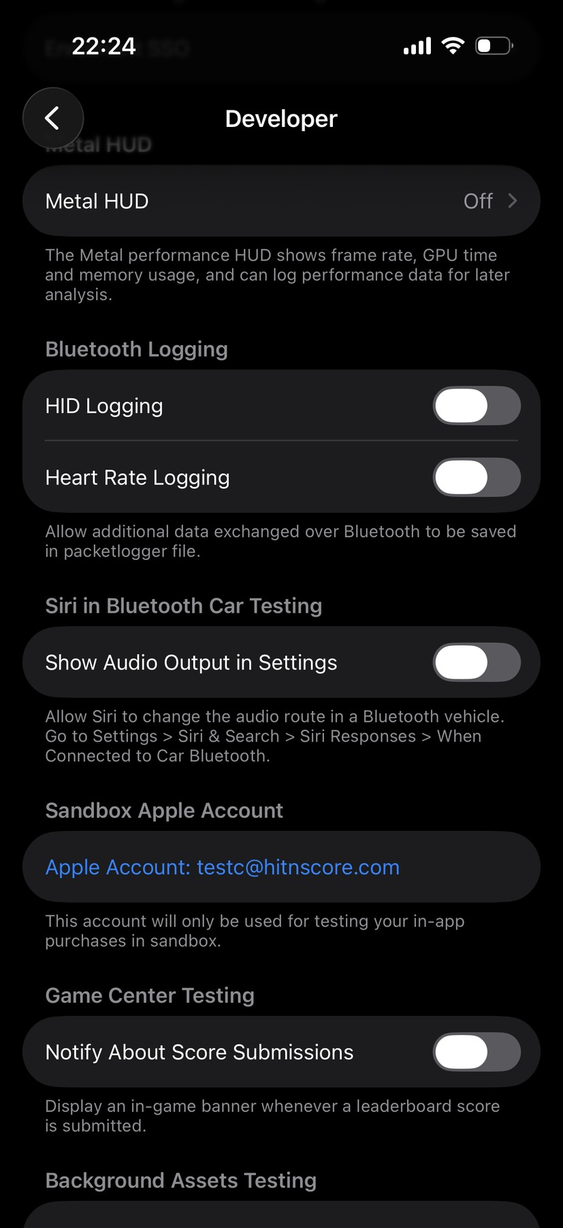
Figure C1 Device Developer settings showing the Test C Sandbox Apple Account
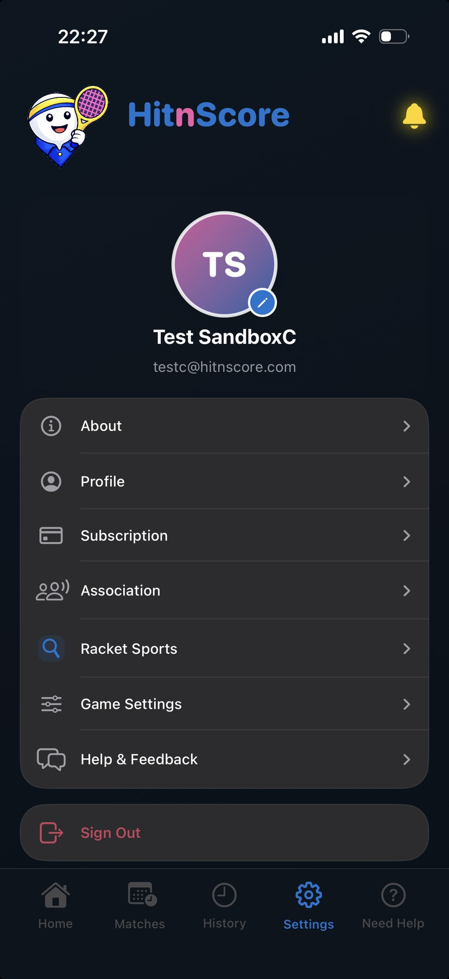
Figure C2 HitnScore signed in as Test SandboxC
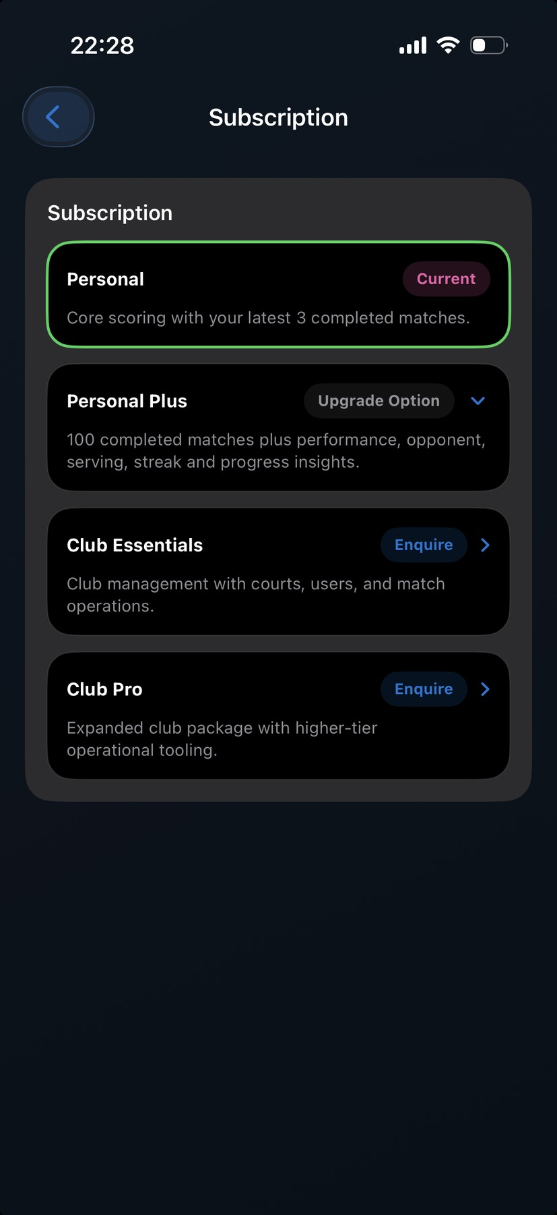
Figure C3 Initial HitnScore state with Personal current and Personal Plus available
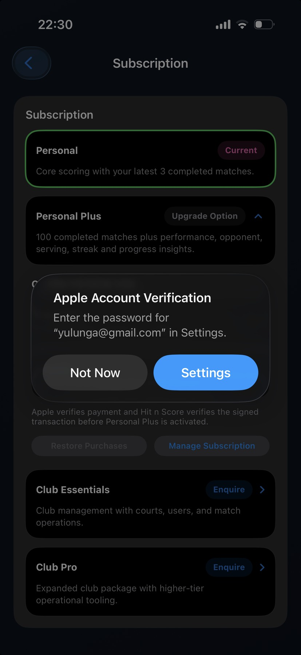
Figure C4 Apple attempted to verify the personal Media and Purchases account instead of the Sandbox tester
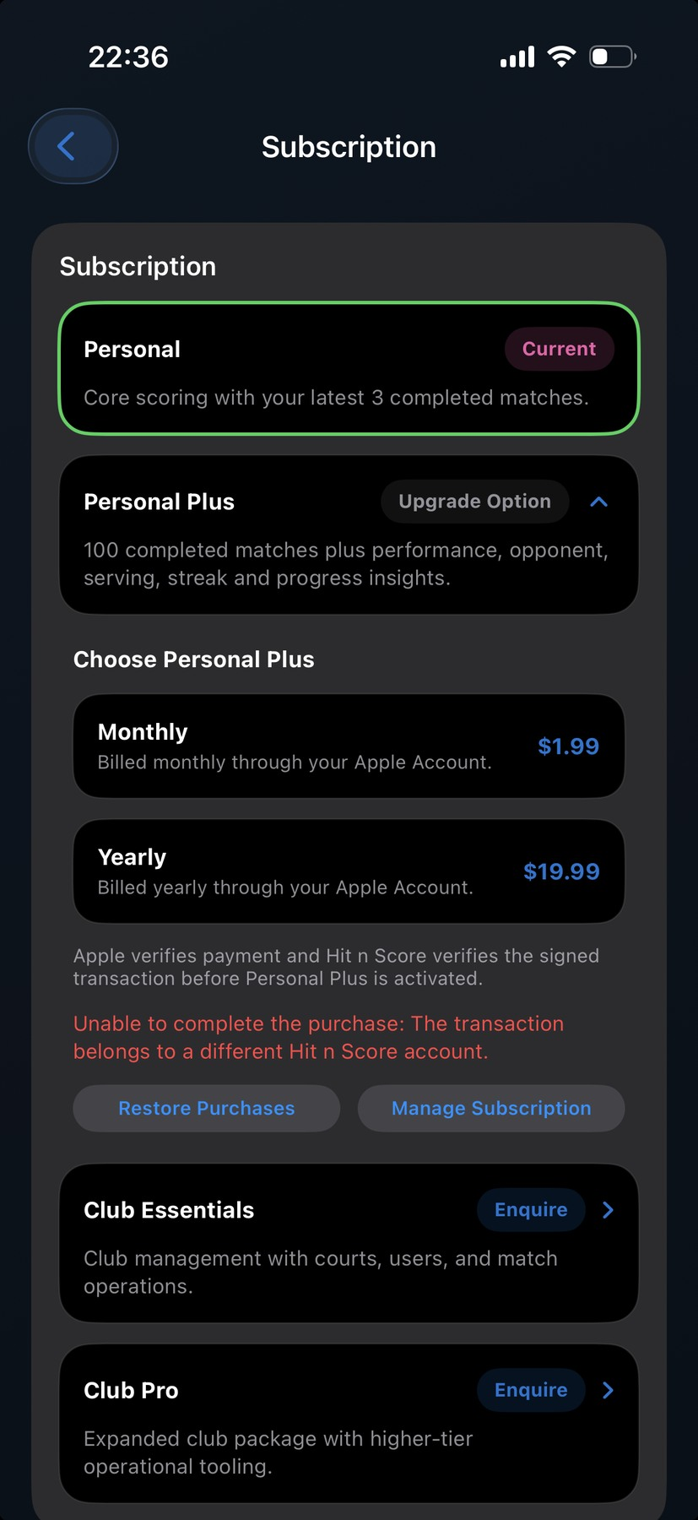
Figure C5 Backend account-binding protection rejected a transaction belonging to another HitnScore account
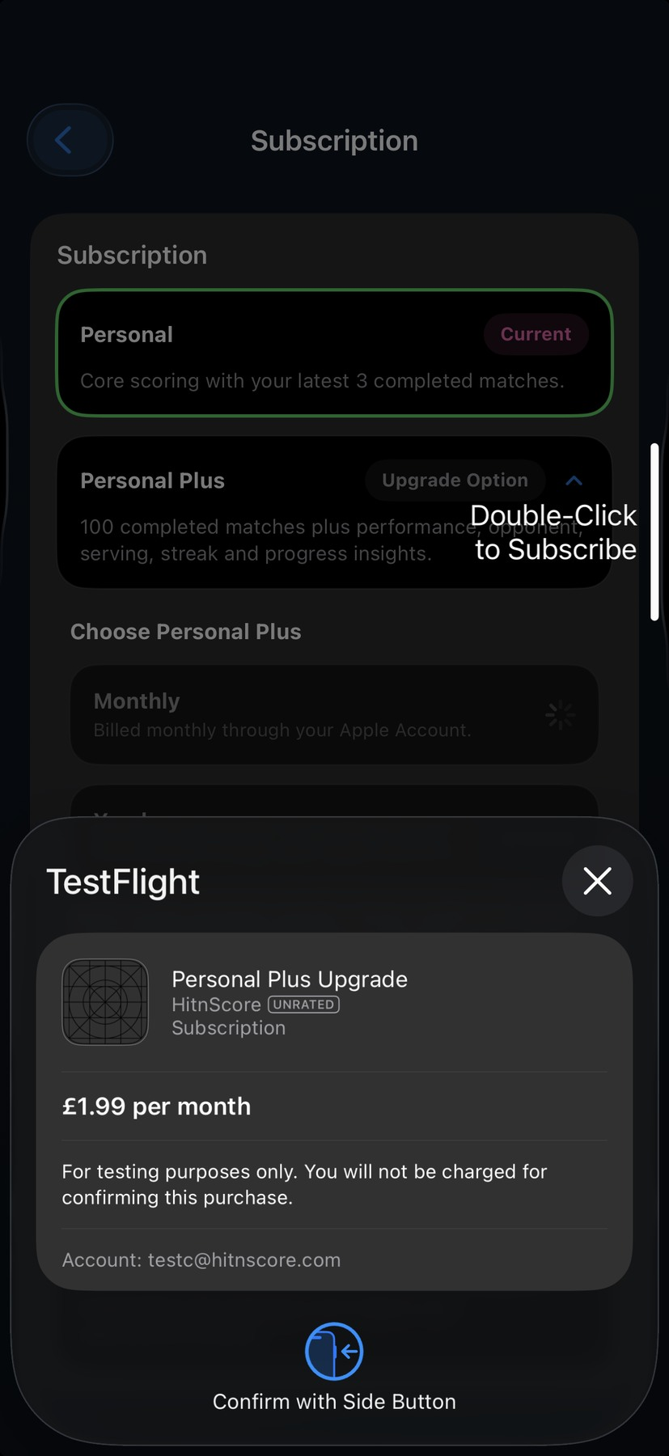
Figure C6 Corrected TestFlight purchase sheet displaying testc@hitnscore.com
Rectification: the personal Media and Purchases Apple session was signed out and the Test C Sandbox tester was selected again. This returned the purchase flow to the correct Apple Sandbox identity without changing backend ownership.

Test C initial purchase
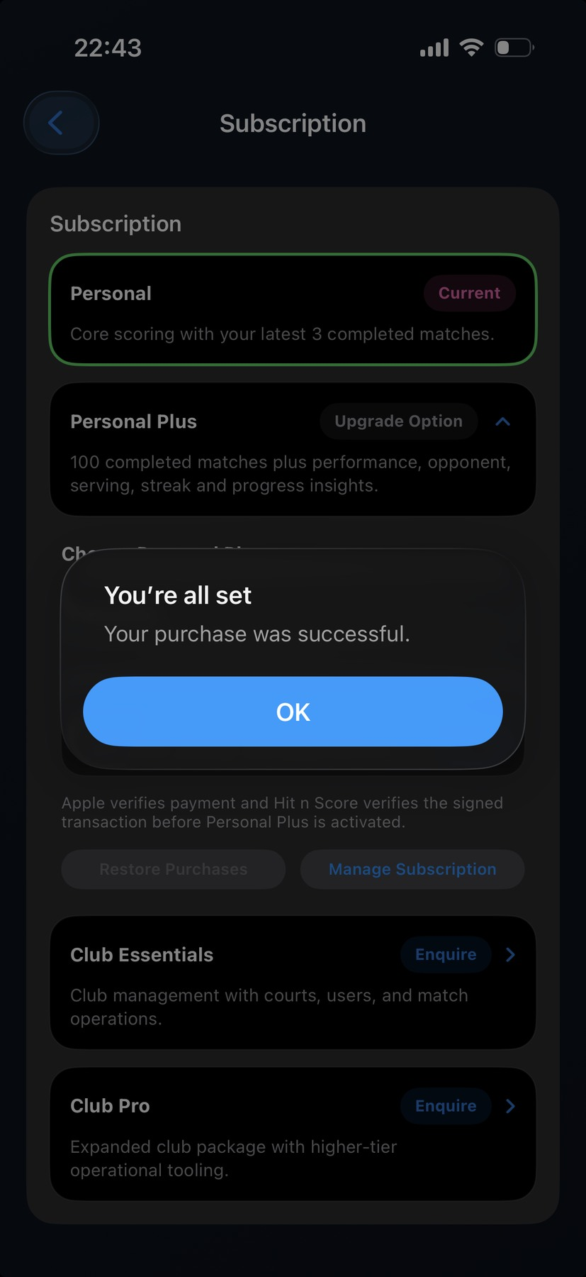
Figure C7 Apple confirmed the Test C purchase was successful
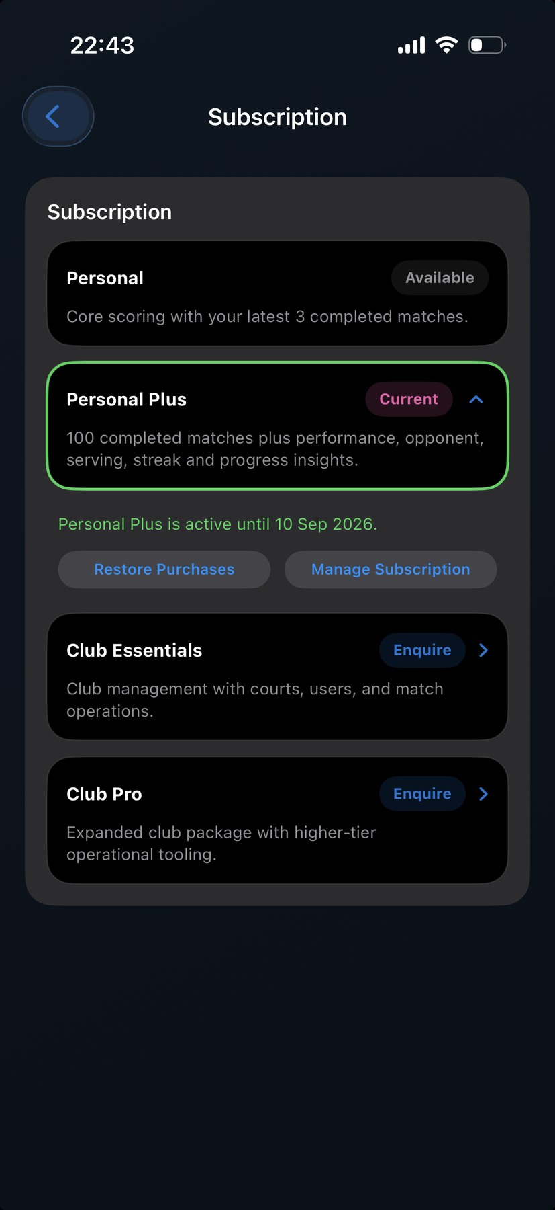
Figure C8 Personal Plus became Current after server verification
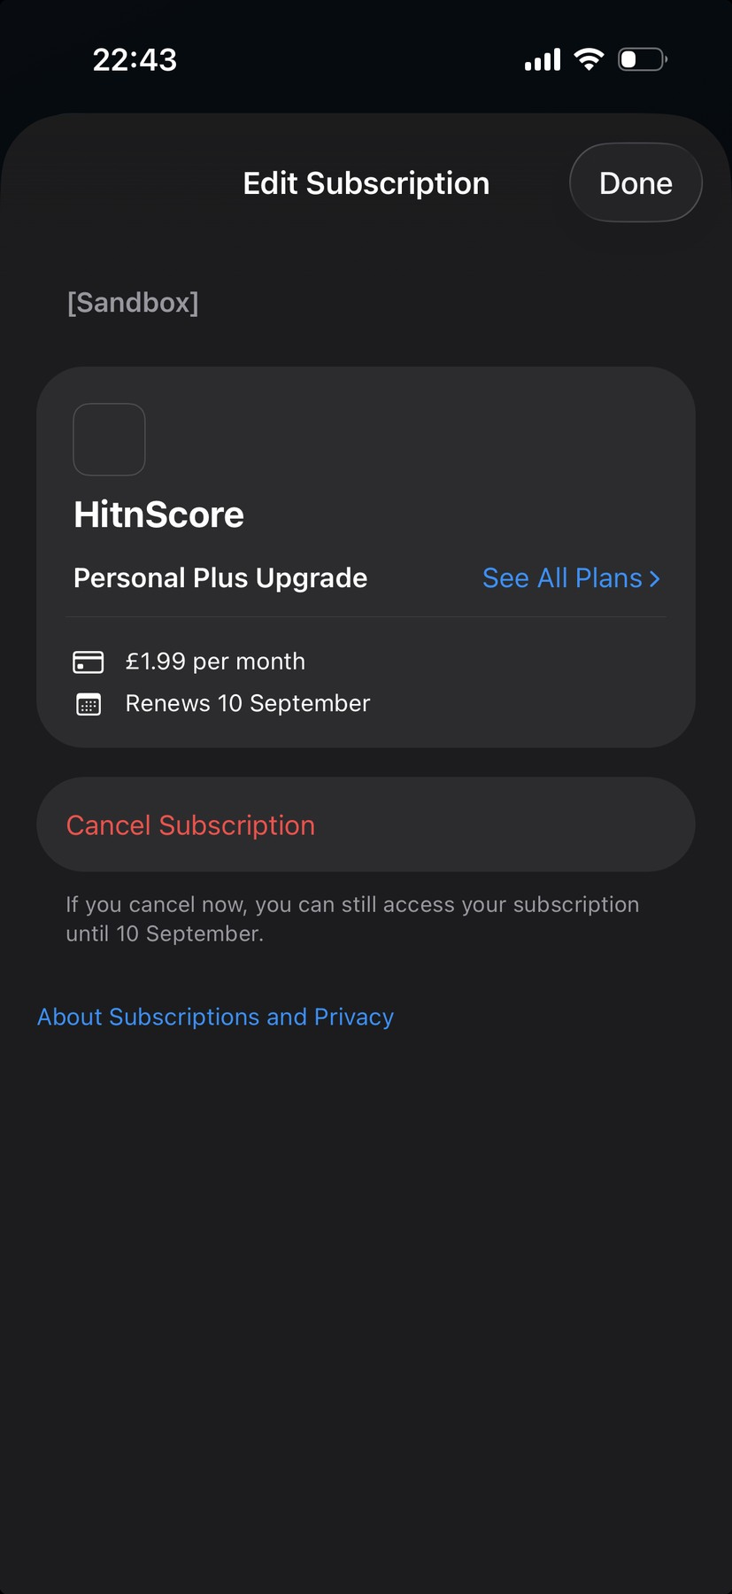
Figure C9 Apple Sandbox subscription management confirmed the monthly plan
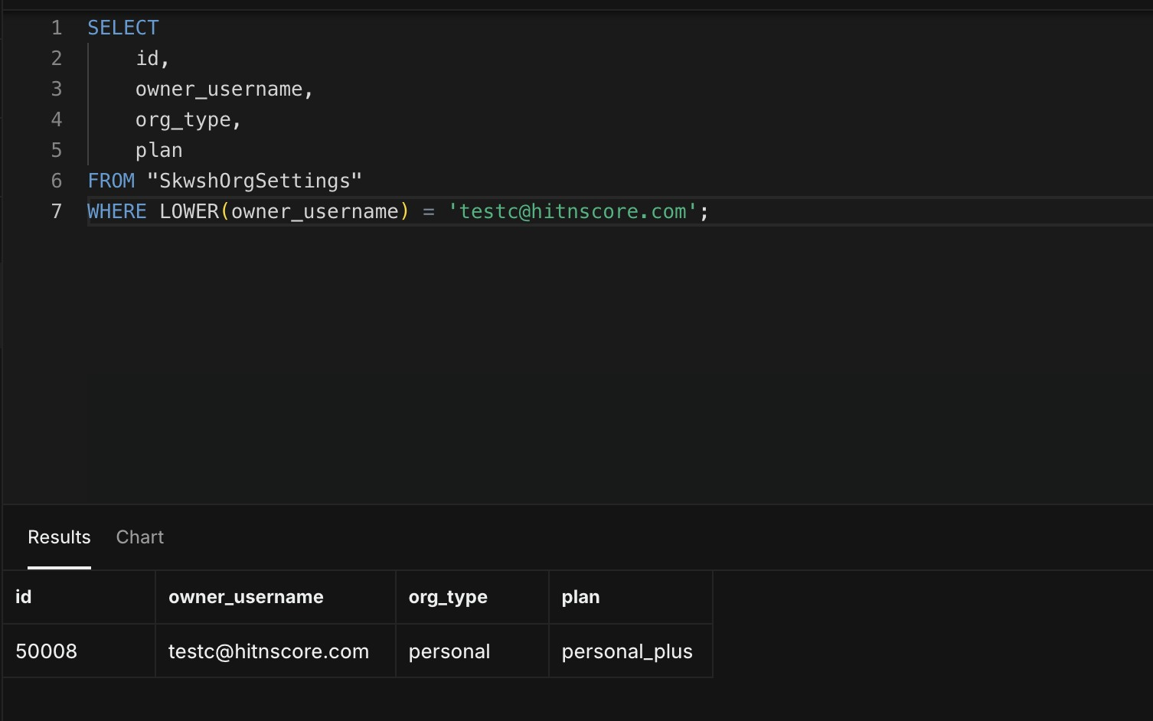
Figure C10 Test C organisation 50008 and Personal Plus plan
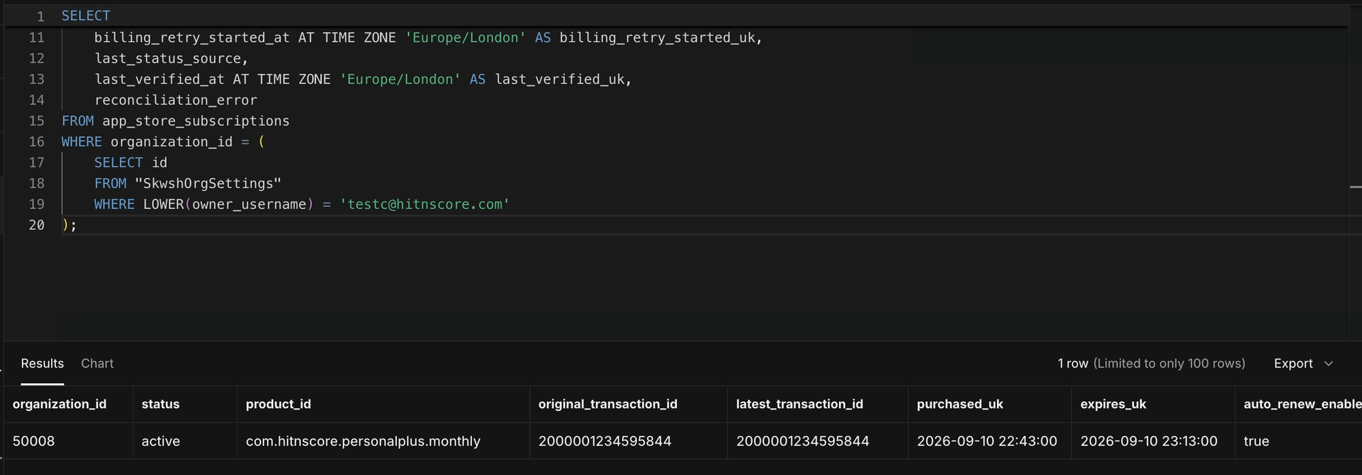
Figure C11 Active monthly subscription purchased at 22:43 with expiry at 23:13
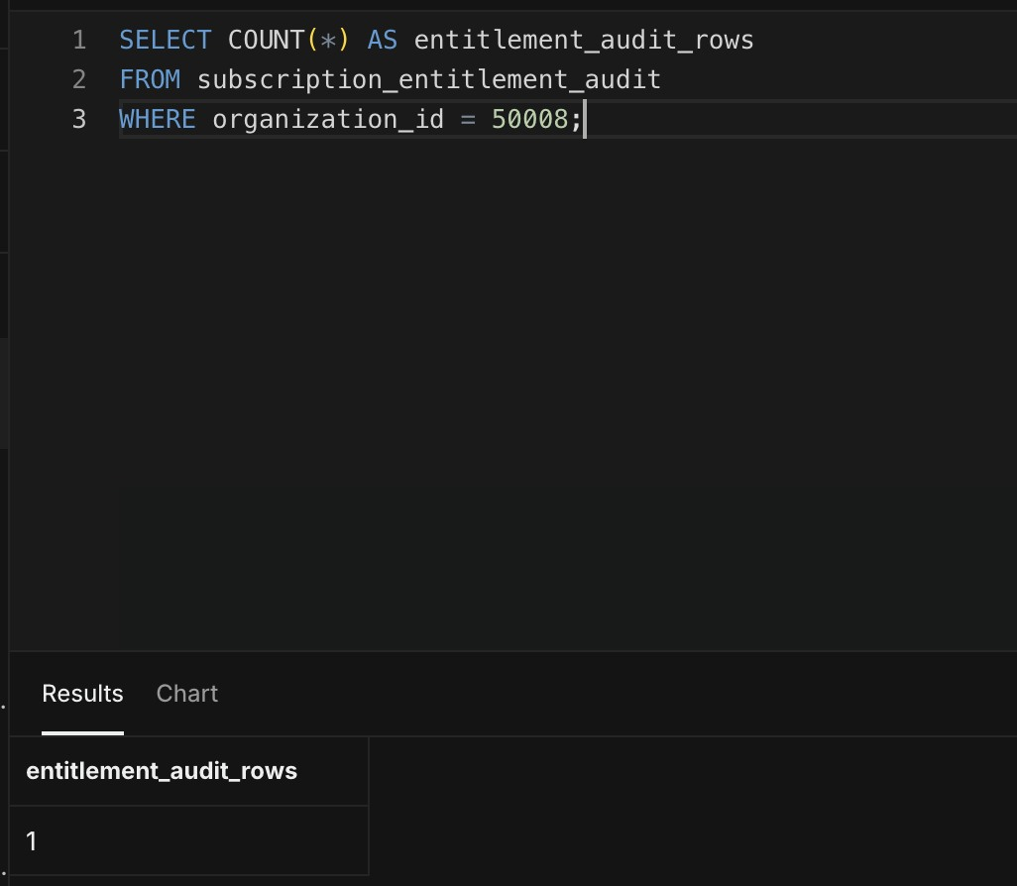
Figure C12 Initial Test C audit count of one

Test C grace entry and final expiry
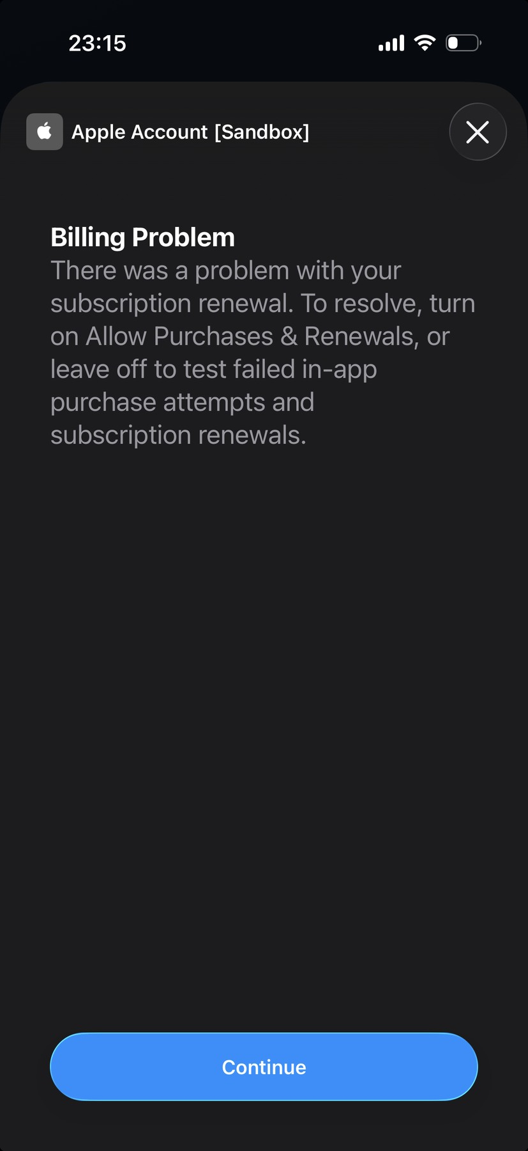
Figure C13 Apple Sandbox billing problem after renewal failure
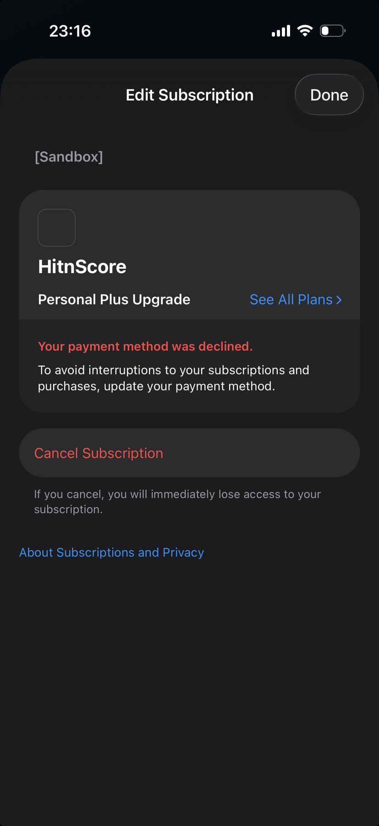
Figure C14 Apple subscription screen showing the declined payment state
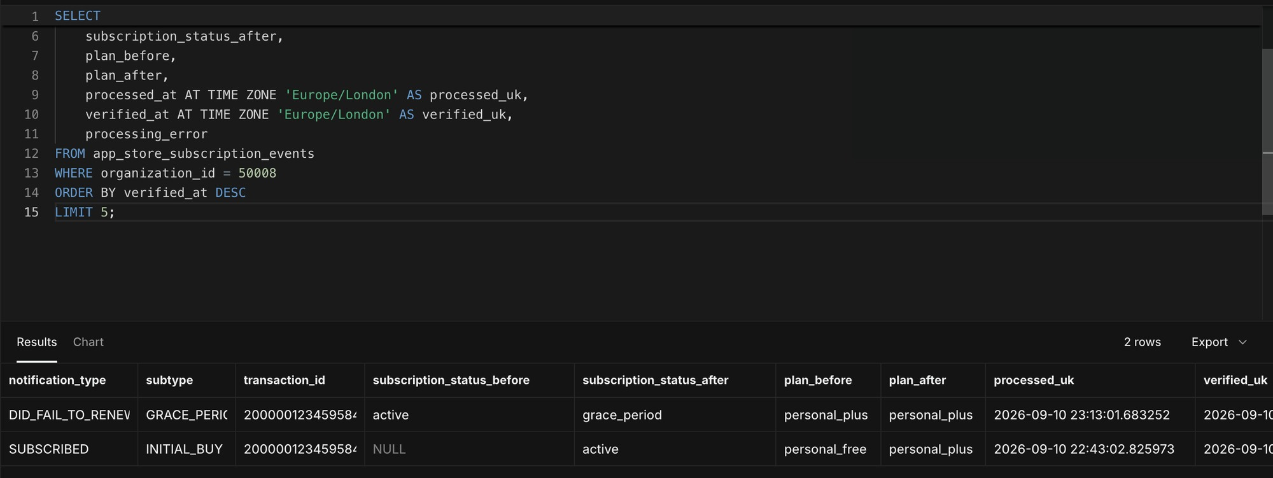
Figure C15 DID_FAIL_TO_RENEW with GRACE_PERIOD and Personal Plus retained
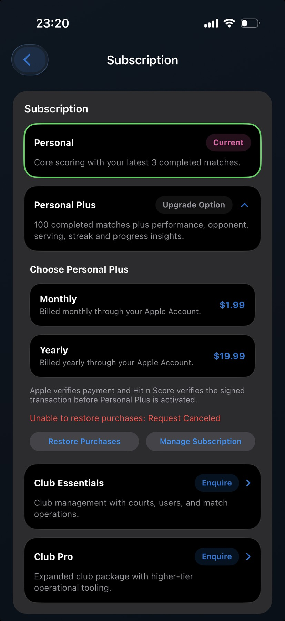
Figure C16 HitnScore returned to Personal Free after grace expiry
Evidence file unavailable: codex-clipboard-f60a8bbc-970c-47b9-9a4b-88f2-dd1cc814713b.png
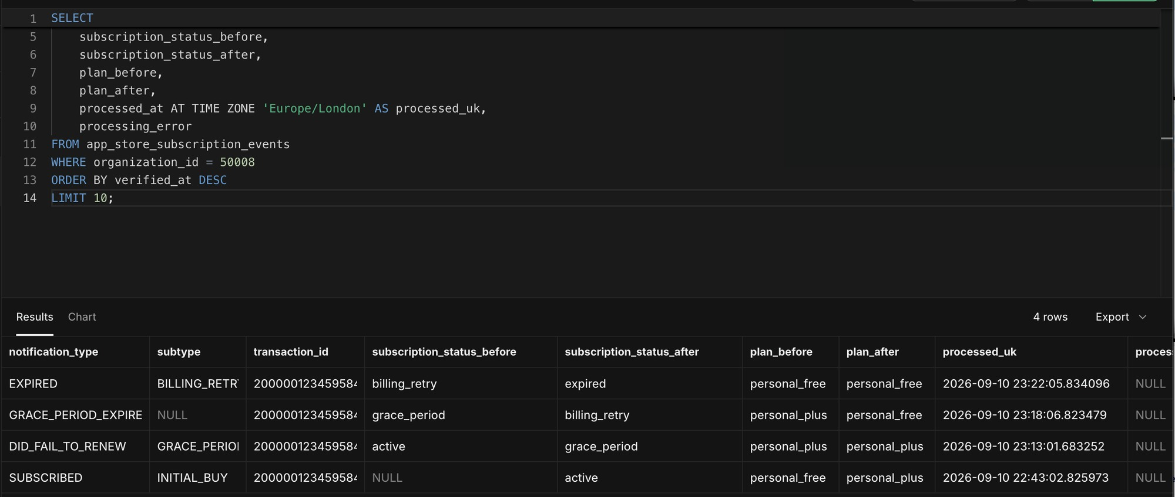
Figure C18 Complete Test C event chain through grace expiry and billing retry expiry
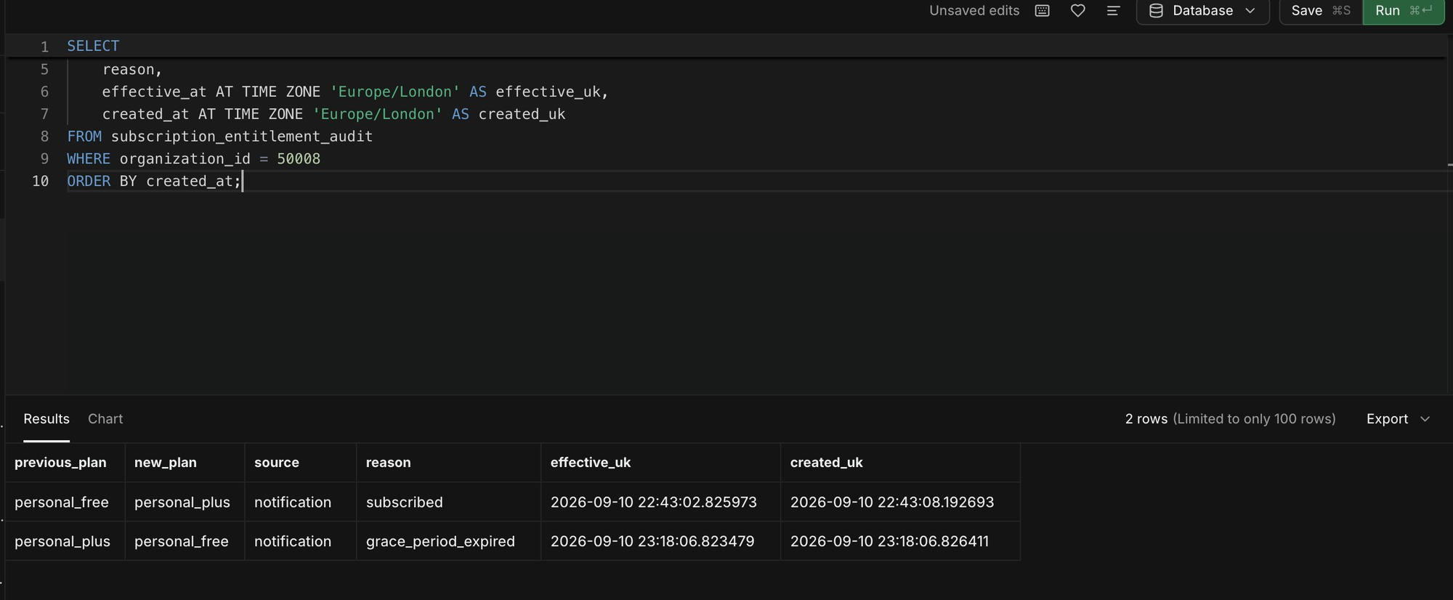
Figure C19 Audit contains only the genuine Free to Plus and Plus to Free entitlement changes
The red Unable to restore purchases Request Cancelled message was produced when the restore interaction was cancelled. It was not a lifecycle-processing failure and was kept separate from the Test C result.
Test C result: Passed. Access remained Plus during verified grace, changed to Free exactly when grace expired, remained Free through final billing-retry expiry, and generated no duplicate entitlement audit entry.

Test D billing recovery within grace
Test D used HitnScore and Apple Sandbox account testd@hitnscore.com with organisation 50009. The objective was to fail the first renewal, prove continued access during grace, re-enable purchases and renewals before grace expired, and verify recovery without any temporary downgrade.
Time | Action or event | Subscription transition | Plan result
11:14:36 | SUBSCRIBED INITIAL_BUY | none to active | Free to Plus
11:16 | Allow Purchases and Renewals OFF | Failure simulation armed | Plus retained
11:19:34 | DID_FAIL_TO_RENEW GRACE_PERIOD | active to grace_period | Plus retained
11:22 | HitnScore refresh during grace | grace_period | Plus still Current
11:23 | Allow Purchases and Renewals ON | Recovery enabled | Plus retained
11:23:10 | DID_RENEW BILLING_RECOVERY | grace_period to active | Plus retained
11:23:44 | Normal DID_RENEW | active to active | Plus retained
11:25 | Final HitnScore refresh | active | Plus Current; no error

Test D preparation and initial purchase
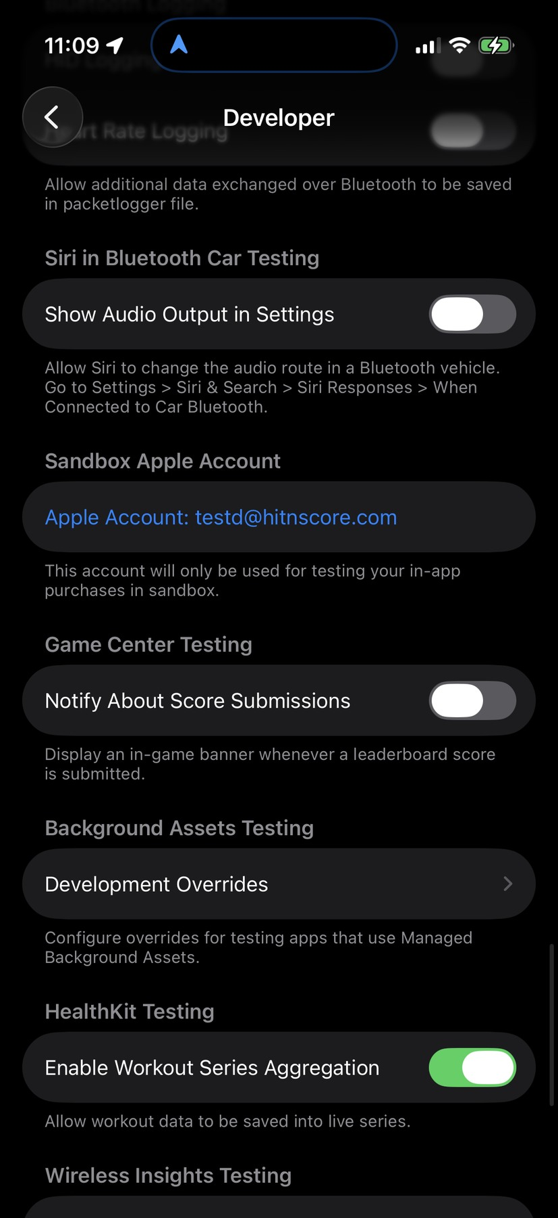
Figure D1 Device Developer settings using testd@hitnscore.com
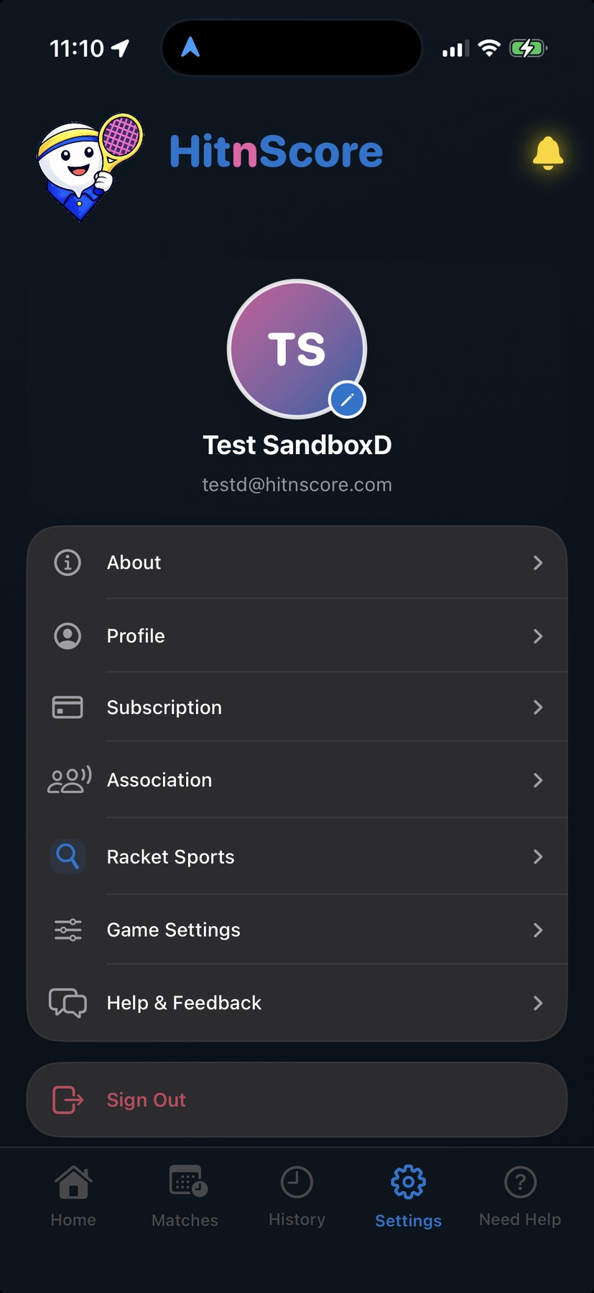
Figure D2 HitnScore signed in as Test SandboxD
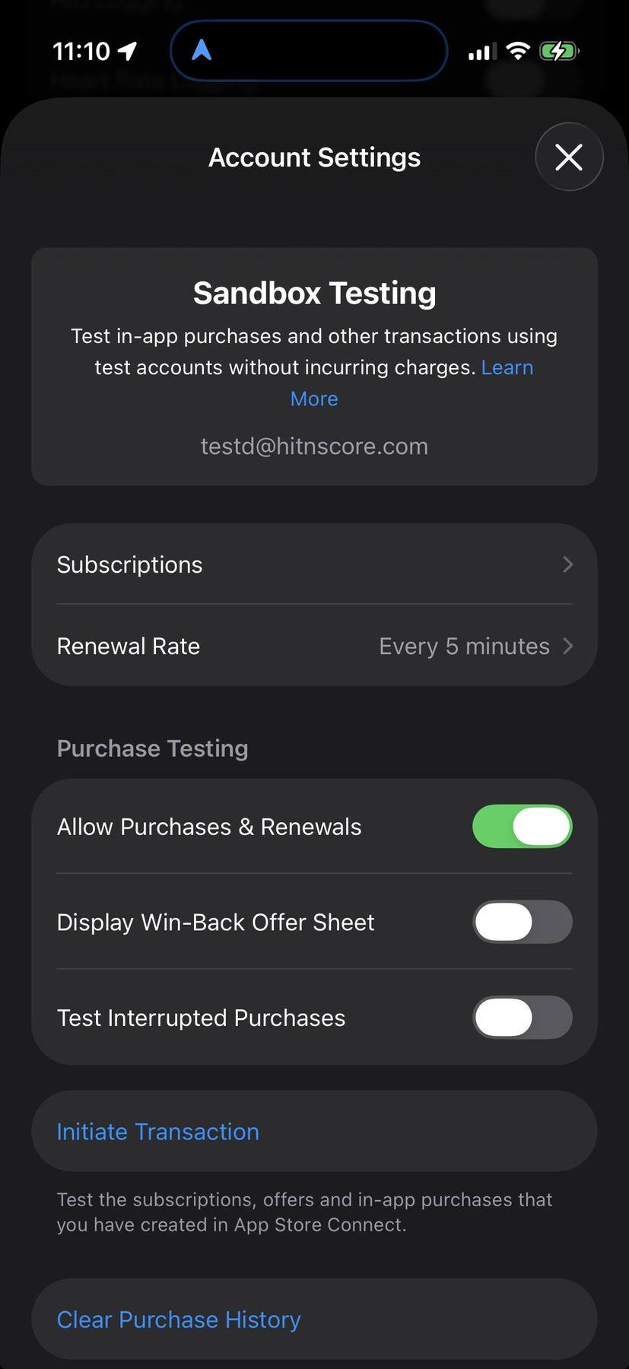
Figure D3 Five-minute rate and renewals enabled before purchase
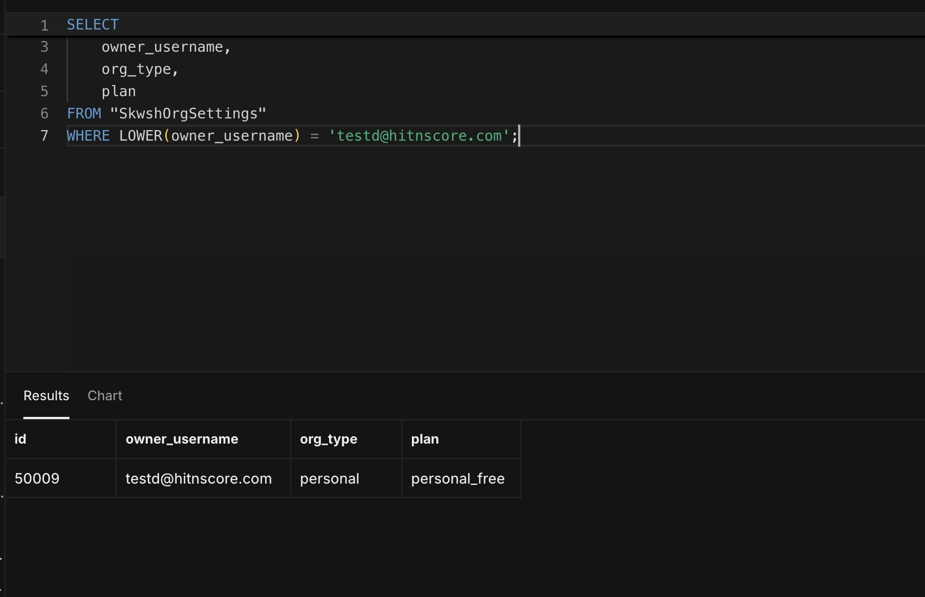
Figure D4 Test D organisation 50009 began on Personal Free
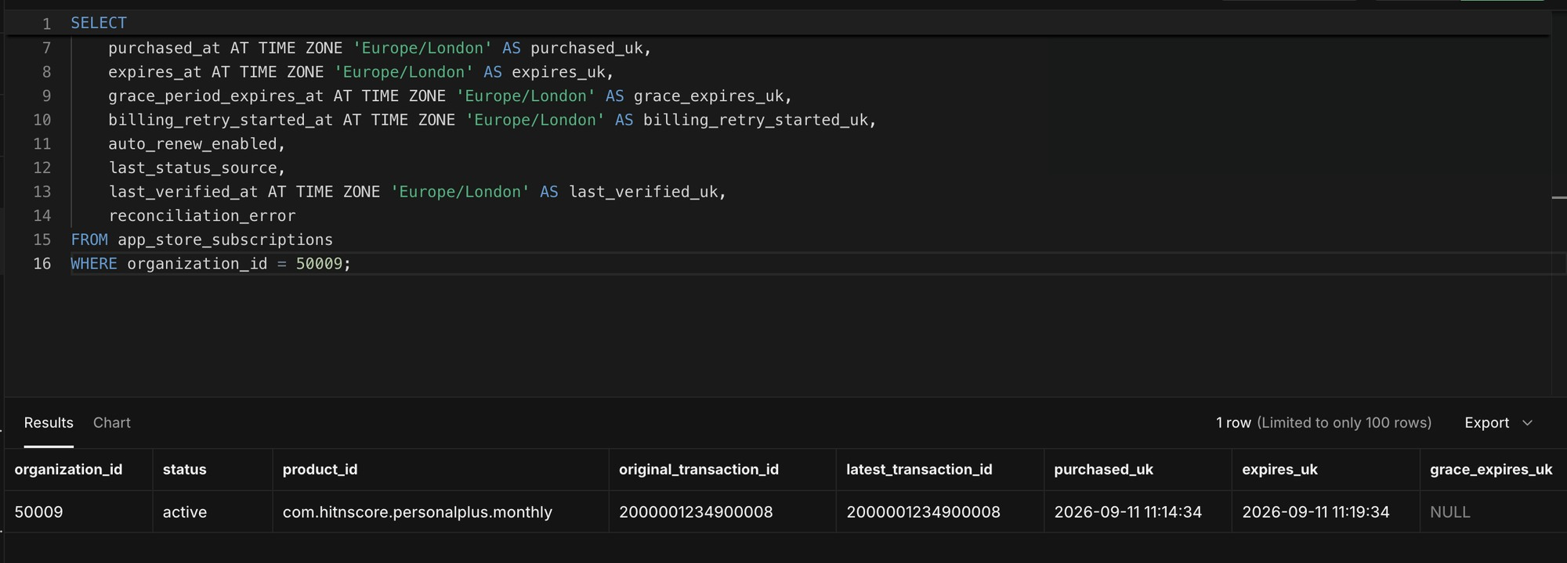
Figure D5 Initial active monthly subscription from 11:14:34 to 11:19:34
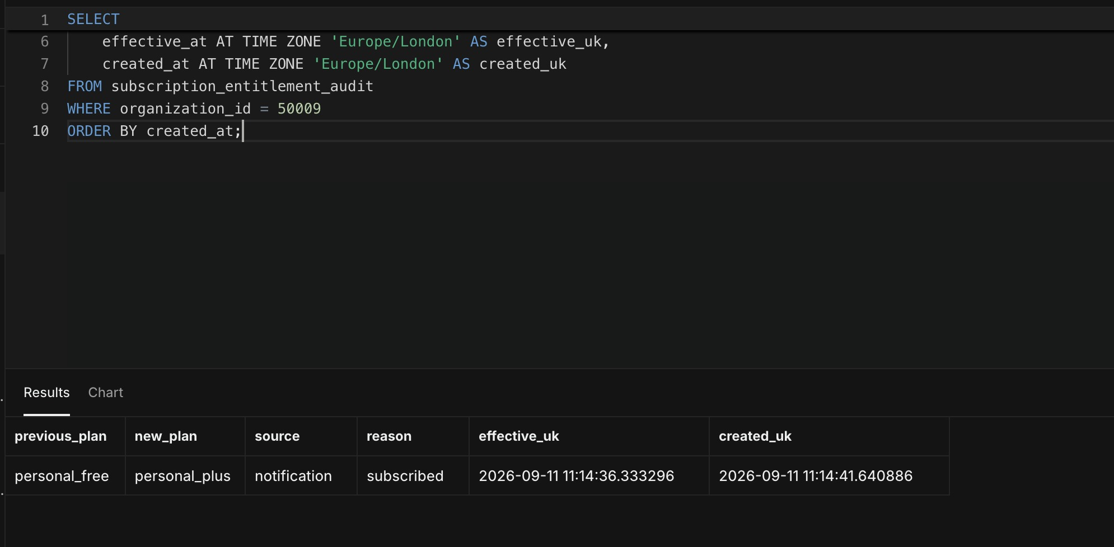
Figure D6 Baseline audit contains one subscribed Free to Plus change

Test D failure and grace access
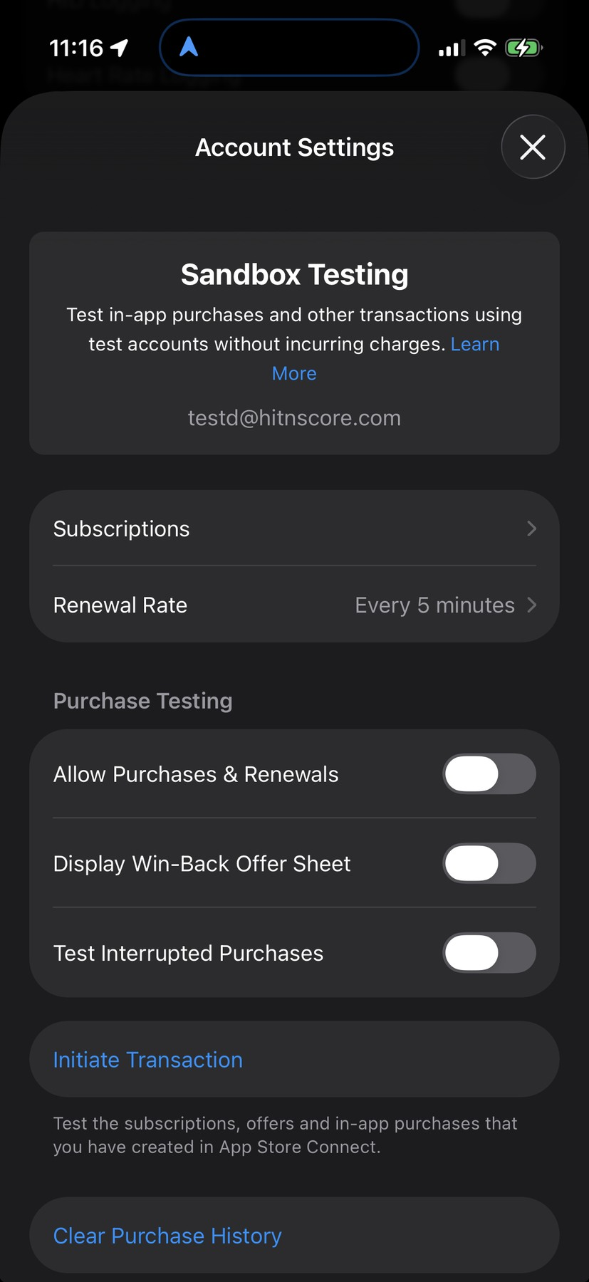
Figure D7 Purchases and renewals disabled before the first renewal
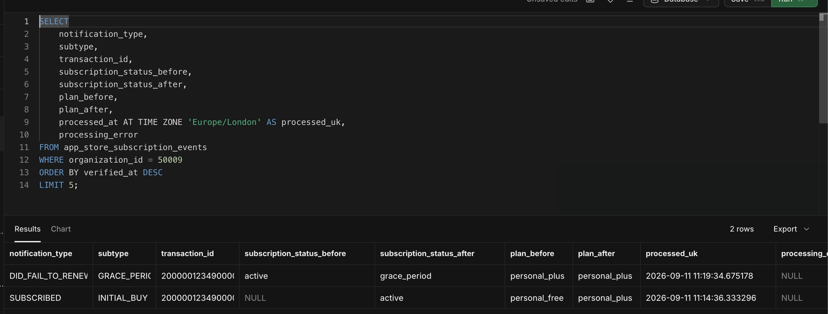
Figure D8 Failed renewal entered grace while the plan remained Personal Plus
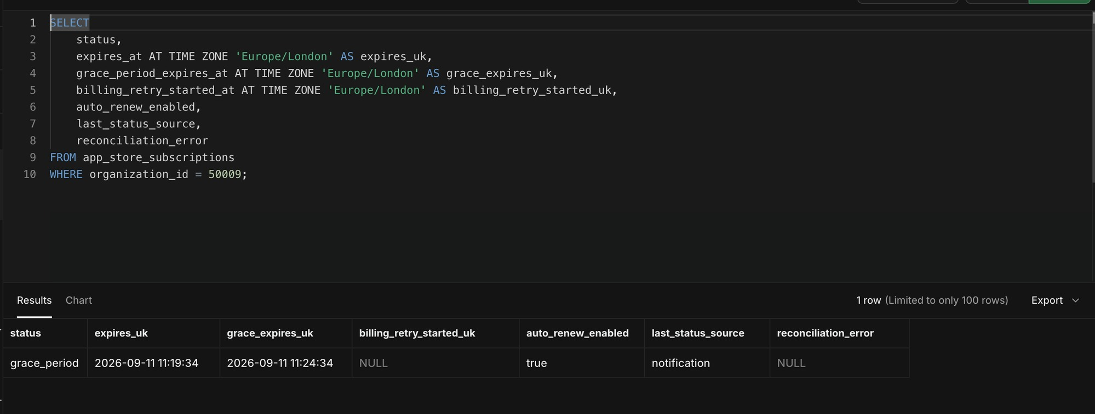
Figure D9 Grace period ran from 11:19:34 to 11:24:34 with no reconciliation error
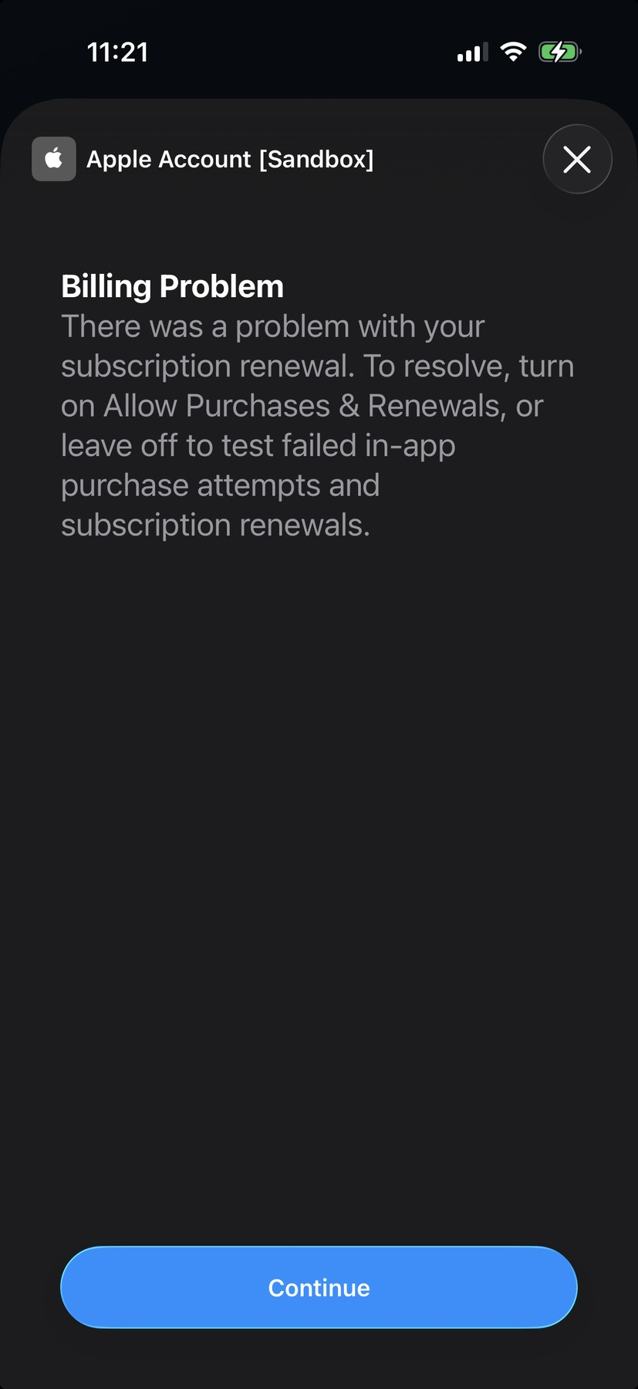
Figure D10 Apple Sandbox billing-problem prompt during the simulated failure
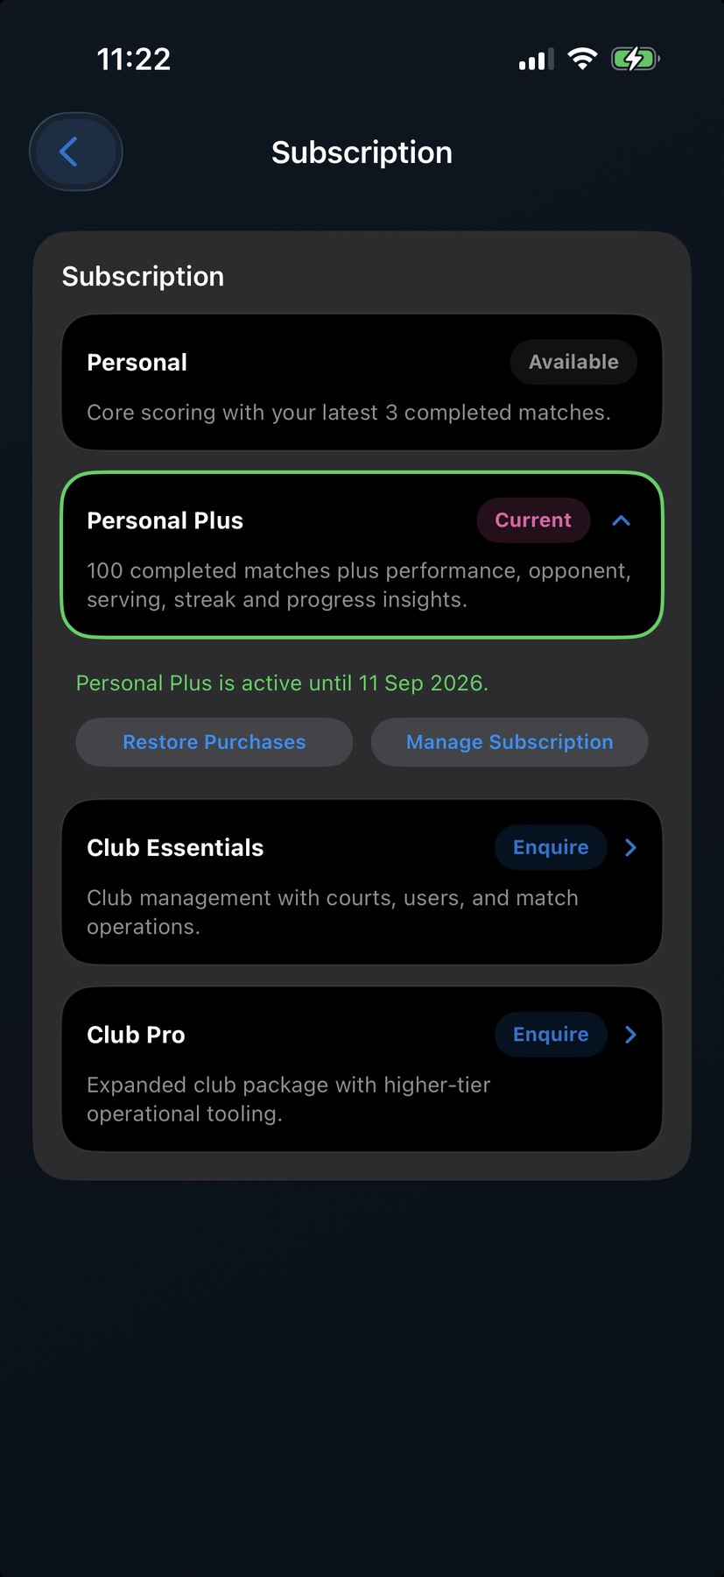
Figure D11 HitnScore still displayed Personal Plus Current during grace

Test D recovery and final state
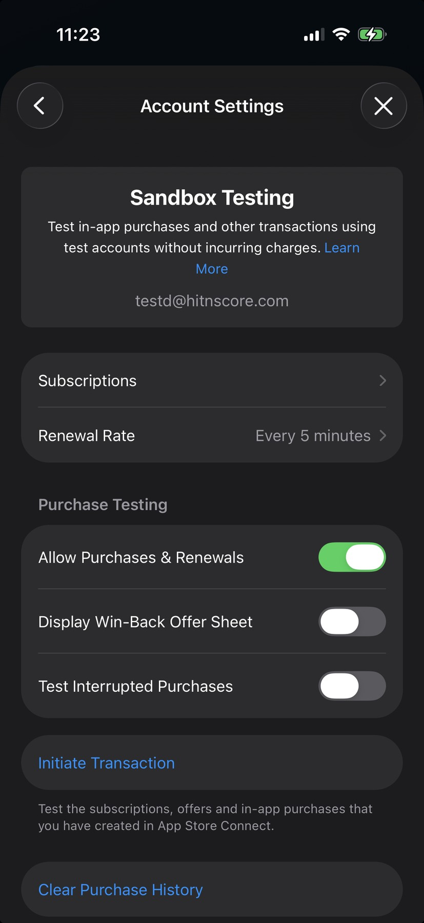
Figure D12 Purchases and renewals re-enabled before grace expiry
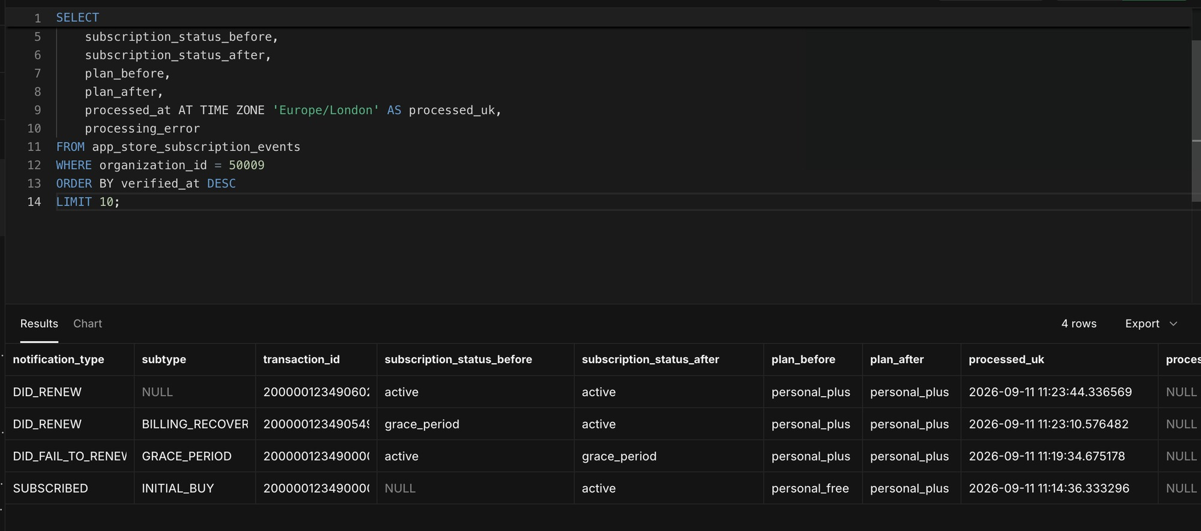
Figure D13 Billing recovery followed by a normal renewal with all processing errors NULL
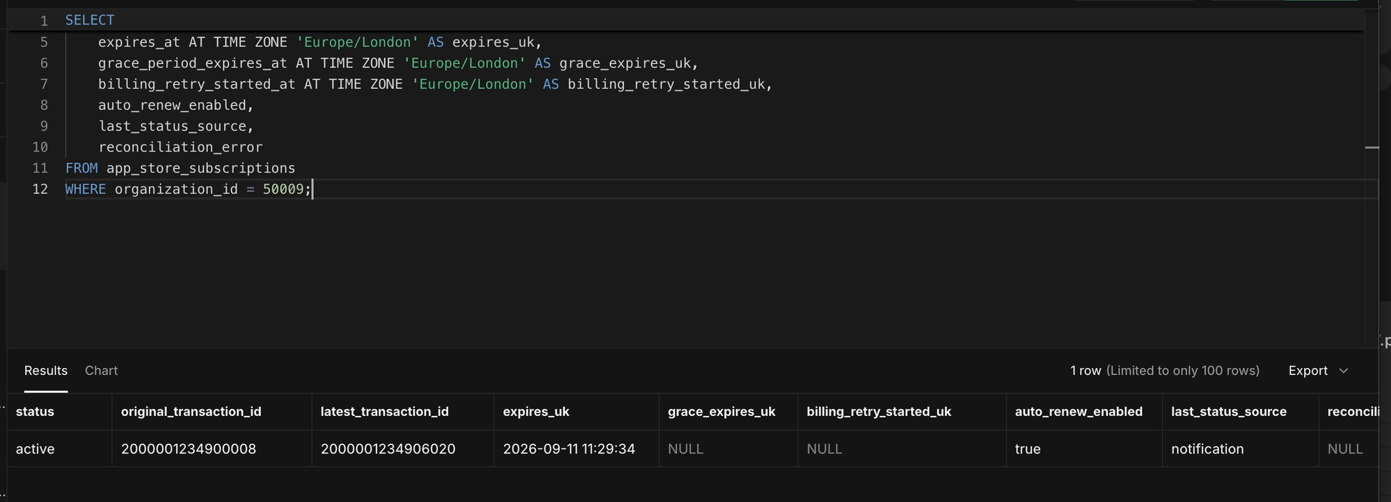
Figure D14 Final active subscription with advanced transaction and expiry and cleared grace fields
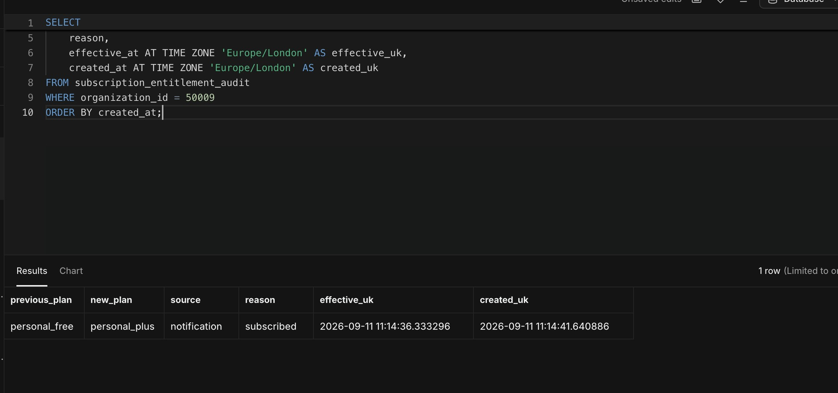
Figure D15 Audit remained at one row because recovery never removed entitlement
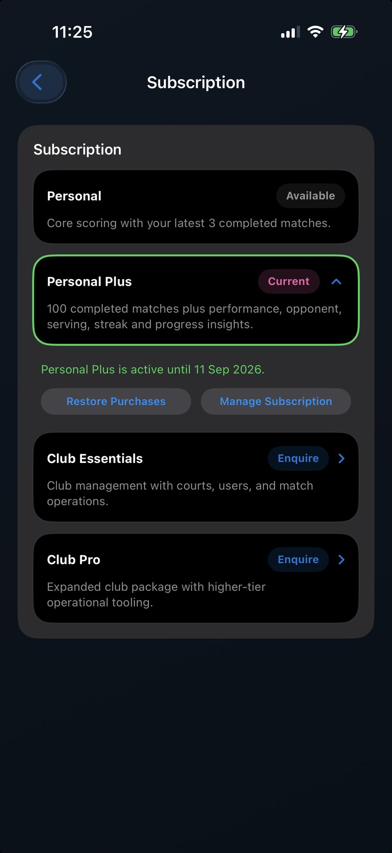
Figure D16 Final device refresh showed Personal Plus Current with no error
Test D result: Passed. The account remained entitled throughout grace, recovered to active before grace expired, processed the subsequent normal renewal, and produced no Plus to Free to Plus churn in either the app or audit trail.

Consolidated results
Requirement demonstrated | Evidence | Status
Monthly purchase and voluntary cancellation preserve access through paid expiry | Test A active with auto-renew false, followed by EXPIRED VOLUNTARY and Plus to Free | Passed
Monthly initial purchase upgrades the signed-in account | Tests C and D; server plan and device both changed to Personal Plus | Passed
Yearly renewal remains continuously entitled | Test B DID_RENEW active to active with stable app state | Passed
Different-account transaction cannot be attached | Test C displayed backend ownership rejection | Passed
Failed renewal enters grace | Tests C and D DID_FAIL_TO_RENEW with GRACE_PERIOD | Passed
Grace retains paid access | Plan remained Plus and Test D device displayed Plus Current | Passed
Grace expiry removes paid access | Test C GRACE_PERIOD_EXPIRED and audited Plus to Free | Passed
Billing retry expiry is idempotent | Test C EXPIRED retained Free without another audit change | Passed
Billing recovery restores active state without churn | Test D DID_RENEW BILLING_RECOVERY and one-row audit | Passed
Normal renewal works after billing recovery | Test D second DID_RENEW active to active | Passed
Device refresh reflects the server-authoritative plan | Final C Free and final D Plus screens matched database state | Passed
Lifecycle and reconciliation processing is clean | All inspected processing_error and reconciliation_error fields NULL | Passed

Remaining production release evidence
The manual scenarios above are complete. The following requirements from the production plan were not fully demonstrated end to end in this chat and should remain open until separately evidenced:
- Refund, revocation, and refund-reversal entitlement handling.
- Restore Purchases on another device while mapping to the correct HitnScore account.
- A deliberately missed notification repaired by App Store Server API reconciliation.
- Real Sandbox negative cases for invalid signature, wrong bundle ID, Apple app ID, product, environment, and account token.
- Real duplicate notification and out-of-order notification delivery, although automated regression coverage exists.
- Root-admin subscription activity and audit parity after every remaining scenario.
- Production V2 notification URL, Production environment enablement, monitoring, DLQ, and operational runbook gates.

Sign off statement
The Test A, Test B, Test C and Test D Apple Sandbox and TestFlight subscription scenarios described in this report are signed off as passed. The observed defects were either rectified in the backend and iOS client or resolved through correct Sandbox account configuration. The final database, audit, and device states were consistent for all four testers. Production purchasing should remain gated until the separate outstanding release evidence listed above is completed.

Appendix SQL evidence queries

Organisation lookup
SELECT id, owner_username, org_type, plan
FROM "SkwshOrgSettings"
WHERE LOWER(owner_username) = 'tester@hitnscore.com';

Subscription state
SELECT organization_id, status, product_id, original_transaction_id, latest_transaction_id,
purchased_at AT TIME ZONE 'Europe/London' AS purchased_uk,
expires_at AT TIME ZONE 'Europe/London' AS expires_uk,
grace_period_expires_at AT TIME ZONE 'Europe/London' AS grace_expires_uk,
billing_retry_started_at AT TIME ZONE 'Europe/London' AS billing_retry_started_uk,
auto_renew_enabled, last_status_source, reconciliation_error
FROM app_store_subscriptions
WHERE organization_id = :organization_id;

Lifecycle event history
SELECT notification_type, subtype, transaction_id, subscription_status_before,
subscription_status_after, plan_before, plan_after,
processed_at AT TIME ZONE 'Europe/London' AS processed_uk, processing_error
FROM app_store_subscription_events
WHERE organization_id = :organization_id
ORDER BY verified_at DESC
LIMIT 10;

Entitlement audit
SELECT previous_plan, new_plan, source, reason,
effective_at AT TIME ZONE 'Europe/London' AS effective_uk,
created_at AT TIME ZONE 'Europe/London' AS created_uk
FROM subscription_entitlement_audit
WHERE organization_id = :organization_id
ORDER BY created_at;

