# -*- coding: utf-8 -*-

"""

Created on Mon Apr 29 11:05:51 2024

@author: ELISHA JOY R. YUMANG

"""

import numpy as np

import matplotlib.pyplot as plt

# Generate some sample data

np.random.seed(42)

X = np.linspace(0, 10, 100)

true_slope = 2

true_intercept = 5

y = true_slope * X + true_intercept + np.random.normal(0, 2, 100)

# Define the Bayesian linear regression model

def bayesian_linear_regression(X, y, num_samples=1000):

# Define prior hyperparameters

prior_mean = np.zeros(2)

prior_cov = np.eye(2) * 0.1

# Compute posterior parameters

X_b = np.c_[np.ones_like(X), X]

posterior_cov = np.linalg.inv(prior_cov + X_b.T @ X_b)

posterior_mean = posterior_cov @ (prior_cov @ prior_mean + X_b.T @ y)

# Sample from the posterior distribution

samples = np.random.multivariate_normal(posterior_mean, posterior_cov, size=num_samples)

return samples

# Perform Bayesian linear regression

samples = bayesian_linear_regression(X, y)

# Plot the results

plt.figure(figsize=(10, 6))

plt.scatter(X, y, label='Data')

for i in range(50):

y_pred = samples[i, 0] + samples[i, 1] * X

plt.plot(X, y_pred, color='gray', alpha=0.1)

plt.plot(X, true_slope * X + true_intercept, color='r', linestyle='--', label='True Regression Line')

plt.xlabel('X')

plt.ylabel('y')

plt.title('Bayesian Linear Regression')

plt.legend()

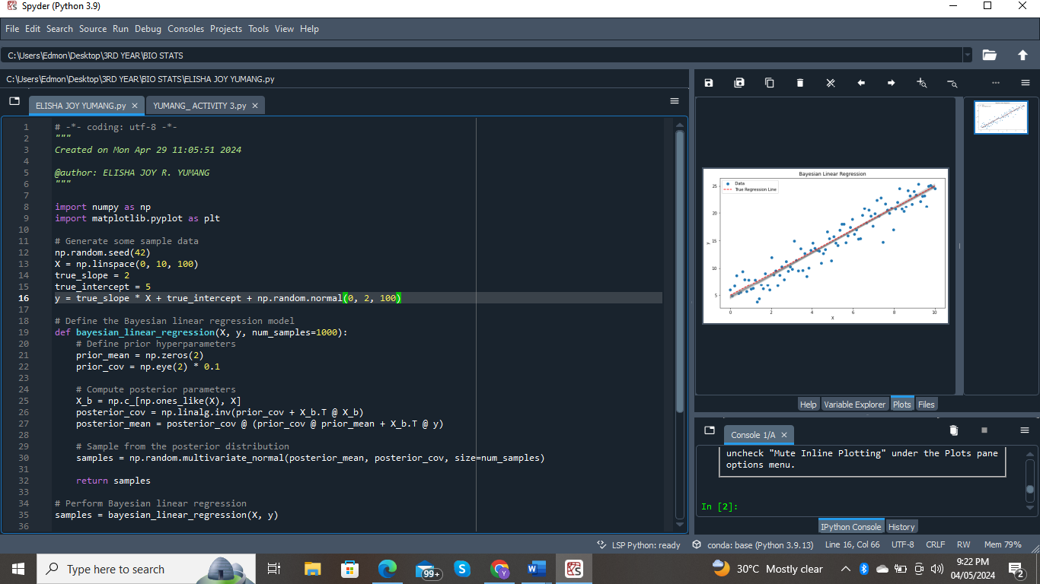plt.show()

