**Candidates**

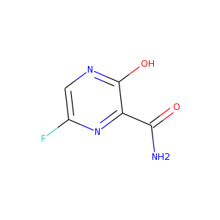Favipiravir

NC(=O)c1nc(F)cnc1O

Mr=157.1

LogP=-0.16

HBD: 2

HBA: 5

Remdesivir

CCC(COC(=O)[C@@H](NP(=O)(Oc1ccccc1)OC[C@H]1O[C@@]([C@@H]([C@@H]1O)O)(C#N)c1ccc2n1ncnc2N)C)CC

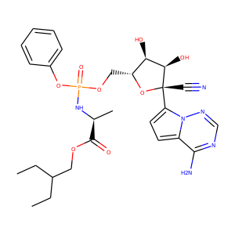

Mr= 602.58

LogP= 1.53

HBD: 4

HBA: 12

Ribavirin Triphosphate

NC(=O)c1ncn([C@@H]2O[C@H](CO[P@@](=O)(O)O[P@@](=O)(O)OP(=O)(O)O)[C@@H](O)[C@H]2O)n1

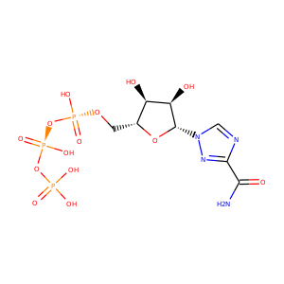Mr= 484.14

LogP= -4.17

HBD: 7

HBA: 16

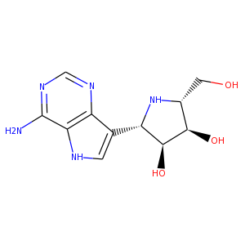Galidesivir

O[C@H]3[C@H](c2c1ncnc(N)c1[nH]c2)N[C@H](CO)[C@H]3O

Mr= 265.27

LogP= -1.51

HBD: 6

HBA: 6