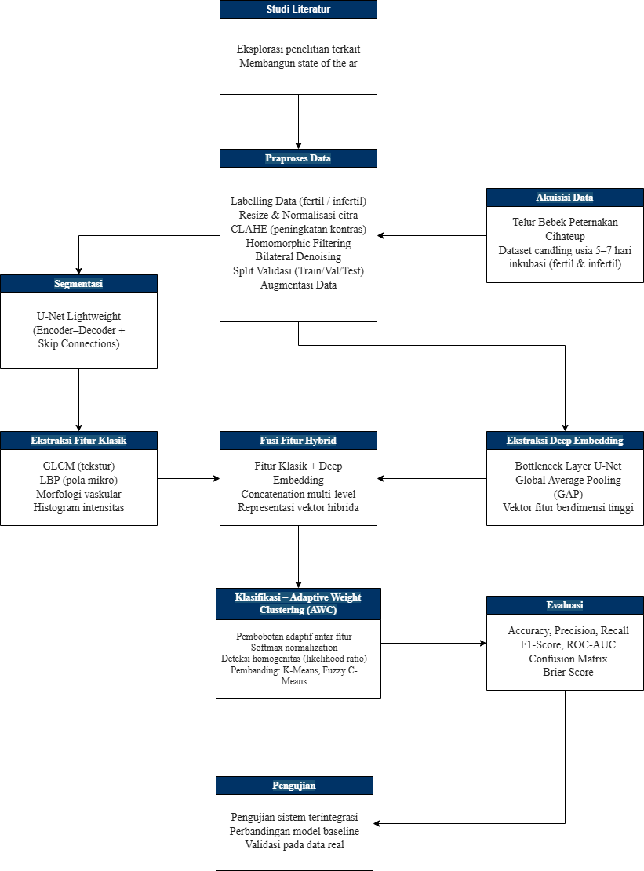

3.3 Formula Matematika yang Digunakan

1. Contrast Limited Adaptive Histogram Equalization (CLAHE)
CLAHE membagi citra menjadi blok lokal (tiles) dan melakukan ekualisasi histogram dengan pembatasan kontras untuk menghindari amplifikasi noise berlebihan. Fungsi transfer ekualisasi histogram:
$$s_{k} = T\left(r_{k}\right) = \sum_{j=0}^{k}{\frac{n_{j}}{N}}$$
Pembatasan kemiringan histogram (clip limit):
$$β_{clip} = \frac{N_{pixels}}{L} + \frac{excess}{L}$$

2. Homomorphic Filtering
Citra f(x,y) dimodelkan sebagai perkalian komponen iluminasi i(x,y) dan reflektansi r(x,y):
$$f\left(x,y\right) = i\left(x,y\right) · r\left(x,y\right)$$
Proses filter dengan transformasi logaritmik:
$$ẑ\left(x,y\right) = ℱ^{−1}\left\{H\left(u,v\right) · ℱ\left\{ln f\left(x,y\right)\right\}\right\}$$
Filter Butterworth orde-n untuk normalisasi pencahayaan:
$$H\left(u,v\right) = \left(γ_{H} − γ_{L}\right)\left[1 − \frac{1}{1 + {\left(\frac{D\left(u,v\right)}{D_{0}}\right)}^{2n}}\right] + γ_{L}$$

3. Fungsi Loss U-Net (Binary Cross-Entropy + Dice Loss)
Binary Cross-Entropy Loss:
$$ℒ_{BCE} = −\frac{1}{N} \sum_{i_{}}^{N}{\left[y_{i} log\left({ŷ}_{i}\right) + \left(1−y_{i}\right)log\left(1−{ŷ}_{i}\right)\right]}$$
Dice Loss:
$$ℒ_{Dice} = 1 − \frac{2\sum_{i}{y_{i}{ŷ}_{i}} + ε}{\sum_{i}{y_{i}} + \sum_{i}{{ŷ}_{i}} + ε}$$
Total loss (kombinasi):
$$ℒ_{total} = ℒ_{BCE} + ℒ_{Dice}$$

4. Ekstraksi Fitur Tekstur – GLCM (Gray Level Co-occurrence Matrix)
Elemen matriks GLCM pada arah γ dan jarak d:
$$P\left(i,j | d, γ\right) = \frac{C\left(i,j | d, γ\right)}{\sum_{i,j}{C\left(i,j | d, γ\right)}}$$
Kontras:
$$Con = \sum_{i,j}{{\left(i − j\right)}^{2}P\left(i,j\right)}$$
Energi:
$$Ene = \sum_{i,j}{{P\left(i,j\right)}^{2}}$$
Homogenitas:
$$Hom = \sum_{i,j}{\frac{P\left(i,j\right)}{1 + \left|i − j\right|}}$$
Korelasi:
$$Cor = \sum_{i,j}{\frac{\left(i − μ_{i}\right)\left(j − μ_{j}\right)P\left(i,j\right)}{σ_{i} σ_{j}}}$$

5. Local Binary Pattern (LBP)
Untuk piksel pusat (xc, yc) dengan P tetangga pada radius R:
$${LBP}_{P,R}\left(x_{c}, y_{c}\right) = \sum_{p=0}^{P − 1}{s\left(g_{p} − g_{c}\right) · 2^{p}}$$
Fungsi ambang:
$$s\left(u\right) = \left\{1 jika u ≥ 0 ; 0 jika u < 0\right\}$$

6. Adaptive Weight Clustering (AWC)
(a) Jarak Euclidean antar sampel:
$$d\left(x_{i}, x_{j}\right) = {\left\|x_{i} − x_{j}\right\|}_{2} = \sqrt{\sum_{k=1}^{d}{{\left(x_{ik} − x_{jk}\right)}^{2}}}$$
(b) Massa Empiris Overlap (irisan dua bola):
$$m_{ij}^{ov} = \# \left\{x_{l} ∈ B\left(x_{i}, r_{t}\right) ∩ B\left(x_{j}, r_{t}\right), l ∈ X, l≠i,j\right\}$$
(c) Massa Empiris Komplemen:
$$m_{ij}^{co} = \# \left\{x_{l} ∈ B\left(x_{i}, r_{t}\right) ∪ B\left(x_{j}, r_{t}\right) | xₗ ∉ \left(B\left(x_{i}, r_{t}\right) ∩ B\left(x_{j}, r_{t}\right)\right)\right\}$$
(d) Massa Union:
$$m_{ij}^{un} = m_{ij}^{ov} + m_{ij}^{co}$$
(e) Rasio Kepadatan Overlap:
$${ρ̂}_{ij} = \frac{m_{ij}^{ov}}{m_{ij}^{un}}$$
Dibandingkan dengan rasio volume teoretis:
$$ρ_{0} = \frac{Vol\left(B\left(x_{i}, r_{t}\right) ∩ B\left(x_{j}, r_{t}\right)\right)}{Vol\left(B\left(x_{i}, r_{t}\right) ∪ B\left(x_{j}, r_{t}\right)\right)}$$
(f) Statistik Uji Likelihood Ratio (No-Gap):
$$T_{ij} = 2\left[m_{ij}^{ov} ln\frac{{ρ̂}_{ij}}{ρ_{0}} + m_{ij}^{co} ln\frac{1 − {ρ̂}_{ij}}{1 − ρ_{0}}\right]$$
(g) Pembaruan Bobot:
$$w_{ij}^{(t+1)} = \left\{1 jika Tᴵⱼ ≤ λ ; 0 jika Tᴵⱼ ≥ λ\right\}$$
(h) Softmax Normalization Bobot Fitur:
$$w_{k} = \frac{e^{α_{k}}}{\sum_{j=1}^{K}{e^{α_{j}}}}, \sum_{k=1}^{K}{w_{k}} = 1$$

7. Metrik Evaluasi Model
Akurasi:
$$Accuracy = \frac{TP + TN}{TP + TN + FP + FN}$$
Presisi:
$$Precision = \frac{TP}{TP + FP}$$
Recall (Sensitivitas):
$$Recall = \frac{TP}{TP + FN}$$
Spesifisitas:
$$Specificity = \frac{TN}{TN + FP}$$
F1-Score:
$$F_{1} = 2 · \frac{Precision · Recall}{Precision + Recall}$$
Dice Coefficient dan IoU untuk segmentasi:
$$DC = \frac{2 |A ∩ B|}{|A| + |B|}, IoU = \frac{|A ∩ B|}{|A ∪ B|}$$
Brier Score:
$$BS = \frac{1}{N} \sum_{i=1}^{N}{{\left({p̂}_{i} − y_{i}\right)}^{2}}$$

