Swimming Meet Management & Timing System User Manual
Version v2026.09.28 · applies to SwimmingScoreboard_Setup_v20260928 and later installers
This version substantially expands four areas — Race Control, Scheduling & Results Processing, Big-Screen Display & Display Control, and Athlete Registration (the "Display & Display Control" chapter, in particular, now documents the display-control entry points for the first time) — with real on-screen screenshots (all sample/dummy data, not from a real meet).

How to Use This Manual
- Setting up for the first time / running your first meet → read Chapters 1–3; follow them once end to end and you'll have it running.
- Something goes wrong on meet day → jump straight to Chapter 12, On-Site Troubleshooting — a one-page cheat sheet for most problems.
- Want to understand why a rule works the way it does → read Chapter 4, The Five Rules; that's the root of the whole system's behavior.
- Technical integration, hardware debugging → see Appendix A, Hardware Protocol and Appendix B, File Reference.
Every paragraph marked ⚠ throughout this book was learned the hard way, on-site. Follow them as written — don't try to shortcut around them.

Part One: Setup and Running a Meet

1. System Components
This is one program, many roles: the same main program behaves as a different machine depending on how it's started.

1.1 Five Desktop Programs
Program | Installed where | What it does
SwimmingScoreboard.exe — Main Server | Meet office | The sole authority for competition data: rosters, schedule, heats, results, records, document output. Opens a WebSocket (3002) and a web server (8080)
RemoteTimingControl.exe — Race Control (timing station) | Poolside, wired to timing hardware | Ready / start / time / rule / confirm results. This is the machine actually connected to the timer
ScheduleEditor.exe — Schedule Editor | Scheduling desk | Registration, heat assignment, promotion, result correction, document printing. No hardware, no timing
RegistrationTool.exe — Registration Tool | Check-in desk | On-site late registration
RemoteDisplayControl.exe — Display Control | Big-screen station | Big-screen preview and switching

1.2 Six Web Pages
Open in a browser: http://<main server IP>:8080/xxx.html
Page | Who it's for
display.html | Big screen: live race, heat results, overall ranking, awards, welcome screen, schedule
race_control.html | Web version of race control (works on tablets)
query.html | Result lookup (spectators / coaches)
register.html | Online registration
checkin.html | Check-in desk
leaderboard.html | Ranking board

1.3 Three Typical Setups
A. Single machine (small meets)
One main server does everything: data + timing + big screen. The big-screen browser connects to localhost:8080.
B. Main server + timing station (recommended, the default this manual assumes)
The main server owns the data; the timing station, poolside, owns timing. Each does its own job. The big screen and other web pages all connect to the main server.
C. Main server + timing station + schedule editor (large meets)
Add a scheduling desk so later events can be scheduled while the meet is running.
⚠ In setups B and C, start the main server with a role argument (see 2.3) — it then automatically removes the "Race Control" tab, since timing is the timing station's job; removing the entry point avoids two machines issuing commands at once.

1.4 Machine Requirements
- Windows 10 / 11, 64-bit
- .NET Framework 4.5 or later (included with Windows)
- VC++ 2015-2022 Redistributable (bundled with the installer, installed automatically)
- The timing station needs a serial or Ethernet port to the timing hardware
- All machines on the same LAN, able to reach each other

2. Installation and Startup

2.1 Installation
- Unzip SwimmingScoreboard_Setup_vYYYYMMDD_N.zip
- Right-click Setup.exe → Run as administrator
- Choose an install directory (default C:\SwimmingScoreboard) → Next through to the end
The installer does three things: lays down the program files, installs the VC++ redistributable (skipped automatically if already installed), and creates a desktop shortcut (this can now be turned off with a checkbox on the install-directory step — new this version, on by default).
⚠ Don't skip the VC++ redistributable. Without it, SQLite.Interop.dll can't load and the competition database never opens at all — no results recorded, no rankings, no heat results — and nothing on screen looks wrong. A whole meet day was once lost to this. The program now shows a warning dialog on startup if it's missing, but it's still best to let the installer install it.

2.2 Web Files Must Be Updated Together With the EXE
⚠ The web pages and the main program are versioned and changed together. Updating only one half produces symptoms that look unrelated to the real cause — device-status lights that stop refreshing, a race log that stops updating.
The system guards against this itself:
- Web pages are served by the main program and are never cached by the browser — a refresh always gets the latest version
- Each page and the main program carry a version number; when they don't match, a red banner appears at the top of the page naming both versions, and the main server's "System Log" calls it out too
If you see the red banner, press Ctrl+F5 to force-refresh; if it's still mismatched, that machine's Web\ folder wasn't updated along with the EXE.

2.3 Startup Order
① Main server (start this first)
Double-click the desktop icon. For the "main server + timing station" setup, use the role-parameter shortcut instead:

SwimmingScoreboard.exe --role server
With --role server:
- The "Race Control" tab is removed (not just disabled — it's not there at all)
- The main server no longer handles timing itself; any timing command it receives is refused with an explanation
After startup, check the top bar: Server: ws://192.168.x.x:3002 | Web: http://192.168.x.x:8080 — give this IP to the other machines.
② Timing station
Double-click RemoteTimingControl.exe → log in → fill in the main server's IP at the top → connect.
Then, under "Race Control → System Hardware", connect the timing hardware.
③ Schedule editor / registration tool / display control
Same as above — fill in the main server's IP and connect.
④ Big screen and web pages
Open http://<main server IP>:8080/display.html in a browser and press F11 for fullscreen.

2.4 Login
All five desktop programs share one dark-themed login window. The default first-run account is admin / 123456 (the program writes this default the first time no credentials file exists — see Appendix B for the file location). After logging in, change your password immediately under "Settings → Username and Password".

2.5 Firewall
On first launch, Windows will ask whether to allow network access — you must choose "Allow" (check both Private and Public networks). Otherwise other machines can't connect.
Ports to allow: 3002 (WebSocket), 8080 (web).

3. Running a Full Meet, Start to Finish
Follow this line all the way through and you've run a complete meet. Each step names which machine it happens on.

3.1 Before the Meet (Main Server / Schedule Editor)
① Create the meet
"Events & Registration → Overview → New Meet" — fill in name, dates, venue, pool spec (length / lane count / lane numbering start), and the officials list.
② Age groups / events / genders / stages
Under "Competition Settings", configure the age groups (with age ranges), events, genders, and stages this meet will use. These tables feed every dropdown that follows.
③ Registration
Three options, any of which works:
- "Swimmers → Add" — enter by hand
- "Swimmers → Import CSV" — bulk import (headers in Appendix C)
- The register.html web page lets each team register itself; the check-in desk uses RegistrationTool.exe for late entries
Relay teams are created under "Relay Teams" — fill in all four legs one by one.
⚠ The "Athlete Registration" form on the right only appears on the Swimmers and Relay Teams pages; it auto-collapses everywhere else — it hasn't disappeared, those other pages just don't need it.
④ Generate the schedule
"Schedule → Generate Schedule (one click)" estimates the number of heats from the entry count and lays out sessions and times. You can adjust it by hand in the table afterward.
⑤ Seed into heats
- "Auto-Seed by Event" — seeds by entry time following FINA SW 3 (see 6.2)
- "Manual Seeding" — seat one event by hand
- "Append Seeding" — only places newly-added, unseeded entrants, leaving existing heats untouched
- "Import Heat Sheet (Excel)" — import from an external seeding sheet
⑥ Print the program book
"Documents → Program Book".

3.2 Check-In (Check-In Desk)
Use the checkin.html web page or check in from a desktop program. Mark no-shows DNS.
⚠ A DNS mark from check-in flows straight through to the competition database and result sheets — you don't need to mark it again at the timing station.
If a heat is short of swimmers, merge it into another using "Merge Heats / Cancel Heat" (see 7.3).

3.3 Racing (Timing Station)
Repeat these six steps for each heat:
Step | Action | Notes
1 | Select the heat in the schedule navigator | The "Live Lane Status" panel switches to this heat's roster
2 | Press Ready | The start blocks arm, and the big screen switches to this heat
3 | Start | Hardware start or press Start Race
4 | During the race | Touchpads/backup watches record automatically; splits, reaction times, and lap counts update live
5 | Apply any rulings | DSQ / DNS / DNF / TRI (see 4.3)
6 | Press Confirm Heat Result | Results are locked into the database, and the big screen switches to this heat's result
Then press Clock Reset to move on to the next heat.

3.4 After the Meet (Main Server / Schedule Editor)
- "Results & Rankings" — view placings and team totals
- "Promotion" — seed semifinals/finals from prelim results
- "Documents" — print the result book, record-breaking report, certificates
- "System Log & Data → Backup" — save a copy of the meet archive

Part Two: The Rules

4. The Five Rules
This chapter is the root of the whole system's behavior. Every place the UI stops you from doing something traces back to one of these five rules.

4.1 Who Controls Racing: EXE > Web > Main Server
There can only be one place issuing commands for a given race. The priority order is fixed:
Priority | Who | When someone higher is present
1 (highest) | The Race Control program (RemoteTimingControl.exe) | Never locked out — it's the one wired to the hardware
2 | The Race Control web page (race_control.html) | Timing buttons are disabled, with an orange banner explaining why
3 (lowest) | The main server's "Race Control" tab | The tab greys out and can't be opened
It's not just the buttons that are blocked — the server enforces this too. Ready, start, reset, confirm result, ruling, lap adjustment, manual result entry, and hardware connect/disconnect/enable-all from a lower-priority source are all refused with an explanation — a greyed-out button alone can't stop a stale page or a cached browser tab, and two sources issuing commands at once leaves nobody sure what state the race is actually in.
Switching events, switching heats, and display control are unaffected — the web page can still do those normally, since they touch data and the big screen, not timing commands.
When the higher-priority source disconnects, the lower one is restored automatically — no restart needed.

4.2 A Confirmed Heat Cannot Be Changed
"Confirmed" means the operator pressed "Confirm Heat Result" — the schedule tree marks it [Confirmed]. It does not mean "looks finished" or "everyone has a result."
Once confirmed:
What you try to do | What happens
Edit a result, apply/remove DSQ/DNS/DNF/TRI | Refused, with a dialog explaining why
Merge or cancel the heat | Refused
Swap lanes, move up/down, add or remove a swimmer | Refused
Re-seed the whole event (manual/append/auto seeding, import a heat sheet) | The whole operation is refused
Import results from a file that would overwrite this heat | Skipped — the completion dialog lists which heats were skipped
The only way out is "Unlock Heat Result" (see 4.4).

4.3 TRI Means Exhibition — Timed, But Not Ranked
 | Timed | Result recorded | Ranked | Scored | Counts for records
Normal | ✅ | ✅ | ✅ | ✅ | ✅
TRI (exhibition) | ✅ | ✅ | ❌ | ❌ | ❌
DSQ / DNS / DNF | — | ❌ | ❌ | ❌ | ❌
If a lane is marked TRI before the race, it's timed exactly as normal — touchpad, backup watch, splits, and reaction time all record as usual, and the result still displays — but the remark column shows a red "TRI", and the swimmer is excluded from placing, from team scoring, and from record consideration.
An empty lane can also be marked TRI on the fly (a placeholder swimmer is created automatically) — useful for touchpad testing.

4.4 Unlocking a Heat Result
Pressing "Confirm Heat Result" locks that heat. But on-site, mistakes happen — the wrong button gets pressed, or a bad result is only noticed afterward. Without a way to unlock, that wrong result would stay locked in forever.
So there's an escape hatch — the amber "Unlock Heat Result" button directly below the confirm button on the Race Control tab.
How to use it:
- Not available while the heat is running or ready (it hasn't finished yet)
- First confirmation: a dialog states which heat and what unlocking will do
- Second confirmation: type the heat number and a mandatory reason — typing the number by hand stops someone from reflexively clicking "Yes" without looking
- Once unlocked, the heat returns to "has a result but not confirmed" — results and rulings can be edited again
- After editing, you must press "Confirm Heat Result" again to re-lock it
Audit trail: one line in the system log, one row in the database audit table — who, when, why. The log rolls off eventually; the audit table doesn't.
⚠ Unlocking is only available on the timing station (the main-server role has no "Race Control" tab). Unlock it on whichever machine confirmed it.

4.5 You Can Edit Other Events While a Race Is Running
While a race is in progress, the schedule editor can still merge heats, reorder lanes, and seed promotions for other events, other heats — only the heat currently racing is locked.
Two things make this possible:
① Locking is per-heat, not a blanket "race in progress" lock.
A heat counts as "untouchable" only when: it's the one currently running or ready; it's already confirmed; it has a result but isn't confirmed yet; or the timing station currently has it open. Everything else is allowed.
② Edits travel as incremental patches, not a full re-push.
An edit from the schedule editor sends only "this one operation" to the main server (a merge sends a merge, a re-seed sends just that event's heat table), and the main server applies it to just those few people — it never reloads the whole database or swaps out objects, so the heat currently being timed is never touched, not even by a byte.
If an edit is refused, the schedule editor tells you exactly why and re-fetches the data — you'll never end up thinking something saved when it didn't.

5. Where Data Lives, and How It Doesn't Get Lost

5.1 Three Storage Layers
Layer | What it is | When it's written
Memory | Everything currently on screen | Continuously
Current-heat storage | Just this heat's dozen-or-so rows: current_heat.db + current_heat_progress.json (a few KB) | Every timing event during the race
Meet database + meet archive | meet.db + Database\<meet name>.json | The moment you press "Confirm Heat Result"
⚠ Nothing writes to the main database, and nothing does a full save, while a race is running. Everything in between goes only to the "current heat" file. This rule dates back to an incident where memory usage climbed into the gigabytes during a 400m race — the root cause was serializing the entire ~1.2MB meet package on every single touchpad hit.

5.2 What Happens If It Crashes
If the program is force-killed or the power drops mid-race: reopen it and load the same meet — a dialog appears saying "An unfinished heat was found; its progress has been recovered", restored from the current-heat progress file. Check it over, then press "Confirm Heat Result" as usual.
Already-confirmed heats are unaffected — they were written to the database long before the crash.

5.3 The Database Is the Source of Truth for Rankings
Once a heat is confirmed, its placings exist in exactly one authoritative copy — the meet database. The UI, the big screen, and printouts all read that same copy; nothing recalculates on its own. So you'll occasionally see "placings shift slightly right after confirming" — that's the database's re-sort taking effect, and it's correct.

6. Seeding Rules

6.1 Heat Numbers and Gaps
After a merge or cancel, heat numbers keep their gaps. If heat 2 merges into heat 1, it still holds the number 2 and is marked "Cancelled" — the total heat count doesn't shrink.
By the time the program book is in swimmers' hands, renumbering heat 3 to heat 2 would cause chaos on deck.
The schedule tree, big screen, and Previous/Next Heat navigation all skip cancelled heats automatically.

6.2 Auto-Seeding (FINA SW 3)
Implements the World Aquatics SW 3.1.1.4 / 3.1.1.5 / 3.1.2 standard:

Short-distance events (50 / 100 / 200m)
- seedHeats = min(total heats, 3): the last 3 heats are seeded circular ("seeded")
- Earlier heats are seeded straight, slowest to fastest by heat number; the slowest heat (heat 1) gets whatever's left over
- Seeding order: 1st place → center lane of the last heat, 2nd → center lane of the second-to-last heat, 3rd → center lane of the third-to-last heat; 4th → the next-priority lane of the last heat (lanePriority[1]), cycling to fill the rest

Middle/long distance and relays (400 / 800 / 1500m, 4×N relays)
- seedHeats = min(total heats, 2): the last 2 heats are seeded circular
- Earlier heats are seeded straight
Implemented in HeatScheduler.AssignFinaSeeding(...); distance category is auto-detected via IsShortDistanceEvent(eventName).

Spearhead Lane Assignment
Pool | Priority order (fastest → slowest)
8 lanes | 4, 5, 3, 6, 2, 7, 1, 8
10 lanes | 4, 5, 3, 6, 2, 7, 1, 8, 0, 9
The fastest seed always gets lane 4; the slowest goes to the outside lane (0 or 9 in the 10-lane case).

6.3 Lane Assignment
New entrants fill empty lanes, center-out priority (the order 4-5-3-6-2-7-1-8). Existing swimmers in the target heat keep their lanes. You can adjust manually afterward with "Move Up / Move Down / Swap Lane".

Part Three: Screen-by-Screen Reference

7. Main Server

7.1 System Status
The first thing you see when the program opens.
Current race: event / stage / heat / status / competition mode / pool spec.
⚠ While a timing station is connected, this shows the timing station's heat, with "(timing station)" appended. It clears the moment the timing station disconnects — immediately on a clean exit, within 30 seconds after a hard power loss.
Connections: how many big screens, ranking boards, registration clients, timing EXEs, and timing web pages are connected, plus the timing hardware's status. Red 0 means nothing is connected.
Top bar: server address, memory usage (with a "Release" button), battery voltage, timing hardware, and control mode (local / remote EXE / remote web).

7.2 Events & Registration
Seven sub-tabs: Overview, Swimmers, Relay Teams, Schedule, Lineup Tuning, Competition Settings, Records.
The "Athlete Registration" form on the right only appears on the Swimmers and Relay Teams tabs; the other tabs auto-collapse it and hand its width back to the table on the left.

7.2.1 Swimmers (Individual Registration)
The roster table and its filters (event/age group/gender/name/bib) are on the left; the "Athlete Registration" form is on the right.
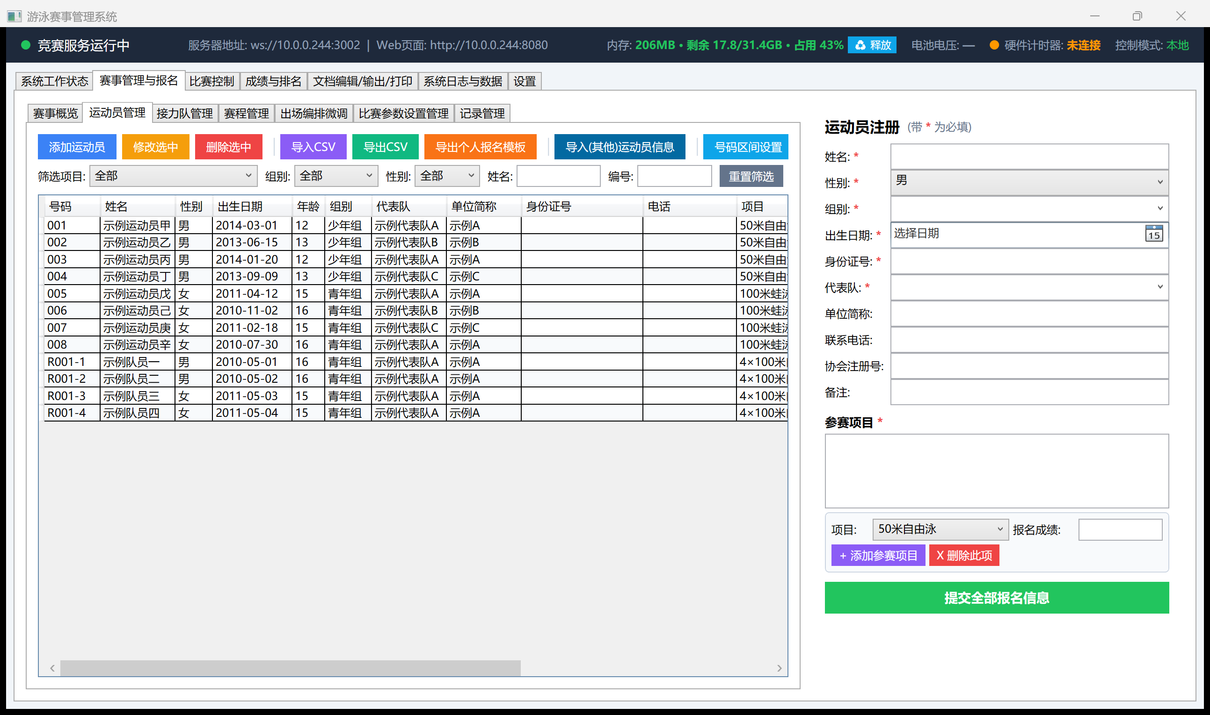Swimmers: roster table + athlete registration form
Adding a swimmer:
- Fill in the form on the right: Name / Gender / Age Group / Date of Birth / ID Number / Team (fields marked * are required); unit short name, phone, association registration number, and notes are optional
- In the "Events" section: pick an "Event" from the dropdown, fill in "Entry Time" (this drives seeding order — see 6.2), then click + Add Event — one swimmer can enter multiple events, added one at a time
- Once all events are added, click the big green Submit All Registrations button at the bottom — only this actually writes the swimmer into the roster
- The bib number defaults to whatever the "Bib Ranges" setting assigns; to set one manually, edit it directly in the table
⚠ Clicking only "+ Add Event" without clicking "Submit All Registrations" leaves this swimmer out of the table on the left — adding an event only appends a row to the form's temporary list; the final green button is what actually saves it.
Toolbar above the table:
Button | What it does
Add | Clears the form on the right to start a new entry
Edit | Loads the selected row's data into the form on the right; click "Submit All Registrations" again after editing to save
Delete | Deletes the selected swimmer (and all their event entries)
Import CSV / Export CSV | Bulk import/export; headers in Appendix C
Export individual registration template | A blank form to send out to teams
Import (other) swimmer info | Import basic swimmer info from another meet archive (events not included)
Bib Ranges | Reserve number ranges per team/age group so new entrants fall inside them automatically

7.2.2 Relay Teams
The relay team list (grouped by event) is at top left; leg assignments are below it; the "Athlete Registration" form on the right is the same one used for individual registration — relay teams and their legs are all rows in the same roster.
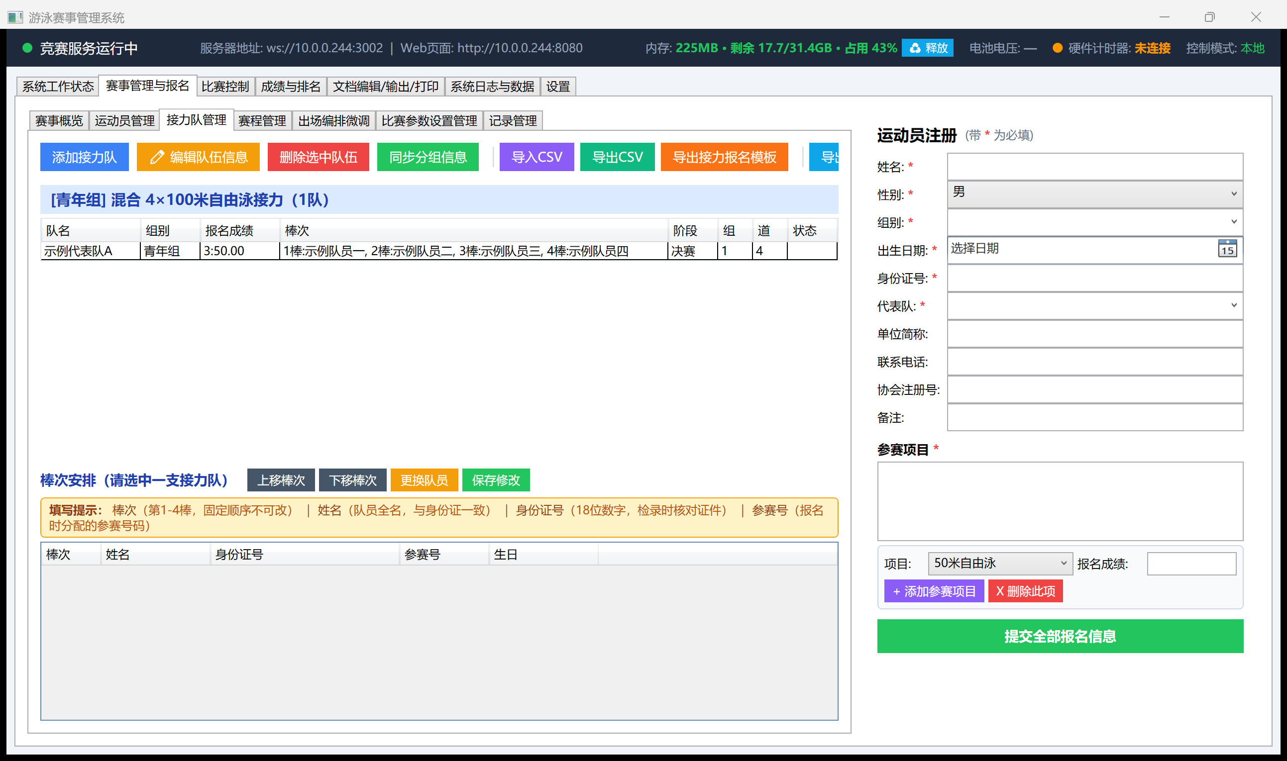Relay Teams: relay team list + leg assignments
Creating a relay team:
- Click Add Team, fill in the team name (usually the team's short name), age group, gender, event, and entry time
- In "Leg Assignments", fill in each of legs 1–4 with the swimmer's name / ID number / bib — the ID number is used to verify identity at check-in; the bib is that swimmer's existing roster number (a relay leg swimmer usually also needs to be registered individually, or exist as a relay-only record, in "Swimmers")
- Click Save
Adjusting legs: with a relay team selected, "Move Leg Up / Move Leg Down" reorders who swims which leg; "Replace" swaps out a leg's swimmer (the ID number must match, to prevent an unauthorized substitution); click Save after either change.
Sync Heat Info: a relay team's heat assignment (which heat, which lane) is handled centrally by Schedule/Auto-Seed; if you change legs or swap a swimmer afterward, click this button to push the latest lineup into the already-generated heat sheet, so it doesn't keep showing the old legs.
⚠ A relay team is stored in the database as one "team summary" record (bib like R001) plus four "leg member" records (R001-1 through R001-4). Race Control's schedule navigator, result sheets, and the big screen all use the team summary record; leg records exist to verify ID numbers and to list team members in the program book. The system maintains both automatically — you generally don't need to touch this by hand.

7.2.3 Athlete Registration — the register.html Web Page and the RegistrationTool.exe On-Site Tool
Besides entering data by hand on the "Swimmers / Relay Teams" desktop pages, the system offers two dedicated channels for registration. Both ultimately write to the same roster — whichever channel a swimmer is registered through, they show up immediately on the desktop "Swimmers" page; nothing needs to be imported or exported back and forth.

A. register.html: Let Each Team Register Itself
Open http://<main server IP>:8080/register.html in a browser and send the link to each team's coach/manager so they can fill it in from their own phone or computer. The page has two parts — Individual Event Registration and Relay Event Registration — and both work the same way: "build up a batch first, submit it all at once", not "submit as you go":
Individual event registration, start to finish:
- Fill in the swimmer's basic info: Name / Gender / Date of Birth / Team are required; the ID Number field is now optional as of this version, and no longer restricted in length or format — international athletes' ID documents don't follow the domestic 18-digit format, so it no longer has to be numeric or any particular length; leave it blank or enter any ID and it can still be submitted
- Pick an "Event", fill in "Entry Time", and click "+ Add Event" — this only adds the event to a temporary list on the page; it isn't submitted yet
- To register the same swimmer for more events, repeat the previous step — one swimmer can add multiple events
- Once this swimmer's events are all added, click "+ Add to Registration List" (or a similar "register another swimmer" entry point) to start the next swimmer, and repeat until the whole team is queued up
- Once everyone is queued, click "Submit All Registrations" at the bottom to write every queued swimmer's events into the main server's roster in one shot
Relay event registration (substantially reworked this version, start to finish):
⚠ The previous version could only register one relay team, in one relay event, and that was it — very inconvenient for teams that needed to enter multiple relay events (say, mixed relay + men's relay + women's relay) or multiple teams. As of this version, relay registration works exactly like individual registration above, as a two-step process, and no longer has that limitation:
- Fill in the team's info: team name / age group / gender / event, then fill in each of legs 1–4 with that swimmer's name / ID number (also optional and unrestricted in format)
- Click "+ Add Relay Event" — this one team, in this one relay event, is added to a temporary list on the page
- To register the same team for another relay event (say, they already registered men's 4x100 relay and now need mixed relay too), pick the new event and re-enter the legs (the same swimmers or different ones), then click "+ Add Relay Event" again — one team can add several relay events this way
- To register another team, repeat step 1 to add it — one submission can include multiple teams, not just one
- Once every relay team you want to register is queued, click "Submit All Relay Registrations" to write them all to the main server at once
⚠ A trap for first-time users: just like individual registration, only clicking "+ Add to Registration List" / "+ Add Relay Event" without clicking the final "Submit All..." button leaves the data sitting in the browser page's temporary queue — refreshing the page or closing the browser loses it, and the main server never receives it at all. Always finish by clicking that final green submit button.

B. RegistrationTool.exe: The On-Site Late-Registration Tool
Installed on the check-in desk's computer, specifically for registering last-minute entries before or during the meet. After launching, log in (same credentials as the other four desktop programs — see 2.4) and enter the main server's IP at the top. The interface has "Individual Registration" and "Relay Registration" tabs, and works exactly the same way as register.html (reworked to match this version):
- Individual registration: fill in a swimmer → add events → "Add to Queue" → keep adding more swimmers → once done, "Submit All Registrations (N swimmers)" submits everyone at once (the number on the button updates live as you queue people, so you can confirm nothing was missed)
- Relay registration: fill in a team → add legs → "Add to Queue" → keep adding more events for the same team, or another team → once done, "Submit All Relay Registrations (N teams)" submits them all at once
⚠ The previous version of RegistrationTool.exe could only register one swimmer or one relay event at a time — with a line at the check-in desk during a meet, operators often had to restart the program repeatedly, which was very inefficient. This version now supports "queue up a batch, submit once", the same as the web version, so you can fill in everyone who needs late registration and submit them together.

7.2.4 Schedule
"Schedule Navigator" on the left, grouped by session; the right side lists this session's events, including a Sequence Number (the on-deck running order used for printing and announcing, adjustable via "Edit Schedule"), time, age group, gender, event, stage, entrant/team count, and heat count.
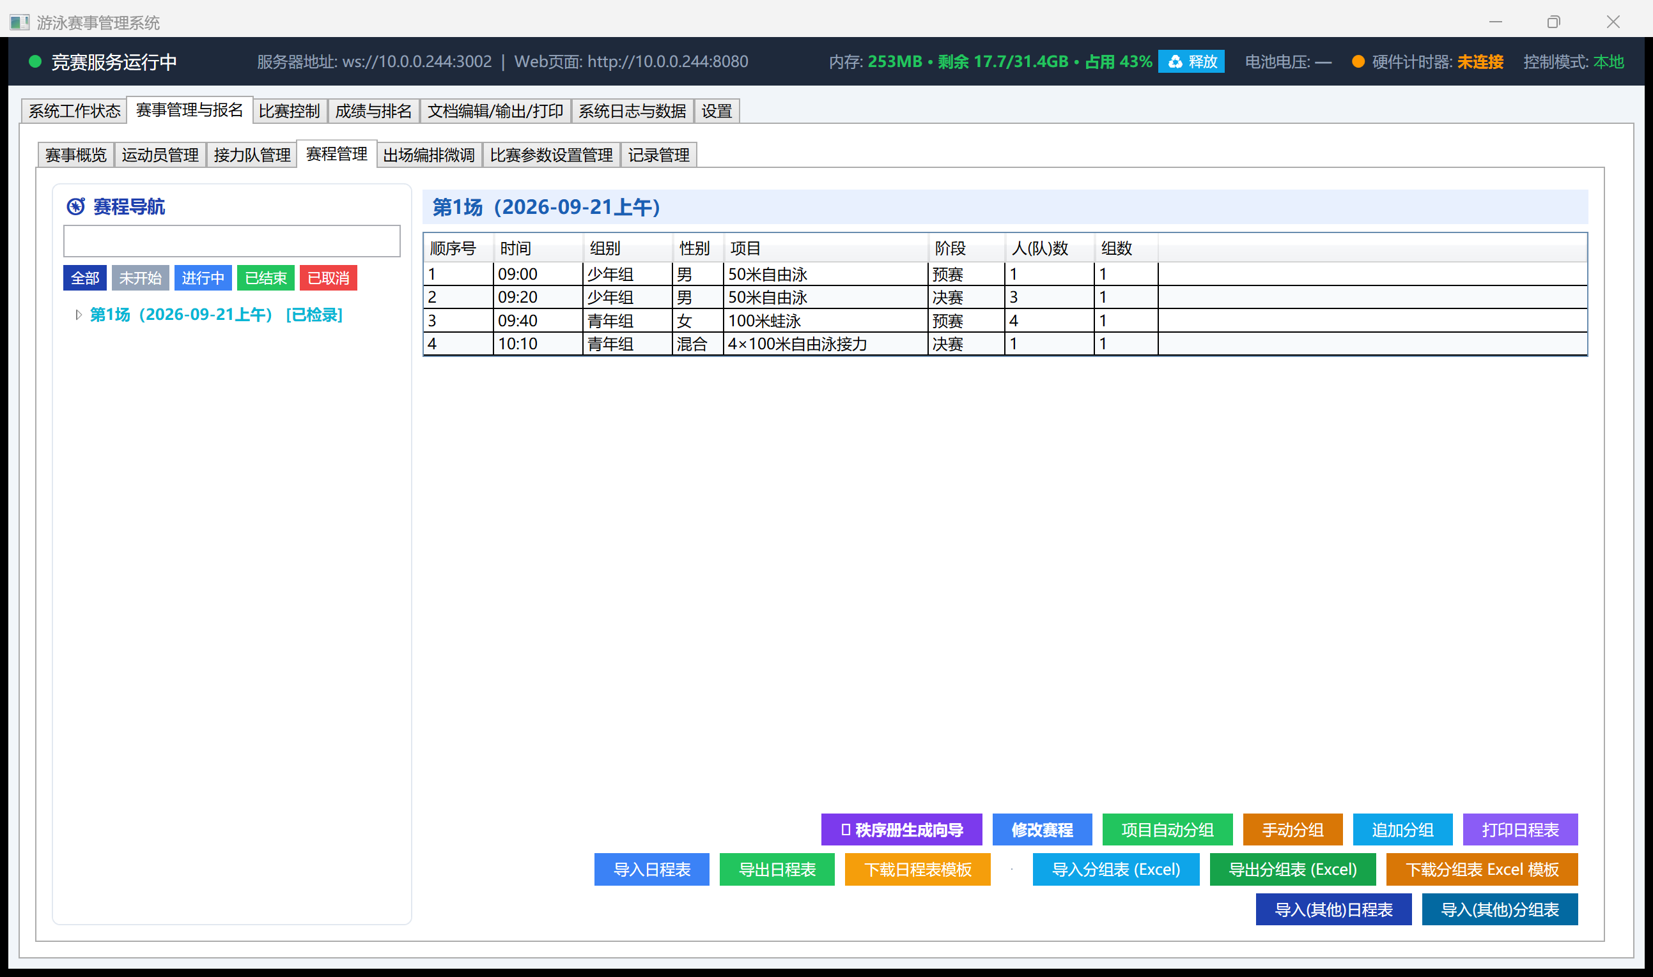Schedule: sequence number + session event list
Button | What it does
Program Book Wizard | Guided generation of the full program book (cover / foreword / technical rules / schedule / etc.)
Edit Schedule | Change an event's time, sequence number, session assignment, etc.
Auto-Seed by Event | Auto-seed by entry time, following FINA SW 3 (see 6.2)
Manual Seeding | Seat one event by hand
Append Seeding | Places only newly-added, unseeded entrants; leaves existing heats untouched
Print Schedule | Prints the session running-order sheet
Import/Export Schedule, Import/Export Heat Sheet (Excel) | Interoperate with external Excel files; templates via the "Download ... Template" buttons
Import (Other) Schedule / Heat Sheet | Import from another meet archive
The All / Not Started / Running / Finished / Cancelled filter buttons on the left of the schedule navigator filter by session status; the [Checked In] and [Confirmed] tags after a session's name use the same status labels as Race Control (see the status table in 8.1).

7.2.5 Lineup Tuning (On-the-Fly Adjustments)
After selecting an age group/gender/event/stage/heat, the table on the right shows this heat's current lane, bib, name, gender, team, entry time, age group, and status:
As of v2026.09, a schedule navigator tree also appears on the left (the same one used in "Race Control" and "Schedule") — clicking an event/heat node on the tree automatically sets all four filter dropdowns on the right to match, so you no longer have to select age group/gender/event/stage one dropdown at a time — this is new this version; previously you could only pick through the dropdowns one by one, which was easy to get wrong.
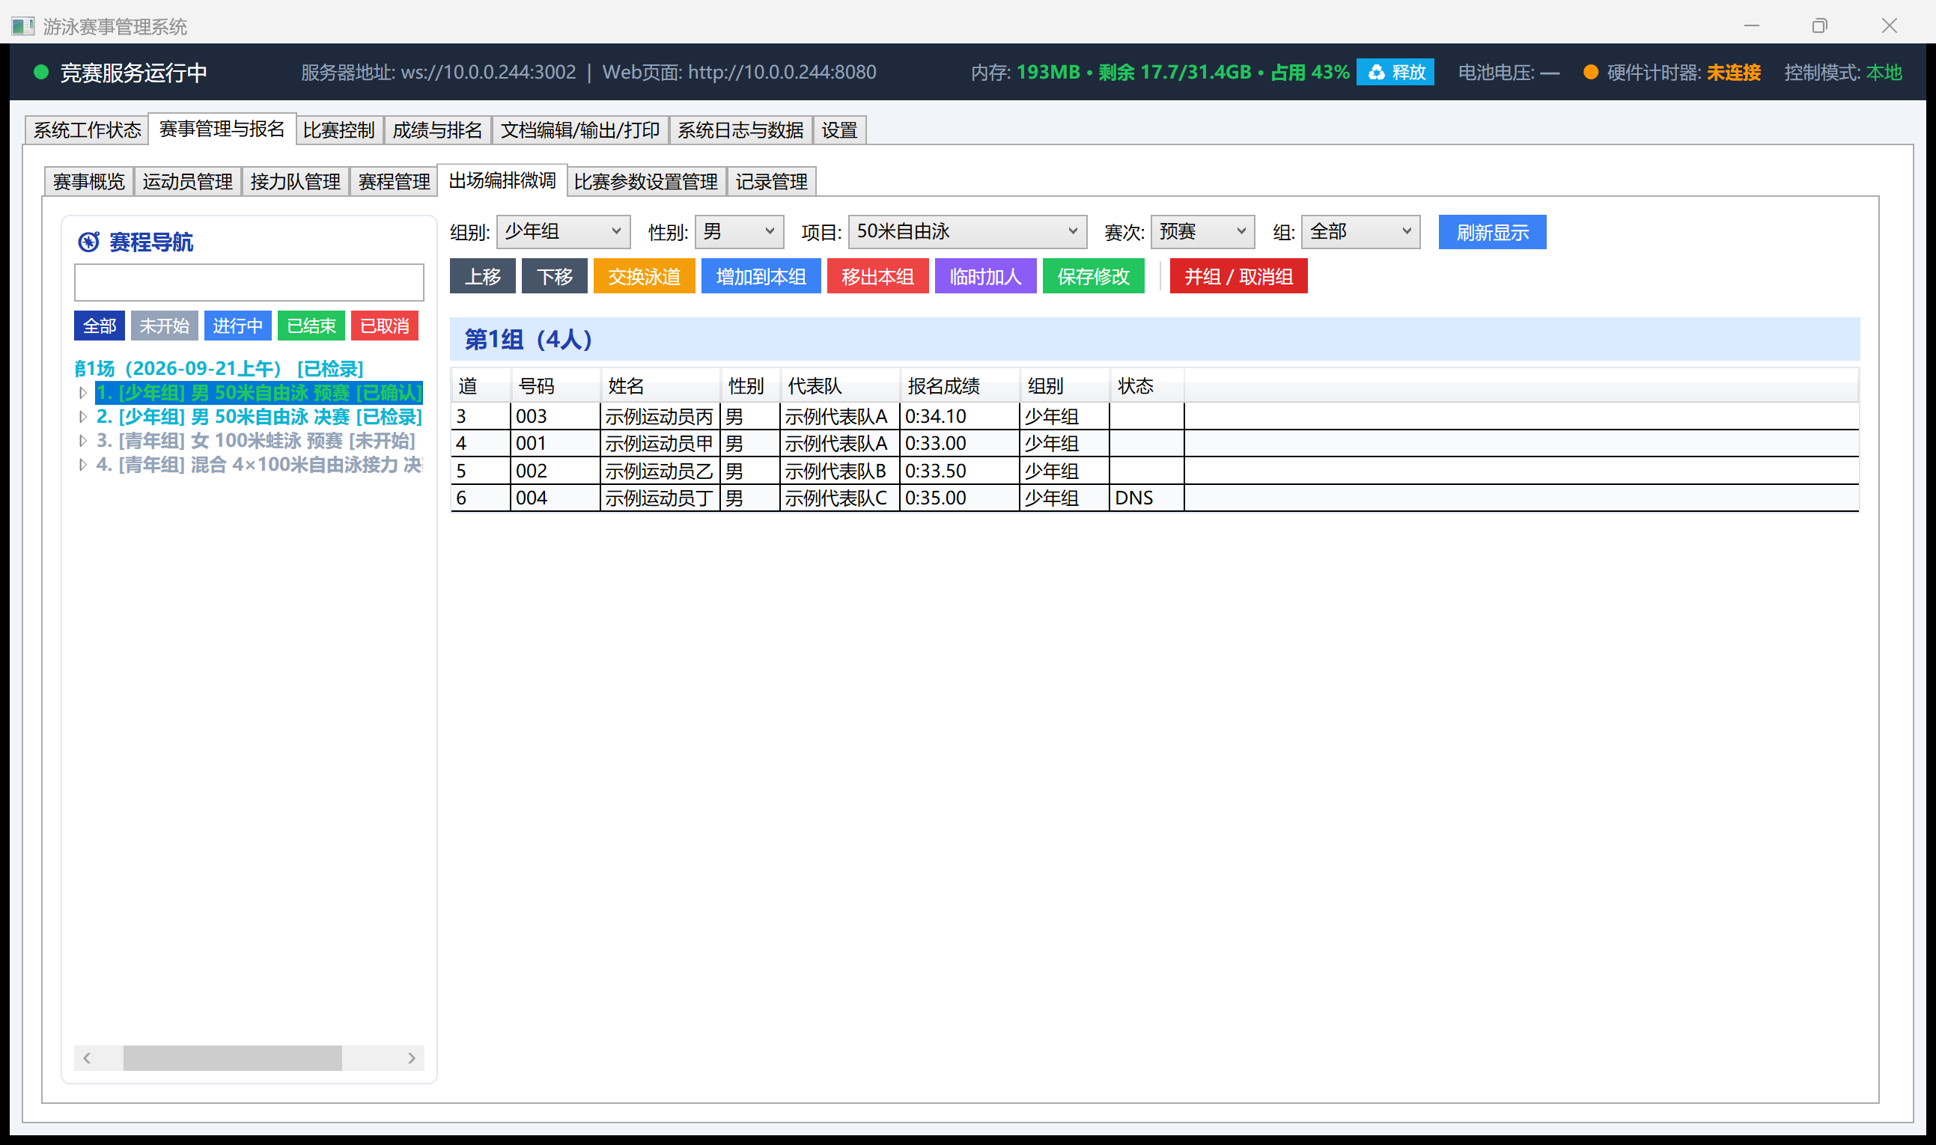Lineup Tuning: schedule navigator + heat detail table
Button | What it does
Move Up / Move Down | Reorders lanes within the same heat
Swap Lane | Swap with another swimmer, or move to an empty lane
Add to Heat | Add an unseeded swimmer into this heat
Remove | Remove a swimmer from this stage's seeding
Add Temp Swimmer | Add a person / relay team on the spot (starts unseeded)
Merge Heats / Cancel Heat | See below
Save | Saves and syncs
⚠ A heat that's already finished, currently racing, or currently open at the timing station cannot be adjusted here (see 4.2, 4.5) — a heat marked [Confirmed] on the tree, or one currently locked at the timing station, will refuse the edit and explain why; every other heat is unaffected, and the schedule editor/main server can keep adjusting other events normally while a race is in progress.

Merge Heats / Cancel a Heat
If check-in reveals a heat is short of swimmers (say heat 2 only has 2 people), merge it entirely into heat 1.
- The dialog labels each heat's headcount; heats that can't be touched are marked "(locked)" with the reason
- Pick a source heat → pick a target heat (or "cancel only, don't merge") → enter a reason → execute
- The heat number keeps its gap; the source heat is marked cancelled
- Merged-in swimmers fill empty lanes fastest-to-slowest by entry time
- Merging is only possible before results exist

7.2.6 Units & Bib Numbers (New This Version)
A new tab called "Units & Bib Numbers" now sits to the left of "Swimmers", for centrally managing how each participating unit (team/school/club) assigns athlete bib numbers. This step is not required — without it, the system still assigns everyone a number automatically via "Bib Ranges" (see 7.2.1); but if your meet requires numbers to be organized by unit and by gender (say a school's boys always use 101–110), this feature saves a lot of manual cross-checking.
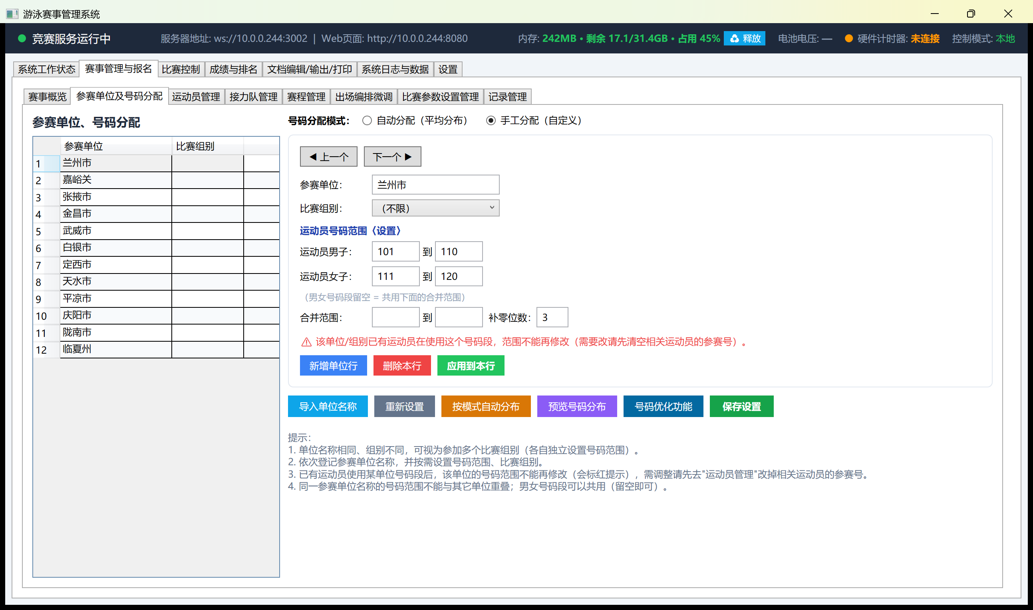Units & Bib Numbers: the unit list is on the left; the selected unit's number range settings are on the right (sample data)
Start to finish:
- Choose a number allocation mode first (the two radio buttons at top right):
  - Auto (Even Distribution): the system spreads out number ranges automatically based on unit count and reserved numbers per unit — good for meets where the actual numbers don't matter, just that they're unique and roughly contiguous
  - Manual (Custom): you specify each unit's number range yourself — good for meets where the numbers carry meaning (say, at a school sports day, number ranges map to specific classes)
- On the left, use "Add Unit Row" to add participating units one at a time (or click "Import Unit Names" to bulk-import from the existing unit list instead of typing them all by hand); the same unit name with a different group counts as that unit entering multiple age groups, each with its own number range
- Click a unit row on the left, and its detailed settings appear on the right: the Male Athletes number range (start–end) and the Female Athletes number range (start–end) — these can differ, or both can be left blank so the "Combined Range" field below is shared by both genders
- Click "Apply to Row" to commit this unit's settings; use "◀ Previous / Next ▶" to move quickly to another unit without clicking back into the table each time
- Once every unit is set, click "Preview Distribution" to check for overlaps or unconfigured units before committing
- Once you're satisfied, click "Save Settings" — this is what actually makes the ranges take effect. From then on, whenever "Swimmers" adds a new athlete with a matching team and gender, the system automatically assigns the next available number from that unit's range
Number Optimization: if a range is running low, or you want to reclaim numbers that were never assigned, click "Number Optimization" to open a small dialog where you can set a start number and how many spare numbers to keep per unit, then repack and reclaim unused numbers — back up your registered-athlete data first (there's a backup option under System Log & Data); repacking numbers is not reversible, so think carefully before doing it.
⚠ Once any athlete is using a unit's number range, that unit's range and allocation mode can no longer be changed — the page shows a red warning: "Athletes are already using this unit/group's number range — it can no longer be changed." To adjust it anyway, you'll first need to go to "Swimmers" and clear or change the bib numbers of the athletes using it. So it's best to finalize your number-allocation approach before registration opens — changing it afterward is a lot of extra work.
Once set up, you can also print a "Unit Number Distribution" report from "Documents" (columns: Unit / Group / Male Numbers / Female Numbers) to hand out to each team for cross-checking.

7.3 Records
Maintains World / Continental / National / Provincial / Municipal / Meet records, etc.
Button | What it does
Add Record | Adds a blank row — you must click "Save Records" after filling it in
Delete Selected | Deletes one row
Save Records | Saves and syncs any edits made in the table
Import Standard Records | Built-in world records
Import CSV Records | Bulk import
Download Record Template | A blank template
⚠ This table is edited in place — after changing a cell, you must click "Save Records", or it only exists in memory. Clicking Save first commits whatever cell your cursor is currently in — you don't need to click elsewhere first.
"Display Records on Big Screen" chooses which record tier shows beneath the event name on the big screen.

7.4 Results & Rankings
The schedule navigator on the left filters by session/status; on the right, filter by age group/gender/event/stage/heat to view results. Columns: place, lane, name, team, bib, age group, heat, final time, time behind leader, timing source, reaction time.
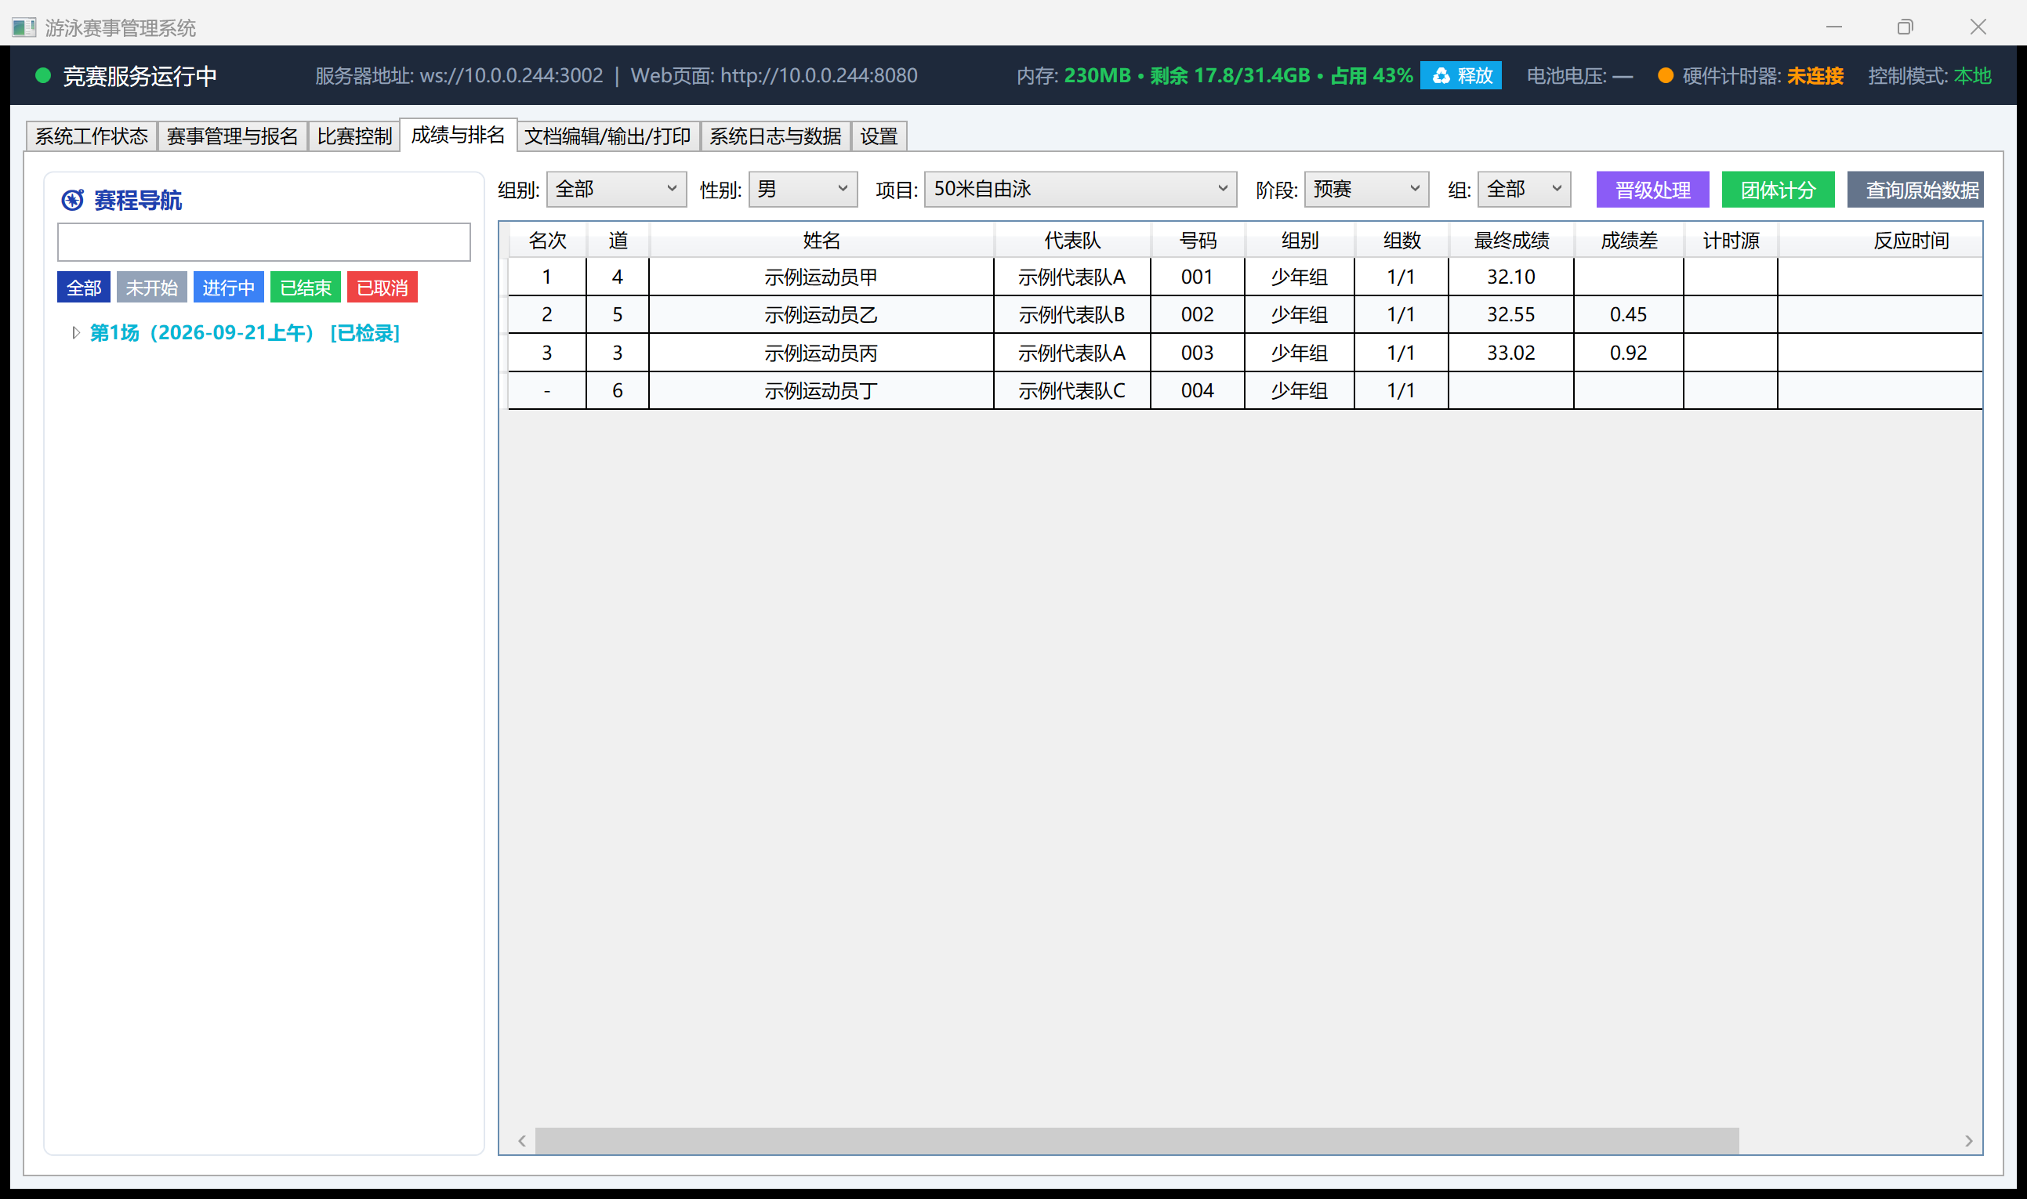Results & Rankings: a preliminary heat's result table
Places are printed as plain numbers; no place shows "-" (as in the sample above, bib 004 is DNS — no place, no time); tied places are never prefixed with "="; "time behind leader" is the gap from this heat's 1st place.
Three buttons at top right:
Button | What it does
Promotion | Seeds the next stage (semifinal/final) from prelim/semifinal results, following FINA SW 3
Team Score | Rolls up each team's total using the pre-configured scoring table (e.g. top 8 scoring 9-7-6-5-4-3-2-1)
Raw Data Lookup | For disputes — view every timing source's raw record for a lane (touchpad/backup watch/manual touch, etc. — see 8.5)
⚠ For a confirmed heat, only the copy in the meet database is authoritative for placings (see 5.3); this table reads that same copy, so what you see here, on the big screen, and on printouts always agree.

7.5 Documents
Category one, pre-meet documents: Program Book (cover / foreword / technical rules / schedule / officials / team roster), Competition Schedule, Heat Sheet, Start List; category two, race results: Result Book (cover / medal table / sportsmanship award / record-breaking announcement / placings announcement / result announcement), Event Results (final ranking summary), Batch Publish by Age Group, Split-Time Report, Results .txt Export; plus award certificates, relay four-leg reaction times, and more.
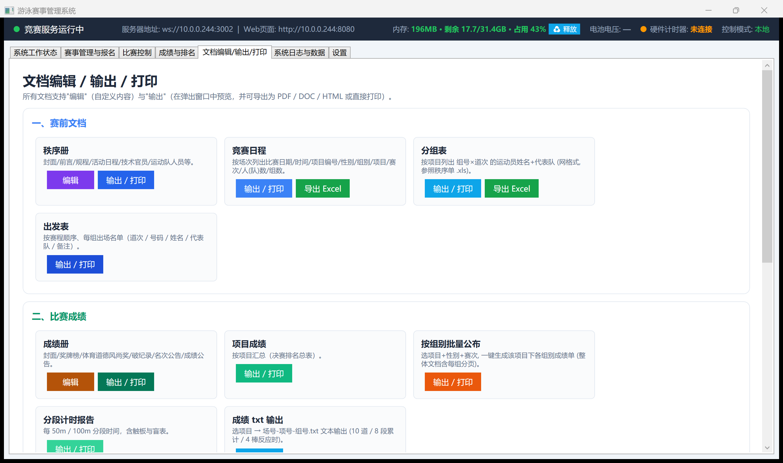Documents: two categories — pre-meet documents and race results
Every document supports two actions:
- Edit (purple/brown buttons): opens an editor where you can customize cover text, foreword, rules, and other content, then save
- Export / Print (blue/green/orange buttons): opens a preview you can save as PDF / DOC / HTML, or send straight to a printer
"Export Excel" is a separate channel for tables — like heat sheets and schedules — that need further editing; it produces an editable Excel file, not a print layout.
⚠ Printing is blocked while a race is running or the heat's result isn't confirmed yet, with the message "Race in progress — cannot print, please try again shortly."

7.6 System Log & Data
System log, raw timing data, meet archive backup/restore, memory monitor, and hardware key-press backup lookup.

8. Race Control (Timing Station)
This is the most detailed chapter in the book — it's where hardware, results, and the big screen all meet, and getting the sequence wrong can delay a start or, worse, void a whole heat's results. The screenshots below are from the "Race Control" screen shared by RemoteTimingControl.exe and the main server (sample data, not a real meet).

8.1 Layout Overview
Left: the schedule navigator (a tree — session → event → heat), each node tagged with a status label (see the table below)
Center: Live Lane Status — one row per lane: lane number, three groups of device indicator lights (backup watch 3/2/1, start/touchpad, lap count/touchpad/start/backup watch 1/2/3), lap-count adjustment, reaction time/result
Right: three control groups — Race Control, Lane Operations, Display Control (scroll down for System Hardware)
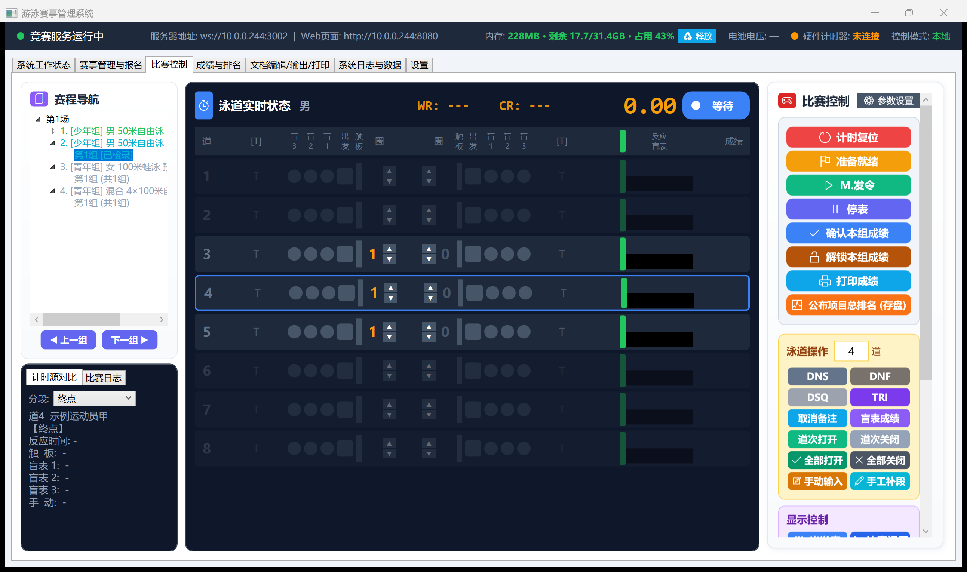Race Control: schedule navigator + live lane status + three button groups (a checked-in heat)
In the screenshot above, 2. [Junior] Men's 50m Freestyle Final → Heat 1 [Checked In] is selected in the left-hand navigator, and the center panel shows that heat's live status; the WR:--- CR:--- at the top are the world/meet record applicable to this event (shows --- if none is configured), 0.00 is the current running time, and the blue pill shows the current phase (Waiting/Ready/Racing).

8.2 Heat Status: Five Phases, With Numeric Codes
The tag next to each heat node on the schedule navigator maps to the table below (the system stores these internally as numbers; the UI translates them to a label — switching to an English UI in future only needs a new translation table, the numbers themselves don't change):
Code | Status | Label | When it happens
1 | Pending | Not Started | Default state — not checked in, timing hasn't started
2 | CheckedIn | Checked In | The check-in desk/check-in web page marked this heat's swimmers as present (see 3.2)
3 | Running | Running | After pressing Ready or Start in Race Control
4 | Done | Finished (timed but not confirmed) | The clock has stopped/all touchpads registered, a result exists, but the operator hasn't clicked "Confirm Heat Result" yet
5 | Confirmed | Confirmed (= "concluded" per 4.2) | "Confirm Heat Result" was clicked, locking it into the database — changes require "Unlock Heat Result" first
6 | Cancelled | Cancelled | A gap heat number produced by a merge/cancel (see 6.1)
⚠ "Checked In" only means the swimmers are present, not that timing data exists yet. This version fixes a long-standing bug: switching to a heat that's "checked in but hasn't started" used to be misjudged as "this heat has data, switching is blocked." Switching between heats now only ever reads this status table, and no longer tries to infer anything from the result table.

8.3 The Standard Sequence for One Heat
Repeat these steps for each heat; the status bar advances Not Started → Checked In → Running → Finished → Confirmed:
Step | Button/Action | Effect
1 | Select the heat in the schedule navigator | "Live Lane Status" switches to this heat's roster; this step alone doesn't change the status
2 | Press Ready | Start blocks arm, hardware waits for the start signal, and the big screen switches to this heat's start list; status → Running
3 | Press Manual Start (or let the hardware start automatically) | Timing officially begins, the top readout starts counting up
4 | During the race | Touchpads/backup watches record automatically; each lane's lap count and reaction time refresh live; rulings can be applied any time with DSQ/DNS/DNF/TRI (see 8.5)
5 | Once everyone has finished, press Pause Clock (or let it stop automatically) | Status → Finished; the results column shows places and times, but nothing is in the database yet
6 | After checking the results, press Confirm Heat Result | Results are locked into the meet database, the big screen automatically switches to this heat's result, and status → Confirmed; from now on this heat is protected by the "confirmed heat" rule in 4.2
7 | Press Clock Reset | Automatically jumps to the next heat, back to step 1
Full list of button groups:
Group | Buttons
Race Control | Clock Reset, Ready, Manual Start, Pause Clock, Confirm Heat Result, Unlock Heat Result, Print Result, Publish Event Ranking (save)
Lane Operations (applies to the selected lane) | DNS, DNF, DSQ, TRI, Clear Remark, Backup Watch Result, Open Lane, Close Lane, Open All, Close All, Manual Entry, Manual Split
Display Control | Live, Starters, Result, Ranking, Team Total, Records, Referees, Awards, Welcome Screen, Pause Screen, Schedule, Publish, etc. — each drives one of the big screen's display modes (see Chapter 10)
System Hardware (scroll down) | Connect/disconnect hardware, device test, enable-all/restore filtering

8.4 Two Meanings of "Clock Reset"
A) The heat is already confirmed → a full reset, automatically advancing to the next heat and arming it. Confirmed results are locked permanently and unaffected.
B) The heat isn't confirmed yet (a false-start recall) → clears this heat's times and splits, keeping any remarks (DSQ/DNS/DNF/TRI), and stays on the current heat. Clearing remarks requires "Clear Remark" specifically.

8.5 Rulings and Manual Splits
- DSQ: for relays, you'll first be asked which leg committed the infraction; splits for the earlier legs are kept
- DNS / DNF: that lane stops accepting data
- TRI: timed as normal, just not ranked (see 4.3)
- Clear Remark: undoes a ruling; the result is restored
- Backup Watch Result: when a manual touchpad press is missed or the touchpad fails, substitute the backup (hand-timed) watch reading for that lane's result
- Manual Entry: key in the whole lane's result by hand (for disputed rulings or a total equipment failure)
- Manual Split: fix just one split/lap's time without touching the lane's final result
- Open Lane / Close Lane / Open All / Close All: temporarily enable or disable a lane (an empty lane, a scratched swimmer), corresponding to hardware command 0x60 Set_LaneEnableDisable (see Appendix A.3)
⚠ A ruling writes to memory and to current-heat storage at the same time; it's committed to the database when the result is confirmed. Confirmed heats can't be re-ruled — unlock first (see 4.4).

8.6 Unlocking a Heat Result
The button sits directly below "Confirm Heat Result"; see 4.4 for the procedure and its double-confirmation requirement — not repeated here.

8.7 Backup Results (For Disputes)
Each lane's touchpad time, start-block reaction time, backup watches 1/2/3, and manual left/right touch are all kept in the "Timing Source Comparison" panel at bottom left — select a lane to see them. For a dispute, you can also compare them line by line under "Results & Rankings → Raw Data Lookup" (see 7.4).

8.8 Parameter Settings (Time Parameters) — Worth a Look Before Your First Meet
There's a small "Parameter Settings" button next to the "Race Control" heading in the top-right corner — easy to overlook, since it sits right beside the big "Race Control" title. Click it, choose "Time Parameters" from the menu on the left, and a dialog opens with these fields, top to bottom:
Field | Default | What it's for
Lane Close Time | 20 sec | If a lane's touchpad/backup watch has no data for this long, it's automatically marked as having no result (a DNF-like state), so equipment doesn't wait forever
Start Block Close Delay | 3 sec | How long after the start signal before the start block accepts its next trigger (prevents a false "false start" right after the gun)
Result Confirm Close Delay | 3 sec | After confirming a heat's result, how long before lane devices close, giving the touchpad a bit of buffer
False Start Threshold | 0.10 sec | If leg 1's (or an individual event's) start reaction time is shorter than this, the system flags it red as "possible false start" — whether it's ruled an actual false start is still up to the referee; the system only flags it and never rules automatically
Relay Handoff False Start Threshold (new) | -0.03 sec | Specifically for relay legs 2, 3, and 4 at the handoff — the value is "the incoming swimmer's start reaction time" minus "the outgoing swimmer's touchpad time," which in theory should be ≥ 0 (touch first, then push off); but the touchpad and start block each have a few milliseconds of measurement error, so a difference between -0.03 and 0 is normal jitter, not a false start. Only a difference below -0.03 seconds (clearly pushing off before the touch) gets flagged red. This value only affects legs 2/3/4's handoff judging — it does not affect leg 1 (leg 1 still uses the "False Start Threshold" above)
Split Time Display Duration | 5 sec | How long each split shown on the big screen stays up before being replaced by the next one
Backup Watch Replace Delay | 5 sec (0–9 adjustable) | If the touchpad has no data for this long, automatically substitute the backup (hand-timed) watch reading, instead of requiring someone to click "Backup Watch Result" manually
Relay Reaction Event Window | 3 sec (1–10 adjustable) | At a relay handoff, from the moment the first related signal (touchpad/start block/backup watch) arrives, wait this long to collect all the signals for that one handoff before calculating reaction time together, instead of calculating the moment any single signal arrives (avoiding a wrong calculation from an incomplete set of signals)
1st Place Result Hold Time / Big Screen Page Interval | 3 / 5 sec respectively | Timing for a couple of cosmetic big-screen effects — display-layer only, has no effect on any ruling
⚠ First-time users often overlook the "Relay Handoff False Start Threshold" row — it sits directly below "False Start Threshold," and the two very similar-sounding names actually govern two completely different things: one governs the start (leg 1), the other governs the handoff (legs 2/3/4). If your country/region has a different tolerance for handoff violations, you only need to adjust this one number, not the one above it.

9. Schedule Editor (ScheduleEditor: The Scheduling & Results Processing Station)
ScheduleEditor.exe has no hardware connection and doesn't time races — it's a standalone package of the main server's "Events & Registration," "Results & Rankings," and "Documents" pages. Sections 7.2, 7.4, and 7.5 apply identically on the schedule editor — the screenshots and steps are the same; the only difference is that it must connect to the main server's IP to get data (its login window is the same as the other four desktop programs — see 2.4). It's meant for running a second machine during a meet to keep scheduling later events, without tying up the poolside timing station.
Can do: add/edit/delete swimmers and relay teams (7.2.1, 7.2.2), schedule and seed heats (7.2.4), on-the-fly lineup tuning (7.2.5), merge/cancel heats, promotion, result correction (7.4), record maintenance (7.3), document printing (7.5).
Cannot do: connect timing hardware, start a race, apply rulings, confirm/unlock a heat's result — these are Race Control–only operations, and the schedule editor simply doesn't show those entry points.

9.1 Two Sync Mechanisms
Type of change | How it syncs | Allowed while a race is running?
Merge/cancel heats, heat/lane adjustments, on-the-fly tuning (7.2.5), promotion, record maintenance | Incremental patch (EDITOR_PATCH): only this one operation is sent to the main server, taking effect within a second | Yes, as long as it doesn't touch the heat currently racing or already confirmed (see 4.5)
Registration info, schedule structure, and other changes | Full save | Refused while the main server is timing a race — a dialog asks you to wait for a clock reset or a confirmed result
This distinction is one of this version's key reliability improvements: earlier versions mostly used "full save" for schedule-editor changes — one save meant re-pushing the entire meet archive to the main server, which carried a small risk of scrambling in-progress timing data if a heat happened to be racing at that exact moment. The most common on-the-fly operations (merges, tuning, promotion, records) now all use incremental patches that send just "this one change," never a full re-push, so poolside and the scheduling desk can genuinely work at the same time during a race.

9.2 What to Do When an Edit Is Refused
When refused, the schedule editor tells you exactly why (e.g. "This heat is currently racing and cannot be adjusted"), and automatically re-fetches its data from the main server — whatever you just changed on screen gets overwritten by that refresh. So when you see a refusal, redo the change; don't assume it already saved.

10. Big-Screen Display and Display Control
This chapter has two parts: 10.1–10.3 cover the big screen itself (display.html) — what it shows, for the audience/athletes; 10.4 onward covers how to "control" it — the control.html web page and RemoteDisplayControl.exe desktop program, the two dedicated "remote controls." It's easy for a newcomer to conflate "the big screen itself" with "the remote that controls the big screen" — clear up that distinction first: the big screen (display.html) can't be operated directly by a person — it only receives commands and displays content; what actually flips the big screen's content is the "Display Control" button group on the "Race Control" page, or the two dedicated remotes covered later in this chapter.

10.1 Display Modes
Live race, start list, heat result, event ranking, team total, records table, officials list, awards, welcome screen, pause screen, schedule, published results, full-screen image/video.

10.2 Automatic vs. Manual
- After a result is confirmed, the display switches to that heat's result automatically
- But once the operator manually presses "Live," manual wins — pressing it returns to the live view, and the automatic switch no longer overrides it
- The automatic switch resumes once the next heat starts

10.3 Live-View Layout
Top: meet name + event/stage/heat + the applicable record line for this event
Middle: one row per lane — lane, name, team, age group, live time/split, place, reaction time, remark
Bottom: running clock
Empty lanes are hidden. Remark-column priority: DSQ/DNS/DNF > TRI > record-broken indicator.

10.4 Display Control: Three Entry Points, Identical Functionality (Major Addition This Version)
There are three entry points that can "control" what the big screen shows, and their functionality is now fully aligned — which one you use is purely a matter of which machine is convenient on site:
Entry Point | Where | Notes
The main server's (or timing station's) "Race Control" page, "Display Control" button group | On the meet server / poolside timing machine | Same screen as timing operations, so you can switch displays on the fly without opening a separate program
RemoteDisplayControl.exe (desktop program) | A dedicated computer near the big-screen station | For a dedicated "display controller" role — the UI includes a live big-screen preview pane that mirrors exactly what's on the actual big screen, so you don't have to look across the venue to confirm you switched to the right thing
control.html (web page) | Any phone/tablet/computer with a browser: http://<main server IP>:8080/control.html | No install needed — good for "I just want to flip it from my phone"
⚠ All three entry points can be operated by anyone, with no priority order — unlike Race Control (timing), which has the EXE > web > main server gate (see 4.1), whoever clicks last wins here. If two people are using different entry points to control the display at the same time, they can easily "fight" each other — agree on-site who owns display control, and don't let multiple people operate it at once.

10.5 Display Control Buttons, In Detail
All three entry points share the exact same buttons, grouped into four sections:
Group | Button | What happens when you press it
Live Race | Starters | The big screen switches to the current heat's start list (lane/name/team) — use this before the race starts, so the audience knows who's in which lane
Live Race | Live | The big screen switches to the current heat's live race view (see the layout in 10.3) — this is the default view while a race is in progress
Live Race | Result | The big screen switches to the current heat's just-finished result (places/times) — the system also switches to this automatically after a result is confirmed (see 10.2)
Live Race | Ranking | ⚠ Pressing this first pops up a "Select Event" dialog, listing every event that already has results — pick one, and only then does the big screen show that event's overall ranking. It does not display immediately on click; you must choose which event's ranking to view first
Honors & Introductions | Team | The big screen switches to the team-total leaderboard
Honors & Introductions | Awards | ⚠ Same as "Ranking" — a "Select Award Event" dialog pops up first; after you pick one, the big screen shows that event's podium/awards view for the top places
Honors & Introductions | Referees | The big screen switches to the officials introduction screen
Honors & Introductions | Welcome | The big screen switches to the welcome screen (meet name/host, etc.) — typically used before the meet starts, or during a break
Resources / Popups | Publish | Pushes an already-generated result sheet/placings announcement to the big screen as an image (saved)
Resources / Popups | Schedule | The big screen switches to today's/this session's schedule
Resources / Popups | Media | Pushes a prepared image or video to the big screen, full screen (e.g. sponsor content, a meet promo video)
Resources / Popups | Play PPT | Pushes a PPT to the big screen and plays through it slide by slide
Display Style / Switching | Display Style | See 10.6 — adjusts the big screen's background color, font size, and customizable text
Display Style / Switching | Records | Switches which record tier shows at the top of the big screen — World Record, Meet Record (or another tier, depending on what's configured under 7.3 Records)
Display Style / Switching | Remarks: toggle reaction-time visibility | Shows/hides the "reaction time" column in the live view for each lane — some meet regulations don't require reaction times to be shown publicly

10.6 Display Style Settings (Background / Font Size / Text)
The "Display Style" button opens a dialog where you can adjust, separately:
- Background: the big screen's overall background color
- Font Size: text size in each region, adjustable for different screen sizes and viewing distances
- Text: the color and font of a few customizable text elements on the big screen, including the title row, the placings row, and Record (row 3) — these have been filled in progressively over successive versions; an earlier version had missed the "Record" row's style setting here, and this version fixes it (see Appendix D)
Changes take effect on the real big screen immediately; RemoteDisplayControl.exe's preview pane also updates in real time, so you don't have to keep walking over to the big screen to check the effect while adjusting it on site.

11. Race Control Web Page (race_control.html)
A timing console for a tablet or laptop, functionally equivalent to the desktop timing station.
⚠ While the Race Control program (EXE) is running, this page's timing buttons are disabled, with an orange banner explaining why (see 4.1). Switching events, switching heats, and display control are unaffected.
The race log and device-status lights are pushed the instant something changes, not on a timer — the moment hardware reports a fault, the light changes.

Part Four: On-Site Troubleshooting and Appendices

12. On-Site Troubleshooting Cheat Sheet
If something goes wrong on meet day, check this page first. The left column is what you're seeing; the right column is what to do.

12.1 Can't Connect / Won't Start
Symptom | What to do
Another machine can't connect to the main server | ① Is the IP in the top bar correct? ② Are ports 3002/8080 allowed through the firewall? ③ Is the main server actually running? ④ Same network segment?
The main server's window is open, but no clients can connect at all | Most likely two main servers are running and fighting over port 3002. Check the system log for "WebSocket failed to start," and close the extra one
Dialog: "competition database won't open" | Missing the VC++ redistributable. Reinstall using the installer (it installs it automatically), or install vc_redist.x64.exe separately
"Timing Hardware" stays red at the top | ① Wrong COM port/baud rate? ② Cable seated properly? ③ Hardware powered? ④ Try a different port

12.2 Timing
Symptom | What to do
A lane marked TRI doesn't record a time | Fixed. Confirm you're on v2026.09.14 or later
A lane marked DSQ stops responding on the touchpad | Normal: a lane marked DSQ/DNS/DNF stops accepting data. To keep timing it, use "Clear Remark" to undo the ruling
Pressed a ruling button and nothing happened | Check whether the heat is already confirmed — confirmed heats can't be changed; unlock it first ("Unlock Heat Result")
Start/ruling buttons on the web page don't respond | The timing station program is running, so the web page yields to it (see 4.1). Operate from the timing station instead
A false start needs a re-race | Just press "Clock Reset" and take branch B: times are cleared, remarks are kept, and it stays on the current heat

12.3 Results
Symptom | What to do
A result turns out to be wrong after confirming | "Unlock Heat Result" → fix it → press "Confirm Heat Result" again. Both steps are required
A fix reverts on its own a little while later | Did you skip that final "Confirm Heat Result"? After unlocking and editing, changes never make it into the database without re-confirming
DNS/DSQ disappeared from the remark column | Fixed. Confirm you're on v2026.09.14 or later
Someone has no place on the result sheet | Check the remark — DSQ/DNS/DNF/TRI are all unranked. TRI having a time but no place is correct behavior
Team total is missing someone | Check whether their place shows "-". Ruled-out or exhibition (TRI) swimmers don't score
The big screen's result doesn't match the on-screen UI | The meet database is authoritative (after confirming, only that one copy has the real placings). The two will match again once the database read-back completes, within about 10 seconds

12.4 Big Screen
Symptom | What to do
After publishing a result, pressing "Live" doesn't return to the live view | Fixed. Confirm you're on v2026.09.14 or later
The big screen switches views slowly | Already optimized (the big screen uses a dedicated data package). If still slow, check the network
A red banner at the top says the version doesn't match | Press Ctrl+F5 to force-refresh; if that doesn't fix it, copy the Web\ folder over together with the EXE
The big screen is completely blank | Check the WebSocket connection (indicator at the top of the page), and whether the main server has a meet loaded
Device-status lights aren't refreshing | The web page version is out of date. Same fix — force-refresh

12.5 Scheduling
Symptom | What to do
A save from the schedule editor is refused during a race | Check the reason given. Merges/seeding adjustments/promotion/records go via incremental patches and generally shouldn't be refused; other changes must wait for a clock reset or a confirmed result
"Heat N cannot be changed" | That heat is currently racing, already confirmed, or currently open at the timing station. Edit a different heat instead
Clicking "Merge Heats" says "not enough heats (need at least 2)" | This event only has 1 heat, or fewer than 2 heats are available to merge
Auto-seeding skipped some events | Those events contain a confirmed or currently-racing heat; the completion dialog lists which ones

13. Regression Test Checklist
After any code change, before a real meet, walk through docs\回归测试清单_计时与判罚.md (Regression Checklist: Timing & Rulings). Four groups, 29 checks in total:
- A. Single machine — a pre-race TRI mark must still time normally; the confirm → unlock → rule → re-confirm chain; wait 30 seconds after a change and check the new value stuck
- B. Timing station + main server — control priority; big-screen switch latency; how quickly device-fault lights update; the main server must clear "current race" after the timing station disconnects
- C. Editing other events during a race — other events can be edited; the racing and confirmed ones cannot
- D. Power loss / crash — recovery after a force-kill mid-heat
Steps marked "bitten by this before" in the checklist are places that have caused real problems in the past — don't skip them.

Appendix A: Hardware Communication Protocol

A.1 Frame Format

F1 53 [CMD] [D3] [D4] [D5] [D6] [D7] [D8] [D9] [D10] F4
│ │ │ └───────────── 8 data bytes ─────────────┘ │
│ │ command byte end of frame
SOH 'S'
12 bytes total: D0=0xF1 (SOH), D1=0x53 ('S'), D2=command, D11=0xF4 (EOT).

A.2 Full Command Byte Table
Wire byte | USER case | Command name | Direction | Version
0x16 | 0x06 | Touchpad | Hardware→PC | Original protocol
0x17 | 0x07 | PushButton1 (Backup Watch 1) | Hardware→PC | Original protocol
0x18 | 0x08 | PushButton2 (Backup Watch 2) | Hardware→PC | Original protocol
0x19 | 0x09 | PushButton3 (Backup Watch 3) | Hardware→PC | Original protocol
0x1A | 0x0A | StartingBlock (+D10 false-start sign bit) | Hardware→PC | v05.13
0x1C | 0x0C | StartCommand (manual-start acknowledgment) | Hardware→PC | Original protocol
0x1D | 0x0D | TestCommand (device test) | PC↔Hardware | Original protocol
0x20 | 0x10 | TimerReset (clock reset) | PC↔Hardware | Original protocol
0x21 | 0x11 | TimerReady (ready) | PC↔Hardware | Original protocol
0x39 | 0x29 | Set_DateTime (clock sync) | PC→Hardware | v05.13
0x3A | 0x2A | Set_PoolSingleOrDoubleTP (single/double-end touchpads) | Bidirectional | v05.16 (extension)
0x40 | 0x30 | PoolConfig | Hardware→PC | Original protocol
0x41 | 0x31 | Set_ArmDelay_Time (D5 backup-watch replace delay) | PC→Hardware | v05.13 (extension)
0x42 | 0x32 | SetCommand (sub-codes 0x01–0x0A) | Bidirectional | v05.13 (extension)
0x43 | 0x33 | Set_MatchEvent (D8 relay flag + lane bitmap) | PC→Hardware | v05.13 (extension)
0x44 | 0x34 | Set_PoolConfiguration_Com1 (alias of 0x40) | PC→Hardware | v05.16
0x46 | 0x36 | Set_TPSBMB_State (device fault + enable bits) | PC→Hardware | v05.13 (semantics)
0x47 | 0x37 | Set_LaneOpenClose (lane open/close) | Bidirectional | v05.16 (extension)
0x4B | 0x3B | BatteryVoltage (big-endian mV / 1000) | Hardware→PC | v05.13
0x4C | 0x3C | Set_ForceAllOpen (device state-machine override) | PC→Hardware | v05.13
0x60 | 0x50 | Set_LaneEnableDisable (single-lane blackout) | PC→Hardware | v05.17 ★
0x61 | 0x51 | Set_LapRemaining (remaining-lap sync) | PC→Hardware | v05.17 ★
0x62 | 0x52 | Set_LaneOrder (forward/reverse) | Bidirectional | v05.17 ★
0x63 | 0x53 | Set_FinishPosition (finish end) | Bidirectional | v05.17 ★
0x64 | 0x54 | Set_TimingsBundle (5 timing values bundled) | Hardware→PC | v05.17 ★
0x65 | 0x55 | Set_RefreshDisplay (redraw hardware main unit) | PC→Hardware | v05.18 ★
0x7F | 0x6F | RunningTime (rolling-clock tick) | Hardware→PC | Original protocol
★ Added in the v2026.05.20 cycle. USER case = wire byte − 0x10 (the hardware dispatcher routes by this offset).

A.3 Key Commands in Detail

0x43 Set_MatchEvent (race setup)
- D3 total lap count / D4 right-touchpad count / D5 left-touchpad count
- D6 lane bitmap 0–4 (bit=1 means occupied/enabled)
- D7 lane bitmap 5–9
- D8 relay flag (1=relay / 0=individual)
- Lane indices are encoded by "on-screen position": in reverse-order mode, hwIndex = 9 − lane
- Sent when "Ready" is pressed, followed 30–50 ms later by 0x21 Ready

0x60 Set_LaneEnableDisable
- D3 lane number 0–9 (must be a single lane, 0xFF is not supported)
- D4 1=enable / 0=blackout (also toggles the hardware's lane button display)
How this differs in meaning from the other two lane-scoped commands, 0x47 / 0x4C:
Command | Scope | Effect
0x47 | All lanes or one | Enables/disables TP/SB/MB as a whole (does not touch the lane-button display)
0x60 | Single lane only | Toggles TP/SB/MB enable state and the lane-button display together
0x4C | All lanes or one | Device state-machine override (accept all signals vs. filter by state)

0x61 Set_LapRemaining
- D3 lane number 0–9
- D4 end: 0=left / 1=right
- D5 laps remaining, 0–255
Sent immediately when the PC-side "remaining laps ▲▼" spinner is adjusted; the hardware sets laps[D3][D4] = D5 and redraws that lane's lap-count display.

0x62 / 0x63 Bidirectional Sync
- 0x62 Set_LaneOrder: D3=0 forward / 1 reverse
- 0x63 Set_FinishPosition: D3=0 finish at left end / 1 finish at right end
Sent to the hardware when changed on the PC side; reported back to the main unit when changed by the user on the hardware's net_test sub-screen, at which point the PC automatically updates _laneCloseSettings + calls ApplyTouchpadInstallModeToLanes() to refresh each lane's NotInstalled state and Broadcast()s it to all clients. Neither direction ever echoes the value back, to prevent a feedback loop.

0x64 Set_TimingsBundle (Hardware → PC)
When the user finishes entering the 5 time fields on the hardware's net_test "Parameter Settings" sub-screen and exits, the current values are packed into one frame and reported up:
Field | Meaning | Unit
D3 | Lane close time — LaneCloseTime | seconds
D4 | Touchpad close delay — ResultConfirmCloseDelay | seconds
D5 | Start-block close delay — StartBlockCloseDelay | seconds
D6 | Backup-watch replace delay — BlindReplaceDelay | seconds (integer)
D7 | Result display duration — SplitDisplayTime | seconds
⚠ BlindReplaceDelay's unit was standardized to "whole seconds" as of v2026.05.18; the legacy commands 0x41 D5 / 0x42 sub-code 0x09 use 0.1-second precision, and the PC side multiplies by 10 when sending via SendXxx. Internally on the hardware, MBdelay_Time = d5 * 10.

0x65 Set_RefreshDisplay
Sent after the PC-side parameter dialog is confirmed; the hardware's main unit redraws its screen with the new parameters, but without losing race state (missing lanes / remaining laps / TP-SB-MB Open_State are all preserved and restored). D3–D10 are all 0.

0x4B BatteryVoltage (Hardware → PC)
D3:D4 are big-endian mV; the main unit computes (D3<<8 | D4) / 1000.0 V.
Range | Color
≥ 7.4 V | Green
6.8 – 7.4 V | Yellow
< 6.8 V | Red
Refreshes the main server's "System Hardware" panel and the remote console's top bar live on receipt. Shows "—" automatically after 30 seconds with no update.

0x39 Set_DateTime (periodic clock sync)
Sent once immediately after connecting to the hardware; after that, a DispatcherTimer _clockSyncTimer refreshes it every 30 minutes. Fields: D3 YearLo / D4 YearHi / D5 Month / D6 Day / D7 Hour / D8 Min / D9 Sec.

A.4 Inter-Frame Delay
TimingBridge.DelayBetweenFrames(int ms = 50) is the wait used between consecutive sends. The hardware's state machine processes frames serially, and frames spaced too closely get dropped:
Scenario | Delay
0x43 followed by → 0x21 Ready | 20 ms
0x40 followed by → the 0x42 sub-code sequence (~9 frames total) | 50 ms × N
Each per-lane device-status frame (up to 10 lanes) | 30 ms × N
After a 0x20 reset → any subsequent frame | 50 ms
Total send latency for pressing "Manual Start" is roughly ~800 ms, which is acceptable in practice.

A.5 Remote-EXE Forwarding (the _REPORT Sub-Command Family)
When RemoteTimingControl.exe is connected directly to the hardware, it splits hardware→PC extension commands into WebSocket TIMING_CMD sub-commands and forwards them to the main server:
Hardware frame | WebSocket TIMING_CMD | data field
0x4B BatteryVoltage | BATTERY_REPORT | { voltage }
0x64 TimingsBundle | TIMINGS_BUNDLE_REPORT | { laneCloseTime, ... } — 5 fields total
0x62 LaneOrder | LANE_ORDER_REPORT | `{ order: "forward" | "reverse" }`
0x63 FinishPosition | FINISH_POS_REPORT | `{ pos: "left" | "right" }`
0x3A PoolSingleOrDouble | POOL_SIDE_REPORT | { single: bool }
0x47 LaneOpenClose | LANE_OPEN_CLOSE_REPORT | `{ lane: -1 | 0..9, open: bool }`
On the main-server side, HandleHardwareReportForwarded reconstructs a TimingData object and calls ProcessTimingDataFromHardware, reusing the original processing path.
This only applies to "EXE directly connected to hardware" mode; when the main server is connected to the hardware directly, it uses the original OnTimingData path instead.

Appendix B: File Reference

B.1 Program Directories
File / Directory | Purpose
Database\<meet name>.json | The meet archive (roster, schedule, heats, results, records, configuration)
Database\meet.db | The meet database (SQLite): results, placings, team ranking tables, the audit log
Database\current_heat.db | The current-heat database — high-frequency writes during a race go here only
Database\current_heat_progress.json | The small current-heat progress file that crash recovery relies on
Web\ | The six web pages
Records\swimming_records.csv | The record-import template
Logs\ | Daily system logs
x64\SQLite.Interop.dll | The native SQLite library — depends on the VC++ redistributable

B.2 Configuration Files
File | Contents
timing_settings.json | Timing parameters (lane close time, reaction-time toggle, finish end, etc.)
timing_connection.json | Hardware connection (serial/Ethernet port, baud rate)
device_states.json | Per-lane device fault/not-installed flags
editor_sync.json | The schedule editor's/timing station's main-server address and auto-reconnect setting
meet_service.json | The competition data service address + machine role
last_competition.txt | The last meet that was open

B.3 Credential Files
File | Belongs to
auth_credentials.json | Main server
editor_credentials.json | Schedule editor
display_credentials.json | Display control
rtc_credentials.json | Timing station
reg_credentials.json | Registration tool
⚠ None of these files are checked into version control or shipped with the installer — each machine has its own.

B.4 Packaging (Development/Maintenance Use)
Path | Notes
build_installer.ps1 | One-click rebuild + package, producing InstallerBuild\Setup.exe
prereq\vc_redist.x64.exe | The VC++ redistributable — must be placed here before packaging (not checked into version control). Get it from https://aka.ms/vs/17/release/vc_redist.x64.exe
docs\回归测试清单_计时与判罚.md | Walk through this before releasing a build

Appendix C: CSV Header Reference
⚠ The header row must stay exactly as shown below, in Chinese — these are literal column names the CSV import/export code matches against, not just labels for this manual. An English translation is given alongside each for reference only; do not translate the header text itself when preparing a CSV file.
File | Header row (first line) — keep in Chinese
Swimmer registration | 号码,姓名,性别,代表队,项目,报名成绩,年龄,出生日期,身份证号,电话,备注,组别,单位简称  (Bib, Name, Gender, Team, Event, Entry Time, Age, Date of Birth, ID Number, Phone, Notes, Age Group, Unit Short Name)
Event list | 比赛项目 (Event)
Age group list | 组别名称 (Age Group Name)
Gender list | 性别 (Gender)
Stage list | 赛次 (Stage)
Heat count table | 组数 (Heat Count)
Team bib ranges | 代表队,起始号,结束号,位宽 (Team, Start Number, End Number, Digit Width)
Heat sheet | Excel workbook (.xlsx), with columns for Event / Age Group / Heat / Lane / Name / Team / Entry Time

Appendix D: Major Changes This Version (v2026.09.21 → now)

Race Control / Display Control Buttons Aligned
- The "Display Control" button group on the main server's/timing station's "Race Control" page is now mirrored in control.html and RemoteDisplayControl.exe — previously, buttons on these two entry points either did nothing or behaved differently from the main server; as of this version all three are fully aligned (see 10.4, 10.5)
- The "Ranking" and "Awards" buttons now pop up a "Select Event" dialog first, instead of not responding or showing the wrong event
- The "Display Style" settings now include the "Record (row 3)" text-style item that was previously missing from control.html/RemoteDisplayControl.exe (see 10.6)
- Fixed a bug where RemoteDisplayControl.exe's big-screen preview pane went black with "An attempt was made to load a program with an incorrect format" — the root cause was the preview component's runtime library being the wrong bitness (32-bit where the 64-bit build needed it); now corrected

Units & Bib Numbers (New Feature)
- A new "Units & Bib Numbers" tab under "Events & Registration → Swimmers" lets you assign number ranges per unit and per gender, with automatic and manual allocation modes, number optimization, and a printable report (see 7.2.6)

Relay Handoff False Start Threshold (New Feature)
- A new field under "Race Control → Parameter Settings → Time Parameters", defaulting to -0.03 seconds, specifically for judging whether relay legs 2/3/4's handoff was a false start — an independent field from the existing "False Start Threshold" (see 8.8)

Athlete Registration: Relays Support Multiple Events and Teams; ID Number Restriction Lifted
- Relay registration in register.html and the RegistrationTool.exe on-site tool has changed from "one team, one event only" to the same "queue it up, submit once" flow as individual registration, supporting multiple relay events per team and multiple teams per submission (see 7.2.3)
- The ID Number field is now optional and no longer restricted in length or format, to support international meets (see 7.2.3)

Schedule Page Button Layout
- Under "Events & Registration → Schedule", the action button row (Program Book Wizard / Edit Schedule / Auto-Seed by Event, etc.) moved from below the table to above it, so it's easier to operate while looking at the table; the schedule import/export buttons and the heat-sheet import/export buttons now sit on two separate rows instead of being crowded onto one row with a divider (see 7.2.4)

Installer: New "Create Desktop Shortcut" Option
- The desktop shortcut used to be created unconditionally; as of this version it's optional during setup, still checked by default (see 2.1)

Cross-Client Language Sync (System-Level Feature)
- Toggling "Chinese/English" on the main server's "Settings" page now automatically syncs to every connected desktop client (ScheduleEditor.exe / RemoteTimingControl.exe / RegistrationTool.exe / RemoteDisplayControl.exe); these clients also sync to the main server's current language the instant they connect, without needing to set it manually each time. Web pages (register.html / control.html, etc.) keep their own independent language choice and are unaffected by this sync

This Manual
- This pass substantially expanded four chapters — Race Control, Scheduling & Results Processing, Big-Screen Display & Display Control, and Athlete Registration. "Display & Display Control" now documents the control.html/RemoteDisplayControl.exe display-control entry points for the first time (previously this chapter only covered what display.html itself shows, with nothing on how to control it). "Athlete Registration" now fully documents the new multi-event, multi-team registration flow

Appendix D-1: Major Changes This Version (v2026.09.14 → v2026.09.21)

Heat Status Changed to a Numeric Code Table
- Heat status went from a free-form Chinese string to a unified HeatDisplayStatus numeric enum (1 Not Started / 2 Checked In / 3 Running / 4 Finished / 5 Confirmed / 6 Cancelled — see 8.2); the Chinese label is now just the last translation layer
- The check-in web page, the race-control web page, and the main server/schedule editor UI all now read this one status table, instead of each having its own separate logic
- The purpose is to pave the way for a future English UI — switching languages will only require swapping in a new translation table, not touching the underlying logic

Heat-Switch Gate Fixed to Pure Status Checks
- ⚠ Fixed: switching to a heat that's "checked in but hasn't started timing yet" used to scan the result table trying to guess "does this have data," and misjudged this class of heat as "not allowed to switch"
- The heat-switch gate now only ever reads the numeric heat status (see the table in 8.2) — "checked in" simply means checked in, no more inferring from the result table

"Checked In" Tag Completed on Race Control's Schedule Tree
- The "checked in" tag previously only showed on the check-in web page (checkin.html); Race Control's own schedule navigator (both the EXE and the race_control.html web page) didn't show it, so operators couldn't tell whether a heat was checked in when switching to it
- Now filled in — all three (check-in web page, Race Control EXE, Race Control web page) show the tag identically (see the screenshot in 8.1)

Schedule Navigator Added to Lineup Tuning
- "Events & Registration → Lineup Tuning" gained a schedule navigator tree on the left; clicking an event/heat node on it auto-fills the age group/gender/event/stage filters, instead of having to pick each dropdown by hand (see the screenshot in 7.2.5)

"Sequence Number" Column Added to Schedule
- The session/event table under "Events & Registration → Schedule" gained a Sequence Number column, for the on-deck running order used in printing and announcements, adjustable via "Edit Schedule" (see the screenshot in 7.2.4)

Editing Other Events During a Race — Incremental Patches Cover More Ground
- Previously, only merges and heat-assignment adjustments in the schedule editor used incremental patches; this version brings promotion processing and record maintenance into the same incremental-patch path, further reducing the risk of a full save colliding with whatever heat is currently being timed (see 9.1)

Installer Cleanup
- Reworked build_installer.ps1 to strip out debug tools and development-machine leftovers that shouldn't ship to customers (a real meet's data — from a development machine running RemoteTimingControl.exe and others — was found bundled into installers; this version's cleanup now covers all four affected projects)

This Manual
- This pass substantially expanded "Race Control," "Registration," and "Scheduling & Results Processing," with real on-screen screenshots (sample data)
- Documented the default login credentials, admin / 123456, for the first time (see 2.4)

Appendix D-2: Changes From v2026.05.26 to v2026.09.14

Editing Other Events During a Race
- Merges, heat-assignment adjustments, promotion, and record maintenance all switched to incremental patches, now usable during a race — only the currently-racing heat is locked
- During a race, no full save ever hits disk — in-progress data goes only to the "current heat" file, and the database is only written on confirming a result
- When the main server isn't doing the timing itself, it no longer blanket-locks the schedule editor and query clients just because "a race is in progress"

Confirmed-Heat Protection + Unlocking
- "Confirmed" is now uniformly defined as "Confirm Heat Result" was pressed
- A confirmed heat: seeding, lanes, results, and rulings can never be changed
- Added "Unlock Heat Result": double confirmation (typing the heat number + a mandatory reason) + a system-log entry + a meet-database audit record
- Unlock → edit → re-confirm — the edit is correctly written back into the meet database

Race-Control Priority
- Fixed as EXE > Web > Main Server, enforced by the server itself, not just a greyed-out button
- The main server's "Race Control" tab greys out while the timing station is running; it's restored automatically when the timing station exits
- The main server's "current race" display follows the timing station, and clears once the timing station disconnects

TRI Rule Corrected
- A lane marked TRI before the race times and produces a result as normal — it's simply excluded from ranking, scoring, and records
- (Previously, marking TRI shut off that lane's timing gate for the whole race, so touchpad and backup-watch data never came in at all)

Transport and Memory
- The race log switched to incremental appends (about 70 bytes per event, versus re-sending up to 640KB of accumulated text on every frame previously)
- Device status switched to push-on-change, which improved responsiveness rather than hurting it
- Full data is no longer re-sent on a timer — instead, "something changed" is announced, and clients only fetch it when they actually need it
- Web pages are never cached by the browser; the page and the main program now compare version numbers, showing a red banner and logging a named mismatch when they disagree

User Interface
- The "Athlete Registration" form now only appears on the Swimmers / Relay Teams pages
- Records gained a "Save Records" button (previously, in-place editing had no save action at all)
- Big screen: manually pressing "Live" is no longer overridden by the "auto-jump to result after confirming" behavior

Installation and Packaging
- The installer now bundles the VC++ 2015-2022 redistributable and installs it automatically (packaging verifies its Microsoft signature)
- query.html is now included in the installer (previously never shipped)
- Development-machine logs and internal notes no longer leak into customer packages

Appendix E: Version History Summary
Version | Highlights
v2026.09.28 | This version — see Appendix D
v2026.09.21 | See Appendix D-1
v2026.09.14 | See Appendix D-2
v2026.05.26 | Three Race Control regression fixes, device-status persistence, Overview page rework, full relay age-group pipeline
v2026.05.20 | Major hardware protocol expansion, unified button naming, packaged login, ScheduleEditor launched
v2026.05.10 | Team scoring, automatic record comparison, split-time reports
v2026.04.29 | Big-screen partial-refresh optimization
v2026.04.28 | Consistent behavior across the three timing consoles
v2026.04.27 | FINA SW 3 auto-seeding, age-group sync across all three endpoints

This manual is updated together with the program. If it disagrees with the program's actual behavior, the program is authoritative — please report the discrepancy.

