1. Clone the Darknet Repository from GitHub

$ git clone https://github.com/pjreddie/darknet.git

1. Build the project using make

$ make

1. Download the yolov3-tiny.weights and make a new directory [weights].

<https://drive.google.com/file/d/1gZf-FWbybwWPEi1I9GnFA4SEk__-aN34/view?usp=sharing>

(you can download from darknet website too but for convenience, I shared on my google drive)

1. Prepare the training data.

* Copy all the training data and validation data to a new dataset directory

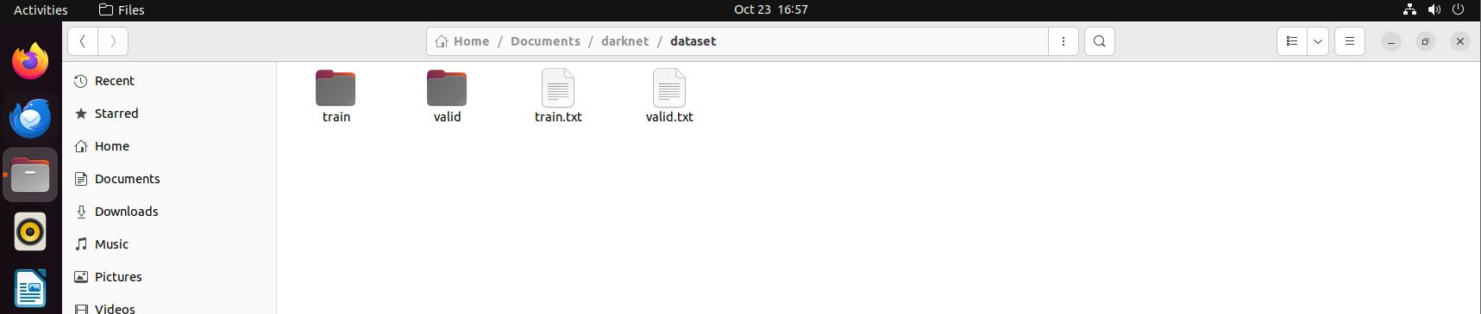

* Copy all the train and validation image path to train.txt and valid.txt

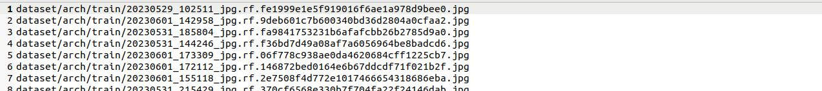

* In the data directory, make new custom.data, custom.names files
* In custom.names file, write all class names to detect
* In custom.data file

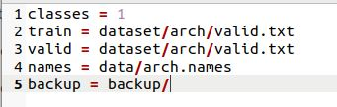

Write number of classes, train, valid, names file path

1. Modify the cfg file

* Modify the classes values to 1 in the two yolo layers
* Modify the filters value in the 1x1 conv layer(before the yolo layer)

Filters = (5+classes)x3 = 18

* Re-calculate the anchor sizes and modify the values in the two yolo layers using anchor_cal.py
* Set the max_batches to 2000~6000

1. Extract the darknet part from yolov3-tiny

$ ./darknet partial cfg/(custom.cfg) weights/yolov3-tiny.weights yolov3-tiny.conv.11 11

1. Train the model

$ ./darknet detector train data/(custom.data) cfg/(custom.cfg) yolov3-tiny.conv.11