# Part4操作指南

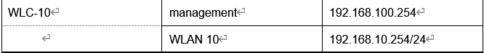

在Admin的web browser输入https://192.168.100.254 进入WLC界面

**Step 1 Configure a VLAN interface**

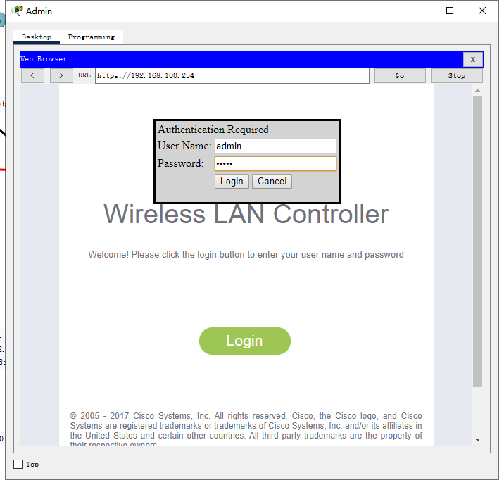

账号admin，密码admin

a.Create a new interface and name it WLAN 10. The interface should use VLAN 10 and physical port 1.

controller ->interfaces ->new

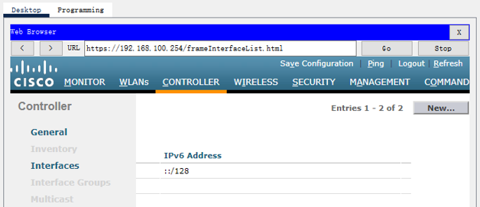

WLAN 10 注意大小写

b. Use the information in the addressing table to configure the addressing settings for the interface. The interface will be using a DHCP pool that is configured on the subinterface that is assigned to VLAN 10 on router R-B-10

点击WLAN 10进行详细配置

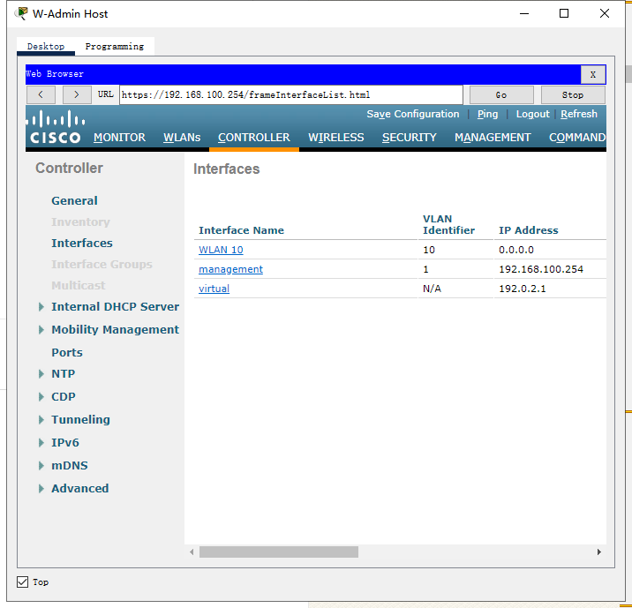

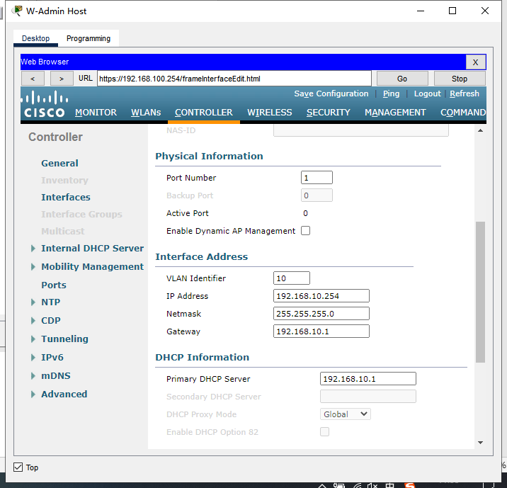

配置好后点击右上角apply

**Step 2 Configure a RADIUS server**

a. Configure the WLC with the RADIUS server IPv4 address

b. Use a shared secret of RADsecret.

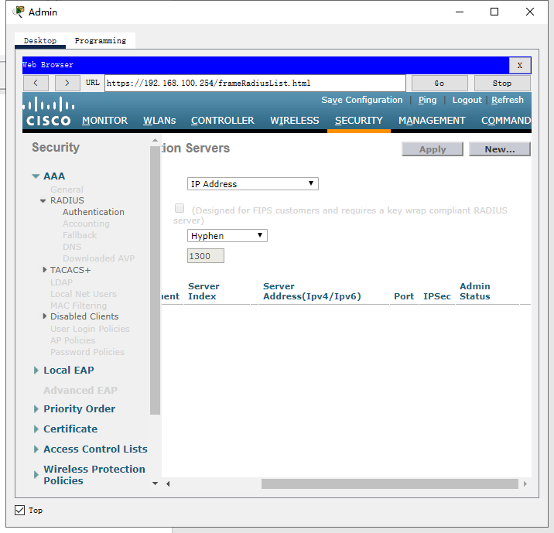

Security -> radius ->new

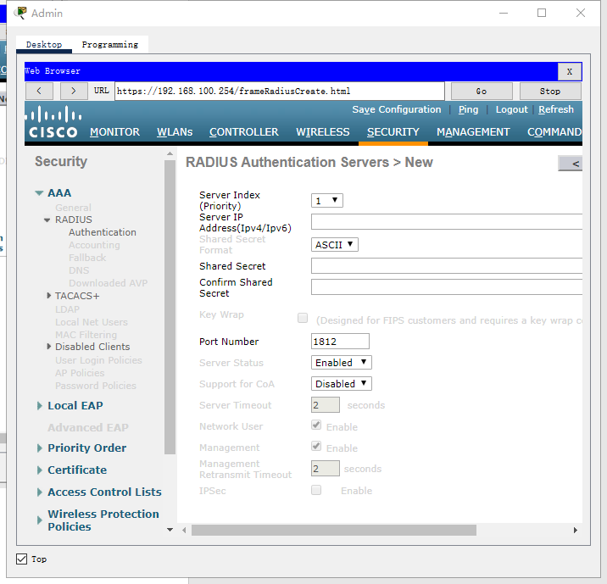

**Step 3 Configure a Wireless LAN**

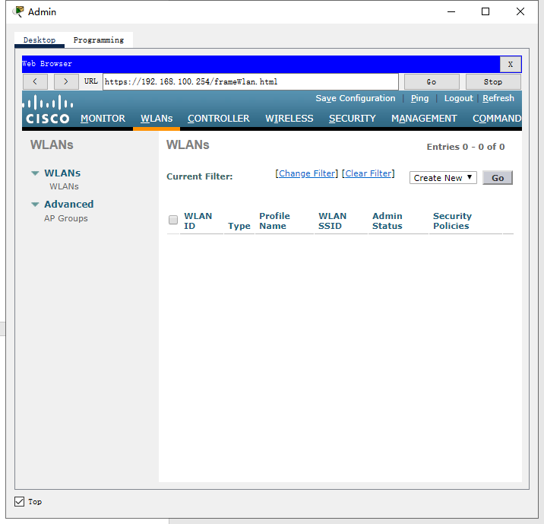

a. Create a new WLAN. Name it WLAN 10 and configure the SSID as SSID-10.

WLANs ->create new->GO

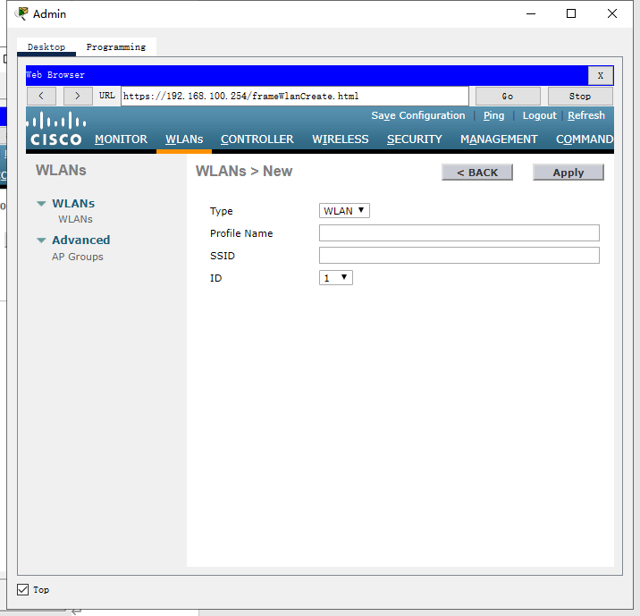

b. The wireless LAN should use the VLAN interface that was previously configured.

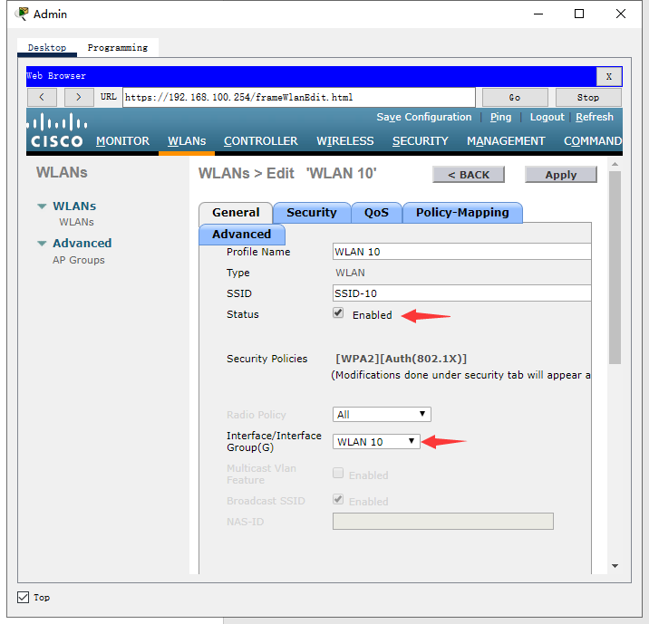

c. Configure the WLAN to use the WPA2 security policy and dot1x Authentication Key Management.

Security -> layer2

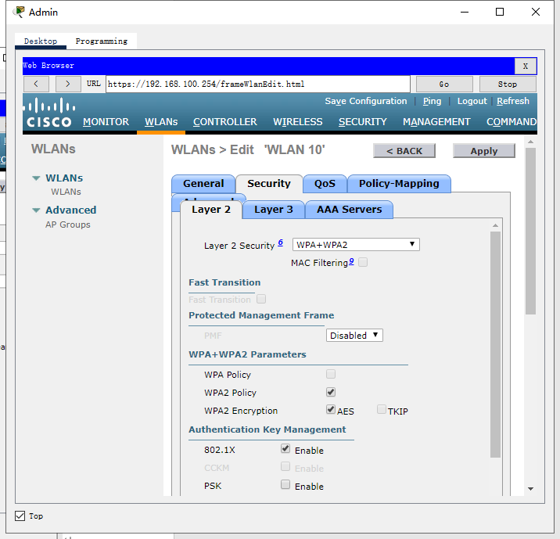

Layer2 security选择WPA+WPA2，勾选WPA2 policy和802.1x

d. Configure the WLAN to use the RADIUS server that was previously configured to authenticate wireless users.

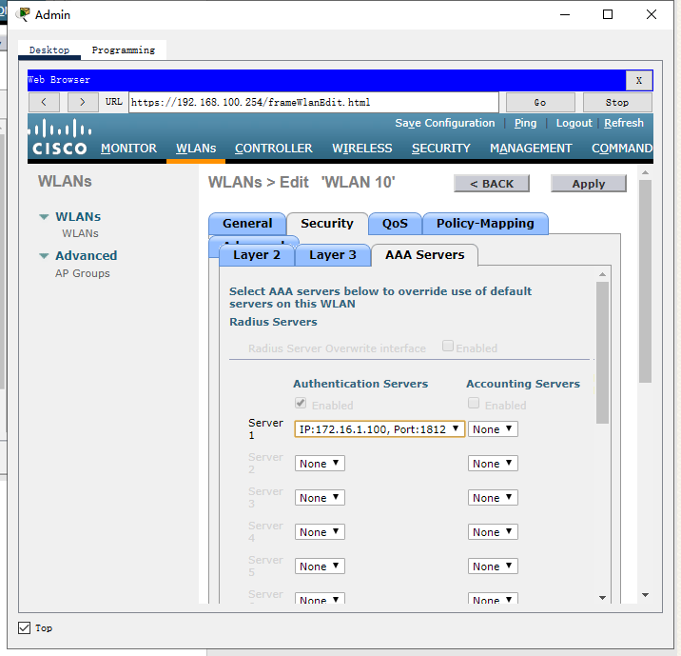

AAA servers中修改server1

e.Open the Advanced tab and scroll down to the Flexconnect sections. Activate FlexConnect Local Switching and FlexConnect Local Auth.

Advanced->flexconnect->local switching + local auth

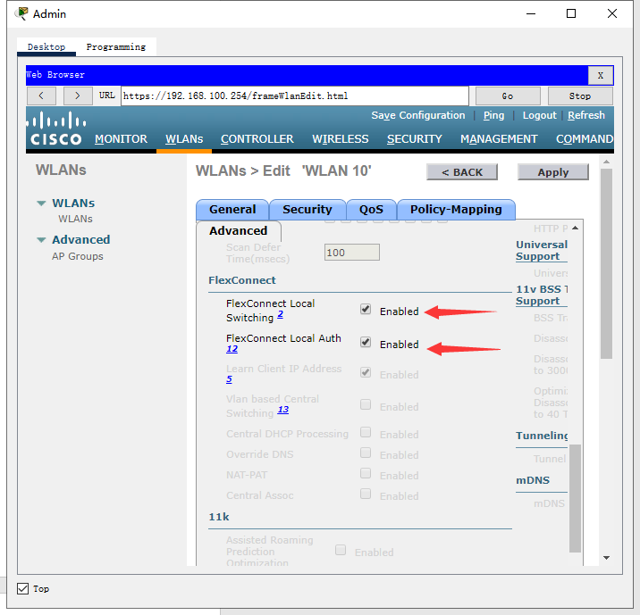

**Step 4 Configure a DHCP scope for the management network**

a.Name the DHCP scope Wired_Admin.

Controller -> internal DHCP server -> DHCP scope->new

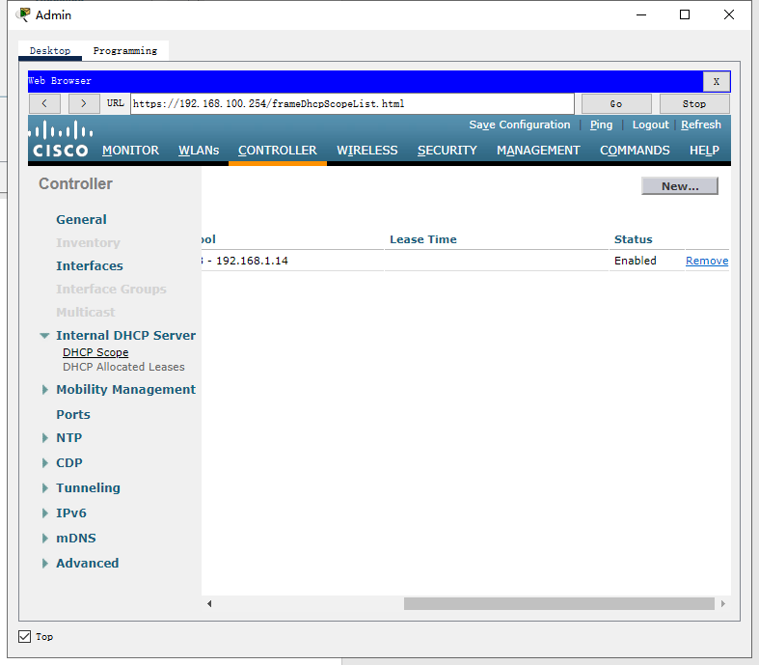

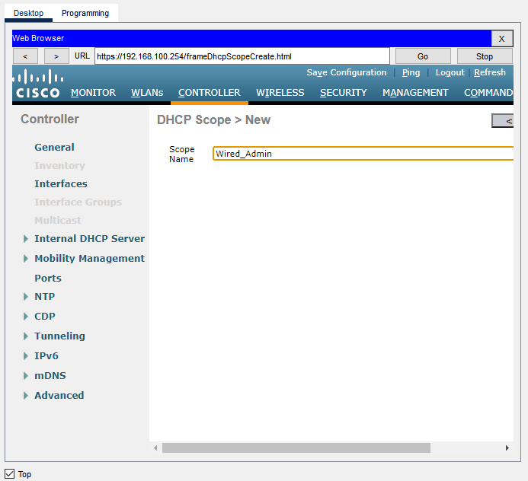

b.Start the scope at address 192.168.100.240. End the scope at address 192.168.100.249.

c.Other information that is required can be found in the Addressing Table.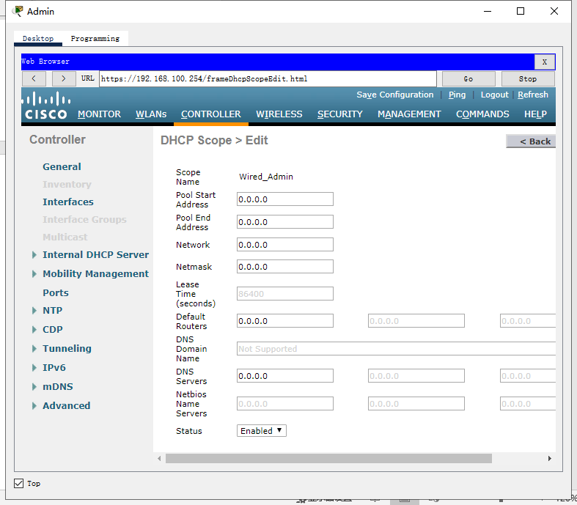

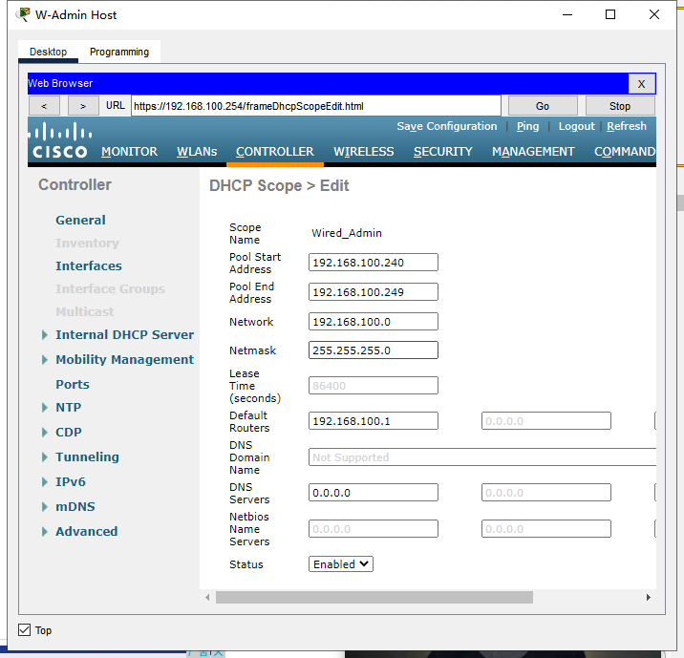

**Step 5 Configure an SNMP server**

a. Use the community name branch-wireless.

b. Use 172.16.1.100 as the server address.

Management -> snmp ->trap receivers -> new

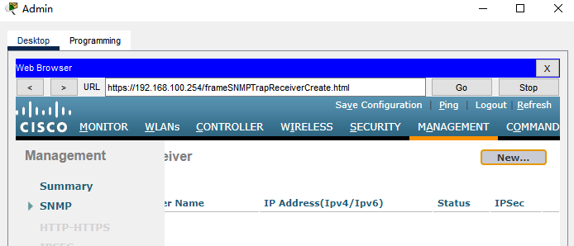

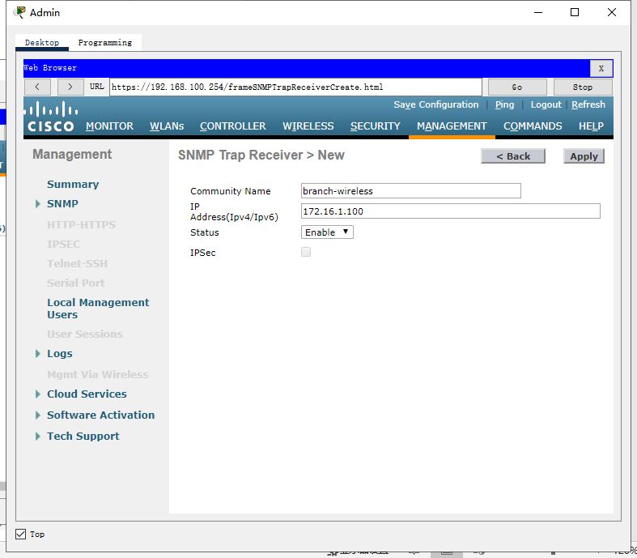

配置完成后apply，然后点击右上角的save configuration

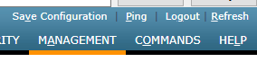

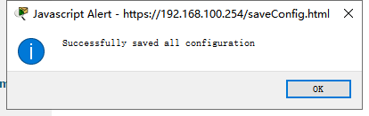

**Step 6 Configure the wireless host**

Configure the LT-1 laptop to connect to the WLAN.

1. Create a new wireless profile on the host. Use the name work net for the profile.

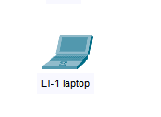

Laptop -> pc wireless -> profiles -> new

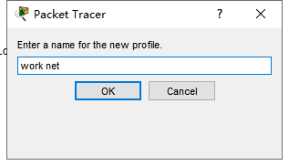

b. Configure the profile for the SSID of the WLAN.

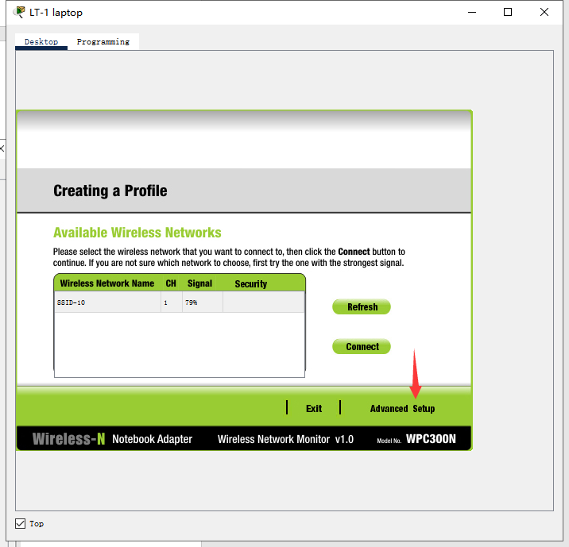

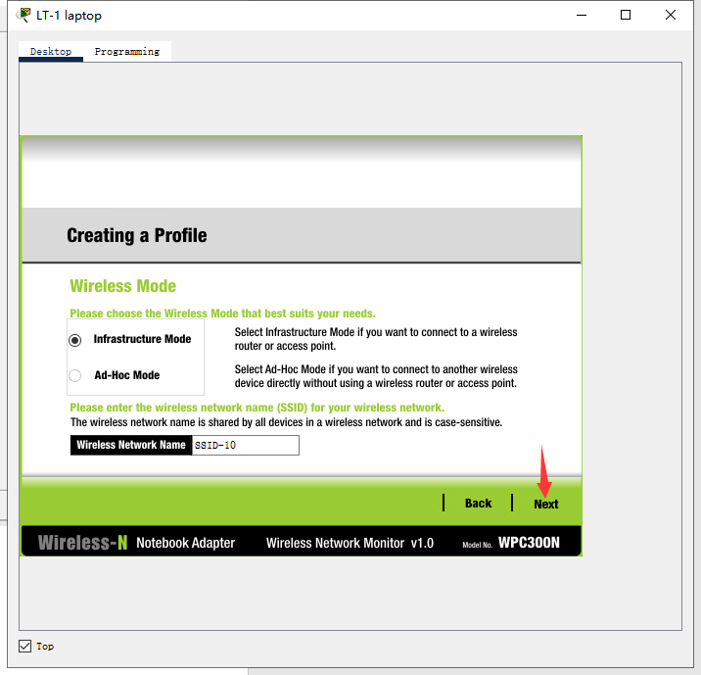

连续next，直到wireless security页面

将security改为WPA2-Enterprise

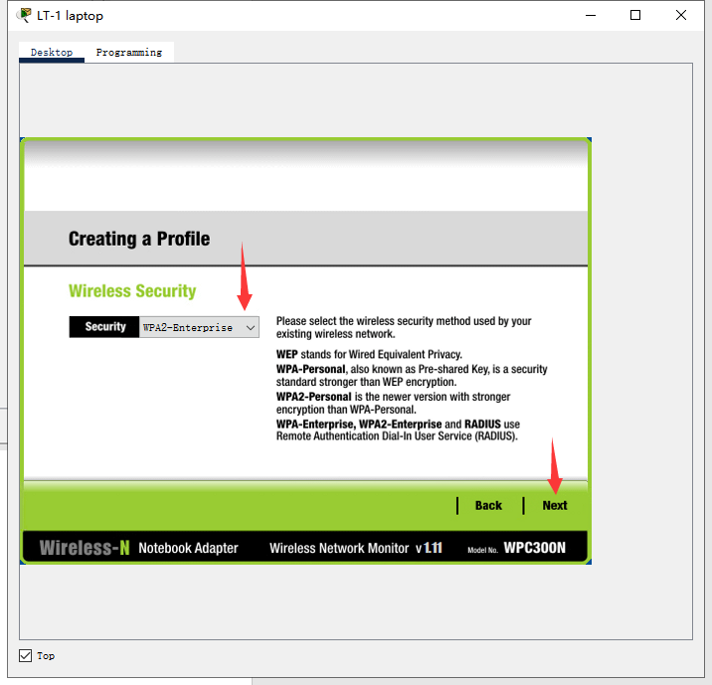

c. Use enterprise authentication with a username of user1 and password of user1Pass.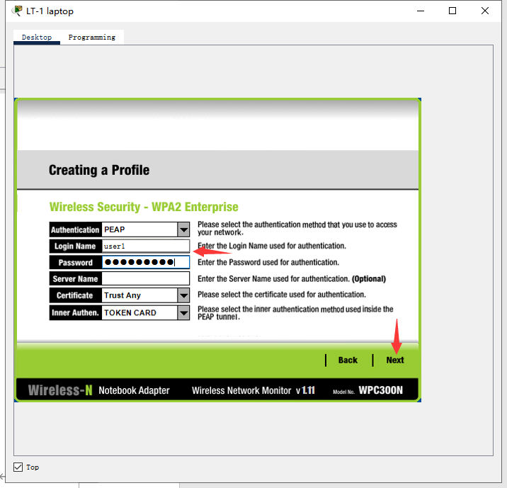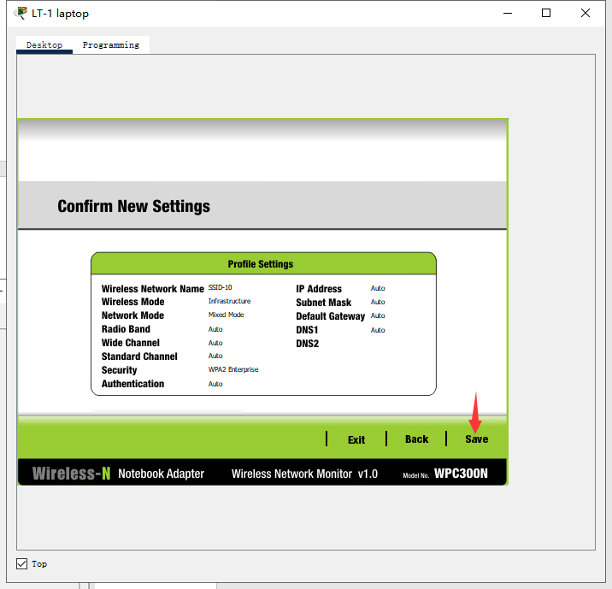

d. When you are finished, click Connect to Network. It will take time for the connection to be established.

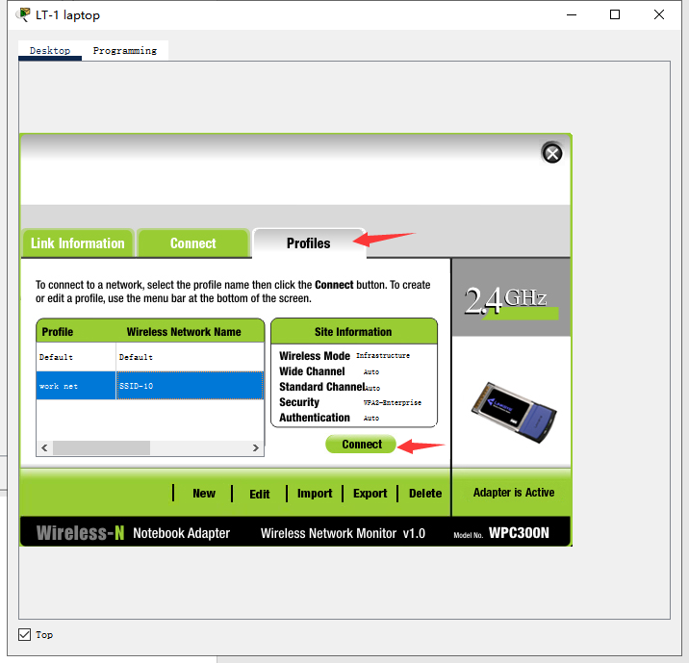

最终效果如下：

