**实验一题目与得分点**

思科的实验有多套题目，但其中的区别并不大，注意自己拿到的题目可能与这个文档和实验指导上的内容略有不同，一般是命名和ip地址有区别，大家仔细一点。

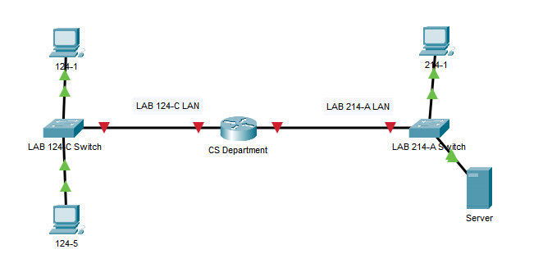

**ITN Practice Skills Assessment - Packet Tracer**

A few things to keep in mind while completing this activity:

1. Do not use the browser Back button or close or reload any exam windows during the exam.

2. Do not close Packet Tracer when you are done. It will close automatically.

3. Click the Submit Assessment button in the browser window to submit your work.

**Introduction**

In this assessment, you will configure devices in an IPv4/IPv6 network. For the sake of time, you will not be asked to perform all configurations on all network devices as you may be required to do in a real network or other assessment. Instead, you will use the skills and knowledge that you have learned in the labs and packet tracers in this course to configure the Town Hall router. In addition, you will address the hosts on two LANs with IPv4 and IPv6 addresses and activate and address the management interface of the Administration Switch.

You will receive one of several topologies.

You are not required to configure the IT Department Switch, and you will not be able to access it in this practice skills assessment activity.

All IOS device configurations should be completed from a direct terminal connection to the device console. In addition, many values that are required to complete the configurations have not been given to you. In those cases, create the values that you need to complete the requirements. For values that have been supplied to you, they must be entered exactly as they appear in order for you to get full credit for your configuration.

You will practice and be assessed on the following skills:

   Configuration of initial IOS device settings

   Design and calculation of IPv4 addressing

   Configuration of IOS device interfaces including IPv4 and IPv6 addressing when appropriate

   Addressing of network hosts with IPv4 and IPv6 addresses

   Enhancing device security, including configuration of the secure transport protocol for remote device management

   Configuration of a switch virtual management interface

Requirements by device:

**Town Hall router:**

   Configuration of initial router settings

   Interface configuration and IPv4 and IPv6 addressing

   Device security enhancement, or device hardening

   Secure transport for remote configuration connections as covered in the labs and Packet Tracers in the course.

**Administration Switch:**

   Enabling basic remote management by Telnet

   PC and Server hosts:

o   IPv4 full addressing

o   IPv6 addressing

**Addressing Table**

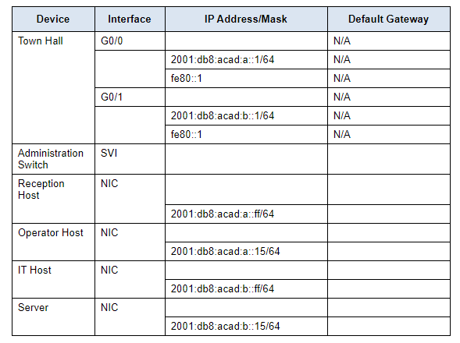

### Step 1: Determine the IP Addressing Scheme.

Design an IPv4 addressing scheme and complete the Addressing Table based on the following requirements.

a.      Subnet the 192.168.1.0/24 network to provide 30 host addresses per subnet while wasting the fewest addresses.

b.      Assign the fourth subnet to the IT Department LAN.

c.      Assign the last network host address (the highest) in this subnet to the G0/0 interface on Town Hall.

d.      Starting with the fifth subnet, subnet the network again so that the new subnets will provide 14 host addresses per subnet while wasting the fewest addresses.

e.      Assign the second of these new 14-host subnets to the Administration LAN.

f.       Assign the last network host address (the highest) in the Administration LAN subnet to the G0/1 interface of the Town Hall router.

g.      Assign the second to the last address (the second highest) in this subnet to the VLAN 1 interface of the Administration Switch.

h.      Configure addresses on the hosts using any of the remaining addresses in their respective subnets.

### Step 2: Configure Host Addressing

a.      Use the IPv4 addressing from Step 1 and the IPv6 addressing values provided in the Addressing Table to configure all host PCs with the correct addressing.

b.      Use the router interface link-local address as the IPv6 default gateways on the hosts.

c.      Complete the configuration of the server using the IPv4 addressing values from Step 1 and the values in the addressing table

### Step 3: Configure the Town Hall Router.

a.      Configure the Town Hall router with all initial configurations that you have learned in the course so far:

o        Configure the router hostname: **Town-Hall**

o        Protect device configurations from unauthorized access with the encrypted privileged exec password.

o        Secure all access lines into the router using methods covered in the course and labs.

o        Require newly-entered passwords to have a minimum length of 10 characters.

o        Prevent all passwords from being viewed in clear text in device configuration files.

o        Configure the router to only accept in-band management connections over the protocol that is more secure than Telnet, as was done in the labs and PT activities. Use the value **1024** for encryption key strength.

o        Configure local user authentication for in-band management connections. Create a user with the name **netadmin** and a secret password of**Cisco_CCNA7**.

b.      Configure the two Gigabit Ethernet interfaces using the IPv4 addressing values that you calculated and the IPv6 values provided in the addressing table.

o        Reconfigure the link local addresses to the value shown in the table.

o        Document the interfaces in the configuration file.

### Step 4: Configure the Administration Switch.

Configure Administration Switch for remote management over Telnet.

a.      Configure VLAN 1 as the SVI.

b.      Configure IPv4 addressing according to your work in Step 1.

c.      Be sure that the switch is able to accept connections from hosts on other networks.

**得分点**

**Performance Component: IP Addressing Design**

Description:  
Maximum Points = 20

|  |  |  |  |  |  |
| --- | --- | --- | --- | --- | --- |
| **Work Product Feature** | | | **Student Result** | **Earned Points** | **Max Points** |
| IP Addressing Design | | | | 20 | 20 |
|  | IPv4 LAN 1 Subnet Mask Calculation | | | 5 | 5 |
|  |  | *Network:[[PC1Name]]:Ports:FastEthernet0:Subnet Mask* | *Correct* |  |  |
|  |  | *Network:[[PC2Name]]:Ports:FastEthernet0:Subnet Mask* | *Correct* |  |
|  | IPv4 LAN 2 Subnet Mask Calculation | | | 5 | 5 |
|  |  | *Network:[[PC3Name]]:Ports:FastEthernet0:Subnet Mask* | *Correct* |  |  |
|  | LAN 1 IPv4 Host Addressing Design and Implementation | | | 5 | 5 |
|  |  | *Network:[[PC1Name]]:Ports:FastEthernet0:IP Address* | *Correct* |  |  |
|  |  | *Network:[[PC2Name]]:Ports:FastEthernet0:IP Address* | *Correct* |  |
|  | LAN 2 IPv4 Host Addressing Design and Implementation | | | 5 | 5 |
|  |  | *Network:[[PC3Name]]:Ports:FastEthernet0:IP Address* | *Correct* |  |  |

**Performance Component: IPv6 Host Address Configuration**

Description:  
Maximum Points = 8

|  |  |  |  |  |  |
| --- | --- | --- | --- | --- | --- |
| **Work Product Feature** | | | **Student Result** | **Earned Points** | **Max Points** |
| IPv6 Host Address Configuration | | | | 4 | 8 |
|  | LAN 1 IPv6 Host Address Configuration | | | 0 | 4 |
|  |  | ***Network:[[PC1Name]]:Ports:FastEthernet0:Ipv6 Address:2001\:DB8\:ACAD\:A\:\:FF:IP Address*** | ***Incorrect*** |  |  |
|  |  | *Network:[[PC2Name]]:Ports:FastEthernet0:Ipv6 Address:2001\:DB8\:ACAD\:A\:\:15:IP Address* | *Correct* |  |
|  | LAN 2 IPv6 Host Address Configuration | | | 4 | 4 |
|  |  | *Network:[[PC3Name]]:Ports:FastEthernet0:Ipv6 Address:2001\:DB8\:ACAD\:B\:\:FF:IP Address* | *Correct* |  |  |

**Performance Component: Router Interface Configuration and Addressing**

Description:  
Maximum Points = 26

|  |  |  |  |  |  |
| --- | --- | --- | --- | --- | --- |
| **Work Product Feature** | | | **Student Result** | **Earned Points** | **Max Points** |
| Router Interface Configuration and Addressing | | | | 26 | 26 |
|  | Router Interface Activation | | | 4 | 4 |
|  |  | *Network:[[Router0Name]]:Ports:GigabitEthernet0/0:Power* | *Correct* |  |  |
|  |  | *Network:[[Router0Name]]:Ports:GigabitEthernet0/0:Description* | *Correct* |  |
|  |  | *Network:[[Router0Name]]:Ports:GigabitEthernet0/1:Power* | *Correct* |  |
|  |  | *Network:[[Router0Name]]:Ports:GigabitEthernet0/1:Description* | *Correct* |  |
|  | Router Interface G0/0 IPv4 Addressing | | | 5 | 5 |
|  |  | *Network:[[Router0Name]]:Ports:GigabitEthernet0/0:IP Address* | *Correct* |  |  |
|  |  | *Network:[[Router0Name]]:Ports:GigabitEthernet0/0:Subnet Mask* | *Correct* |  |
|  | Router Interface G0/1 IPv4 Addressing | | | 5 | 5 |
|  |  | *Network:[[Router0Name]]:Ports:GigabitEthernet0/1:IP Address* | *Correct* |  |  |
|  |  | *Network:[[Router0Name]]:Ports:GigabitEthernet0/1:Subnet Mask* | *Correct* |  |
|  | Router Interface G0/0 IPv6 Addressing | | | 6 | 6 |
|  |  | *Network:[[Router0Name]]:Ports:GigabitEthernet0/0:Ipv6 Address:2001\:DB8\:ACAD\:A\:\:1:IP Address* | *Correct* |  |  |
|  |  | *Network:[[Router0Name]]:Ports:GigabitEthernet0/0:Link Local* | *Correct* |  |
|  | Router Interface G0/1 IPv6 Addressing | | | 6 | 6 |
|  |  | *Network:[[Router0Name]]:Ports:GigabitEthernet0/1:Ipv6 Address:2001\:DB8\:ACAD\:B\:\:1:IP Address* | *Correct* |  |  |
|  |  | *Network:[[Router0Name]]:Ports:GigabitEthernet0/1:Link Local* | *Correct* |  |

**Performance Component: Host Default Gateway Configuration**

Description:  
Maximum Points = 14

|  |  |  |  |  |  |
| --- | --- | --- | --- | --- | --- |
| **Work Product Feature** | | | **Student Result** | **Earned Points** | **Max Points** |
| Host Default Gateway Configuration | | | | 14 | 14 |
|  | LAN 1 Hosts Default Gateway Configuration | | | 7 | 7 |
|  |  | *Network:[[PC1Name]]:Default Gateway* | *Correct* |  |  |
|  |  | *Network:[[PC1Name]]:Default Gateway IPv6* | *Correct* |  |
|  |  | *Network:[[PC2Name]]:Default Gateway* | *Correct* |  |
|  |  | *Network:[[PC2Name]]:Default Gateway IPv6* | *Correct* |  |
|  | LAN 2 Hosts Default Gateway Configuration | | | 7 | 7 |
|  |  | *Network:[[PC3Name]]:Default Gateway* | *Correct* |  |  |
|  |  | *Network:[[PC3Name]]:Default Gateway IPv6* | *Correct* |  |

**Performance Component: Switch Management Interface**

Description:  
Maximum Points = 7

|  |  |  |  |  |  |
| --- | --- | --- | --- | --- | --- |
| **Work Product Feature** | | | **Student Result** | **Earned Points** | **Max Points** |
| Switch Management Interface | | | | 7 | 7 |
|  | Switch Management Interface Configuration | | | 7 | 7 |
|  |  | *Network:[[Switch2Name]]:Ports:Vlan1:Power* | *Correct* |  |  |
|  |  | *Network:[[Switch2Name]]:Ports:Vlan1:IP Address* | *Correct* |  |
|  |  | *Network:[[Switch2Name]]:Ports:Vlan1:Subnet Mask* | *Correct* |  |
|  |  | *Network:[[Switch2Name]]:Default Gateway* | *Correct* |  |
|  |  | *Network:[[Switch2Name]]:VTY Lines:0:Password* | *Correct* |  |

**Performance Component: Initial Device Configuration**

Description:  
Maximum Points = 10

|  |  |  |  |  |  |
| --- | --- | --- | --- | --- | --- |
| **Work Product Feature** | | | **Student Result** | **Earned Points** | **Max Points** |
| Initial Device Configuration | | | | 10 | 10 |
|  | Basic Router Configuration | | | 5 | 5 |
|  |  | *Network:[[Router0Name]]:Host Name* | *Correct* |  |  |
|  |  | *Network:[[Router0Name]]:Enable Secret* | *Correct* |  |
|  |  | *Network:[[Router0Name]]:Banner motd* | *Correct* |  |
|  | Secure Router Communication Lines | | | 5 | 5 |
|  |  | *Network:[[Router0Name]]:Console Line:Login* | *Correct* |  |  |
|  |  | *Network:[[Router0Name]]:Console Line:Password* | *Correct* |  |

**Performance Component: Device Hardening**

Description:  
Maximum Points = 15

|  |  |  |  |  |  |
| --- | --- | --- | --- | --- | --- |
| **Work Product Feature** | | | **Student Result** | **Earned Points** | **Max Points** |
| Device Hardening | | | | 15 | 15 |
|  | Enhance Router Password Security | | | 5 | 5 |
|  |  | *Network:[[Router0Name]]:Service Password Encryption* | *Correct* |  |  |
|  |  | *Network:[[Router0Name]]:Security Password Min-Length* | *Correct* |  |
|  | Router SSH Configuration | | | 10 | 10 |
|  |  | *Network:[[Router0Name]]:VTY Lines:0:Transport Input* | *Correct* |  |  |
|  |  | *Network:[[Router0Name]]:VTY Lines:0:Login* | *Correct* |  |
|  |  | *Network:[[Router0Name]]:IP Domain Name* | *Correct* |  |
|  |  | *Network:[[Router0Name]]:Security:Modulus Bits* | *Correct* |  |